Communications Recommendations – Google Health App Crash - Android v12.0.3

Audience
Support Channels: Social / Community / Voice Channel / Chat / Email

Situation Overview
The Google Health App crashes immediately on launch for Android users running version 12.0.3 or below. Affected users see a white screen for 2–3 seconds before the app force closes with no error message. The issue was first reported on April 28, 2026, and currently impacts approximately 14,000 devices. A hotfix is in development and expected to roll out by May 15, 2026.
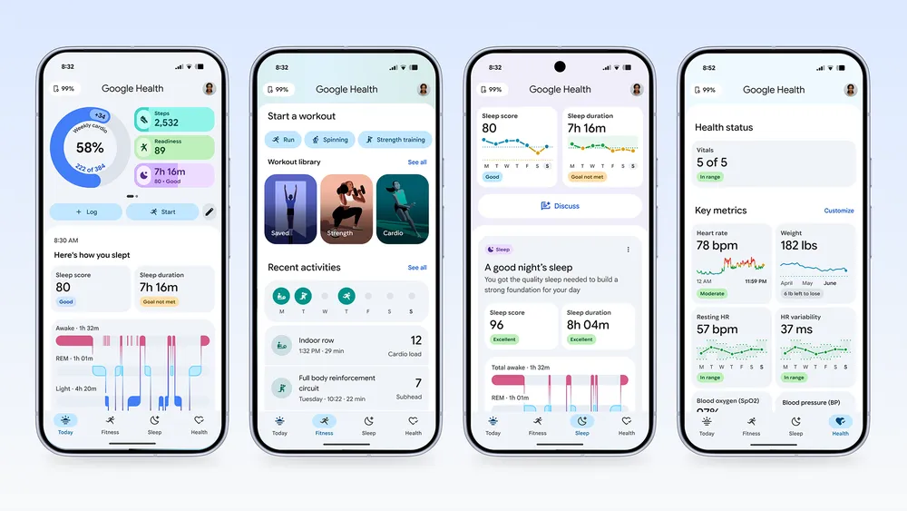

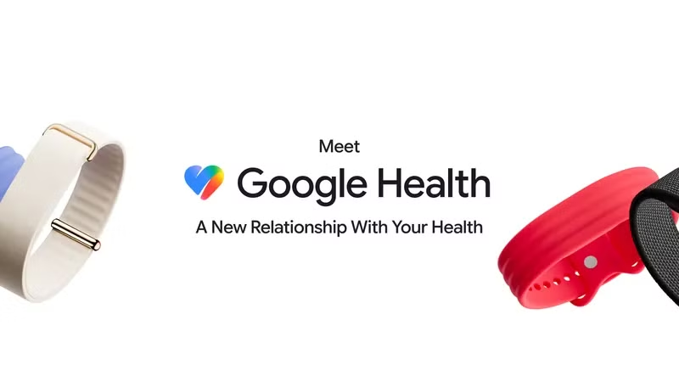

Approach
Incident response: engineering team is developing a hotfix expected by May 15, 2026. Customer support is communicating temporary workarounds. Social and community teams are monitoring for escalations. No data breach or privacy risk identified.

Materials
FAQ document, social media response templates, customer service talking points, in-app notification copy

Messaging Statement
We are aware of an issue affecting Google Health App on Android devices running version 12.0.3 or below. Our engineering team is actively working on a hotfix, expected to roll out by May 15, 2026. In the meantime, affected users can access their health data via health.google.com on a mobile browser. No health data has been compromised.

Social Messaging
We're working on a fix for Android users experiencing app crashes. A hotfix is coming by May 15. Your data is safe — access it temporarily at health.google.com. Thanks for your patience!

Talking Points
• Issue affects Android devices running Google Health App version 12.0.3 or below only
• iOS users are not impacted
• Hotfix expected by May 15, 2026, delivered via Play Store automatic update — no reinstall needed
• Temporary workaround: use health.google.com in mobile browser
• No health data at risk; crash is UI-layer only

FAQs
Q: Who is the target audience for this communication?
A: Android users of Google Health App running version 12.0.3 or below
Q: Which Android versions are affected?
A: Only Android devices running Google Health App version 12.0.3 or below are impacted. iOS users are not affected.
Q: Is my health data safe?
A: Yes. All health data is stored securely on Google's servers and is not at risk. The crash occurs at the UI layer and does not affect data integrity.
Q: What should I do while waiting for the fix?
A: You can access your health data via health.google.com on a mobile browser as a temporary workaround.
Q: Will I need to reinstall the app after the update?
A: No. The hotfix will be delivered as an automatic update through the Play Store. No reinstall is necessary.

Distribution Information
Source Channel | Distribution Channel | Distribution Method
☑ Social | ☑ Social/Community | ☐ SSAM (AI recommendation engine)
☐ Voice Call | ☑ Reactive (DM) | ☐ Training (Classroom)
☐ Chat | ☐ Proactive | ☐ Support S.com (Customer Facing)
☐ Community | ☐ Voice Call | ☐ Vendor Huddle (Conf Call)
☐ Repair Centers | ☐ Chat | ☑ Alert Communication (Email)
☐ Global / HQ | ☐ Repair Centers | ☐ System Modification (Pop-Up)
 | ☐ Carrier | ☐ IVR Message (1800 GOOGLE)
 | ☐ Retail | ☐ Retail Communication (FSM)
 | ☐ E-Com CS
Status Date: | Approval Status | Resource Links:
2026-05-13 | ☑ CSD Internal  ☐ Legal  ☑ PR  ☐ Product Mkt  ☐ Product Mgmt  ☐ HQ PR
Assessment Questions:
Q: Is this issue customer-facing? | A: Yes, the app crash is immediately visible to users on launch.
Q: Are there any legal or compliance concerns? | A: No data breach or privacy risk identified.

