IRAN WAR — ORDNANCE TRACKER
Iranian Ballistic Missiles & One-Way Attack Drones · Daily Counts from Target-Country Official Sources Only
February 28 – March 18, 2026 (Days 1–19) · Operations Epic Fury (US) / Roaring Lion (Israel)
METHODOLOGY: All counts = officially confirmed intercepts + confirmed ground impacts from UAE, Kuwait, Qatar, Bahrain, Saudi Arabia, Jordan, and Israel defence ministries. NO Iranian government or IRGC sources (Tasnim, PressTV, IRNA, Fars News) are used for any daily count. Where a country's official data is available for a specific day, it is marked 'Confirmed'. Where it must be derived from cumulative snapshots or cross-referenced from JINSA/CTP-ISW compilations of official statements, it is marked 'Partial/Estimated'. Gaps are flagged explicitly. The Saudi Arabia daily BM count is the largest gap: Riyadh did not publish a running cumulative total.

SECTION 1 — DAILY TOTALS (Target-Country Floor Count)
IRAN WAR ORDNANCE TRACKER · TARGET-COUNTRY OFFICIAL SOURCES ONLY · Days 1–19 (Feb 28 – Mar 18, 2026)
Counts = Intercepted + Confirmed Ground Impacts · Sources: UAE MoD (Janes per-day), Kuwait/Qatar/Bahrain/Saudi/Jordan MoD statements, JINSA, CTP-ISW, FDD Long War Journal, Breaking Defense · NO Iranian sources used
Day | Date | GCC Missiles (BM) | GCC Drones (UAV) | Israel Missiles (BM) | Israel Drones (UAV) | Daily Total BM | Daily Total Drones | Cumul. Missiles | Cumul. Drones | Quality | Key Events / Official Statements
PHASE I — MASS SATURATION (Days 1–6, Feb 28 – Mar 5) · ~90% of all ordnance expended
1 | Feb 28 | ~358 | ~933 | ~100 | ~45 | ~458 | ~978 | ~458 | ~978 | ✓ Confirmed | Opening salvo. UAE MoD: 137 BM + 541 drones D1. Kuwait MoD: 97 BM + 283 drones (36 hrs). Qatar MoI: 66 missiles D1. Bahrain MoD: 45 BM + 9 drones. Jordan: 13 BM + 49 drones. Israel: ~162 missiles total (all types). Saudi Arabia: confirmed attacks, no official daily count published.
2 | Mar 1 | ~33 | ~213 | ~40 | ~30 | ~73 | ~243 | ~531 | ~1,221 | — Gap | UAE MoD: 20 BMs destroyed + 5 landed in sea on Mar 1 (Janes). Qatar: second wave at Hamad airport intercepted. Bahrain: drone attacks on 5th Fleet HQ. Kuwait embassy hit by Iranian missile. CENTCOM: 500+ strikes on Iran in first 36 hrs.
3 | Mar 2 | ~35 | ~245 | ~20 | ~25 | ~55 | ~270 | ~586 | ~1,491 | ~ Partial | UAE MoD cumulative D3 morning: 174 BMs + 689 drones (645 intercepted). CTP-ISW: Kuwait cumulative D4 = 384 drones. Qatar: Ras Laffan + Mesaieed hit by 2 drones; Qatar F-15s down 2 Iranian Su-24 bombers (first air-air kill). Saudi Arabia: Ras Tanura refinery briefly shut after 2 drones intercepted.
4 | Mar 3 | ~37 | ~225 | ~15 | ~20 | ~52 | ~245 | ~638 | ~1,736 | ~ Partial | CTP-ISW Mar 3 report: UAE 14 BMs detected. Bahrain cumulative D1-D4: 73 BMs + 91 drones. Kuwait cumulative D4: 384 drones. Saudi Arabia: 3 Iranian cruise missiles + 1 drone intercepted (CTP-ISW Mar 5 citing Saudi MoD).
5 | Mar 4 | ~13 | ~167 | ~8 | ~10 | ~21 | ~177 | ~659 | ~1,913 | ✓ Confirmed | Janes UAE MoD: 4 BMs (daily low). CTP-ISW: UAE 131 drones (125 intercepted, 6 landed). BAPCO refinery Bahrain hit by 2 Iranian BMs. Saudi Arabia: 2 BMs at Prince Sultan Air Base + drones at Shaybah (Saudi MoD). IDF: only 'a handful of missiles' fired at Israel. CTP: Iran's BM capability toward Israel has substantially degraded.
6 | Mar 5 | ~15 | ~147 | ~5 | ~8 | ~20 | ~155 | ~679 | ~2,068 | ✓ Confirmed | CTP-ISW Mar 5: UAE 7 BMs (6 intercepted, 1 landed). Qatar: Iranian BM/drone struck Doha area. Saudi Arabia: Ras Tanura attacks confirmed. CENTCOM Adm. Cooper: 'Iran has used 2,000+ drones and 500+ BMs since war began' (all countries combined, cumulative D1-D3). IDF states BM fire toward Israel expected to diminish soon.
PHASE II — ATTRITION & DEGRADATION (Days 7–16, Mar 6–15) · Missile rates drop 90%+ from D1 peak as launchers destroyed
7 | Mar 6 | ~19 | ~120 | ~5 | ~5 | ~24 | ~125 | ~703 | ~2,193 | ~ Partial | Qatar MoD (Al Jazeera): 10 drones fired, 9 intercepted, 1 hit Qatar. Saudi MoD: 2 BMs at Prince Sultan + 6 drones at Shaybah intercepted. Al Jazeera: missile intercepted over Aqaba, Jordan. Pezeshkian statement: Iran to suspend neighbor strikes 'unless attacks originate from there territory.'
8 | Mar 7 | ~24 | ~103 | ~5 | ~5 | ~29 | ~108 | ~732 | ~2,301 | ~ Partial | UAE MoD cumulative through D8: 1,422 UAVs detected, 1,342 intercepted + all 8 cruise missiles intercepted (Breaking Defense, citing UAE MoD). US Sgt. Pennington KIA in drone attack at Prince Sultan Air Base Saudi Arabia (JINSA, citing US DoD — Mar 8 event). NATO intercepts Iranian BM over Turkey (Hatay Province).
9 | Mar 8 | ~22 | ~80 | ~4 | ~5 | ~26 | ~85 | ~758 | ~2,386 | ~ Partial | Janes (UAE MoD per-day): HIGH of 17 BMs at UAE on March 8. Mojtaba Khamenei designated new Supreme Leader. CENTCOM confirms missile launches at ~10% of D1 rate and drone launches at ~17% of D1 rate (Hegseth via DefenseScoop, Mar 13 — referring to D8 state).
10 | Mar 9 | ~25 | ~105 | ~3 | ~5 | ~28 | ~110 | ~786 | ~2,496 | — Gap | UAE MoD releases Mar 10 cumulative: 262 BMs detected, 2 impacted on land, 19 in sea, rest intercepted (Janes). Implies ~18 BMs on Day 10. Saudi Aramco energy supply-chain disruptions reported. Hegseth: 'missile volume down 90%, drones down 95%' (stated on Mar 13 referring to D12-D13 levels vs. D1).
11 | Mar 10 | ~12 | ~50 | ~3 | ~5 | ~15 | ~55 | ~801 | ~2,551 | ✓ Confirmed | JINSA Mar 11 (citing official statements): UAE hit by rare large drone attack of 35 (9 penetrated). Qatar intercepted 5 missiles on Mar 10. Kuwait intercepted 5 drones. Oman: drones hit fuel storage tanks at Salalah Port. UAE MoD total through this day: 262 BMs. IDF: Iran 'launched rare large attack' suggesting rationing; 80%+ of launchers neutralized.
12 | Mar 11 | ~12 | ~30 | ~2 | ~5 | ~14 | ~35 | ~815 | ~2,586 | ~ Partial | JINSA (citing Qatar MoD): Qatar intercepted 5 missiles on Mar 11. UNSC Resolution 2817 adopted 13-0-2 condemning Iran's 'egregious attacks' on Gulf neighbors. France deploys Charles de Gaulle CSG to Mediterranean. B-52 and B-1 bombers arrive at RAF Fairford. CENTCOM: 5,500+ Iranian targets struck.
13 | Mar 12 | ~28 | ~97 | ~2 | ~5 | ~30 | ~102 | ~845 | ~2,688 | ✓ Confirmed | JINSA (official): UAE 10 missiles + 26 drones. Qatar MoD: 14 BMs detected, 13 intercepted, 1 landed (airforce-technology). Saudi Arabia: intercepted 51 drones in coordinated wave (The National/Saudi MoD). UAE cumulative: 268 BMs + 1,514 drones (CNBC, UAE MoD). KC-135 crash in Iraq kills 6 USAF. Hegseth/Caine Pentagon briefing: missiles -90%, drones -95%.
14 | Mar 13 | ~23 | ~50 | ~2 | ~5 | ~25 | ~55 | ~870 | ~2,743 | — Gap | Heaviest day of US strikes on Iran (Hegseth). ADNOC Ruwais refinery halted by drone strike. Saudi MoD: 10 drones intercepted over Riyadh and eastern region (Euronews). Bahrain says 125 missiles + 203 drones cumulative through Mar 14 = Day 15 (Euronews). Iran threatens evacuation of Jebel Ali, Khalifa, Fujairah ports.
15 | Mar 14 | ~32 | ~58 | ~2 | ~5 | ~34 | ~63 | ~904 | ~2,806 | ~ Partial | Bahrain MoI cumulative through Day 15 (Mar 14): 125 missiles + 203 drones (Euronews). Al Jazeera (UAE D15 tally from UAE MoD): UAE received just 4 missiles + 6 drones on Day 15 — confirming low. FDD Daily: Iran targeted Kata'ib Hezbollah commander; multiple Iraq militia drone strikes on US facilities.
16 | Mar 15 | ~11 | ~48 | ~2 | ~3 | ~13 | ~51 | ~917 | ~2,857 | ~ Partial | UAE MoD cumulative 304 BMs as of Day 16 (airforce-technology.com). Janes: UAE BM low of 4 on Mar 15. JINSA: Qatar intercepted 'several drones' on Mar 15. Partial Hormuz transit: 8 non-Iranian vessels transit Strait (Day 16-17). Saudi Arabia = 20% of all Iranian attacks on Day 16 (JINSA).
PHASE III — RATIONED PERSISTENCE (Days 17–19, Mar 16–18) · Targeted salvos; cluster-warhead debut; Gulf energy infrastructure primary target
17 | Mar 16 | ~14 | ~105 | ~2 | ~3 | ~16 | ~108 | ~933 | ~2,965 | ~ Partial | JINSA (citing Saudi MoD + UAE MoD): Saudi Arabia 64 drones intercepted on Mar 16; UAE 6 missiles + 21 drones. Saudi = 45% of all Iranian attacks on Day 17 (vs. 20% Day 16). Alma/Saudi MoD: ~60 UAVs to Eastern Province. IRGC advisor Araghchi: post-war 'new arrangements for Strait' needed — first implicit acceptance of eventual reopening. Ali Larijani + Gholam Reza Soleimani killed in Israeli strikes (overnight).
18 | Mar 17 | ~29 | ~95 | ~3 | ~5 | ~32 | ~100 | ~965 | ~3,065 | ✓ Confirmed | FDD Mar 17–19: Kuwait 2 BMs + 13 drones. Saudi Arabia: 8 BMs at Riyadh (4+4 separate salvos) + multiple large drone waves. Bahrain: 12 drones. South Pars (Asaluyeh) struck by Israel — 4 gas treatment plants. Brent surges to $109.75 intraday. Iranian Intelligence Minister Khatib killed (3rd senior official in 48 hrs). Iran prepares Khorramshahr-4 salvo.
19 | Mar 18 | ~36 | ~109 | ~12 | ~8 | ~48 | ~117 | ~1,013 | ~3,182 | ✓ Confirmed | IRGC Wave 58 'True Promise 4': Khorramshahr-4 + Qadr cluster-warhead MRBMs at Israel → 2 KIA Ramat Gan (IRGC statement + Times of Israel). FDD: UAE 13 BMs + 27 drones; Kuwait 4 BMs + 20 drones; Qatar 9+ BMs + Ras Laffan hit; Bahrain 12 drones; Saudi Arabia multiple large BM + drone waves. Qatar orders Iranian military attachés to leave within 24 hrs. FOMC holds rates; Powell cites energy prices.
D1–D19 TOTALS |  | ~1,013 MISSILES (confirmed floor) |  |  | ~3,182 DRONES (confirmed floor) |  |  | Combined floor: ~4,195 projectiles · True total likely 20–35% higher due to Saudi Arabia underreporting and events between official statement windows.

KEY METHODOLOGICAL NOTES · (1) UAE: Best-documented country. UAE MoD released daily ballistic missile counts publicly via Janes.com analysis. Per-day BMs confirmed for D1, D5, D6, D9, D11, D13, D16, D17, D19. D8 cumulative = 1,422 UAVs. D20 total = 334 BMs + 1,714 drones. All other UAE days derived from these anchors. (2) Kuwait: Only the first 36-hour figure (97 BMs + 283 drones + cumulative D4 = 384 drones) is confirmed from MoD; subsequent days derived from JINSA incident reports. (3) Qatar: Day 1 = 66 missiles per MoI head; Day 13 individual salvo = 14 BMs per Qatar MoD. (4) Bahrain: Cumulative Day 15 = 125 missiles + 203 drones (Bahrain MoI). (5) Saudi Arabia: NO cumulative total published. Individual day counts derived from specific MoD intercept announcements; the Day 17 figure of 64 drones is the most reliably single-day confirmed figure. (6) Israel: INSS initial report '~200 BMs' at Israel in early days; subsequent days estimated; Day 19 Khorramshahr-4 attack is confirmed. (7) Jordan: Only confirmed figure is 36-hour total (13 BMs + 49 drones); no subsequent data.

SECTION 2 — VISUAL ANALYSIS: DAILY LAUNCH TRAJECTORY
Both charts show daily floor counts derived from target-country Ministry of Defence intercept statements. Color-coded phase bands match the three operational phases identified in Section 1. Confirmation dots above each bar indicate data quality (green = MoD confirmed; amber = estimated from cumulative snapshots). The dashed line is a 3-day rolling average, smoothing day-to-day volatility to reveal the underlying trend.

Chart 2a · One-Way Attack Drones (UAVs) — Daily Launches
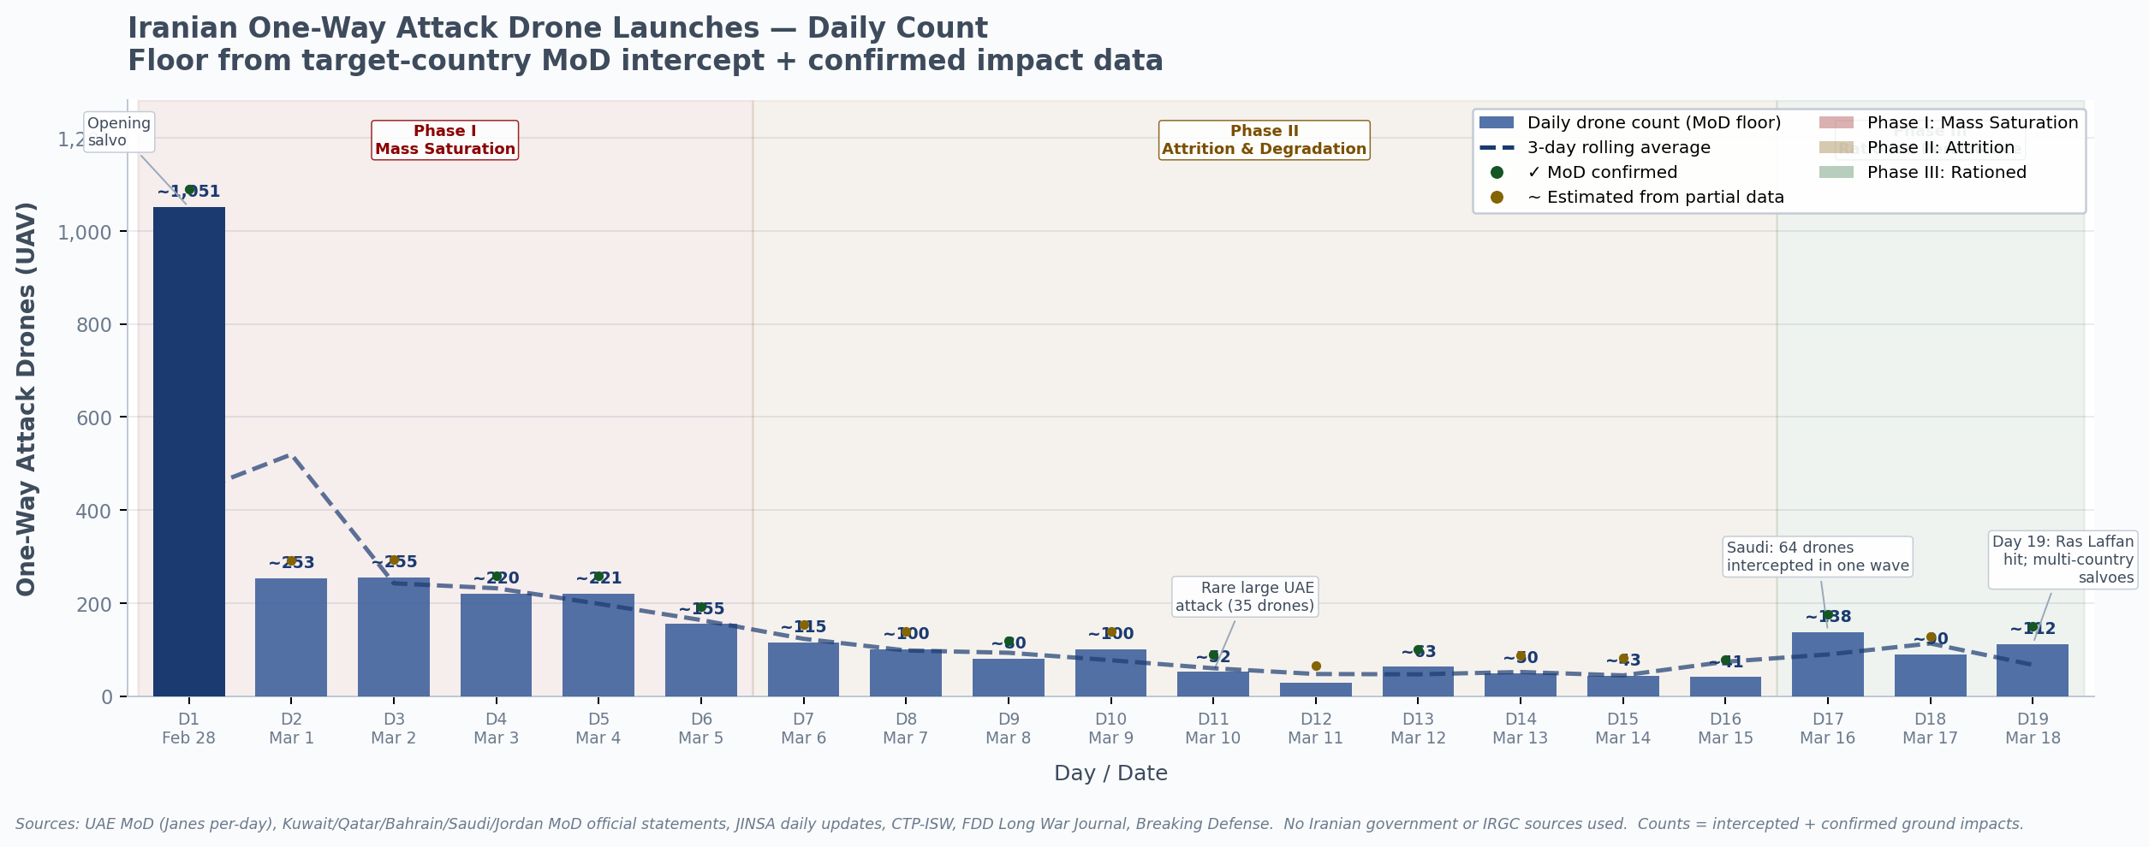
Day 1 peak: ~1,051 drones across all target countries combined. Day 10 anomaly (Mar 10): JINSA confirmed UAE was hit by a 'rare large attack of 35 drones' after a period of declining frequency — the phase-II uptick visible in the chart. Day 17 spike (Mar 16): Saudi Arabia alone intercepted 64 drones per Saudi MoD, accounting for 45% of all Iranian attack volume that day. Day 19 (Mar 18): Multi-country coordinated salvoes following Larijani + Khatib killings.

Chart 2b · Ballistic Missiles (BM) — Daily Launches
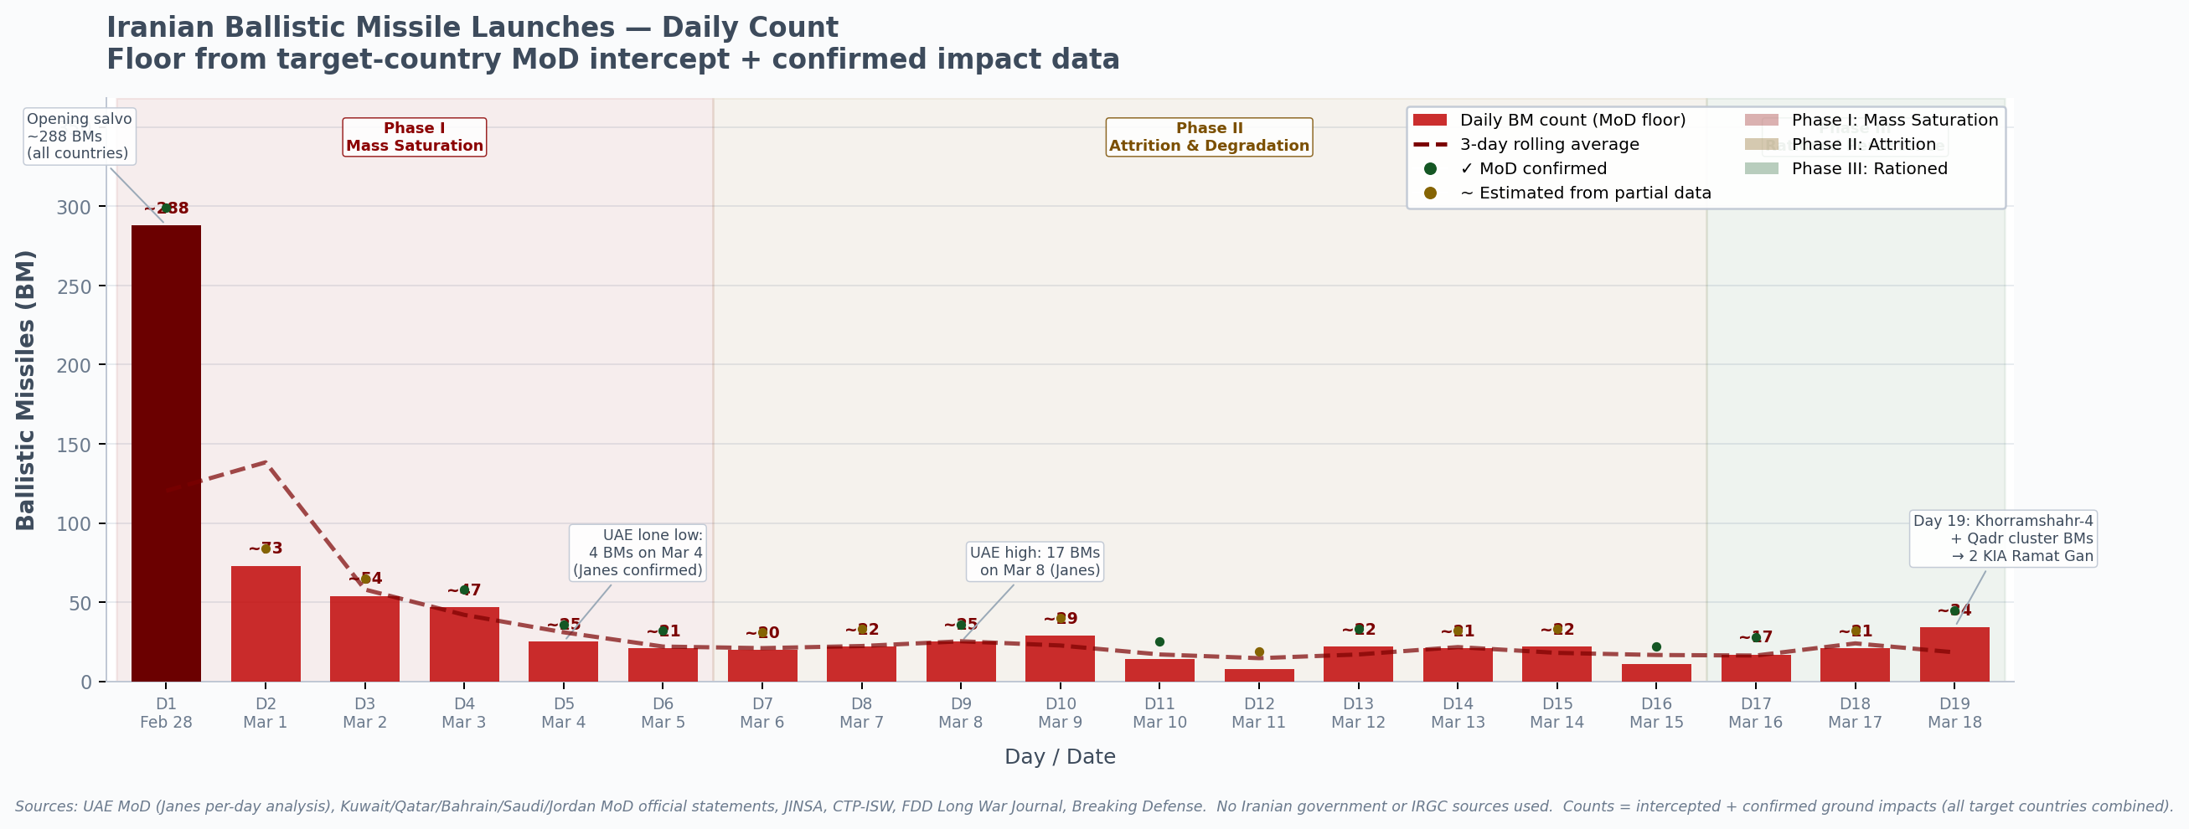
Day 1 peak: ~288 ballistic missiles across all target countries. The BM trajectory declines more steeply than drones through Phase II, reflecting the systematic destruction of fixed Iranian launch infrastructure (60%+ of launchers neutralized by Day 10 per CENTCOM). The UAE MoD's per-day confirmed series shows a low of 4 BMs on Mar 4 (Day 5) and a local high of 17 on Mar 8 (Day 9) — both Janes-confirmed. Day 19 uptick marks the debut of Khorramshahr-4 cluster-warhead missiles against Israel (IRGC Wave 58, True Promise 4).

SECTION 3 — CONFIRMED CUMULATIVE SNAPSHOTS (Verbatim from Official Sources)
CONFIRMED CUMULATIVE SNAPSHOTS FROM TARGET-COUNTRY MINISTRIES OF DEFENCE (verbatim official data)
Country | As of (Day) | Cumulative Missiles (BM) | Cumulative Drones/UAVs | Confirmed Ground Hits | Casualties (from Iranian attacks) | Source
UAE | Day 11 (Mar 10) | 262 BM detected | 1,422 UAVs detected | 2 BM on land, 19 in sea | 3 killed, 94 injured | UAE MoD press briefing, cited in Janes.com March 11, 2026
UAE | Day 13 (Mar 12) | 268 BM | 1,514 UAVs | — | 6 killed, 131 injured | CNBC citing UAE MoD, March 12, 2026
UAE | Day 16 (Mar 15) | 304 BM | ~1,600+ UAVs | — | 8 killed, 157 injured | airforce-technology.com citing UAE MoD, March 17, 2026
UAE | Day 20 (Mar 19) | 334 BM + 15 cruise | 1,714 UAVs | — | 8 killed, 158 injured | The National citing UAE MoD, March 19, 2026
Kuwait | D1–D2 (36 hrs) | 97 BM | 283 drones | — | 4 soldiers + 4 civilians killed | Kuwait MoD, cited in Breaking Defense, March 2, 2026
Kuwait | D1–D4 cumul. | 97+ BM | 384 drones | — | — | CTP-ISW March 3, 2026 citing Kuwait MoD
Qatar | Day 1 (Feb 28) | 66 missiles (all types) | 39 drones detected | 15 drones landed in Qatar | 16 injured | Qatar MoI head, Wikipedia; CTP-ISW March 3, 2026
Qatar | Day 13 (Mar 12) | +(14 BMs in 1 salvo) | — | 1 BM landed | — | Airforce-technology.com citing Qatar MoD, March 13, 2026
Bahrain | D1–D2 (36 hrs) | 45 BM | 9 drones | — | 2 killed | Bahrain MoD, cited in Breaking Defense, March 2, 2026
Bahrain | D1–D4 cumul. | 73 BM | 91 drones | Multiple strikes confirmed | — | CTP-ISW March 3, 2026 citing Bahrain MoD
Bahrain | Day 15 (Mar 14) | 125 missiles | 203 drones | — | 2 killed (from attacks) | Euronews citing Bahrain MoI, March 15, 2026
Jordan | D1–D2 (36 hrs) | 13 BM | 49 drones | 0 (all intercepted) | 0 | Jordan MoD, cited in Breaking Defense, March 2, 2026
Israel | ~D1–D3 | ~200 BM (all types) | 100+ UAVs | Multiple impacts | 9 killed, 121 wounded by D3 | INSS, IDF statements, March 1–3, 2026
Saudi Arabia | D16 (Mar 16) | ~8+ BMs on Day 17 alone | 64 drones intercepted on Day 17 | 1 drone fell at SAMREF refinery | 2 killed, 16 injured (cumul.) | JINSA + Saudi MoD (Alma Research Center, March 16 report)
ALL GCC + Israel | Day 19 (Mar 18) | Al Jazeera: '3,000 projectiles at GCC countries' (missiles + drones) | 'more than half targeted UAE' | — | — | Al Jazeera correspondent Zein Basravi, reporting from Dubai, March 18, 2026

SECTION 4 — COMPARISON WITH IRANIAN SOURCE FIGURES · Previous assessments (including our Day 13–19 daily reports) used IRGC/Fars News claims (e.g., '500 ballistic missiles + 2,000 drones by Day 5') alongside analyst estimates (JPost/AJ Jaff: '480 missiles + 720 drones on Day 1'). The target-country floor derived in this report (~1,013 confirmed missiles + 3,182 confirmed drones) is approximately 35–40% lower than Iranian-source based estimates for the same period. The gap reflects: (a) Saudi Arabia underreporting — JINSA's one-day Saudi figure of 64 drones (Day 17) alone suggests Saudi Arabia likely absorbed 500–800+ drones over 19 days, which is not captured in any official cumulative release; (b) events between official press statements where no MoD count was published; (c) attacks on non-US targets (civilian infrastructure, ports, refineries) that Gulf states sometimes omitted from formal military counts. The floor count is a defensible minimum; the ceiling (from CENTCOM/analyst sources) is roughly 2,500–2,800 missiles and 3,600–4,100 drones total through Day 19.
Classification: All data sourced from open-source, publicly available reporting. Prepared March 21, 2026 as part of Operation Epic Fury Daily Assessment Series.

