Askatos
Chief Prospectors: Maria and Jeff- stayed three days and two nights

PLACE

- Astakos, capital of Xiromero in Greece, regional hub for several villages population 6000, declining annually (approx: 8000 in 1990, 7000 in 2000)
- Daily ferry to Ithaca and Kefalonia- major tourist islands (Princess Diana and Prince Charles went on honeymoon here.)
- Nearest Airport Patras and Preveza, Kefalonia, all about 2 hours away
- Major industries: tourism, agriculture and regional port, previous industries oak, fishing, shipping and agriculture
- Politics: newly elected mayor supported by Greek with Nigerian oil industry ties
- Social issues: possible prostitution ring from Russia, drug smuggling, water pollution, government mismanagement of funds, declining tourism = not enough yachts, golden years of tourism 1981-1989.
- Lots of unused buildings, many building in town in various states of disrepair.

Properties in total: 650-700 stremmata:

1) larger plot of land 10 km out of town ~300 stremma uncultivated land, with wild boars, viper snakes, massive hornets and rats. Currently being used by shepherds for goats, and some land cultivated and managed by serfs with mainly clover and lentils, (current serfs problematic not paying rent anymore.) One small house in good condition with large garden area- kitchen, bath and living room downstairs, 2 bedrooms upstairs. Next to kiwi field and near small church. (probably not practical as main facility, potential satellite property for events/growing own food or camping. )

- Castle: Large plot of land 20 minutes walking (uphill) from town, 134 Strema (134,000 sq. metres). Archeological site with temple of zeus on property and castle and cyclops cave (odyssey). Formerly agricultural land, sequestered by government for 40 years for archeological research, but no research took place and land was given back in mid August, 2014. Picturesque setting, between mountains and overlooking beautiful valley, sea is 15 minutes away. Land nearby currently being used for grazing. No existing structures whatsoever. Secluded, quiet, nice breeze, temporary structures can be built without permission. If there was a structure, like a house this land would be ideal.
- Abandoned house in center of town. Large structure unoccupied for over ten years, now in disrepair, in need of major repairs, and upgrades. Perhaps even new roofing is needed after last earthquakes. 2 floors, could only see into first floor, very large open space. Perfect location, one block from sea front, perhaps 100 years old.
- Beachfront property. On far end of town, 10 minutes walking from center. Private waterfront area. Elina thinks it would make good camping facility, but would need some maintenance and upgrade to make camping feasible.
- Women in pink's house? Perhaps another abandoned house in town available.

Elina's family controls these properties, ownership divided between her father and his three siblings. Currently agricultural is being partially used by growers, Elina's aunt lives off rents, when and if they pay.

The family is open to new ideas, but not sure what the land can be used for. No set idea of what they would like to do with the land. Father doesn't want to sell land because it's been in family for over 150 years.

Background
Family origins from Kefalonia (land of the crazy people). 75% of village is also originally from Kefalonia. Astakos is historic town, known as birthplace of one of Alexander the Great's generals, ancient place.
In summer there are a few months of tourism, mainly Greeks and natives who have left to work and live in Athens or abroad, and in winter the population shrinks to 3000 permanent residence. Many of the tourists are native to the region; this could be a possible resource since they are exposed to new ideas but still have strong regular ties to the area.
The territory is one of the most underdeveloped regions of Greece.
Unclear motives as to why Qatar Emir buys the islands in front of Astakos bay, rumors of imminent petrol research.
No readily apparent partners, except Elina and her cousin Mary (interested in hiking trails) and maybe the sailing club (funded by Nigerian shipowner guy), or horseback riding club.
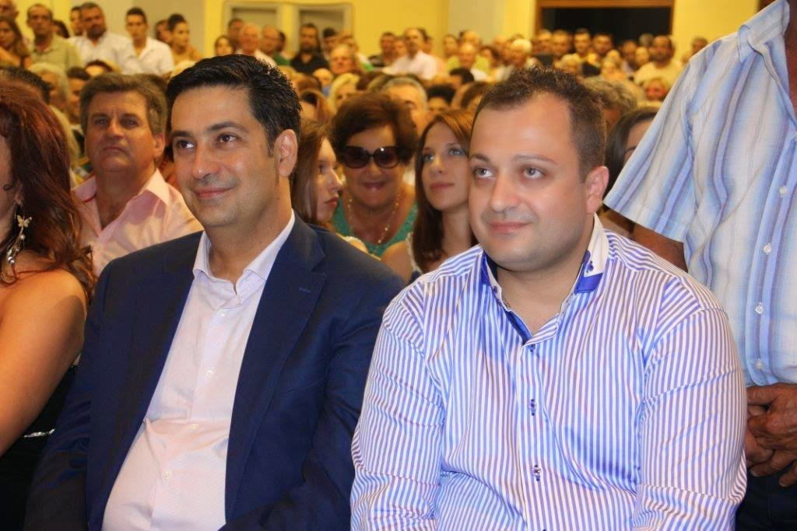Illustration 1: Shipowner guy on right “The Nigerian connection”

Pros & Cons:
- Town small: hard to find possible partners and existing local initiatives, would be able to see impact of work more clearly. Inert population in winter, might be difficult to affect change.
- Regional hub: lots of people from region passing through- good mode of distributing ideas.
- Bare land/derelict houses: need lots of work to make it livable, possible projects for open source ecology and eco warriors, hexiyurt specialists.
- Seaside Location: reachable by ferry from Italy (via Patras) or Kefalonia/Ithaka. Quite far from Athens.
- Unclear if there is need or desire for social innovation. Perhaps good base for regional projects because it's quite far from Athens.
- Pollution: there is pollution from the aquaculture farms further up the coast and also from the town's sewage system which runs (semi-filtered) into port. No suitable drinking water from tap.
- Fishing industry: fresh fish readily available, very inexpensive.
- Agriculture: lots of local produce, potential relationships for exchange of local produce for work or other services.
- Local Government: people criticize often, saying they don't want this or that, but never express what they do want.

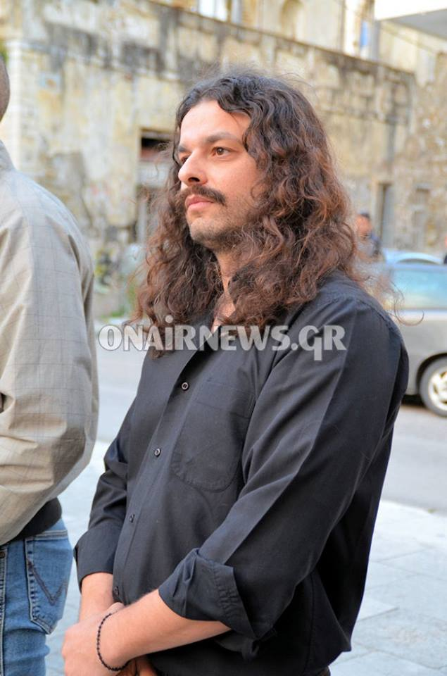Illustration 2: Local Golden Dawn rep. Very Popular

