13016235: C Programming
First Semester, 2019

Project Proposal

- Project developer
Student ID | Name
62011286 | Unn Jertjamjarat

- Project title
Don’t let it cross

- Project description and requirements
Project description:
Point and click 2D platformer game. Use a mouse to point and shoot the zombies.
Earn the money buy killing the zombies and purchase various weapons. The game over
When the zombies cross the screen and the health is zero.

(Note: figures, flowcharts, diagrams may be used to describe the project)

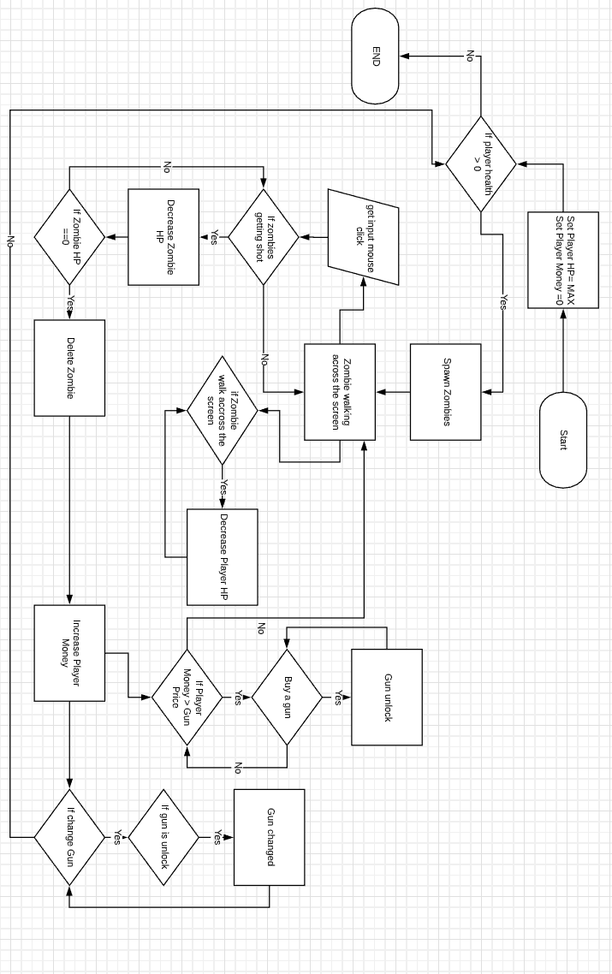

Project requirements:
- C language IDE (MS Visual Studio 2017)
- Raylib library.
- Tile ( for editing sprites )
(Describe the problem’s statements or a specific request of the program that will be achieved.)
