EVM SYSTEM WITH FACE & BIOMETRIC IDENTIFICATION
A major project report submitted to
Jawaharlal Nehru Technological University Kakinada,
in the Partial Fulfillment for the Award of degree of
BACHELOR OF TECHNOLOGY
IN
ELECTRONICS AND COMMUNICATION ENGINEERING

Submitted by
KOTAPATI NARENDRA
MIN GANESH KUMAR
UNNAM BHANUPRASAD
YAGILISETTY BALAJI
Under the esteemed guidance of
Mr.V.MADHAVA REDDY,
M.Tech.,

Assistant Professor
DEPARTMENT OF ELECTRONICS AND COMMUNICATION ENGINEERING
QIS COLLEGE OF ENGINEERING & TECHNOLOGY (AUTONOMOUS)
An ISO 9001:2015 Certified Institution, Approved by AICTE & Reaccredited by NBA, NAAC ‘A’ Grade (Affiliated to Jawaharlal Nehru Technological University, Kakinada)
VENGAMUKKAPALEM, ONGOLE – 523272, A.P

2018-2022

QIS COLLEGE OF ENGINEERING &TECHNOLOGY
(AUTONOMOUS)
An ISO 9001:2015 Certified Institution, Approved by AICTE & Reaccredited by NBA, NAAC ‘A’ Grade (Affiliated to Jawaharlal Nehru Technological University, Kakinada)
VENGAMUKKAPALEM, ONGOLE – 523272, A.P

2018-2022
DEPARTMENT OF ELECTRONICS AND COMMUNICATION ENGINEERING
BONAFIDE CERTIFICATE
This is to certify that the project entitled
“EVM SYSTEM WITH FACE & BIOMETRIC IDENTIFICATION”
Is a Bonafide work of
KOTAPATI NARENDRA 18491A04M4
MIN GANESH KUMAR 18491A04M7
UNNAM BHANUPRASAD 18491A04N5
YAGILISETTY BALAJI 18491A04N8
In the partial fulfillment of the requirement for the award of the degree of Bachelor of
Technology in ELECTRONICS AND COMMUNICATION ENGINEERING and for the academic year 2021-2022.
This work is done under my supervision and guidance.

Signature of the guide Signature of Head of Department
Mr.V.MADHAVA REDDY, Dr. CH. HIMA BINDU,
M.Tech., M.Tech.,Ph.D.,
Assistant Professor H.O.D, Professor in ECE

Signature of External Examiner
ACKNOWLEDGEMENT

We thank the almighty for giving us the courage and perseverance in completing the major project, the major project itself is an acknowledgement for all those people who have given us their heartfelt cooperation in making the major project a grand success.

It was pleasure to expressed deep sense of gratitude to my guide, Mr. V. MADHAVA REDDY, M.Tech., Assistant Professor. We are thankful to his moral support and encouragement throughout the work. His planning and strict adherence to academic schedule has helped us to complete our work.

We would like to thank Dr. CH. HIMA BINDU, M.Tech., Ph.D, Head of the Department of ECE in QIS College of Engineering and Technology for her encouragement.

We thank to Dr. Y.V. HANUMANTHA RAO, M. Tech., Ph.D, Principal QIS College of Engineering and Technology, Ongole for providing a great support for us in completing this project.
We would like to thank all the faculty members of department of ECE for direct or in direct support for helping us in completion of this project.

Finally, we would like to thank all of my friends and family members for their continuous help and encouragement.

Submitted by:
KOTAPATI NARENDRA 18491A04M4
MIN GANESH KUMAR 18491A04M7
UNNAM BHANUPRASAD 18491A04N5
YAGILISETTY BALAJI 18491A04N8

TABLE OF CONTENTS

CONTENTS | PAGE NO.
ABSTRACT | I
LIST OF FIGURES | II
LIST OF TABLES | III
CHAPTER 1: INTRODUCTION | 1
1.1 Introduction to the system | 1
1.2 Aim of the project | 2
1.3 Concept of the project | 3
1.4 Significance of work | 3
1.5 Raspberry pi introduction | 4
1.5.1 Raspberry pi 3 model B | 6
1.5.2 GPIO | 8
1.5.3 Antenna | 9
1.6 Introduction to python | 10
1.6.1 Basic principles of python | 12
1.6.2 Module python | 13
1.6.3 Object oriented programming | 14
1.6.4 Applications of python | 15
CHAPTER 2: LITERATURE SURVEY | 16
2.1 Voting system details | 20
CHAPTER 3: RELATED AND PROPOSED WORK | 23
3.1 Related work | 23
3.1.1 History of EVM | 23
3.1.2 Design and Technology | 24
3.1.3 Procedure to use | 26
3.1.4 Benefits | 27
3.1.5 Limitations | 27
3.1.6 Security issues | 28
3.1.7 Advantages of EVM | 30
3.1.8 Disadvantages of EVM | 31
3.2 Proposed work | 33
3.2.1 Methodology | 35
3.2.2 Power supply | 36
3.2.3 Microcontroller | 37
3.2.4 Monitor display | 37
3.2.5 Block diagram of proposed system | 38
3.2.6 Advantages | 39
3.2.7 Disadvantages | 39
CHAPTER 4: PROPOSED METHODOLOGY AND  EXPERIMENTAL RESULTS | 40
4.1 Working of the system | 40
4.2 Algorithm for the proposed design | 40
4.3 Flowchart | 41
4.4 Case study | 42
4.5 Required components and its details | 42
4.6 Project execution steps | 48
4.7 Final result | 59
CHAPTER 5: CONCLUSION | 61
REFERENCES | 62

CHAPTER 1
INTRODUCTION

1.1 Introduction to the system
The facial recognition technology is used to automatically identify a person through a digital image. It is mainly used in security systems. The facial recognition will directly capture information about the shapes of faces. The main advantage of facial recognition is, it identifies each individual’s skin tone of a human face’s surface, like the curves of the eye hole, nose, and chin, etc. this technology may also be used in very dark condition. It can view the face in different angles to identify.
It is mainly used in airports were it will recognize the face and we can avoid some unwanted terrorist. When compared with other biometrics systems using fingerprint and iris, face recognition has different advantages because it is without touching the person. Through Face images we can capture the person identification from a distance without touching or interacting with them. And also face recognition is used for crime restriction purpose because face images that have been recorded and archived, so that it will help us to identify a person later. This report develops a socio-political analysis that bridges the technical and social-scientific literature on FRT and addresses the unique challenges and concerns that attend its development, evaluation, and specific operational uses, contexts, and goals. It highlights the potential and limitations of the technology, noting those tasks for which it seems ready for deployment, those areas where performance obstacles may be overcome by future technological developments or sound operating procedures, and still other issues which appear intractable. Its concern with efficacy extends to ethical considerations.
In today’s world of connectivity and smart devices there is an urgent need to modify our existing day to day objects and make them smart, also it is not the era when we can blindly trust the old and conventional security measures, specifically speaking is our bank lockers. To change and modernize any object we need to eliminate its existing drawbacks and add extra functionality.The major drawbacks in a conventional door lock by duplicating or stealing the key. An era has come where devices can interact with its users and at the same time ensure of their safety and keep improvising themselves.
The major concepts used to design and model this access control system is advanced knowledge of micro controllers and interfaces, as the Raspberry Pi computing device is used and interfaced with different drivers along with application development to develop a desktop application. Live high quality HD Camera is connected with the display using the same processor to provide the functionalities mentioned above. The photo is captured and processed through the app which detects face out of the available Eigen faces. In addition to this different an intensive study of open cv platform and its inbuilt libraries has been conducted to generate a code, which does correct and reliable facial recognition with new and efficient use of hardware. As the world is progressing people are scared about the safety of their possessions, information and themselves. With the model of Smart Locker, a profound impact is expected on the security industry and it is somewhat anticipated as the time has come to make all daily life objects interconnected and interactive. This model will be a major contribution to the field of Bank Security.

1.2 Aim of the project
Voting has progressed throughout the years from a totally manual to a more technological procedure. Electronic voting is the use of electronic equipment in voting. We should be able to confirm the legitimacy of cast ballots through electronic voting, and transactions should be untraceable. The present voting method is based on a ballot machine, and voting is completed when we hit the button with the symbol. There is a security concern here since the individual voting may be a false voter. People may be unaware that someone is using a forged voting card, which can lead to complications. Bio-metrics can help to improve the security of electronic voting systems. Bio-metrics is the study of a person's unique physical and behavioral features via measurement and statistical analysis. Face recognition, fingerprint recognition, iris recognition, hand geometry, palm veins, palm print, and other biometric methods exist. Face recognition and fingerprints are employed in this technology. Facial recognition is a biometric method of identifying a person by comparing live capture or digital image data with previously recorded image data. Fingerprint recognition is a way of identifying and confirming a person's identity based on a comparison of two fingerprints (a database fingerprint and a detected fingerprint) and used for computerized system authentication.
The use of an electronic voting machine (EVM) minimizes the amount of time
it takes to cast a vote as well as the amount of time it takes to vote. Count votes and announce results with this machine. The systems may have been tampered with recently, and the security may have changed the votes, but this has not been verified. It reduces the amount of paper used. These devices run on batteries and do not require electricity, allowing for continuous voting. In a single constituency, it may accommodate sixty-four voters. Votes can be saved in this machine for up to 10 years. Because EVM can preserve the software indefinitely and feature a sealed security chip, votes cannot be manipulated without causing damage to the programme.

1.3 Concept of the project
The major concepts used to design and model this access control system is advanced knowledge of micro controllers and interfaces, as the Raspberry Pi computing device is used and interfaced with different drivers along with application development to develop a desktop application. Live high quality HD Camera is connected with the display using the same processor to provide the functionalities mentioned An intensive study of Open CV platform and its inbuilt libraries has been conducted to generate a code, which does correct and reliable facial recognition with new and efficient use of hardware. As the world is progressing people are scared about the safety of their possessions, information and themselves. In our proposed work Biometric identifiers are used to provide better security in EVM. By using Biometric identifiers like Face Recognition and Fingerprint Sensor which are linked with Adhaar card. Votes are stored electronically in EVM ballot box. Thus, it cannot be hacked easily because Biometric identifier cannot be easily misplaced or shared. This application can also be used by Handicapped person by just clicking their picture and matching it with the provided information which is stored in the Database.

1.4 Significance of work
With the model of Smart voting a profound impact is expected on the security polling and it is somewhat anticipated as the time has come to make all daily life objects interconnected and interactive. This model will be a major contribution to the field of polling. Privacy and Security are two universal rights and, to ensure that in our daily life we are secure, a lot of research is going on in the field of home security, and IoT is the turning point for the election board, where we connect everyday objects to share
data for our betterment.
Voting System in India has gone through multiple changes. During the first 2 general of Lok Sabha in 1952 and 1957 each candidate were allotted a separate ballot box pasted with the symbol of the candidate and name. Before introduction of EVM, ballot papers were used to cast votes in the Indian Election. Use of ballot paper was time consuming.
In previous work problem with of voting system was that it is more likely to record over votes which end up being cast as no vote. Over vote occurs when voter accidently marks on ballots more than one time in a particular race. Voters cannot vote for more than one candidate. Beside the over vote problem, paper ballots can be lost, misplaced, miscounted. Paper ballots where time consuming but it generates lot of employment for the people who are engaged in vote counting. Where in EVM takes less man power to calculate the votes which directly impacts the employment rate of the people during the election.

What was the need for EVM System?
The main reason for the need of EVM System is its Mobility. Voters always prefer to cast their votes from home, offices, school etc. In this way voters can cast their votes from anywhere. Not only the voter participation will increase but also the Government may save money.

1.5 Raspberry Pi Introduction
Software developer Eben Upton and Software Engineers Pete Lomas and David Braden formed the Raspberry Pi foundation in 2006. The main aim of this foundation was to devise a computer to inspire children. Hence, in order to reduce the cost, the early prototypes of the Raspberry Pi were based on the 8-bit Atmel ATmega microcontroller.
On February 29th, 2012, the team started taking the orders for Model B and in the same year, they started its production run which consisted of around 10,000 units. These models were manufactured by the founders in China and Taiwan.
On February 4th, 2013, they started taking the orders for lower cost Model A. Similarly, on November 10th, 2014, the team launched for even more low-cost Model A+. The cheapest Raspberry Pi Zero was launched on November 26th, 2015.
The name Raspberry Pi was chosen with “Raspberry” as an ode to tradition of naming early computer companies after fruit. Here, "Pi" is for Python Programming Language.Raspberry Pi, developed by Raspberry Pi Foundation in association with Broadcom, is a series of small single-board computers and perhaps the most inspiring computer available today.From the moment you see the shiny green circuit board of Raspberry Pi, it invites you to tinker with it, play with it, start programming, and create your own software with it. Earlier, the Raspberry Pi was used to teach basic computer science in schools but later, because of its low cost and open design, the model became far more popular than anticipated.
It is widely used to make gaming devices, fitness gadgets, weather stations, and much more. But apart from that, it is used by thousands of people of all ages who want to take their first step in computer science.It is one of the best-selling British computers and most of the boards are made in the Sony factory in Pencoed, Wales.

1)Generations and Models
In 2012, the company launched the Raspberry Pi and the current generatios of regular Raspberry Pi boards are Zero, 1, 2, 3, and 4.
Generation 1 Raspberry Pi had the following four options −
- Model A
- Model A +
- Model B
- Model B +
Among these models, the Raspberry Pi B models are the original credit-card sized format.
On the other hand, the Raspberry Pi A models have a smaller and more compact footprint and hence, these models have the reduced connectivity options.
Raspberry Pi Zero models, which come with or without GPIO (general-purpose input output) headers installed, are the most compact of all the Raspberry Pi boards types.

1.5.1 Raspberry Pi 3 Model B
Raspberry Pi is a credit card sized bargain micro Linux machine. The goal behind creating Raspberry Pi was to create a low cost device that would improve programming skills and hardware understanding for students. The latest model of Raspberry Pi comes sporting 1 GB of RAM, 1200 MHz quad – core ARM Cortex-A53 processor, and basic levels of functionality that enables hobbyists, computer enthusiasts, and students to use this device for DIY projects. Raspberry Pi is open hardware with the exception of its primary chip, the Broadcom SOC which runs the main components of the board – CPU, graphics, memory, USB controller etc.

1. Technical Specification:

1)Processor
- Broadcom BCM2387 chipset.
- 1.2GHz Quad-Core ARM Cortex-A53 (64Bit)
2)802.11 b/g/n Wireless LAN and Bluetooth 4.1 (Bluetooth Classic and LE)
- IEEE 802.11 b / g / n Wi-Fi. Protocol: WEP, WPA WPA2, algorithms AES-CCMP (maximum key length of 256 bits), the maximum range of 100 meters.
- IEEE 802.15 Bluetooth, symmetric encryption algorithm Advanced Encryption Standard (AES) with 128-bit key, the maximum range of 50 meters.
3)GPU
- Dual Core Video Core IV® Multimedia Co-Processor. Provides Open GL ES 2.0, hardware-accelerated Open VG, and 1080p30 H.264 high-profile decode.
- Capable of 1Gpixel/s, 1.5Gtexel/s or 24GFLOPs with texture filtering and DMA infrastructure

4)Memory
- 1GB LPDDR2

5)Operating System
- Boots from Micro SD card, running a version of the Linux operating system or Windows 10 IoT.

6)Dimensions
- 85 x 56 x 17mm

7)Power
- Micro USB socket 5V1, 2.5A

1.5.1b Connectors

1)Ethernet
- 10/100 BaseT Ethernet socket

2)Video Output
- HDMI (rev 1.3 & 1.4)
- Composite RCA (PAL and NTSC)

3)Audio Output
- Audio Output 3.5mm jack
- HDMI
- USB 4 x USB 2.0 Connector

4)GPIO Connector
- 40-pin 2.54 mm (100 mil) expansion header: 2x20 strip
- Providing 27 GPIO pins as well as +3.3 V, +5 V and GND supply lines

5)Camera Connector
- 15-pin MIPI Camera Serial Interface (CSI-2)

6)Display Connector
- Display Serial Interface (DSI) 15 way flat flex cable connector with two data lanes and a clock lane

7)Memory Card Slot
- Push/pull Micro SDIO
The GPU provides Open GL ES 2.0, hardware-accelerated Open VG, and 1080p30 H.264 high-profile decodes and is capable of 1Gpixel/s, 1.5Gtexel/s or 24 GFLOPs of general purpose compute. What’s that all mean? It means that if you plug the Raspberry Pi 3 into your HDTV, you could watch BluRay quality video, using H.264 at 40MBits/s.
The biggest change that has been enacted with the Raspberry Pi 3 is an upgrade to a next generation main processor and improved connectivity with Bluetooth Low Energy (BLE) and BCM43143n Wi-Fi on board. Additionally, the Raspberry Pi 3 has improved power management, with an upgraded switched power source up to 2.5 Amps, to support more powerful external USB devices.
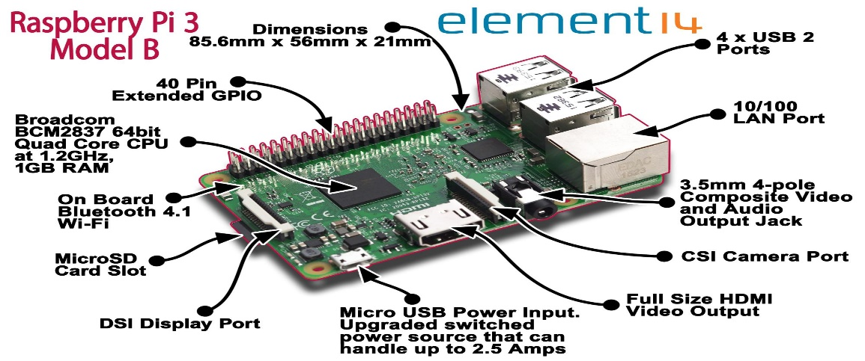

Figure.1.1 Raspberry Pi 3 Model B

Built specifically for the new Pi 3, the Broadcom BCM2837 System-on-Chip (SoC) includes four high-performance ARM Cortex-A53 processing cores running at 1.2GHz with 32kB Level 1 and 512kB Level 2 cache memory, a Video Core IV graphics processor, and is linked to a 1GB LPDDR2 memory module on the rear of the board.

1.5.2 GPIO
The Raspberry Pi 3 features the same 40-pin general-purpose input-output (GPIO) header as all the Pins going back to the Model B+ and Model A+. Any existing GPIO hardware will work without modification; the only change is a switch to which UART is exposed on the GPIO’s pins, but that’s handled internally by the operating system.

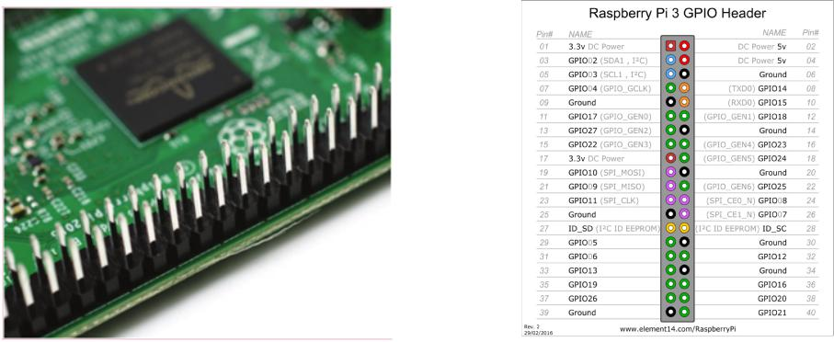

Figure. 1.2 GPIO pins

1.5.3 Antenna
There’s no need to connect an external antenna to the Raspberry Pi 3. Its radios are connected to this chip antenna soldered directly to the board, in order to keep the size of the device to a minimum. Despite its diminutive stature, this antenna should be more than capable of picking up wireless LAN and Bluetooth signals – even through walls.
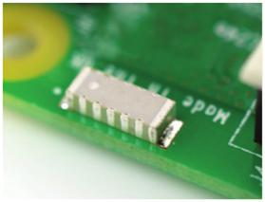

Figure. 1.3 Antenna

Table 1.1:- Raspberry pi 3 Model B details

Raspberry pi 3 Model B
Soc | Broadcom BCM2837
CPU | 4 * ARM Cortex-A53,1.2GHz
GPU | Broadcom VideoCore 1V
RAM | 1GB LPDDR2(900 MHz)
STORAGE | microSD
ETHERNET | 10/100 Ethernet
VIDEO OUTPUT | HDMI
GPIO | 40-pin header,populated
PORTS | HDMI,3.5mm analouge audio-video jack,4*USB 2.0,ethernet,Camera Serial Interface(CSI),Display serial Interface
Price | 50$

1.6 INTRODUCTION TO PYTHON

Python is a high-level scripting language which can be used for a wide variety of text processing, system administration and internet-related tasks. Unlike many similar languages, it’s core language is very small and easy to master, while allowing the addition of modules to perform a virtually limitless variety of tasks. Python is a true object-oriented language, and is available on a wide variety of platforms. There’s even a python interpreter written entirely in Java, further enhancing python’s position as an excellent solution for internet-based problems. Python was developed in the early 1990’s by Guido van Rossum, then at CWI in Amsterdam, and currently at CNRI in Virginia. In some ways, python grew out of a project to design a computer language which would be easy for beginners to learn, yet would be powerful enough for even advanced users. This heritage is reflected in python’s small, clean syntax and the thoroughness of the implementation of ideas like object-oriented programming, without eliminating the ability to program in a more traditional style. So python is an excellent choice as a first programming language without sacrificing the power and advanced capabilities that users will eventually need. Although pictures of snakes often appear on python books and websites, the name is derived from Guido van Rossum’s favorite TV show, “Monty Python’s Flying Circus”. For this reason, lots of online and print documentation for the language has a light and humorous touch. Interestingly, many experienced programmers report that python has brought back a lot of the fun they used to have programming, so van Rossum’s inspiration may be well expressed in the language itself. There are a few features of python which are different than other programming languages, and which should be mentioned early on so that subsequent examples don’t seem confusing. Further information on all of these features will be provided later, when the topics are covered in depth. Python statements do not need to end with a special character – the python interpreter knows that you are done with an individual statement by the presence of a newline, which will be generated when you press the “Return” key of your keyboard. If a statement spans more than one line, the safest course of action is to use a backslash (\) at the end of the line to let python know that you are going to continue the statement on the next line; you can continue using backslashes on additional continuation lines. (There are situations where the backslashes are not needed which will be discussed later.) Python provides you with a certain level of freedom when composing a program, but there are some rules which must always be obeyed. One of these rules, which some people find very surprising, is that python uses indentation (that is, the amount of white space before the statement itself) to indicate the presence of loops, instead of using delimiters like curly braces ({}) or keywords (like “begin” and “end”) as in many other languages. The amount of indentation you use is not important, but it must be consistent within a given depth of a loop, and statements which are not indented must begin in the first column. Most python programmers prefer to use an editor like emacs, which automatically provides consistent indentation; you will probably find it easier to maintain your programs if you use consistent indentation in every loop, at all depths, and an intelligent editor is very useful in achieving this.

1)Invoking Python:

There are three ways to invoke python, each with its’ own uses. The first way is to type “python” at the shell command prompt. This brings up the python interpreter with a message similar to this one: Python 2.2.1 (#2, Aug 27 2002, 09:01:47) [GCC 2.95.4 20011002 (Debian prerelease)] on linux2 Type "help", "copyright", "credits" or "license" for more information. The three greater-than signs (>>>) represent python’s prompt; you type your commands after the prompt, and hit return for python to execute them. If you’ve typed an executable statement, python will execute it immediately and display the results of the statement on the screen. For example, if I use python’s print statement to print the famous “Hello, world” greeting, I’ll immediately see a response: >>> print ’hello,world’ hello,world The print statement automatically adds a newline at the end of the printed string. This is true regardless of how python is invoked. (You can suppress the newline by following the string to be printed with a comma.) When using the python interpreter this way, it executes statements immediately, and, unless the value of an expression is assigned to a variable (See Section 6.1), python will display the value of that expression as soon as it’s typed. When you use python interactively and wish to use a loop, you must, as always, indent the body of the loop consistently when you type your statements.

Python can’t execute your statements until the completion of the loop, and as a reminder, it changes its prompt from greater-than signs to periods. Here’s a trivial loop that prints each letter of a word on a separate line notice the change in the prompt, and that python doesn’t respond until you enter a completely blank line.

1.6.1 BASIC PRINCIPLES OF PYTHON :

After creating a file, say myprogram.py, which contains the special comment as its first line, you would make the file executable (through the UNIX command “chmod +x myprogram.py”), and then you could execute your program by simply typing “myprogram.py” at the UNIX prompt. When you’re running python interactively, you can instruct python to execute files containing python programs with the execfile function. Suppose that you are using python interactively, and wish to run the program you’ve stored in the file myprog.py. You could enter the following statement: execfile("myprog.py") The file name, since it is not an internal python symbol (like a variable name or keyword), must be surrounded by quotes. Python has many features that usually are found only in languages which are much more complex to learn and use. These features were designed into python from its very first beginnings, rather than being accumulated into an end result, as is the case with many other scripting languages. If you’re new to programming, even the basic descriptions which follow may seem intimidating. But don’t worry – all of these ideas will be made clearer in the chapters which follow. The idea of presenting these concepts now is to make you aware of how python works, and the general philosophy behind python programming. If some of the concepts that are introduced here seem abstract or overly complex, just try to get a general feel for the idea, and the details will be fleshed out later. Python is designed so that there really isn’t that much to learn in the basic language. For example, there is only one basic structure for conditional programming (if/else/elif), two looping commands (while and for), and a consistent method of handling errors (try/except) which apply to all python programs. This doesn’t mean that the language is not flexible and powerful, however. It simply means that you’re not confronted with an overwhelming choice of options at every turn, which can make programming a much simpler task. when used with different types of data. For example, in python, when you’re dealing with numbers, the plus sign (+) has its usual obvious meaning of addition. But when you’re dealing with strings, the plus sign means to join the two strings together. In addition to being able to use overloading for built-in types (like numbers and strings), python also allows you to define what operators mean for the data types you create yourself. Perhaps the nicest feature of object-oriented programming in python is that you can use as much or as little of it as you want. Until you get comfortable with the ideas behind object-oriented programming, you can write more traditional programs in python without any problems.

1.6.2 Modules Python

Relies on modules, that is, self-contained programs which define a variety of functions and data types, that you can call in order to do tasks beyond the scope of the basic core language by using the import command. For example, the core distribution of python contains modules for processing files, accessing your computer’s operating system and the internet, writing CGI scripts (which handle communicating with pages displayed in web browsers), string handling and many other tasks. Optional modules, available on the Python web site (http://www.python.org), can be used to create graphical user interfaces, communicate with data bases, process image files, and so on. This structure makes it easy to get started with python, learning specific skills only as you need them, as well as making python run more efficiently by not always including every capability in every program.
1.6.3 Object Oriented Programming
Python is a true object-oriented language. The term “object oriented” has become quite a popular buzzword; such high profile languages as C++ and Java are both object oriented by design. Many other languages add some object-oriented capabilities, but were not designed to be object oriented from the ground up as python was. Why is this feature important? Object oriented program allows you to focus on the data you’re interested in, whether it’s employee information, the results of a scientific experiment or survey, setlists for your favorite band, the contents of your CD collection, information entered by an internet user into a search form or shopping cart, and to develop methods to deal efficiently with your data. A basic concept of object oriented programming is encapsulation, the ability to define an object that contains your data and all the information a program needs to operate on that data. In this way, when you call a function (known as a method in object-oriented lingo), you don’t need to specify a lot of details about your data, because your data object “knows” all about itself. In addition, objects can inherit from other objects, so if you or someone else has designed an object that’s very close to one you’re interested in, you only have to construct those methods which differ from the existing object, allowing you to save a lot of work.

1)Why to Learn Python?
Python is a high-level, interpreted, interactive and object-oriented scripting language. Python is designed to be highly readable. It uses English keywords frequently where as other languages use punctuation, and it has fewer syntactical constructions than other languages.
Python is a MUST for students and working professionals to become a great Software Engineer specially when they are working in Web Development Domain. I will list down some of the key advantages of learning Python:
- Python is Interpreted − Python is processed at runtime by the interpreter. You do not need to compile your program before executing it. This is similar to PERL and PHP.
- Python is Interactive − You can actually sit at a Python prompt and interact with the interpreter directly to write your programs.
- Python is Object-Oriented − Python supports Object-Oriented style or technique of programming that encapsulates code within objects.
- Python is a Beginner's Language − Python is a great language for the beginner-level programmers and supports the development of a wide range of applications from simple text processing to WWW browsers to games.

2)Characteristics of Python
Following are important characteristics of Python Programming −
- It supports functional and structured programming methods as well as OOP.
- It can be used as a scripting language or can be compiled to byte-code for building large applications.
- It provides very high-level dynamic data types and supports dynamic type checking.
- It supports automatic garbage collection.
- It can be easily integrated with C, C++, COM, ActiveX, CORBA, and Java.

1.6.4 Applications of Python

As mentioned before, Python is one of the most widely used language over the web. I'm going to list few of them here:
- Easy-to-learn − Python has few keywords, simple structure, and a clearly defined syntax. This allows the student to pick up the language quickly.
- Easy-to-read − Python code is more clearly defined and visible to the eyes.
- Easy-to-maintain − Python's source code is fairly easy-to-maintain.
- A broad standard library − Python's bulk of the library is very portable and cross-platform compatible on UNIX, Windows, and Macintosh.
- Interactive Mode − Python has support for an interactive mode which allows interactive testing and debugging of snippets of code.
- Portable − Python can run on a wide variety of hardware platforms and has the same interface on all platforms.

CHAPTER 2
LITERATURE SURVEY
The current voting method is based on the principles of an electronic voting machine (EVM), which has a basic design, is reliable, and is easy to use. Unfortunately, the malfunctioning officers' illegitimate voters' invalid votes are being cast, and the same individual can vote several times owing to hardware flaws with EVM. The voting system has to provide results rapidly, however the current voting mechanism takes a long time to do so. Unimodal bio-metrics, such as fingerprints, have a number of limitations. For example, when a fingerprint is obtained, dirt, oil, and other contaminated substances are recorded, and there is a potential that the fingerprint may be rejected. A person will be regarded an ineligible voter if he or she has markings on their finger or a cut on their finger [2]. This study presents a conceptual solution for fraud voting procedures using multimodal bio-metrics, which aids in increasing security, eliminating fraud, providing high-level authentication, and requiring less time to produce results. The fusion of two or more forms of bio-metrics is known as multi-model bio-metrics. In comparison to the current EVM system, the merger of Face and Fingerprint identification technologies will reach high accuracy.

1.Hanady Hussien, Hussien Aboelnaga, IEEE 2013. “Design of secured E-voting systems.” is able to desire with the widespread use of computers and embedded systems. Security is the essential problem should be considered in such systems. This paper proposes a new e-voting system that fulfils the security requirements of e-voting. It is based on homomorphic property and blind signature plan. The suggest system is executed on an embedded system which serves as a voting machine. The system employees RFID to store all conditions that comply with the rule of the government to check voter eligibility.

2. Daniel petcu, Dan Alexandru stoichescu, The International Symposium on Advanced topics in electrical engineering; May 7-9, 2015. “A Hybrid mobile Biometric- based E- voting system.” Information technology changes and gives shape to networked society all over the world today & its solutions are becoming main drivers in almost all field of human life activity. Although the acceptance rate of egovernment applications is increasing e-voting is hardly accepted as main tool in its field because it shortages in offering good solutions to common problems like fraud, bribery, anonymous character of the vote and absence of good independent monitoring.

3. Urmila Shrawankar Dr. Vilas Thakare, “techniques for feature extraction in speech recognition system” The time domain waveform of a speech signal carries all of the auditory information. From the phonological point of view, very little can be said on the basis of the waveform itself. However, past research in mathematics, acoustics, and speech technology have provided many methods for converting data that can be considered as information if interpreted correctly. In order to find some statistically relevant information from incoming data, it is important to have mechanisms for reducing the information of each segment in the audio signal into a relatively small number of parameters, or features. These features should describe each segment in such a characteristic way that other similar segments can be grouped together by comparing their features. There are enormous interesting and exceptional ways to describe the speech signal in terms of parameters. Though, they all have their strengths and weaknesses, we have presented some of the most used methods with their importance.

4. Steven J.Anderson, A.C.M Fong, senior member, IEEE, Jie Tang, member, IEEE, “Robust Tri-Model Automatic Speech Recognition for consumer Applications.” IEEE Transactions on Consumer Electronics, Vol. 59, No. 2, May 2013. Commercial automatic speech recognition (ASR) started to appear in the late 1980‟s and can proposal a more natural means of receiving user inputs than methods such as typing on keyboards or touch screens. This is a especially eventful consideration for small consumer devices such as smart phones. In many practical circumstances, however, presentation of ASR can be significantly. Compromised due to ambient noise and variable lighting circumstances. Prior research has shown that adding visual signals to standard ASR can mitigate the effects of ambient noise. ASR using adaptations of established techniques such as MT, DCT and MFCC.

5. M.Venkata Rao, Venugopal Rao Ravula, Pavani Pala. “Development Of Antirigging Voting System Using Biometrics Based On Adharcard Numbering”. Now a day‟s voting process is exercised by using EVM (Electronic voting machine). In this paper we present and use implementation is to execute the progress of anti rigging voting system using finger print .The purpose of the project and implementation is to provide a safety and good environment to the customers is to electing the candidates by using the intelligent electronic voting machine by providing a rival naming to every user using the FINGER PRINT identification technology. Here in this project and satisfy we are going supply the at most security since it is taking the FINGER PRINTS as the authentication for EVM. Brilliant EVM is an Embedded based project and implementation. It involves microcontroller and interfaces. Intelligent EVM has been particularly designed to collect, record, store, count and display cent percent accurately.

6. Firas I. Hazzaa, Seifedine Kadr, This paper deals with the design and development of a “Web-Based Voting System Using Fingerprint Design and Implementation”, in order to provide a high performance with high security to the voting system also we use web technology to make the voting system more practical. The new design is proposed an election for a university for selecting the president of the university. The proposed EVS allows the voters to scan their fingerprint, which is then matched with an already saved image within a database. Developed Web-based Voting System using Fingerprint Recognition. This system has provided an efficient way to cast votes, free of fraud, and make the system more trustable, economic and fast. We have used Minutiae-based fingerprint identification and matching with high accuracy.

7 Smart Voting: Author: Bhuvanapriya, R.Rozil babu, international conference on computing and communication technology, Chennai,India,2017. Using the concepts of biometric and steganographic authentication, proposed a safe online voting system. The homomorphic approach encrypts and decrypts the casted vote during the results process. It is a finger-print-based program that uses the Aadhar card database to compile a list of all people over the age of 18. He or she can vote using his or her Aadhar number. This system is extremely secure. If he tries a second time, he will not be able to vote because this system includes a tracking element. When each voter casts his or her vote, the count is updated in the admin database at the same moment via the serve.

8)Smart Electronic Voting System Based On Biometric Identification-Survey: Author: J.Deepika, S.Kalaiselvi, Third International Conference on Science Technology Engineering &Management (ICONSTEM), , Chennai, India, 2017. Some other studies employ different algorithms than the proposed voting system, which uses biometric identification as a major feature. They presented in this paper the idea of getting a voter's fingerprint impression and entering it as an input to the system. The data was then compared to what was available in the database. Access to cast a vote is allowed if the particular pattern matches anyone on the a ccessible record. The outcome is then instantaneous, and counting is accomplished using IOT. They use the GSM module to improve the voting system's speed and security. Using the GSM module, a message will be delivered to the voter's mobile phone indicating that he has successfully cast his vote, allowing him to confirm his vote without any doubt. The Internet of Things (IoT) is another new technology that is being used here, and it is the most important in this notion. The counted votes can be quickly communicated to the whole database server via IOT, allowing the overall counted votes and the elected party, which is the chosen party, to be easily announced.

9) A proposed frame work for Biometric electronic voting system: Author: Md. Mahaboob karim, Nabila Shahbaz khan, IEEE international conference on telecommunications and photonics(ICTP) They focused on developing a biometric electronic voting machine (BEVM) with fingerprint authentication and a centralized database in their article. For different elections in Bangladesh, numerous BEVMs will be deployed in each polling station based on the total number of voters, which will help to deploy the fingerprint matching task accurately in less time. The suggested system is a biometric e-voting system that is divided into two sections: voter registration and voting control and result calculation. Each user must first register as a voter using the system, which requires biometric (fingerprint) verification. The voter's information will be maintained in a central database.

10)Arduino based Smart Electronic Voting Machine: Author: V. Kiruthika Priya, V. Vimaladevi, international conference on trends in electronics and informatics (ICEI),tirunelveli, India, 2017. Proposes a system with the addition of a biometric fingerprint sensor, in which each voter is only accepted into the system a fter being identified and compared to a database of registered voters. The voter will be able to choose their preferred candidate from a panel of buttons after the corresponding fingerprint is matched with the information provided. The final vote is then presented on an LCD for voters' enjoyment. The suggested project is transparent, and it also has the capability of being self-contained during operation. They present an idea for avoiding fraud in the procedure for making e-voting a reality in India. Because one human finger print is intrinsically different from another, it increases security and prevents false votes.

2.1.VOTING SYSTEM DETAILS:
From 1948 onwards, India has conducted the election process at a time interval of 5 years. The following methods are used to elect an appropriate candidate:
A. Paper ballot system
B. Electronic voting machine
A. PAPER BALLOT VOTING SYSTEM
Paper Ballots were used in India before 1997 for conducting the public elections. Votes captured in ballots can be stored for a very short period as the ink used in voting may discharge or ballot paper may lose its quality. Proper care has to be taken in maintaining these ballots to protect them from humidity, sunlight and other factors, which affect the ballot papers. Once the ballot is corrupted, we cannot recover the original data. After the election process, it takes more time and effort for counting the votes manually by checking each ballot paper. Paper is an Inflammable material accidentally it may catch fire in case all records will be lost and cannot be recovered and hence the government has to spend extra money for conducting reelections. Bogus ballots can be made and in-numerous fake votes can be casted. Physically disabled people were facing difficulties in casting their votes, in those cases they needed others' help, but privacy while casting votes was vomited.
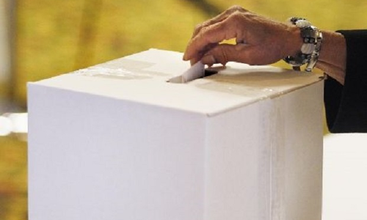

FIG.2.1:-BALLOT BOX

B. ELECTRONIC VOTING MACHINE

Electronic Voting Machines ("EVM"), Idea mooted by the Chief Election Commissioner in 1977. The EVMs were devised and designed by Election Commission of India in collaboration with Bharat Electronics Limited (BEL), Bangalore and Electronics Corporation of India Limited (ECIL), Hyderabad. The EVMs are now manufactured by the above two undertakings. An EVM consists of two units, i) Control Unit ii) Balloting Unit The two units are joined by a five-meter cable. The Control Unit is with the Presiding Officer or a Polling Officer and the Balloting Unit is placed inside the voting compartment.

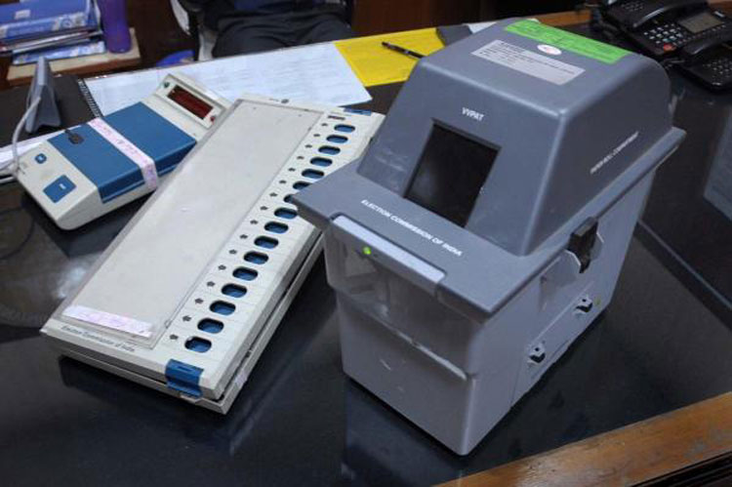

FIG.2.2:-EVM System

There are many types of problems with EVM which is currently in use they are:

1. Accuracy: It is not possible for a vote to be altered to eliminate the invalid vote should not be counted in the final tally.

2. Democracy: It permits only eligible voters to vote and it ensures that eligible voters vote only once.

3. Security Problems: One can change the program installed in the EVM and tamper the results after the polling.

4. Illegal Voting (Rigging): The very commonly known problem Rigging which is faced in every electoral procedure. This can be done externally at the time of voting.

5. Privacy: Neither authority nor anyone else can link any ballot to the voter

6. Verifiability: Independently verification of all votes and tally them correctly. proposed method.

7. Resume Ability: The system allows any voter to interrupt the voting process to resume it or restart it while the poll stands. But the proposed system prevents the election from being accurate. To overcome drawbacks and reduce the manual work we have proposed a new system which is based on biometric verification of voters and easy to handle for election officers. It is used by the voter and placed in the election booth It is the unit of the EVM which is operated by the voter to exercise his/her vote. It consists of: Voter Name, OTP, Date, Time, Candidate Party Name, Party symbols, Submit buttons and various buttons with the party name labelled on it.

Table 2.2:- level of awareness of the respondents on Evm
Level of Awareness | No.of respondent | Percentage(%) |  | Cumulative percentage(%)
Very Low | 20 | 60.61 |  | 60.61
Low | 7 | 21.21 |  | 81.82
Moderate | 5 | 15.15 |  | 96.97
High | 0 | 0.00 |  | 0.00
Very High | 1 | 3.03 |  | 100.00
Total | 33 |  | 100.00 | 100.00

CHAPTER 3
RELATED WORK AND PROPOSED WORK

3.1 RELATED WORK
3.1.1 HISTORY OF EVM:
India used paper ballots till the 1990s. The sheer scale of the Indian elections with more than half a billion people eligible to vote, combined with election-related criminal activity, led Indian election authority and high courts to transition to electronic voting. According to Arvind Verma – a professor of Criminal Justice with a focus on South Asia, Indian elections have been marked by criminal fraud and ballot tampering since the 1950s. The first major election with large scale organized booth capturing were observed in 1957. The journalist Prem Shankar Jha, states Milan Vaishnav, documented the booth capturing activity by Congress party leaders, and the opposition parties soon resorted to the same fraudulent activity in the 1960s. A booth-capture was the phenomenon where party loyalists, criminal gangs and musclemen entered the booth with force in villages and remote areas, and stuffed the ballot boxes with pre-filled fake paper ballots. This problem grew between the 1950s and 1980s and became a serious and large scale problem in states such as Uttar Pradesh and Bihar, later spreading to Andhra Pradesh, Jammu and Kashmir and West Bengal accompanied with election day violence. Another logistical problem was the printing of paper ballots, transporting and safely storing them, and physically counting hundreds of millions of votes. The Election Commission of India, led by T.N. Seshan, sought a solution by developing Electronic voting machines in the 1990s. These devices were designed to prevent fraud by limiting how fast new votes can be entered into the electronic machine. By limiting the rate of vote entered every minute to five, the Commission aimed to increase the time required to cast fake ballots, therefore, allow the security forces to intervene in cooperation with the volunteers of the competing political parties and the media.
The Commission introduced other features such as EVM initialization procedures just before the elections. Officials tested each machine prior to the start of voting to confirm its reliable operation in the front of independent polling agents. They added a security lock “close” button which saved the votes already cast in the device's permanent memory but disabled the device's ability to accept additional votes in the case of any attempt to open the unit or tamper. The Commission decided to conduct the elections over several weeks in order to move and post a large number of security forces at each booth. On the day of voting, the ballots were also locked and then saved in a secure location under the watch of state security and local volunteer citizens. Additionally, the Election Commission also created a database of thumb impressions and electronic voting signatures, open to inspection by polling agent volunteers and outside observers. The EVMs-based system at each booth matches the voter with a registered card with this electronic database in order to ensure that a voter cannot cast a ballot more than once. According to Debnath and other scholars, these efforts of the Election Commission of India – developed in consultations with the Indian courts, experts and volunteer feedback from different political parties – have reduced electoral fraud in India and made the elections fairer and more competitive.

3.1.2 DESIGN AND TECHNOLOGY
The EVM was designed by two professors of IIT Bombay, A.G. Rao and Ravi Poovaiah. An EVM consists of two units, a control unit, and the balloting unit. The two units are joined by a five-meter cable. Balloting unit facilitates voting by a voter via labeled buttons while the control unit controls the ballot units, stores voting counts and displays the results on 7 segment LED displays. The controller used in EVMs has its operating program etched permanently in silicon at the time of manufacturing by the manufacturer. No one (including the manufacturer) can change the program once the controller is manufactured. The control unit is operated by one of the polling booth officers, while the balloting unit is operated by the voter in privacy. The officer confirms the voter's identification then electronically activates the ballot unit to accept a new vote. Once the voter enters the vote, the balloting unit displays the vote to the voter, records it in its memory. A "close" command issued from the control unit by the polling booth officer registers the vote, relocks the unit to prevent multiple votes. The process is repeated when the next voter with a new voter ID arrives before the polling booth officer.
EVMs are powered by an ordinary 6 volt alkaline battery manufactured by Bharat Electronics Limited, Bangalore and Electronics Corporation of India Limited, Hyderabad. This design enables the use of EVMs throughout the country without interruptions because several parts of India do not have the power supply and/or erratic power supply. The two units cannot work without each other. After a poll closes on a particular election day, the units are separated and the control units moved and stored separately in locked and guarded premises.
Both units have numerous tamper-proof protocols. Their hardware, by design, can only be programmed once at the time of their manufacture and they cannot be reprogrammed. They do not have any wireless communication components inside, nor any internet interface and related hardware. The balloting unit has an internal real-time clock and a protocol by which it records every input-output event with a timestamp whenever they are connected to a battery pack. The designers intentionally opted for battery power, to prevent the possibility that the power cables might be used to interfere with the reliable functioning of an EVM.
An EVM can record a maximum of 3840 (now 2000) votes and can cater to a maximum of 64 candidates. There is provision for 16 candidates in a single balloting unit and up to a maximum of 4 balloting units with 64 candidate names and the respective party symbols can be connected in parallel to the control unit. If there are more than 64 candidates, the conventional ballot paper/box method of polling is deployed by the Election Commission. After a 2013 upgrade, an Indian EVM can cater to a maximum of 384 candidates plus "None Of The Above" option (NOTA).
The current electronic voting machines in India are the M3 version with VVPAT capability, the older versions being M1 and M2. They are built and encoded with once-write software (read-only masked memory) at the state-owned and high-security premises of the Bharat Electronics Limited and the Electronics Corporation of India Limited. The inventory of election EVMs is securely tracked by the Election Commission of India on a real-time basis with EVM Tracking Software (ETS). This system tracks its digital verification identity and physical presence. The M3 EVMs has embedded hardware and software that enables only a particular control unit to work with a particular voting unit issued by the Election Commission, as another layer of tamper-proofing. Additional means of tamper proofing the machines include several layers of seals. Indian EVMs are stand-alone non-networked machines. In order to mitigate these threats, the researchers suggest moving to a voting system that provides greater transparency, such as paper ballots, precinct count optical scan, or a voter verified paper audit trail, since, in any of these systems, skeptical voters principle, observe the physical counting process to gain confidence that the outcome is fair.
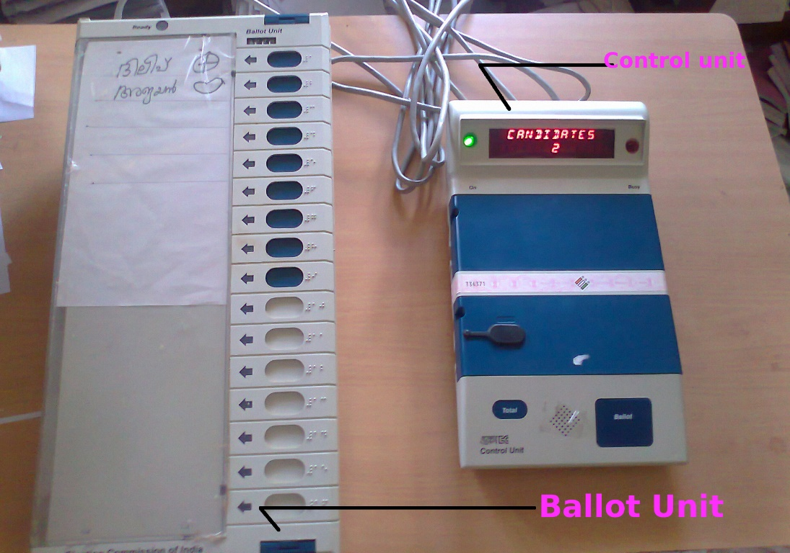
Figure 3.1:- EVM machine

3.1.3 PROCEDURE TO USE
The control unit is with the presiding officer or a polling officer and the balloting Unit is placed inside the voting compartment. The balloting unit presents the voter with blue buttons (momentary switch) horizontally labeled with corresponding party symbol and candidate names. The Control Unit, on the other hand, provides the officer-in-charge with a "Ballot" marked button to proceed to the next voter, instead of issuing a ballot paper to them. This activates the ballot unit for a single vote from the next voter in the queue. The voter has to cast his vote by once pressing the blue button on the balloting unit against the candidate and symbol of his choice.
As soon as the last voter has voted, the Polling Officer-in-charge of the Control Unit will press the 'Close' Button. Thereafter, the EVM will not accept any votes. Further, after the close of the poll, the Balloting Unit is disconnected from the Control Unit and kept separately. Votes can be recorded only through the Balloting Unit. Again the Presiding officer, at the close of the poll, will hand over to each polling agent present an account of votes recorded. At the time of counting of votes, the total will be tallied with this account and if there is any discrepancy, this will be pointed out by the Counting Agents. During the counting of votes, the results are displayed by pressing the 'Result' button. There are two safeguards to prevent the 'Result' button from being pressed before the counting of votes officially begins.
(a) This button cannot be pressed till the 'Close' button is pressed by the Polling Officer-in-charge at the end of the voting process in the polling booth.
(b) This button is hidden and sealed; this can be broken only at the counting center in the presence of a designated office.

3.1.4 BENEFITS
The cost per EVM was ₹5,500 (equivalent to ₹50,000 or US$660 in 2020) at the time the machines were purchased in 1989–90. The cost was estimated to be ₹10,500 (equivalent to ₹14,000 or US$190 in 2020) per unit as per an additional order issued in 2014. Even though the initial investment was heavy, it has since been expected to save costs of production and printing of crores of ballot papers, their transportation and storage, substantial reduction in the counting staff and the remuneration paid to them. For each national election, it is estimated that about 10,000 tonnes of the ballot paper is saved. EVMs are easier to transport compared to ballot boxes as they are lighter, more portable, and come with polypropylene carrying cases. Vote counting is also faster. In places where illiteracy is a factor, illiterate people find EVMs easier than ballot paper system. Bogus voting is greatly reduced as the vote is recorded only once. The unit can store the result in its memory before it is erased manually. The battery is required only to activate the EVMs at the time of polling and counting and as soon as the polling is over, the battery can be switched off. The shelf life of Indian EVMs is estimated at 15 years.

3.1.5 LIMITATIONS
A candidate can know how many people from a polling station voted for them. This is a significant issue particularly if lop-sided votes for/against a candidate are cast in individual polling stations and the winning candidate might show favoritism or hold a grudge on specific areas. The Election Commission of India has stated that the manufacturers of the EVMs have developed a Totaliser unit which can connect several balloting units and would display only the overall results from an Assembly or a Lok Sabha constituency instead of votes from individual polling stations.

3.1.6 SECURITY ISSUES
An international conference on the Indian EVMs and their tamperability was held under the chairmanship of Subramanian Swamy, President of the Janata Party and former Union Cabinet Minister for Law, Commerce, and Justice at Chennai on 13 February 2010. The conclusion was that the Election Commission of India was shirking its responsibility on the transparency in the working of the EVMs. In April 2010, an independent security analysis was released by a research team led by Hari K. Prasad, Rop Gonggrijp, and Alex Halderman.
In order to mitigate these threats, the researchers suggest moving to a voting system that provides greater transparency, such as paper ballots, precinct count optical scan, or a voter verified paper audit trail, since, in any of these systems, skeptical voters could, in principle, observe the physical counting process to gain confidence that the outcome is fair.
Manufacturers of Electronic Voting Machines, namely Electronics Corporation of India Limited, Hyderabad and Bharat Electronics Limited, Bengaluru have said that EVMs are unhackable and tamper-proof as programming for EVMs is done at a secure manufacturing facility in ECIL and BEL (where operations are logged electronically) and not with chip manufacturers. Control and ballot units in EVMs and VVPATs have an anti-tamper mechanism by which they become non-operational if it is illegally opened. EVMs are standalone machines, have no radio frequency transmission device features, operate on battery packs and cannot be reprogrammed. The Control Unit of EVMs has a real-time clock that logs every event on its right from the time it was switched on. The anti-tamper mechanism in the machine can detect even 100-millisecond variations.
On 25 July 2011, responding to a PIL (Writ Petition (Civil) No. 312 of 2011), Supreme Court of India asked EC to consider request to modify EVMs and respond within three months. The petitioner Rajendra Satyanarayan Gilda had alleged that EC has failed to take any decision despite his repeated representation. The petitioner suggested that the EVMs should be modified to give a slip printed with the symbol of the party in whose favour the voter cast his ballot.
On 17 January 2012, Delhi High Court in its ruling on Dr. Subramanian Swamy's Writ Petition (Writ Petition (Civil) No. 11879 of 2009) challenging the use of EVMs in the present form said that EVMs are not "tamper-proof". Further, it said that it is "difficult" to issue any directions to the EC in this regard. However, the court added that the EC should itself hold wider consultations with the executive, political parties and other stake holders on the matter.
Swamy appealed against Delhi High Court's refusal to order a VVPAT system in Supreme Court. On 27 September 2012, Election Commission's advocate Ashok Desai submitted to a Supreme Court bench of Justice P. Sathasivam and Justice Ranjan Gogoi that field trial for the VVPAT system is in progress and that a status report will be submitted by early January 2013. Desai said that on pressing of each vote, a paper receipt will be printed, which will be visible to the voters inside a glass but cannot be taken out of the machine. Dr. Swamy said that the new system was acceptable to him.
The Supreme Court posted the matter for further hearing to 22 January 2013 and on 8 October 2013, it delivered a verdict, that the Election Commission of India will use VVPAT.
1)2019 allegations:
Syed Shuja, an expert on EVMs as claimed by India Today, has alleged that Indian EVMs can be hacked and also made serious allegations against Prime Minister Narendra Modi and the BJP-led government at the Centre, Shuja addressed a press conference in London via video conferencing and demonstrated hacking of the EVM. The cyber expert also claimed that late minister Gopinath Munde, who died in June 2014, was allegedly murdered because he was about to expose his own government over the hackings. Shuja appeared from a remote location using Skype in January 2019 for a press conference organized by the Indian Journalists’ Association and the London-based Foreign Press Association. He alleged that the EVM units can be wirelessly tampered with, and have been tampered with the help of Reliance Communications. He also made allegations of many murders and other criminal activity associated with EVMs tampering, allegations he could not substantiate nor did he present any evidence for his allegations before journalists gathered in London for the Shuja press interview.
The possibility of EVM tampering as described by Shuja have been rejected by the Election Commission of India. The Commission stated that the Indian EVMs do not contain any wireless chips and related communication components. The Election Commission reiterated that their official EVMs are manufactured in India under very strict supervisory and security conditions and there are "rigorous Standard Operating Procedures meticulously observed at all stages under the supervision of a Committee of eminent technical experts constituted way back in 2010". The commission has charged Shuja under Section 505(1)(b) of the Indian Penal Code (titled "Punishment for Statements Conducing to Public Mischief") by lodging a First Information Report against him with the Delhi Police. The Bharatiya Janata Party attributed this claim to the opposing Indian National Congress as an attempt by them to manipulate the electorate with fake news before forthcoming elections.
In January 2019, the London-based press conference organizer stated, "The Foreign Press Association strongly disassociates itself with any claims made by the speaker Syed Shuja during the #IJA event [about Indian EVMs and related matters] in London yesterday. Not one of the masked speaker’s accusations has so far been corroborated."]The India Today called Shuja's allegations as "sensationalism without substance.
2)PROBLEM FORMULATION
Voting System in India has gone through multiple changes. During the first 2 general of Lok Sabha in 1952 and 1957 each candidate were allotted a separate ballot box pasted with the symbol of the candidate and name. Before introduction of EVM, ballot papers were used to cast votes in the Indian Election. Use of ballot paper was time consuming
. • In previous work problem with of voting system was that it is more likely to record over votes which end up being cast as no vote.
• Over vote occurs when voter accidently marks on ballots more than one time in a particular race. Voters cannot vote for more than one candidate.
• Beside the over vote problem, paper ballots can be lost, misplaced, miscounted.
• Paper ballots where time consuming but it generates lot of employment for the people who are engaged in vote counting. Where in EVM takes less man power to calculate the votes which directly impacts the employment rate of the people during the election.

3.1.7 ADVANTAGES OF EVMS:
- EVMs reduce the time in casting votes.
- EVMs also reduce the time taken to count votes and declare election results.
- Claims were made earlier that the systems could be tampered with and the security could be breached, but this has not been proved.
- EVMs save paper.
- These machines are powered by batteries and do not rely on electricity which ensures uninterrupted voting.
- EVMs can accommodate 64 candidates in a single constituency.
- Votes can be stored for up to 10 years.
- The program of EVMs cannot be changed and have a sealed security chip, therefore votes cannot be rigged without damaging the program. This prevents fraud.
- Only one vote can be cast per person as the machine will register only the first button pressed.
- EVMs restrict 5 votes for every minute.
- NOTA was introduced recently at EVMs for voters to cast their vote even if they are not in favor of any of the candidates or parties. NOTA votes are counted and indicates that the elector is not happy with any of the candidates.

3.1.8 DISADVANTAGES OF EVM

Despite the particular advantages to electronic voting system, there are also drawbacks to the system. The cons of the electronic voting system should be considered seriously by all concerned before taking any kind of random decision on e-voting. These are:
- Vulnerability to hacking: According to the Congressional Research Service of Election Reform and Electronic Voting Systems, vendors and election jurisdictions generally state that they do not transmit election results from precincts via the internet, but they may transmit them via a direct modem connection or Virtual Private Network (VPN). However, even this approach may be subject to attack via the internet, especially if encryption and verification are not sufficient. That is because telephone transmission systems are themselves increasingly connected to the internet and computers to which the receiving server may be connected, such as through a local area network (LAN), may have internet connections. So, using internet would be out of the question in case of Bangladesh where we continuously have history of suspicion over electoral fraud.

- Voter verified paper audit trails: All fully-electronic (touch screen, DRE, internet) voting systems are subject to the limitations and risks of computer technology. This includes the inability to detect the presence of hardware and/or software that could be used, deliberately or inadvertently, to alter election outcomes. According to Rebecca Mercuri, PhD, president, Notable Software, democratic elections require independent verification that all balloting choices have been recorded as intended and vote totals have been reliably and indisputably created from the same material examined by the voters. A Voter Verified Paper Ballot (VVPB) provides an auditable way to assure voters that their ballots will be available to be counted. Without VVPB there is no way to independently audit the election results.

- Susceptibility to fraud: Voting fraud is not either present everywhere or absent everywhere. Especially in our country, there have always been allegations of fraud by all the losing political parties. Fraud comes in degrees and increments. A malicious voting system created and distributed by one vendor to hundreds of thousands of polling booths, can systematically falsify millions of votes. Although some may believe that tampering with an electronic voting machine is extremely hard to do, computer scientists have tampered with machines to prove that it is quite easily done. However, if people have access to the machines, and know how to work them, they can take the memory card out of the machine, which stores the votes, and in place they put their own memory card with a virus that can tamper with the votes. It is a fraud on a large scale and wholesale level. Stuffing a ballot box, in contrast, works at a retail level. A tamperer, however malicious and skilled, can stuff only as many ballots as might plausibly be cast at the polling place, but a faulty and corrupted voting system (malicious DRE software) could affect far more votes.

- Accuracy in capturing voters’ intent: If a touch screen is used in the elections, the sensors in touch screen devices can be knocked out of alignment by shock and vibration that may occur during transport. Unless these sensors are realigned at the polling place prior to the start of voting, touch screen machines can misinterpret a voter’s intent. For example, a voter might touch the part of the screen identified with candidate X, but candidate Y’s would light up instead.

- Political ties of manufacturers: The present government’s decision not to keep the provision of caretaker government and to hold next general election under a political government and the election commission, has made the attempt of using e-voting system more unreasonable and unfair. Our election commission itself were also subject to considerable amount of criticism because of its controversial comments and actions during the emergency period after January 11 takeover, and also during the last 2008 general elections. Considering our political culture, it is undeniably a fact that any manufacturer or company hired for the e-voting system will tailor the e-voting machines according to the ‘needs’ of the current political party in power. So these machines will be subject to scrutiny, distrust and inquiry from all the other political parties in the country.

- Malicious software programming: Any computer software is basically generated from software programming and coding. And all these softwares could be tampered with by a computer programmer who knows the source code. Testing electronic voting systems for security problems, especially if they were intentionally introduced and concealed, is basically impossible. If malicious coding is inserted by programmers into commercial software that are triggered by obscure combinations of commands and keystrokes via the computer keyboard, then election results can change completely.

3.2 PROPOSED WORK
The current voting method is based on the principles of an electronic voting machine (EVM), which has a basic design, is reliable, and is easy to use. Unfortunately, the malfunctioning officers' illegitimate voters' invalid votes are being cast, and the same individual can vote several times owing to hardware flaws with EVM. The voting system has to provide results rapidly, however the current voting mechanism takes a long time to do so. Unimodal bio-metrics, such as fingerprints, have a number of limitations. For example, when a fingerprint is obtained, dirt, oil, and other contaminated substances are recorded, and there is a potential that the fingerprint may be rejected. A person will be regarded an ineligible voter if he or she has markings on their finger or a cut on their finger. This study presents a conceptual solution for fraud voting procedures using multimodal bio-metrics, which aids in increasing security, eliminating fraud, providing high-level authentication, and requiring less time to produce results. The fusion of two or more forms of bio-metrics is known as multi-model bio-metrics. In comparison to the current EVM system, the merger of Face and Fingerprint identification technologies will reach high accuracy. Electronic voting is often seen as a tool for making the electoral process more efficient and forincreasing trust in its management. Properly implemented, e-voting solutions can increase the security of the ballot, speed up the processing of results and make voting easier. However, the challenges are considerable. If not carefully planned and designed, e-voting can undermine the confidence in the whole electoral process. This policy paper outlines contextual factors that can nfluence the success of e-voting solutions and highlights the importance of taking these fully into account before choosing to introduce new voting technologies.
Electronic Voting Machine (also known as EVM) is voting using electronic means to either aid or take care of thechores of casting and counting votes.An EVM is designed with two units: the control unit and the balloting unit. These units are joined together by a cable. The control unit of the EVM is kept with the presiding officer or the polling officer. The balloting unit is kept within the voting compart-ment for electors to cast their votes. This is done to ensure that the polling officer verifies your identity.With the EVM, instead of issuing a ballot paper, the polling officer will press the Ballot Button which enables the voter to cast their vote. A list of candidates names and/or symbols will be available on the machine with a blue button next to it. The voter can press the button next to the candidate’s name they wish to vote for.

One of the inputs to the proposed EVM system is a Face picture, and the other is a Fingerprint. Initially, the web camera takes and processes the facial image in the Face recognition section. The Viola and Jones algorithm will be used to recognize the facial region, which has three types: Haar-like feature, AdaBoost, and Cascading. The HOG method is used to extract facial characteristics from the detected face picture. The Intensity-based approach and the Feature-based method are the two methods that make up the HOG algorithm. Face intensity features are extracted using an intensity-based approach, and the magnitude and angle of the face are using a feature-based method.
Our project will be hosted on the Raspberry Pi. This minicomputer has the ability to process photos as well as control the voting machine system. Residents' faces will be photographed using a USB camera to ensure that the user is a legitimate voter in that place. A citizen will be allowed to vote if he or she is both eligible and has yet to do so. Each voting machine is protected with a fingerprint access module. The user's fingerprint will be permitted to vote on a certain computer when the person has been recognized. Each voting machine is connected to the central Raspberry Pi voting identification system.

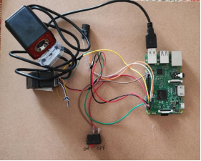
Fig 3.2: Proposed Hardware Model

This project is split into two halves. The first step of the identification procedure will take place at the base station, and the second phase will take place at the voting machine. The base station contains a USB camera (for face verification) and a Fingerprint Scanner as input devices (for thumb identification). The processing unit of the voting system has been utilized to display the total number of voters, user id, and successful authentication. Raspberry Pi's operating system is Linux. This EVM technology will ensure a fair election for voters while lowering the Toll process time.
3.2.1 METHODOLOGY:
The Raspberry Pi will serve as the host in our project. This minicomputer can process images as well as operate the entire voting machine system. A USB camera will be used to photograph residents' faces in order to verify that the user is a legitimate voter in that location. If a citizen is both eligible and has yet to vote, he or she will be permitted to do so. A finger print access module secures each voting machine. After the user has been recognized, his or her finger print will be authorized to vote on a certain computer. The central Raspberry Pi voting identification system is connected to each voting machine.
This project is divided into two halves. The base station is where the first phase of the identification process will take place, and the voting machine is the second. As input devices, the base station has a USB camera (for face verification) and a Fingerprint Scanner (for thumb identification). The second is the voting system's processing unit, which has been used to show the total number of voters, user id, and successful authentication. Raspberry Pi uses Linux as its operating system. This EVM technology will successfully administer a fair election for voters while reducing the Toll time procedure.
The major concepts used to design and model this access control system is advanced knowledge of micro controllers and interfaces, as the Raspberry Pi computing device is used and interfaced with different drivers along with application development to develop a desktop application. Live high quality HD Camera is connected with the display using the same processor to provide the functionalities mentioned An intensive study of Open CV platform and its inbuilt libraries has been conducted to generate a code, which does correct and reliable facial recognition with new and efficient use of hardware. As the world is progressing people are scared about the safety of their possessions, information and themselves. In our proposed work Biometric identifiers are used to provide better security in EVM. By using Biometric identifiers like Face Recognition and Fingerprint Sensor which are linked with Adhaar card. Votes are stored electronically in EVM ballot box. Thus, it cannot be hacked easily because Biometric identifier cannot be easily misplaced or shared. This application can also be used by Handicapped person by just clicking their picture and matching it with the provided information which is stored in the Database.

3.2.2 Power Supply:

This section is meant for supplying Power to all the sections mentioned above. It basically consists of a Transformer to step down the 230V ac to 9V ac followed by diodes. Here diodes are used to rectify the ac to dc. After rectification the obtained rippled dc is filtered using a capacitor Filter. A positive voltage regulator is used to regulate the obtained dc voltage.

3.2.3 Microcontroller:
This section forms the control unit of the whole project. This section basically consists of a Microcontroller with its associated circuitry like Crystal with capacitors, Reset circuitry, Pull up resistors (if needed) and so on. The Microcontroller forms the heart of the project because it controls the devices being interfaced and communicates with the devices according to the program being written.

3.2.4 Monitor Display:

This section is basically meant to show up the status of the project. This project makes use of monitor to display / prompt for necessary information.We use the VNC viewer to display the raspberry pi 3B model.

1)VNC viewer :
VNC stands for Virtual Network Computing. It is a crossplat form screen sharing system that was created to remotely control another computer. This means that a computer’s screen, keyboard, and mouse can be used from a distance by a remote user from a secondary device as though they were sitting right in front of it. VNC works on a client/server model. A server component is installed on the remote computer (the one you want to control), and a VNC viewer, or client, is installed on the device you want to control from. This can include another computer, a tablet, or a mobile phone. When the server and viewer are connected, the server transmits a copy of the remote computer’s screen to the viewer. Not only can the remote user see everything on the remote computer’s screen, but the program also allows for keyboard and mouse commands to work on the remote computer from afar, so the connected user has full control (after being granted permission from the remote computer). VNC was created in Cambridge in the late 1990s by the founders of RealVNC, and was commercialized in 2002 when the company was established. A server is a piece of computer hardware or software that provides capabilities for other programs called “clients.” This is called the client-server model, whereas a server can provide services such as data or resource sharing to one or multiple clients. One server can serve multiple clients in this way, and one single client can use multiple servers. A client will send a request to a server, which then sends a response back to the client.
A computer with VNC Server software installed can be accessed and controlled from a different device in a different location. The software allows a broadcast of the device desktop to a secondary device with VNC Viewer installed. Connected VNC Viewer users send a request, and then (with permission) can see the same thing as the person sitting in front of the remote computer.

3.2.5 BLOCK DIAGRAM OF PROPOSED EVM

Switch

System

Microcontroller

Buzzer

Camera

Fingerprint Module
Power Supply

Fig 3.3:- Block Diagram Of Proposed Method

    - ADVANTAGES

Security levels will be significantly improved
- The integration process is easy and flawless
- High accuracy allows avoiding false identification
- Facial Recognition System is fully automated
- Time fraud will be excluded
- Inexpensive technique of identification
3.2.7 DISADVANTAGES

- Difficulties with data processing and storing
- Troubles with images size and quality
- Strong influence of the camera angle

CHAPTER 4
PROPOSED METHODOLOGY AND EXPERIMENTAL RESULTS

4.1 Working of the system
The features of the Face module and the Finger print module are fused and recognition result is given to the micro controller and the person is matched or not matched is displayed in the LCD display. Then the person, who is recognized, will be allowed to vote. LCD display is used to display the messages to the voter for example, select a candidate, vote accepted, matched, not matched etc. A buzzer is used to alert the user. The buzzer will turn on if the person comes again to vote, if the input does not match and if any malpractice takes place or if the person comes again for voting. Switch can be operated in two modes which are mode A and mode B. Mode A indicates that switch is in voting mode and mode B indicates that switch is in counting mode. Votes will be accepted only when the switch is in the voting mode. The voter should press any one of the button. If the voter will press more than one button at a time the buzzer will turn on or the first button pressed will be taken as the vote.After completing the voting process then the results will be display at the same day of polling conducted then we check the total votes of the partys.

  - Algorithm For The Proposed Design: Algorithm for voting module:
Step 1: Collect the required components for the project.
Step 2: Give the internal connection of the project.
Step 3: Keep the switch in voting mode.
Step 4: Capture the face of the voter using web cam.
Step 5: Enroll the finger print using finger print sensor.
Step 6: If both the inputs are matched go to step (8).
Step 7: If both the inputs does not matched then alarm will turn on and LCD will display unknown person.
Step 8: The voter will be allowed to press in one of the buttons with candidates symbol and the votes will be stored in the memory.
Step 9: After completing the voting process then results will be displayed on screen.

4.3 FLOWCHART
Start

Scan IP address of raspberry pi in Advanced IP Scanner

Open the VNC viewer and search the IP adress that found in Advanced IP Scanner

Raspberry pi screen will be displayed on VNC viewer

Enroll the face

Enroll the fingerprint

Start Voting process

If Face &Fingerprint matched
NO YES

STOP

Display Party Names

Click on Party name to vote

Display Results

STOP

Figure 4.0: Flowchart for proposed method

4.4 CASE STUDY
Case I: Both the inputs (face image, finger print) are matched. The LCD will display that the inputs are matched then it will ask the user to vote by displaying the candidates profile.
Case II: Finger print is matched but face image doesn't match. The booth head will check whether the voter is the right person or not by checking the database. The voter will be allowed to vote if he/she is the right person.
Case III: Face image is matched but finger print doesn't match The booth head will check whether the voter is the right person or not by checking the database. The voter will be allowed to vote if he/she is the right person.
Case IV: Both the inputs doesn't match
The alarm will turn on and the user will not be allowed to access till the booth head will approve his/her identity
Case V: An unauthorized person comes to vote. The alarm will turn on to alert the officers that he is a fake person.
4.5 REQUIRED COMPONENTS AND ITS DETAILS
- CAMERA
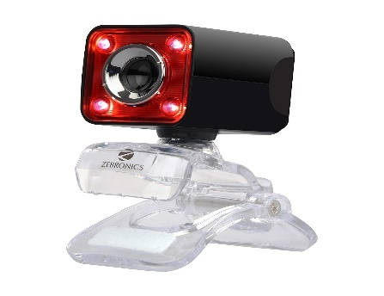
Figure4.1:- Camera
In this project camera is use to capture photos of the voters for data storage of the individual voters and identification of the voters when they entered to the polling booth.It will capture the quality photos of the voters. Webcams typically include a lens, an image sensor, and some support electronics. Various lenses are available, the most common being a plastic lens that can be screwed in and out to set the camera's focus. Fixed focus lenses, which have no provision for adjustment, are also available. Image sensors can be CMOS or CCD, the former being dominant for low-cost cameras, but CCD cameras do not necessarily outperform CMOS-based cameras in the low cost price range. Consumer webcams are usually VGA resolution with a frame rate of 30 frames per second. Higher resolutions, in mega pixels, are available and higher frame rates are starting to appear. Biometric face recognition, otherwise known as Automatic Face Recognition (AFR), is a particularly attractive biometric approach, since it focuses on the same identifier that humans use primarily to distinguish one person from another: their “faces”. One of its main goals is the understanding of the complex human visual system and the knowledge of how humans represent faces in order to discriminate different identities with high accuracy. Face Recognition technology is a well advanced, that it can be applied for many commercial application such as personal identification, security system, image file processing, psychology, computer interaction, entertainment system, smart card and so on.

- FINGERPRINT SENSOR:
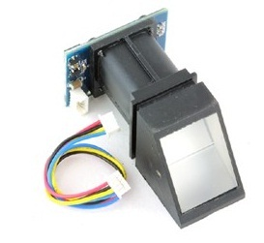
Figure 4.2 FINGERPRINT SENSOR
Fingerprint sensor is used for this project to take the voters fingerprints and it will be stored and this sensor is used to identify the correct person or not while voting in polling booth. Fingerprint detection is a biometric Technology. Fingerprint is unique for every individual. Every individual person has different fingerprint patterns. A fingerprint is a collection of many Ridges and Furrows (Valleys).This is the main Objective what makes fingerprint such an amazing tool for fingerprint identification Likewise we cannot change DNA, in the same way we cannot change our fingerprint. The scars formed in the process of identifying fingerprint become a tool for identification in them. They are a unique id. Fingerprints are same for whole lifetime. They don’t change with time.
- RASPBERRYPI 3B MODEL
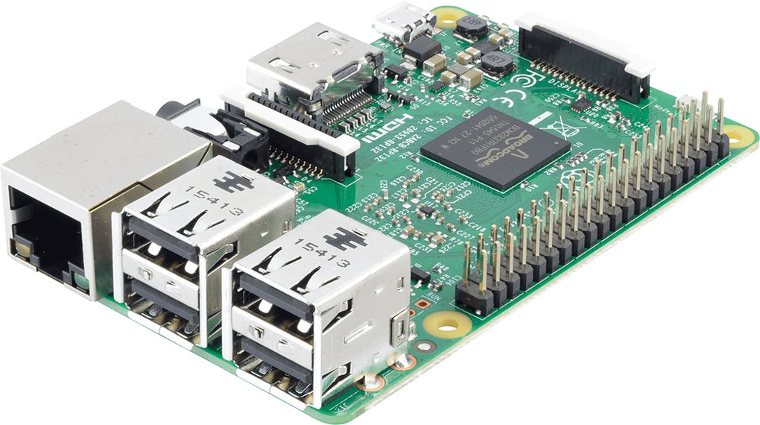
Figure 4.3:- Raspberrypi 3B model
The Raspberry Pi 3 Model B is the third generation Raspberry Pi. This powerful credit-card sized single board computer can be used for many applications and supersedes the original Raspberry Pi Model B+ and Raspberry Pi 2 Model B. Whilst maintaining the popular board format the Raspberry Pi 3 Model B brings you a more powerful processer, 10x faster than the first generation Raspberry Pi. Additionally it adds wireless LAN & Bluetooth connectivity making it the ideal solution for powerful connected designs. It is used to perform all tasks given by the user it will be main equipment in this project and Raspberry pi as operating system,it performs the tasks on that assigned to all equipments in the project,equipments will be connected to the raspberry pi only. Raspberry Pi is a credit card sized bargain micro Linux machine. The goal behind creating Raspberry Pi was to create a low cost device that would improve programming skills and hardware understanding for students. The latest model of Raspberry Pi comes sporting 1 GB of RAM, 1200 MHz quad – core ARM Cortex-A53 processor, and basic levels of functionality that enables hobbyists, computer enthusiasts, and students to use this device for DIY projects. Raspberry Pi is open hardware with the exception of its primary chip, the Broadcom SOC which runs the main components of the board – CPU, graphics, memory, USB controller etc.
- BUZZER :
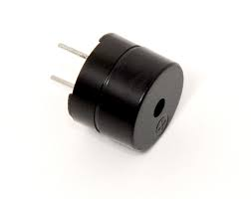
Figure 4.4:- Buzzer

Buzzer is used in this project for making sound,it makes sound when voter enter again after completing his/her vote and we understand that voter was repeat again to vote.
- SPST SWITCH
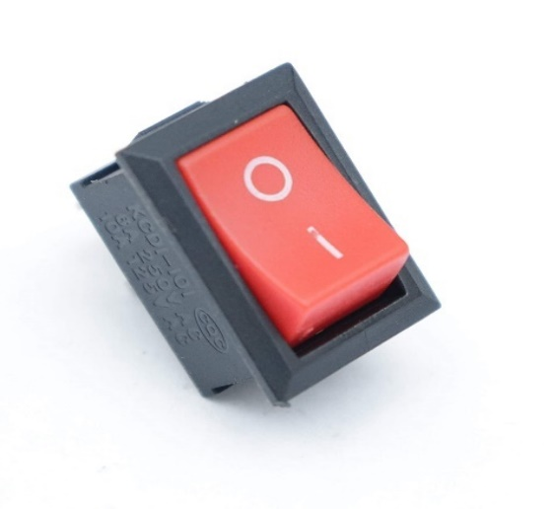
Figure 4.5:- SPST switch
A Single Pole Single Throw (SPST) switch is a switch that only has a single input and can connect only to one output. This means it only has one input terminal and only one output terminal. A Single Pole Single Throw switch serves in circuits as on-off switches.

- VNC VIEWER

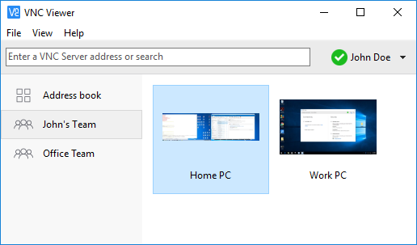
Figure 4.6:- VNC viewer
VNC stands for Virtual Network Computing. It is a cross-platform screen sharingsystem that was created to remotely control another computer. This means that a computer’s screen, keyboard, and mouse can be used from a distance by a remote user from a secondary device as though they were sitting right in front of it.
VNC works on a client/server model. A server component is installed on the remote computer (the one you want to control), and a VNC viewer, or client, is installed on the device you want to control from. This can include another computer, a tablet, or a mobile phone. When the server and viewer are connected, the server transmits a copy of the remote computer’s screen to the viewer. Not only can the remote user see everything on the remote computer’s screen, but the program also allows for keyboard and mouse commands to work on the remote computer from afar, so the connected user has full control after being granted permission from the remote computer. A viewer, on the other hand, is a program that renders the contents of a digital file on screen. VNC Viewer is used for local computers and mobile devices you want to control from. A device such as a computer, tablet, or smart phone with VNC Viewer software installed can access and take control of a computer in another location. It is a graphical desktop sharing system that allows a user to remotely control the desktop of a remote computer (running VNC Server) from your device, and it transmits the keyboard and mouse or touch events to VNC Server, so that once you are connected, you have control over the computer you’ve accessed. If you’re using your mobile phone, for example, you would be able to use the computer you’ve remotely accessed as though you were sitting right in front of it.
- ADVANCED IP SCANNER:-
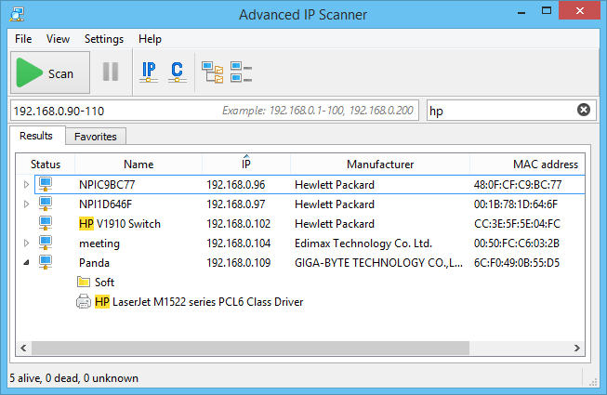
Figure 4.7:- Advanced IP Scanner
Advanced IP Scanner is fast and free software for network scanning. It will allow you to quickly detect all network computers and obtain access to them. With a single click, you can turn a remote PC on and off, connect to it via Radmin, and much more. Advanced IP Scanner is a comprehensive network scanning solution that can do more than what its name hints at. You may be thinking that a tool called “Advanced IP Scanner” can’t do much besides scanning for IPs in an advanced mode.
In fact, this tool can handle a lot of other network-related tasks. For instance, you can see all the devices available on your network, and even access remote-shared folders. However, we’ll get into more detail in the following sections. IP scanning is the ongoing IT task of analyzing a business network to discover IP addresses and identify relevant information associated with those IP addresses and devices. Armed with an IP range scanner, admins can set a specified range of addresses to discover any IP addresses within that range.
4.6 PROJECT EXECUTION PROCESS
1)Components required
a)Camera b)SPST switch c)Fingerprint Sensor
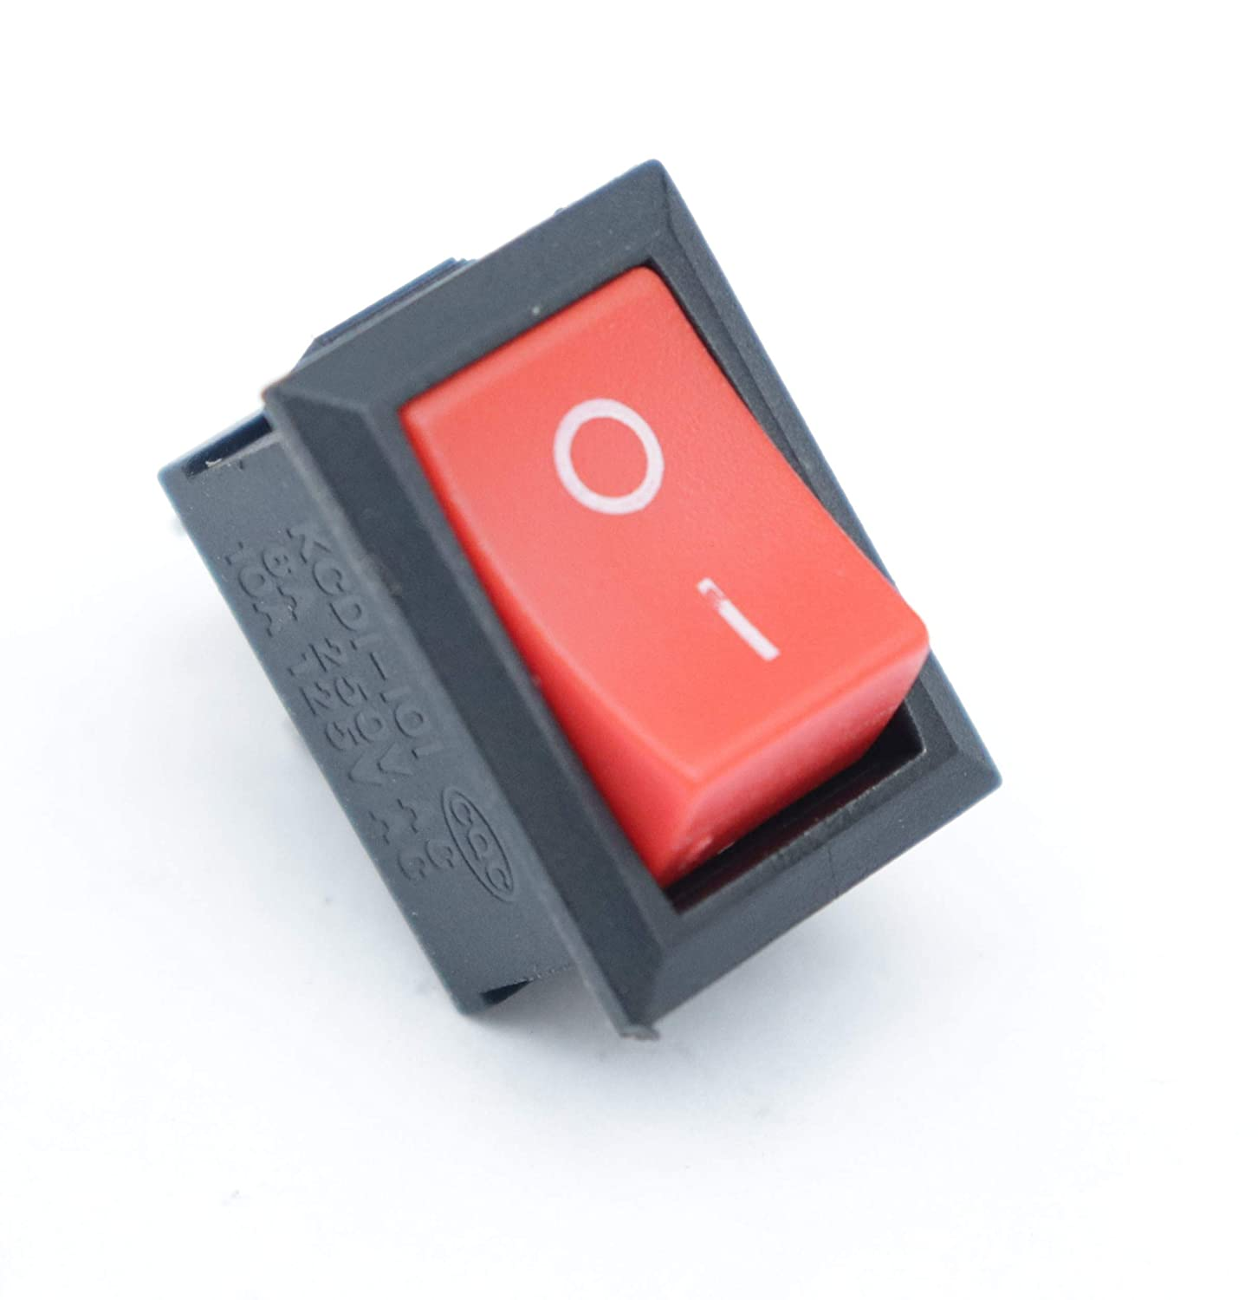
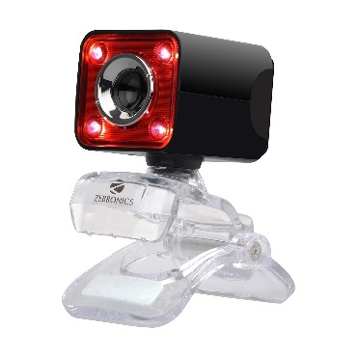

d)Raspberrypi 3B model e)Buzzer



2)Interconnection Of The Circuit

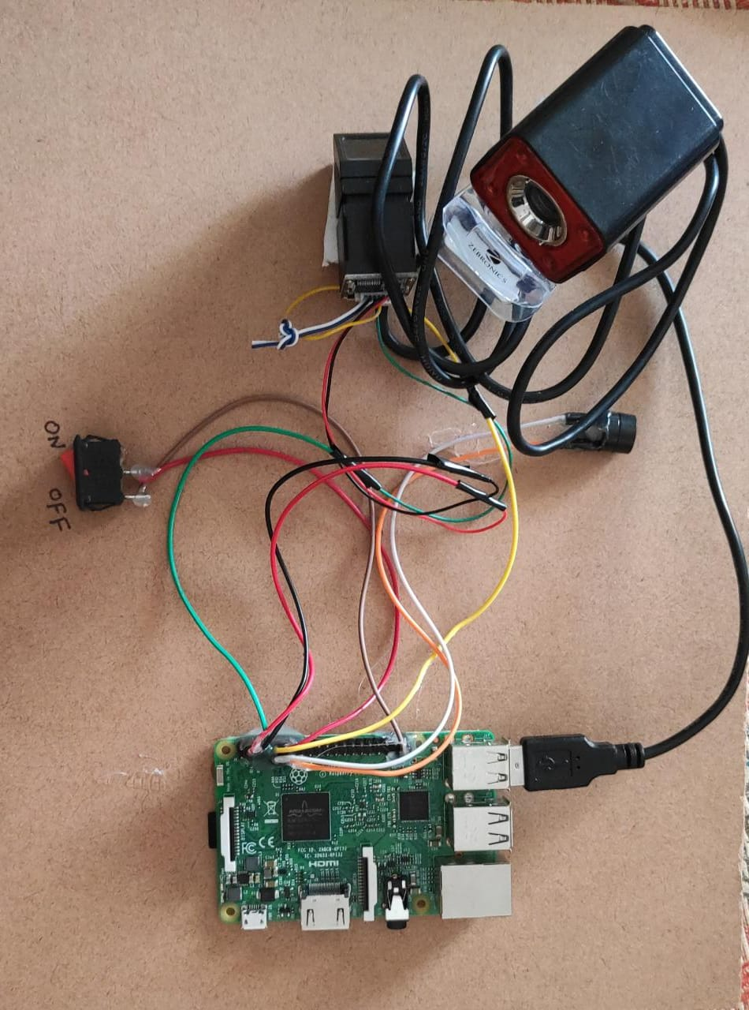
Figure 4.8:- Interconnection of Circuit [Project Protocol]
The project Raspberry Pi Based Evm With Fusion Of Face And Fingerprint Recognition System has been successfully designed and tested. The developed scheme is cheap, fast, and highly reliable and provides enough flexibility to suit the requirements of different systems.This the finally connected kit and we will check the results from it and detailedly explained below.

1)Starting Step For Project
First we take the kit and giving power supply to the Raspberry pi by the use of mobile charger then the Raspberry pi will become active stage and we want to on our mobile hotspot as raspberry pi requirements and automatically Raspberry pi will be connected to the our mobile hotspot then we want to connect same hotspot network to our laptop then we go to step2
2)Advanced IP Scanner Process
We want to install the Advanced ip scanner app to our laptop this app is used for scan the IP address of the equipments that connected to the network that means our mobile hotspot it will scan and display the IP adress,then we take the Raspberry pi IP address for next step.


Figure 4.9 Advanced IP Scanner to scan ip address.

3)VNC Viewer Process
We want to install the VNC viewer this app is used for to display the Raspberry pi view,before scanned ip address will be enter to VNC viewer then it check the ip address and display the screen of Raspberry pi we can do the total voting operation in the VNC viewer and we write the coding in the Raspberry pi that will be display in the vnc viewer fingerprint enroll and delete files ,Face enrollment file and saved files are be display in this app it is like a mini computer. VNC stands for Virtual Network Computing. It is a cross-platform screen sharing system that was created to remotely control another computer. This means that a computer’s screen, keyboard, and mouse can be used from a distance by a remote user from a secondary device as though they were sitting right in front of it. VNC works on a client/server model. A server component is installed on the remote computer (the one you want to control), and a VNC viewer, or client, is installed on the device you want to control from.

Figure 4.10:- VNC Viewer in laptop
VNC Viewer is used for local computers and mobile devices you want to control from. A device such as a computer, tablet, or smart phone with VNC Viewer software installed can access and take control of a computer in another location. It is a graphical desktop sharing system that allows a user to remotely control the desktop of a remote computer (running VNC Server) from your device, and it transmits the keyboard and mouse or touch events to VNC Server, so that once you are connected, you have control over the computer you’ve accessed. If you’re using your mobile phone, for example, you would be able to use the computer you’ve remotely accessed as though you were sitting right in front of it.
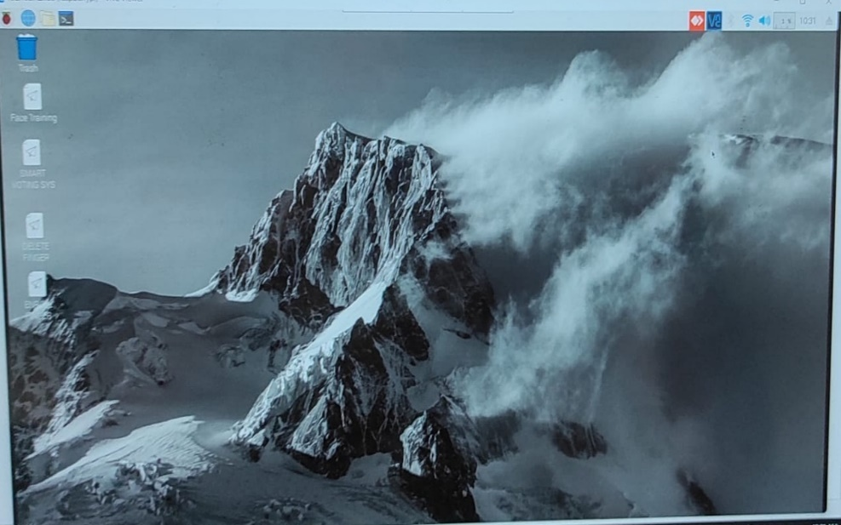
Figure 4.11:- VNC Raspberry pi viewer
4)Face Image Snapshots
In this step we will enrolled our face with a newfolder and we can take as nearly five snaps of our face with different angles and then after we can stop and then save it we can take different persons photos and it will be saved by the numbers because fingerprint will be saved by the numbers so it will easily matched when voting process starts and every photo will be saved by the jpg format as shown bellow figure. Voter face will be stored by clicking different snaps in different angles it may identify quick and we can store required input faces for the folder.
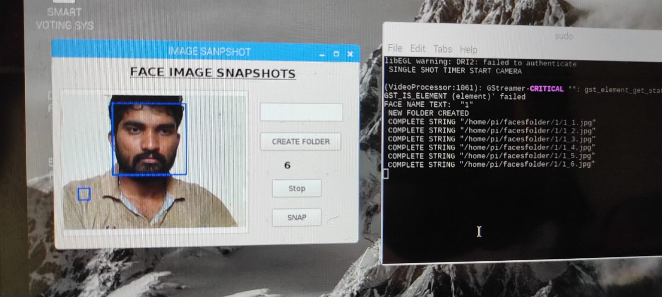
Figure 4.12:- Face Enrollment stage
5)Fingerprint Enrollment
In this step we will add our fingerprint in fingerprint enroll folder we can add our fingerprint then if we want to delete the delete option will be available on screen named as fingerprint deletion and the enrolled fingerprints will be stored in a numbers. When we click the fingerprint enroll then the fingerprint sensor will be trun on and we can see light on sensor then it indicates it ready to take fingerprint after taking data it will be off and it ask refinger again to take finaly it shown below figures and we can delete enrolled fingerprints by clicking the number what we want to delete.
Fingerprint sensor is used for this project to take the voters fingerprints and it will be stored and this sensor is used to identify the correct person or not while voting in polling booth. If the system does not take the fingerprint clearly it will doesn’t save if it match two times then only system save the finger print data in the system and the finger print will be stored by the numbers format only then the face that we stored in the folders is also must be stored in the numbers format only other wise system canot find the data becouse finger print will be saved by the numbers in this project face link to fingerprint file so both files must be same numarical numers for example first person will store data with folder number1 and second person store data with folder number 2 like that we want to store the data.
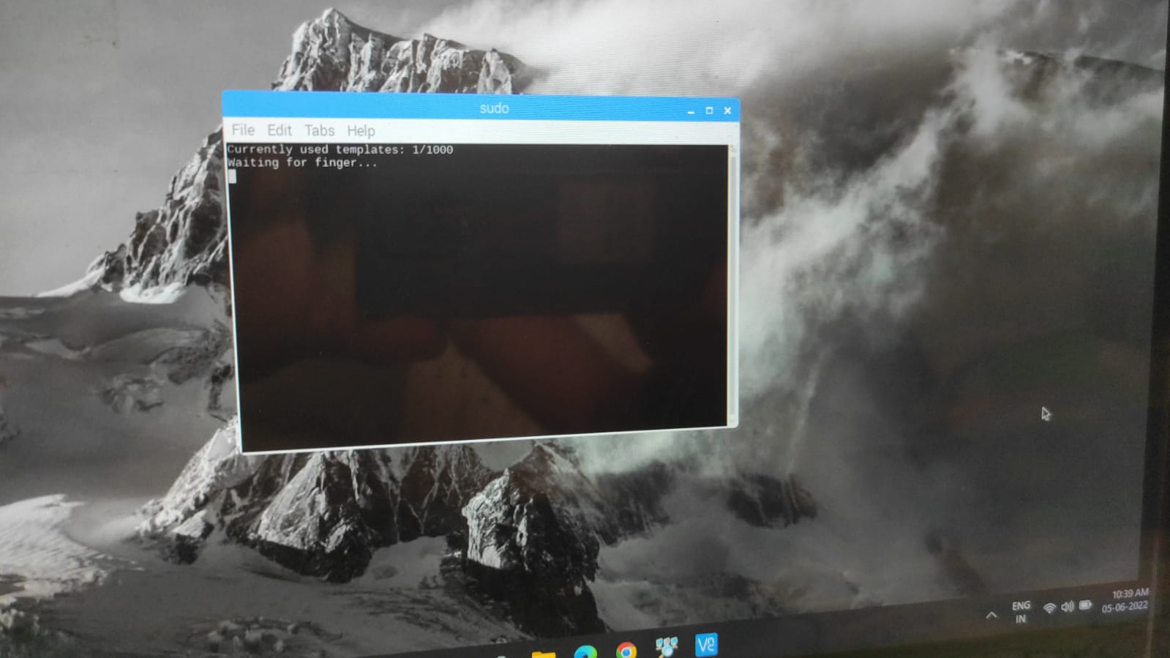
Figure 4.13:- Fingerprint enrollment step1
By the above figure we can see that system will be allowed for fingerprint enrollment then it waiting for fingerprint we want to place our fringer on scanner then it read our fingerprint data and it will ask same finger again because of verification shown below figure.
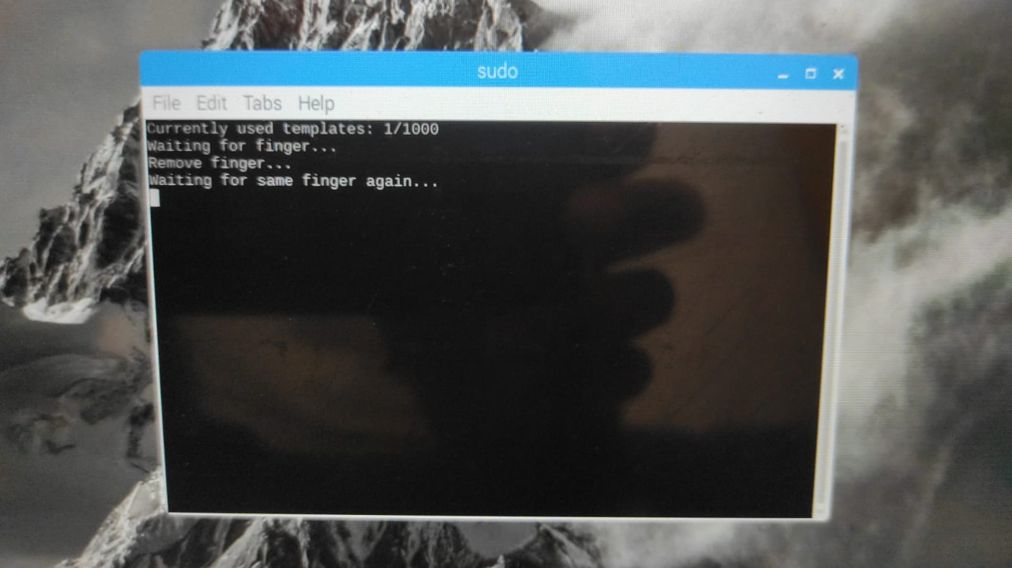
Figure 4.14:- Fingerprint enrollment display step2
By the above figure we can identify that system asking for second time verification of the same finger that placed before it and if it match second time then the system stores the data other wise it doesn’t store the data in to the system so fingerprint enrolling stage must keep only one finger twise for two stage verification and while giving fingerprint your finger must be clean because for exact data.
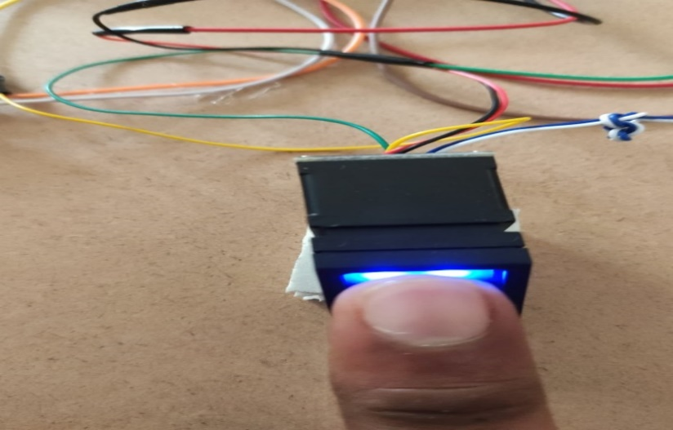
Figure 4.15:- Fingerprint sensor at enrollment stage

6)Face Verification
After completing the enrollment of fingerprint and face then we will do the experiment that smart voting shown on screen of Raspberry pi open it and the system will collect the total fingerprints and face folders that enrolled before it then camera will be opened and check the person who is infront of camera the person will be matched in to the enrolled data then system will allows for fingerprint option if other unkown person will be infront of camera it shows unknown person and makes buzzer sound and it indicates duplicate person entered in to the polling booth.
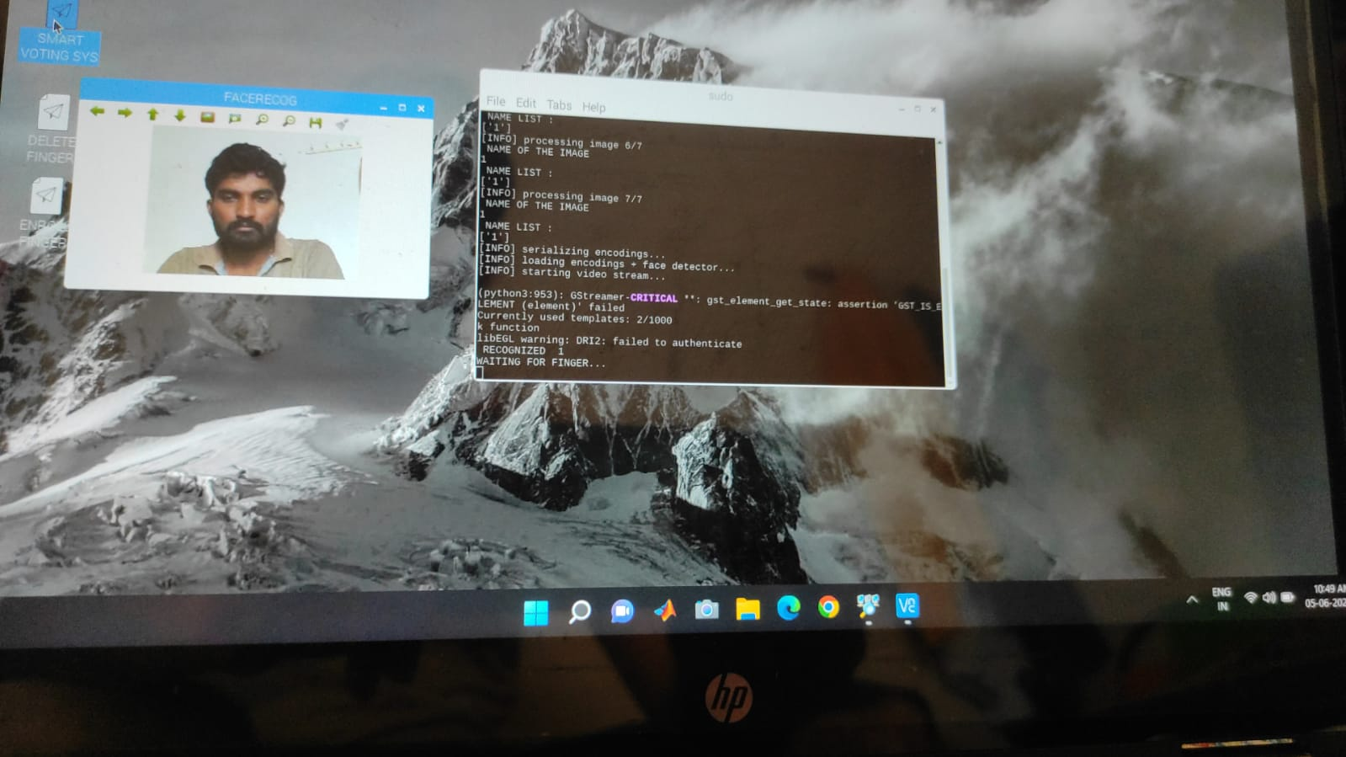
Figure 4.16:- Registered person
After face verification completed then system ask for the fingerprint shown below if the fingerprint is valid then the system will allows for voting both face and fingerprint of voter must be valid then only system alows for the voting. Fingerprint sensor is used for this project to take the voters fingerprints and it will be stored and this sensor is used to identify the correct person or not while voting in polling booth. Fingerprint detection is a biometric Technology. Fingerprint is unique for every individual. Every individual person has different fingerprint patterns. A fingerprint is a collection of many Ridges and Furrows This is the main Objective what makes fingerprint such an amazing tool for fingerprint identification. Fingerprint will be stored in number format only and if face 1 is enrolled then we want enroll that person finger print it stored in number 1 and enrollment fingerprint shown bellow.

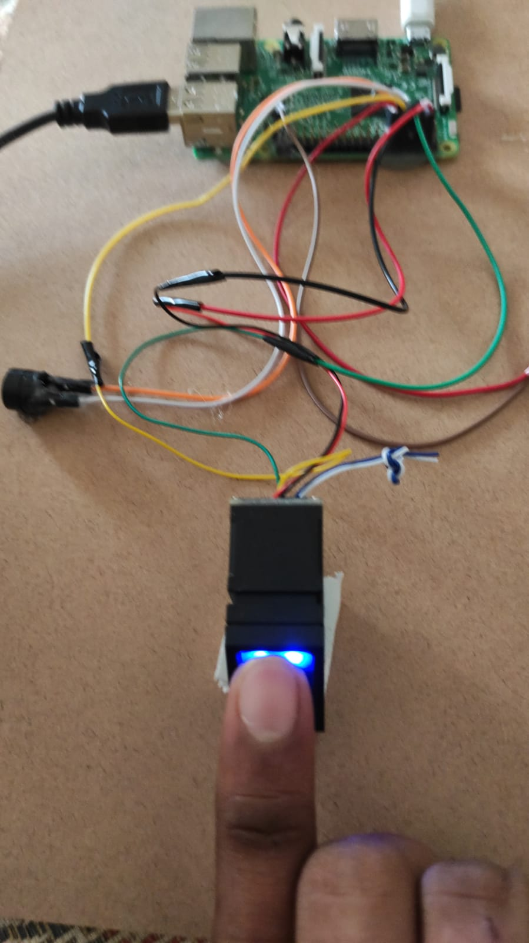
Figure 4.17:- Register person biometric enrolled
When system allows to vote then voter can see party names that will be display on the screen and voter can vote by clicking the party symbol and after completing vote the system will close party symbols and it doesn’t allow second time to vote.If the person enter second time then system will show the vote is done or in process it means that person complete the voting process. We can add different voters fingerprints and faces by the storage of memory card we can store the voters data. After completing the face and fingerprint checking if both are done successfully then system will be allows for the voter to vote if any duplicate person is try to enther to the polling booth if he or she infront of camera the sytem will find the person is valid or not by checking the data that enrolled in the system if the person doesn’t match in the stored data then buzzer will make sound and gives information for the agent and the voter is valid person then allows for voting as shown in below figure.
If face is verified then only system will allows for the fingrtprint if both are verified then the system display the party symbols on the screen then we can vote our required party by single click.
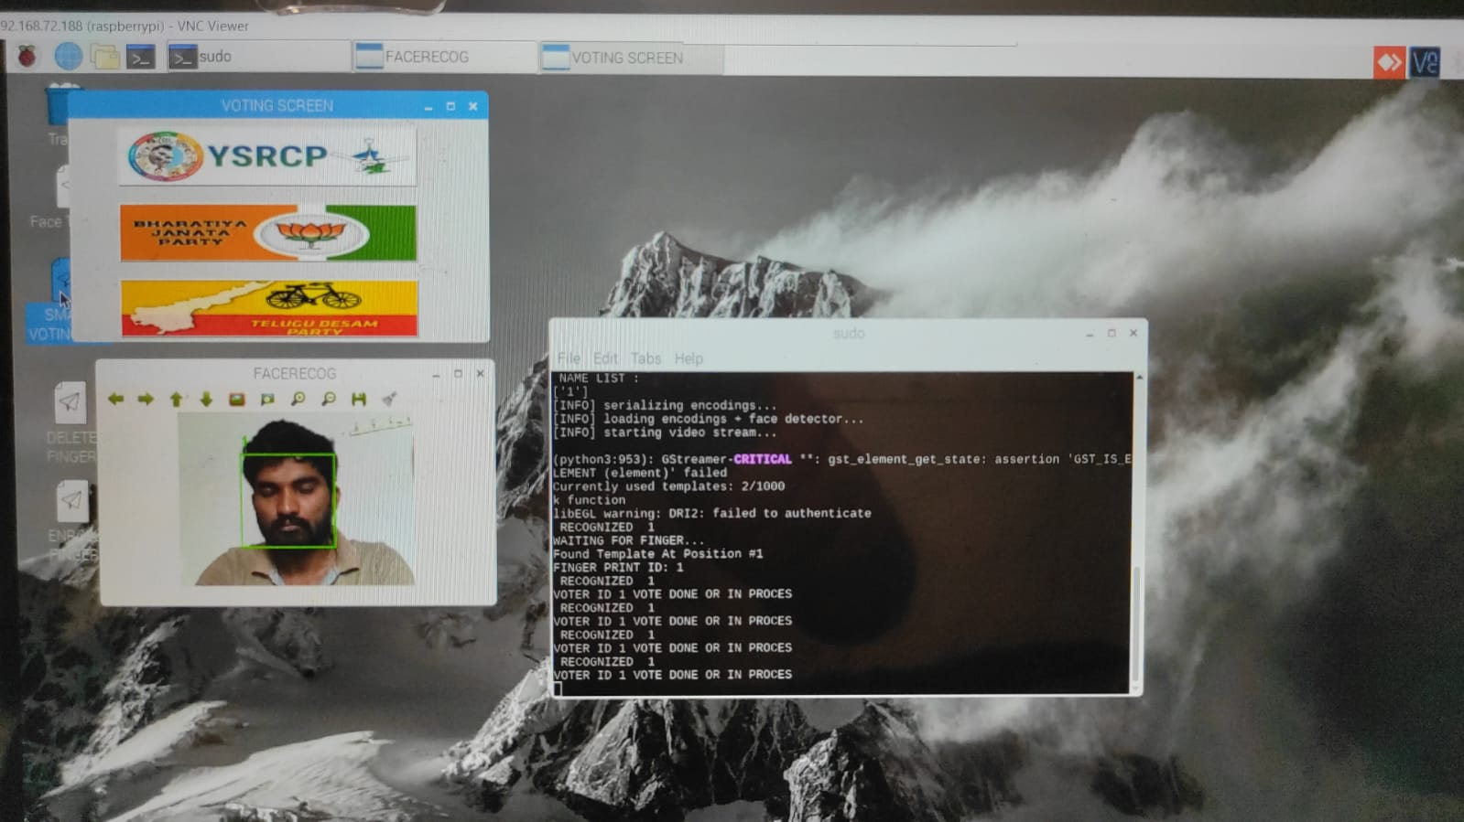
Figure 4.18 :- Voting Process for Valid Person

In the above figure shows that a valid person is ready to vote after completing his identifications in the system. The features of the Face module and the Finger print module are fused and recognition result is given to the micro controller and the person is matched or not matched is displayed in the LCD display. Then the person, who is recognized, will be allowed to vote. LCD display is used to display the messages to the voter for example, select a candidate, vote accepted, matched, not matched etc. A buzzer is used to alert the user. The buzzer will turn on if the person comes again to vote, if the input does not match and if any malpractice takes place or if the person comes again for voting. Switch can be operated in two modes which are mode A and mode B. Mode A indicates that switch is in voting mode and mode B indicates that switch is in counting mode. Votes will be accepted only when the switch is in the voting mode. The voter should press any one of the button. If the voter will press more than one button at a time the buzzer will turn on or the first button pressed will be taken as the vote.The major concepts used to design and model this access control system is advanced knowledge of micro controllers and interfaces, as the Raspberry Pi computing device is used and interfaced with different drivers along with application development to develop a desktop application. Live high quality HD Camera is connected with the display using the same processor to provide the functionalities mentioned above. The photo is captured and processed through the app which detects face out of the available Eigen faces. In addition to this different an intensive study of open cv platform and its inbuilt libraries has been conducted to generate a code, which does correct and reliable facial recognition with new and efficient use of hardware. As the world is progressing people are scared about the safety of their possessions, information and themselves. With the model of Smart Locker, a profound impact is expected on the security industry and it is somewhat anticipated as the time has come to make all daily life objects interconnected and interactive. This model will be a major contribution to the field of Bank Security.
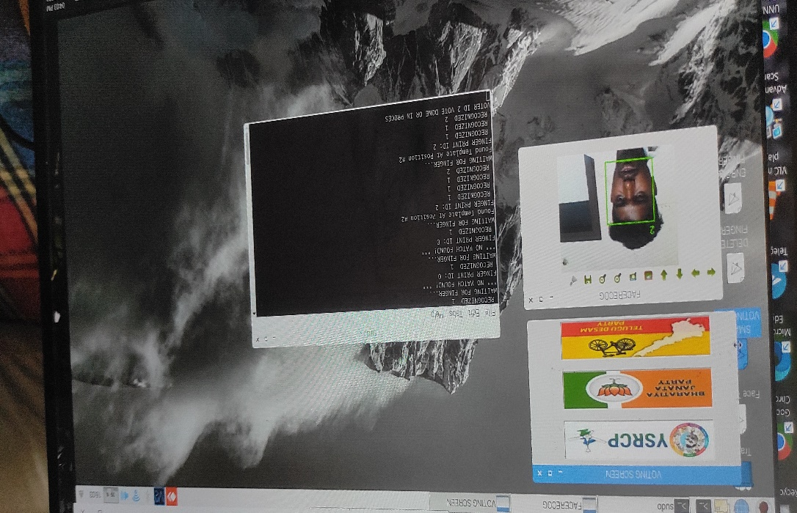
Figure 4.19:- Second valid person to vote
In the above figure shows that the person is a valid person and alows to vote for required partys. Different people can vote in this system but they must be enroll their data before starting voting process in the system this system main aim is to Voting has progressed throughout the years from a totally manual to a more technological procedure. Electronic voting is the use of electronic equipment in voting. We should be able to confirm the legitimacy of cast ballots through electronic voting, and transactions should be untraceable. The present voting method is based on a ballot machine, and voting is completed when we hit the button with the symbol. There is a security concern here since the individual voting may be a false voter. People may be unaware that someone is using a forged voting card, which can lead to complications. Bio-metrics can help to improve the security of electronic voting systems. Bio-metrics is the study of a person's unique physical and behavioral features via measurement and statistical analysis. Face recognition, fingerprint recognition, iris recognition, hand geometry, palm veins, palm print, and other biometric methods exist. Face recognition and fingerprints are employed in this technology. Facial recognition is a biometric method of identifying a person by comparing live capture or digital image data with previously recorded image data. Fingerprint recognition is a way of identifying and confirming a person's identity based on a comparison of two fingerprints (a database fingerprint and a detected fingerprint) and used for computerized system authentication.

The main work of this project is With the model of Smart voting a profound impact is expected on the security polling and it is somewhat anticipated as the time has come to make all daily life objects interconnected and interactive. This model will be a major contribution to the field of polling. Privacy and Security are two universal rights and, to ensure that in our daily life we are secure, a lot of research is going on in the field of home security, and IoT is the turning point for the election board, where we connect everyday objects to share data for our betterment. If the voteing is completed then we trun off switch total votes will be shown on screen.

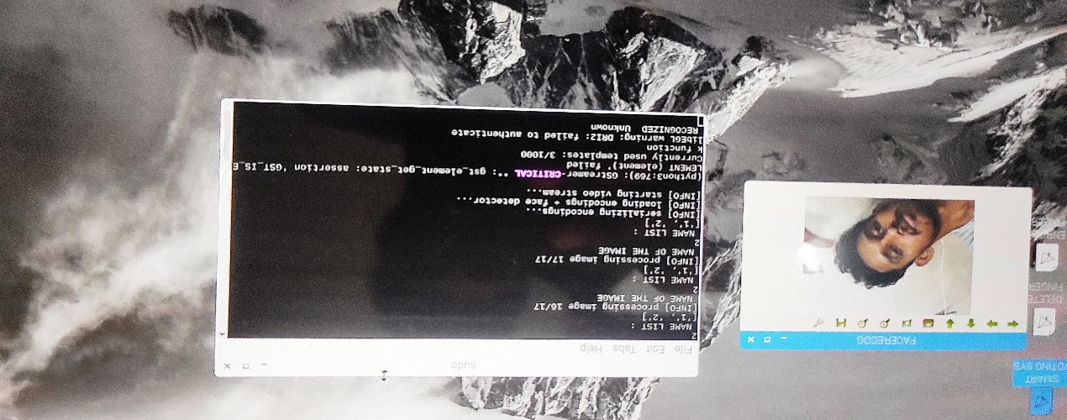
Figure 4.20 :- Unknown Person
When unknown person enter to the pollingbooth then system will show unknown and makes buzzar sound if person so by the use of this project we may avoid the duplicate people in polling booth and the person is valid person then allows for voting after verified finger print successfully that shown bellow figure Now a days duplicate voters are increased in our surrounding we all are observing on elections time for avoiding that problem we invented this project. EVMs reduce the time in casting vote and also reduce the time. And utilizing this machine, count votes and declare results. Recently, that the systems could be tampered with and the security could be changing the votes, but this has not been proved. it save papers. These machines are powered by batteries or also run on electricity which ensures uninterrupted voting. it can accommodate sixty-four voter in a single constituency it will be based on memory storage only. In this machine, Votes can be stored for up to ten years. EVM can permanent save the program whose never be change it and have a sealed security chip, therefore votes cannot be rigged without damaging the program. This prevents fraud. Only one vote can be cast per person as the machine will register only the first button pressed. In our proposed work Biometric identifiers are used to provide better security in EVM. By using Biometric identifiers like Face Recognition and Fingerprint Sensor which are linked with Adhaar card it will be done by the government. Votes are stored electronically in EVM ballot box. Thus, it cannot be hacked easily because Biometric identifier cannot be easily misplaced or shared. This application can also be used by Handicapped person by just clicking their picture and matching it with the provided information which is stored in the Database that system can modify for the requirement then the finger print enrollment .
4.7 FINAL RESULT:
1)HARDWARE KIT

Fig 4.21:- Hardware Kit
After completing the above steps of execution one by one then we get the results,voting is completed we trun off the switch then the total votes will be display on screen we can see the results at the same day of polling. The result of sample example will be shown bellow figure.
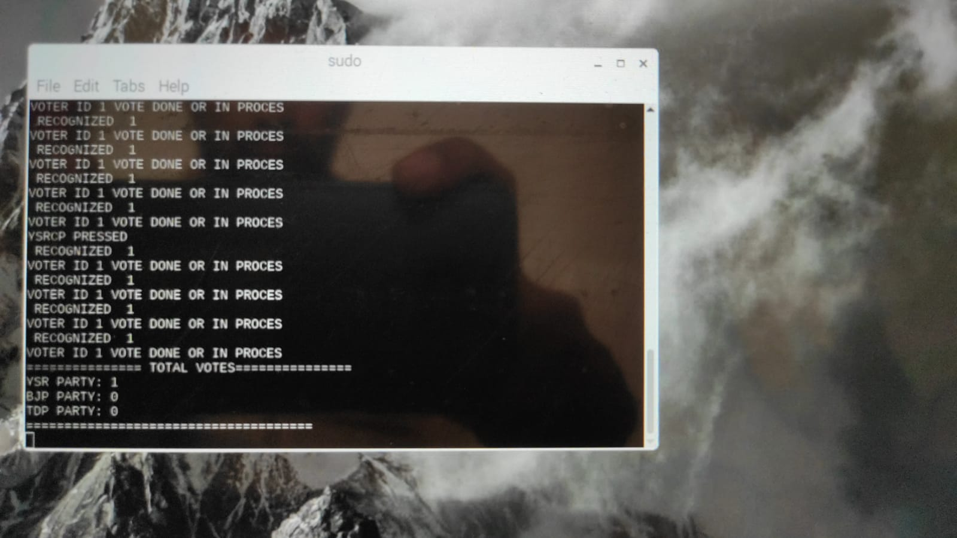
Fig 4.22:- Final output of the system
In the above figure is just a sample result of the system that only one voter vote their vote we can use more voters but before voting we want to enroll the data of that particular voter then the system will allow for voting the inputs are matched then voter can vote for required partys given in the system. If votel click one party it will be save and automatically close that tab and if that person is again infront of camera it shows that vote is done or in process but it does not allow twice for voting.
If unknown person is infront of camera then system will shows that unknown that means there is no data about that person who infront of camera and buzzer makes the sound that indicates a signal for agent and they will alert. If valid person enters then the system scan the face and it valid shows that person recognized number and allows for the fingerprint and if fingerprint match on the recognized number then the system allows for voting the valid person can vote for required party.

CHAPTER 5
CONCLUSION

In the proposed work, the number of person’s faces and finger print are considered for performance analysis. Face features are extracted from hog algorithm. Finger print is taken from R303a finger print sensor. The fusion of face and finger print recognition is done. The recognized person is allowed for voting. Voting module is implanted using micro controller. The results show proposed method provides highly secured voting technique. This proposed work is related to biometric system considering a right to vote from anywhere system which enables the elector to compute their vote from any place in India by using this biometric system based electronic voting machine using raspberry pi which provides the secure way of voting where a person cannot vote more than once where we consider fingerprint &face recongnization system for the security purpose defrauduluence is avoided by using this system and high accuracy, time is saved and fair voting process is been carried out. We done the voting process for six members and we get output results successfully.

Future Scope:
In the Future Scope the proposed voting prototype model, less number of finger prints can be stored in the finger print module which can be increased. This electronic voting machine can be interfaced with the machines at different places for the state elections so that votes can be counted easily. Time stamp can be provided so that no malpractice takes place and provide more security.

REFERENCES

- J. Deepika, S. Kalaisevi, S. Mahalakshmi, S. Agnes Shifani “Smart electronic voting system based on biometric identification survey” IEEE third international conference on science technology engineering & management (ICONSTEM) 2017, pp939-949.

[2] Vidyasree, Viswananda Raju and Dr.G.Madhavi “Desisting the fraud in India”s voting process through multi modal bio-metrics”, IEEE 6th international conference on advanced computed pp. 488-491, 2016.

[3] Dr.S.Ravi, Dattatreya P.Mankame “Multimodal Biometric Approach Using Fingerprint, Face and enhanced Iris features Recognition” International Conference on Circuits, power and Computing Technologies 2013 pp1143-1150.

[4] M. Satiyam, R Nagrajan “Recognition of facial expression using Haar-like feature extraction method” IEEE International conference on intelligent and advanced system 2010 pp1-4

[5] Kamal Nasrollahi, Thomas B. Moeslund “Haar-like features for robust real time face recognition” IEEE International conference on image processing 2013 pp3073-3077.

[6] Rupali L.Telgad, P. D. Deshmukh, Lmas M.N.Siddiqui “Combination approach toscore level fusion for multimodal Biometric system by using face and finger print” International Conference on Recent Advances and innovations in Engineering(ICRAIE) 2014, pp1-6.

[7] J. Kulandai Josephine Juliana, T.Sree Sharmila “Facial recognition using Histogram of Gradients and support vector machines” International Conference on Computer, Communication and Signal Processing(ICCCSP)2017 pp1-5.

[8] Zheng Xiang, Hengliang Tan, Wengliang Ye “the excellent properties of grid based HOG feature on face recognition compared to Gabor and LBP” IEEE early access 2018, pp1-1.
[9] M.Faheem Rana, Ayesha Altaf, Syed Zagham Naseem “Enhanced real time system of e voting using Finger print” IEEE International conference on Electronics, Computer and Computation(ICECCO) 2013, pp297-300.

[10] M.Slavkovic, B.Reljin,A. Gavrovska, M.Milivojevic “Face Recognition using Gabor filters, PCA and neural networks” IEEE 20th International conference on systems, signals and image processing(IWSSIP) 2013, pp35-38.

[11] Jiang Li –Li, Liang Kun,Ye Shuang “Face Recognition based on support vector machine” IEEE Fifth International symposium on computational Intelligence and design 2012 pp115-119.

[12] Sanjay Thakre, Ambikesh Kumar Gupta, Shilpi Sharma “Secure Reliable Multi model Biometric Fingerprint and Face Recognition” International Conference on Computer Communication and Informatics(ICCCI) 2017 pp1-4.

[13] Bhuvanapriya, R.Rozil babu, international conference on computing and communication technology, Chennai,India,2017.

[14] J.Deepika, S.Kalaiselvi,Third International Conference on Science TechnologyEngineering&Management (ICONSTEM), , Chennai, India, 2017. [3] Md. Mahaboob karim, Nabila Shahbaz Khan,IEEE international conference on telecommunications and photonics(ICTP)26_28december,2017,Dhaka, Bangladesh, 2017.

[15] V.Kiruthika Priya, v. Vimaladevi, international conference on trends in electronics and informatics(ICEI),tirunelveli, India, 2017.

[16] Rahil Rezwan, Huzaifia Ahmed, M.R.N. Biplob, S.M. Shuvo, Md AbdurRahman“BIOMETRICALLYSECURED ELECTRONIC VOTING MACHINE”, 2017 IEE Region 10Humanitarian Technology Conference (R10-HTC).

[17] Shashank S Kadam, Ria N Choudhary, SujayDandekar, DebjeetBardhan, Prof.Namdeo B Vaidya “ELECTRONIC VOTING MACHINE WITH ENHANCED SECURITY”, 2018 IEEE Xplore Part Number: CFP18AWO-ART: ISBN: 978-1-5386-4765-3 (ICCES 2018).

[18] Anandaraj S, Anish R, Deva Kumar P.V “SECUREDELECTRONIC VOTING MACHINE USING BIOMETRIC”,2015 IEEE Sponsored ¬second International Conference on Innovtions in Information, Embedded andCommunication Systems(ICIIECS) 2015.

[19] J. Deepika, S.Kalaiselvi, S.Mahalakshmi “SMARTELECTRONIC VOTING SYSTEM BASED ON BIOMETRICIDENTIFICATION SURVEY”, 2017 Third International conference on Science.

[20] Sahibzada Muhammad Ali “Micro-Controller Based Smart Electronic Voting Machine System”,2014.

[21]Nagyen TD, Park J, Lee G. Using 2D tensor voting in text detection. Proceedings of the IEEE International Conference on Acoustics, speech and signal processing.
2010;888-21.

[22]Chiao-Wen Kano, Che-Wei YC, Kuo-Chin F, Bor-Jiunn H, Chin-Pan H. Eye gaze tracking based on pattern voting scheme for mobile device. Proceedings of the First International Conference on Instrumentation Measurement Computer Communication and Control. Beijing, China 2011;337-40.

[23]Md. Asfaqul A, Md. Maminul I, Md. Nazmul H, Md. Sharif Uddin A. Raspberry
Pi and image processing based electronic voting machine. International Journal for
Research in Applied Science and Engineering Technology 2016;4:568-74.

[24]Dhinesh Kumar M, Aranganadhan NS, Santhosh A, Praveen Kumar D. Embedded
system based voting machine system using wireless technology. International Journal
of Innovative Research in Electrical Instrument and Control Engineering 2016;4:127-30.
[25]Louise A. Biometric Borders: Governing motilities in the war on terror. Political
Geography 2006;25:336-51.

