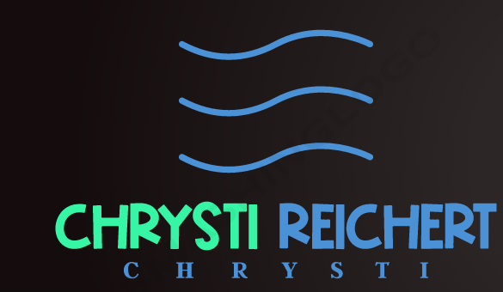**Chrysti Reichert**

St Petersburg, Florida, United States

Email: [momchrysti@gmail.com](mailto:momchrysti@gmail.com) 727-520-5180

Linkedin: <https://www.linkedin.com/in/chrysti-reichert-13675b165/> Portfolio: <https://unnamedmistress.github.io/Portfolio-Dec22/>

|  |  |  |
| --- | --- | --- |
| **Skills:**   * Microsoft SQL Server * OpenAI Integration * AI consulting * OpenAI API models * JavaScript * Database Design * Power BI (3 years) * Power Apps (3 years) * APIs (3 years) * Microsoft Excel (20+ years) * SQL (3 years) * Adobe Acrobat (10+ years) * Google Suite (7 years) * Supervising experience (10+ years) * Time management * Project management * Application Development * MySQL * User Interface (UI) * HTML5 * Git/GitHub * Bootstrap/Tailwind * OOP * Public Speaking * Case Management * Meeting Facilitation * Database management * CSS * Node.js * REST API * React * MongoDB | **Summary**  Experienced Full Stack Web Developer with advanced technical skills and expertise in front-end development, software engineering, and web services. Bachelor's degree and Full Stack MERN Certificate from the University of Central Florida. Excels in HTML5, JavaScript, programming, SQL, database management, and UX design. Accomplished Lead Medicaid Benefit Counselor Coordinator (Manager) with a proven track record of streamlining workflows, implementing new systems, and reducing costs with innovative solutions. Ready to leverage technical acumen and managerial experience to deliver top-notch results for your company.  **Web Development Projects**   * **Tutor Genie:** A tutoring app for anyone. Special moderations given to ensure safety for children. Get your tutoring on! <https://github.com/unnamedmistress/GenieGenZ> * **Typo Terminator:** Typo Terminator. Using the latest State of the Art AI Essay Proofreader, Cover Letter Generator, and Outline Generator, using Node, Express, Mongodb. <https://github.com/unnamedmistress/typoterm> * **ThePawPath:** Adopting a pet has never been easier with ThePawPath. Built with JavaScript, HTML, CSS, Tailwind, and a Rescue API, the pet adoption search site is the perfect tool to help you find your furry friend. See how it works at <https://github.com/unnamedmistress/thepawpath> and discover a better way to find your perfect pet.   **Work Experience**  **Area Agency On Aging of Pasco-Pinellas, Inc.**  **Lead Medicaid Benefit Counselor Coordinator (Manager)**  **August 2009 - December 2022**   * Spearheaded a highly skilled, cross-functional team of 7 with expertise in Medicaid and social services to deliver essential care to over 6,000 seniors annually. * Innovated a pioneering text-based customer feedback system (using forms and automated texting software) that amplified positive feedback by 50%, significantly improving care outcomes and staff morale. * Designed, constructed, and tailored an advanced scheduling platform using HTML, API, Power Apps, and SharePoint, increasing efficiency by over 50%. * Devised and executed an optimized communication strategy between Medicaid and care providers, reducing response time by 65% by developing HIPAA-compliant, one-to-one web-based texting software. * Partnered with high-stakes organizations (DCF and AHCA) to provide comprehensive care to 1,500 seniors per year. * Implemented agile workflows using Google Suite, Microsoft, SharePoint, and custom Power Apps, amplifying productivity by 20% per worker. * Streamlined data management and reporting procedures, minimizing errors and discrepancies by 25% using MySQL and SSRS. * Developed and implemented a comprehensive training program that resulted in a 95% adoption rate of new workflows using cutting-edge video resources, customized quizzes, and recorded Zoom training sessions. * Collaborated with state agencies and developers at Welsky to address gaps in the E-CIRTS (Client Management System) reporting system, improving data accuracy and completeness by 50%. * Engineered a $15k cost reduction by creating an API to connect two web-based applications to a SharePoint Dataverse and designed a long-term maintenance and support plan to sustain this achievement.  |  | | --- | | **Education** |   University of Central Florida 2022 - 2023  Full Stack MERN Certificate, JavaScript, HTML, API, CSS, Node, SQL, OOP  Indiana University - Bloomington Bachelor of Arts, B.A. |
|  |  |