ATM Transaction Simulator - Project Report

ABSTRACT
The ATM Transaction Simulator is a comprehensive console-based application designed to model the core operations of a real-world Automated Teller Machine. Developed in Java, the system rigorously enforces security protocols such as PIN authentication and account lockouts after consecutive failed attempts. Beyond basic balance inquiries and deposits, the simulator features a highly realistic withdrawal mechanism that respects both daily user withdrawal limits and the physical cash inventory of the machine. The hallmark of the project is its dynamic note-dispensing algorithm, which utilizes a greedy approach coupled with recursive backtracking to accurately calculate exact denomination mixes, ensuring that transactions are only approved when the exact physical cash can be dispensed. This project showcases the effective implementation of control flow, method abstraction, parallel arrays, and algorithmic problem-solving.

ADVANTAGES
- Robust Security: Implements strict PIN validation and automatically blocks cards after three failed attempts to prevent unauthorized access.
- Realistic Cash Dispensing: Employs a recursive backtracking algorithm that mimics actual ATM behavior by dispensing exact denomination mixes based on current inventory, refusing transactions if the exact mix is unavailable.
- Comprehensive Limit Tracking: Enforces both individual daily withdrawal limits and the overall physical cash capacity of the machine.
- Efficient Data Management: Utilizes parallel arrays and rolling window techniques to track user balances, limits, and mini-statement histories efficiently.
- Fail-Safe Edge Case Handling: Prevents deposits/withdrawals of non-positive amounts and manages out-of-stock denomination scenarios gracefully.

IMPLEMENTATION
The project is systematically implemented using procedural Java up to Week 6 constraints. Key modules include:
Data Storage & State Management: Instead of advanced objects, parallel arrays are used to maintain parallel state for card numbers, PINs, balances, failed attempts, and block flags. ATM cash cassettes are managed via denomination and note-count arrays.
Authentication Module: A dedicated method checks the provided card against the database. It increments failure counters upon incorrect PINs and toggles the block flag if failures reach three.
Transaction Processing: Validates all financial operations. Withdrawals check against current balance, daily withdrawal limits, and ATM cash availability. It employs a rolling array mechanism to maintain the last 5 transactions for the mini-statement.
Dispensing Algorithm: The core logic utilizes a recursive fallback mechanism. It attempts a greedy distribution of the largest available notes first. If a precise match cannot be made due to specific note depletion, the recursion backtracks to try alternative denomination combinations before ultimately failing or succeeding.

OUTPUT SCREENSHOTS
Note: Below are text representations of the expected console output. You can replace these blocks with actual image screenshots when finalizing your report.
=== Screenshot 1: Successful Authentication and Dispensing ===
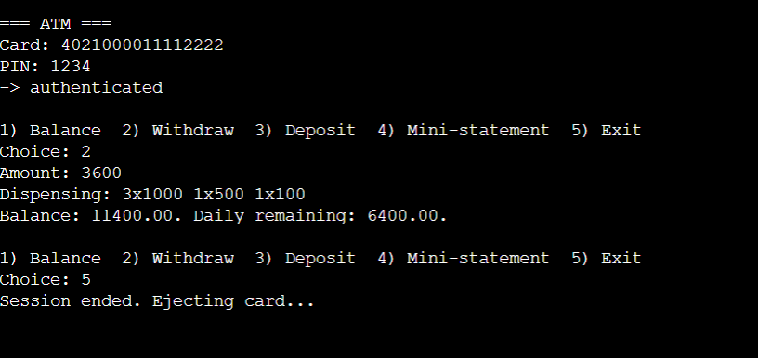
=== Screenshot 2: Failed Authentication & Lockout ===
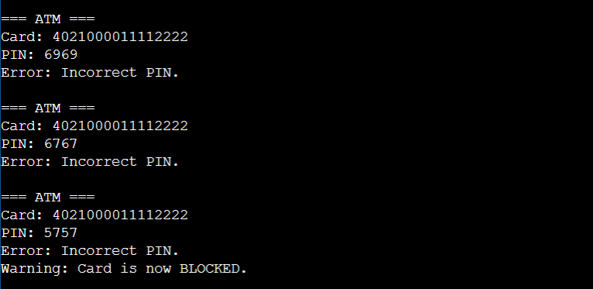

CONCLUSION
The ATM Transaction Simulator successfully bridges the gap between theoretical programming concepts and practical, real-world application logic. By strictly adhering to foundational constraints (primitive types, loops, arrays, and recursion) while enforcing complex domain rules like inventory management and transaction security, the project results in a highly reliable and mathematically sound simulation. It highlights the importance of edge-case handling and optimal algorithm design in software engineering, laying a robust groundwork for future enhancements such as object-oriented refactoring, database integration, and multi-currency support.

