Campus Placement Technical Case Study
Flash Sale Checkout: Selling Exactly 500 Phones Under 100,000 Concurrent Requests
Technical design, implementation and test report
Candidate: Unnathi Vinod
Role: Full-Stack Software Engineer
B.Tech Computer Science and Engineering, Shiv Nadar University Chennai

Submission date: 29 October 2026
Source code: github.com/unnathivinod/flash-sale-checkout

1. Executive Summary
A flash sale releases 500 smartphones at 8:00 PM, and more than 100,000 checkout requests are expected in the first ten seconds (roughly 10,000 requests per second). In trial runs the existing system timed out, suffered row-lock contention on the inventory table, and confirmed 540 orders for 500 phones.
My analysis found three root causes. Every checkout read the stock and then wrote it back in a separate statement, so concurrent requests overwrote each other (a lost-update race). Every request updated the same database row, so the row lock serialised the whole sale. And each checkout made several database round trips inside the HTTP request (an N+1 pattern on the hot path), so the slowest component set the response time for everyone.
My design removes the database from the request path. An atomic Lua script in Redis decides who gets a phone, records the buyer and writes the order to an outbox in one step. The API replies 202 Accepted with a tracking URL. A relay moves orders from the outbox to Amazon SQS, and workers save each order in PostgreSQL with a conditional update, UPDATE inventory SET stock = stock - 1 WHERE product_id = $1 AND stock > 0, inside a single transaction. Database constraints act as a final safety net.
I implemented the design in Node.js and tested it on a Windows laptop with Docker, k6 and Chrome Lighthouse. I kept the original design as a separate endpoint so both could be measured under the same load.
Measure | Original design | My design
Load applied | 300 virtual users, 3,000 requests | 1,000 virtual users, 20,000 requests
Orders confirmed (stock of 500) | 3,000 (oversold by 2,500) | Exactly 500
Failed requests | 0% | 0.00%
Response time, 95th percentile | Not measured | 736 ms
Throughput on one laptop | Not measured | 1,644 requests per second
Database calls on the checkout path | 3 per request | None
Workers killed and Redis restarted mid-sale | Not applicable | Exactly 500 confirmed, nothing lost
Sale page size / Lighthouse performance | Not applicable | About 9 KB / 100
Table 1. Measured results
The correctness target (never more than 500 orders) is met by design and was confirmed in every run. The 10,000 requests per second target was not demonstrated on a single laptop; Section 12 explains how the design reaches it by adding servers.

2. Problem Analysis and Requirements

2.1 Bottlenecks in the existing system
Symptom | Root cause
540 orders for 500 phones | Check-then-act race. Stock is read in one statement and written back in another, so two requests can both read "1 left" and both succeed.
Row-lock timeouts | All requests update one row (product 1). PostgreSQL lets one transaction hold that lock at a time, so 100,000 requests queue behind it.
N+1 database round trips | Each checkout performs several sequential queries (read stock, update stock, insert order, look up user and product). Load on the database grows with requests multiplied by queries.
Latency and timeouts | The database write sits inside the HTTP request, so users wait on the slowest component.
Duplicate checkouts | Nothing stops repeated clicks, and the server has no way to recognise a retry.

A single hot-row transaction takes a few milliseconds, which caps that row at roughly 200 to 500 transactions per second. At 10,000 arrivals per second, more than 90,000 requests would be waiting after ten seconds, far beyond any HTTP timeout. Only 500 requests can ever succeed, so the database should see 500 writes, not 100,000 competing transactions.

2.2 Requirements
Mandatory requirements must hold in every run. Targets are performance goals that can only be shown by measurement.
Requirement | Type | Technical challenge | Proposed approach | Validation
Never more than 500 orders | Mandatory | Race between concurrent buyers | Atomic Redis token plus conditional SQL update and CHECK constraint | Load and chaos tests: confirmed count equals 500
One order per customer, no duplicates | Mandatory | Repeated clicks, client retries, redelivered messages | Click lock, per-user idempotency in Lua, UNIQUE and PRIMARY KEY constraints | 5% double clicks in the load test return the same order
No silently lost accepted orders | Mandatory | Crashes between components | Outbox in the same atomic step, ACK after delivery, SQS retries and DLQ | Chaos test with workers killed and Redis restarted
ACID order records | Mandatory | Partial writes | One PostgreSQL transaction per order | Rollback paths in the worker
No request lost or left hanging | Target | Overload | Every request gets 202, 409, 425, 429 or 503 quickly | k6 http_req_failed = 0%
Bundle under 200 KB, interactive under 1.5 s | Target | Slow mobile networks | Single inline page, no framework | File size, Lighthouse
10,000 requests per second | Target | Peak arrival rate | Stateless API, one Redis call per request, horizontal scaling | k6 (laptop result in Section 12)
Bots and abusive clients limited | Target | Scripted traffic | User-Agent filter, per-IP rate limit | Manual test: 429 and 403
Table 2. Requirements, approach and validation

3. Architecture Design
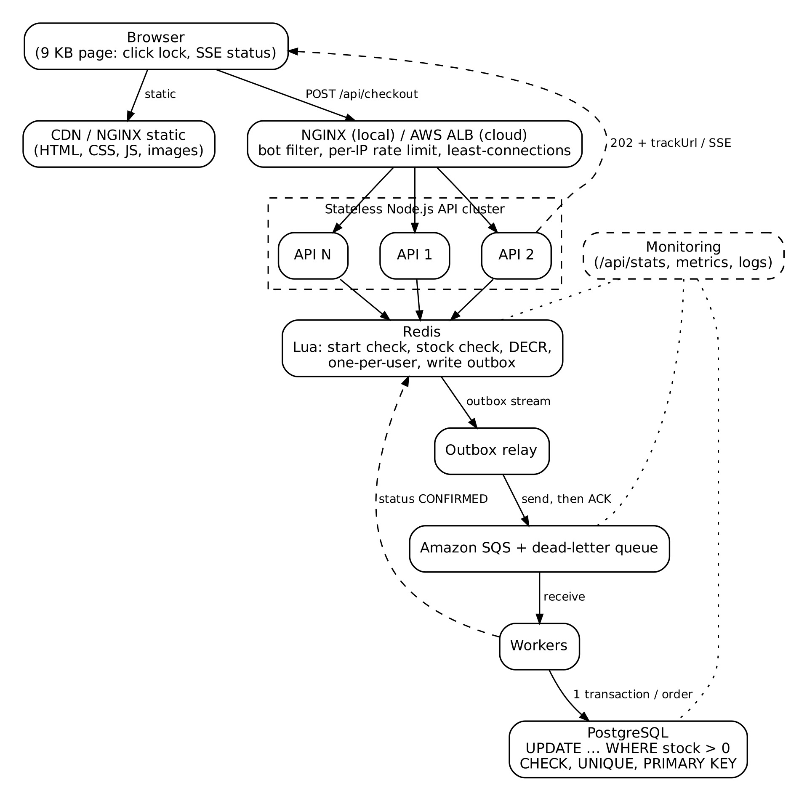
Figure 1. Architecture and direction of data flow
Component | Responsibility | Why it is needed
Browser page | Locks the button on the first click, shows progress, receives live updates | Cuts duplicate traffic at the source and keeps users informed
CDN / NGINX static | Serves HTML, CSS, JS and images | Static traffic never reaches the API
Load balancer (NGINX locally, AWS ALB in the cloud) | Bot filtering, per-IP rate limiting, least-connections balancing, health checks | Protects and spreads load across replicas
Node.js API (5 replicas, 2 event loops each) | Validates input, runs the reservation script, replies 202 or 409 | Stateless, so it scales by adding copies
Redis | Atomic stock token, buyer list, order status, outbox stream | Decides winners in microseconds without locks
Outbox relay | Moves outbox entries to SQS, acknowledges only after SQS accepts | Makes delivery reliable without a cross-system transaction
Amazon SQS with dead-letter queue | Durable queue between the API and the database | Absorbs the spike; failed messages are retried or parked
Workers | Save each order in one PostgreSQL transaction, update status | Writes happen at a rate the database can handle
PostgreSQL | Source of truth for orders and stock; final constraints | ACID storage and last line of defence
Table 3. Components

4. Frontend Strategy (Phase A)

4.1 Preventing repeated clicks
Debouncing waits until clicks stop before sending, which delays the first request at the moment speed matters most. Throttling sends at most one request per interval, which still allows a second request a moment later. For a purchase button I used a hard lock: the first click sends the request immediately and every later click is ignored until a final answer arrives.
btn.addEventListener('click', async () => {
if (phase !== 'idle') return; // every click after the first is ignored
phase = 'reserving';
btn.disabled = true; btn.textContent = 'Reserving…';
show('wait', 'Holding your spot…'); // optimistic message before the server answers
await checkout(0);
});
Listing 1. Button lock (excerpt from frontend/index.html)
Frontend protection is not enough on its own: a user can open two tabs, a network error can trigger a retry, or a script can bypass the page. The server therefore treats the user ID as an idempotency key. If the same user reserves again, the Lua script returns the same order ID and takes no extra stock (Section 7).

4.2 Asset delivery, pre-fetching and bundle size
The sale page is a single file of about 9 KB with inline CSS, JavaScript and an SVG-free layout, no framework and the system font. That is one request instead of dozens, well under the 200 KB budget. Locally, NGINX serves it directly with Cache-Control: no-cache for HTML and a one-year immutable cache for other static files, so static traffic never reaches the API.
In production I would put the files in S3 behind CloudFront, so users in Chennai, Mumbai or Delhi load the page from a nearby edge location. I would use content-hashed file names so assets can be cached permanently, enable Origin Shield so a cache miss across many edges becomes one origin request, serve product images as WebP or AVIF in several sizes with srcset, and request the page through the CDN shortly before 8 PM so the cache is warm. Because users arrive before the sale opens, the page and its data are already loaded during the countdown; at 8:00 PM the only network call is the checkout itself.

4.3 State management and status updates
The checkout is modelled as a small state machine: idle → reserving → queued → confirmed, with sold out, retrying and failed as side states. With only a few variables, a framework store was unnecessary; in a larger React application I would use a lightweight store such as Zustand with the same states, so a stock change re-renders only the stock display.
Option | Strengths | Weaknesses | Decision
Polling | Works everywhere, stateless, cacheable at the CDN | Delay of up to the polling interval; wasted requests | Used for order status (400 ms, backing off to 4 s) and as a fallback
Server-Sent Events | Real server push over plain HTTP, automatic reconnect | One open connection per viewer | Used for sale status: each process pushes one snapshot per second to all viewers
WebSockets | Two-way, lowest latency | Sticky sessions, more memory, harder to cache; we never send data from the browser | Not needed
Table 4. Real-time update options
Each API process reads Redis once per second and pushes the same snapshot to every connected browser, so 100,000 viewers do not mean 100,000 Redis reads. Polling intervals are randomised by about 20% so clients do not hit the server in lock-step, and retries after errors back off at roughly 1, 2, 4 and 8 seconds.

4.4 Loading, success and failure states
The page shows "Holding your spot" the instant the button is pressed (an optimistic message), then a three-step progress line: Reserved, Queued, Confirmed. Every response has its own message: 202 reserved, 409 sold out, 425 not open yet, 429 or 503 retrying automatically. The optimistic message only says the request is in progress; it never claims success before the server confirms, because showing "purchased" and later withdrawing it would be worse than a short wait.
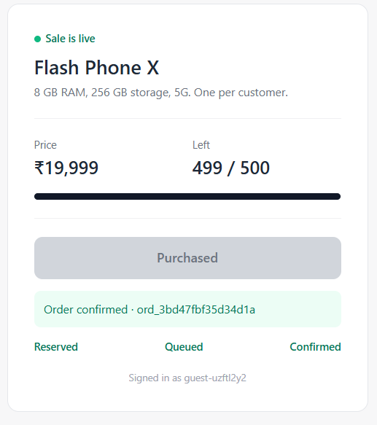
Figure 2. Shop page after a confirmed order (stock 499 of 500)
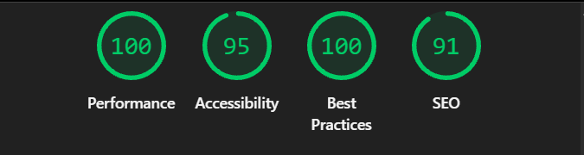
Figure 3. Lighthouse report for the sale page (desktop)
Lighthouse scored the page 100 for performance; Chrome measured the largest content paint at 0.16 s, layout shift at 0 and interaction delay at 0 ms. Newer Lighthouse versions no longer report a separate Time-to-Interactive figure, but a page fully rendered in 0.16 s with no blocking scripts meets the 1.5 s target with a wide margin.

5. Traffic Management and API Design
NGINX (an AWS Application Load Balancer in the cloud) is the only public entry point. It spreads requests across API replicas with least-connections, which suits requests of uneven length better than round robin, keeps connections to the replicas open for reuse, and retries on another replica if one fails. On AWS, the load balancer checks /healthz every ten seconds and removes failing instances.
- Bot filtering: requests with an empty or scripted User-Agent receive 403.
- Rate limiting: each IP may send 5 checkout requests per second (burst 10); the excess receives 429 with Retry-After. Where there is no NGINX, the API enforces the same limit with counters in Redis shared by all replicas.
- Timeouts and limits: 2 s to connect to a replica, 15 s to respond, 1 KB maximum request body.
- Backpressure: the expensive work waits in the queue, not in open HTTP connections, so a slow database never makes the API slow.
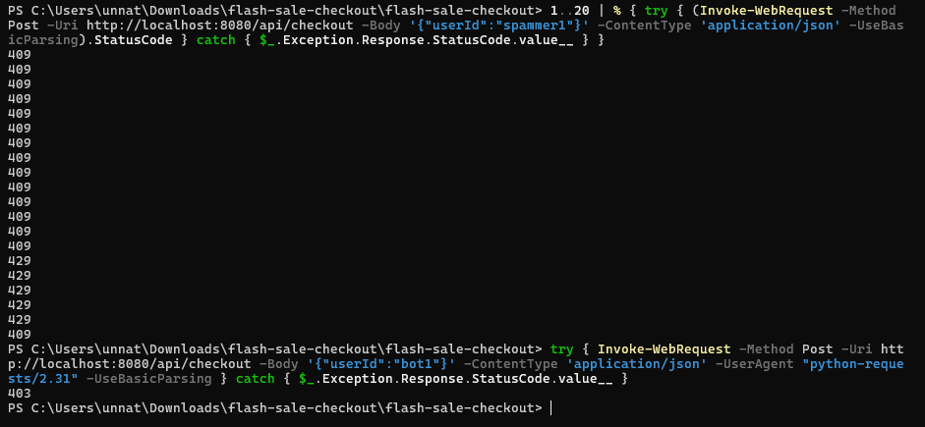
Figure 4. One client sending 20 rapid requests (409 then 429), and a scripted client (403)
What "0% dropped requests" means. I distinguish three outcomes. A request is durably accepted when it receives 202, because its order is already in the Redis outbox. A controlled rejection is a fast, explicit answer such as 409 sold out, 429 slow down or 503 retry. A request is genuinely lost only if it times out, the connection is reset, or it is accepted and then never processed. The target is zero lost requests; controlled rejections are the correct response for 19,500 of 20,000 buyers.
Endpoint | Response
POST /api/checkout with {"userId":"guest-uzftl2y2"} | 202 {"status":"QUEUED","orderId":"ord_3bd4…","trackUrl":"/api/orders/ord_3bd4…"} · 409 sold out · 425 not open · 429 slow down · 503 retry
GET /api/orders/{id} | 200 {"status":"QUEUED"} → "CONFIRMED" (or FAILED_SOLD_OUT)
GET /api/sale and GET /api/events | Sale status, start time, stock left (JSON, or a Server-Sent Events stream)
GET /healthz | Load-balancer health check
Table 5. API

6. Backend Processing Architecture (Phase B)
A fully synchronous design (reserve and write the order inside the request) recreates the hot-row bottleneck. A fully asynchronous design (queue every request without deciding anything) cannot tell the user whether they got a phone. I chose a hybrid: the decision is made synchronously in Redis in about a millisecond, and the slow, durable write happens asynchronously.
202 Accepted means the server accepted the request for processing but has not finished it. In this system, 202 means the phone is reserved and the order is queued; the order becomes confirmed only after the worker commits it to PostgreSQL. The tracking URL lets the client see that transition.

6.1 Queue, relay and workers
Redis and SQS cannot share one transaction. If the API took a token and then sent a message to SQS, a crash between the two would leave a reserved phone with no order. To avoid this, the Lua script writes the order to a Redis outbox stream in the same atomic step as the stock decrement (the transactional outbox pattern). A relay reads the outbox and sends batches to SQS, acknowledging each entry only after SQS accepts it; if the relay crashes, another relay claims the unacknowledged entries after 15 seconds.
Workers receive messages from SQS, save each order in one transaction and delete the message only after the commit. If a worker crashes, SQS makes the message visible again after 30 seconds; after five failed attempts it moves to a dead-letter queue for investigation. SQS delivers at least once, not exactly once, so the worker is idempotent: it checks whether the order ID already exists before writing, and the primary key prevents a second insert.
I chose SQS over RabbitMQ or Kafka because it is fully managed, durable across availability zones, and offers visibility timeouts and dead-letter queues without operating a cluster. RabbitMQ would also work; Kafka is built for high-volume event streams and is more than 500 orders need. Locally, LocalStack provides an SQS-compatible endpoint, and the workers can also read the Redis outbox directly by changing one setting.
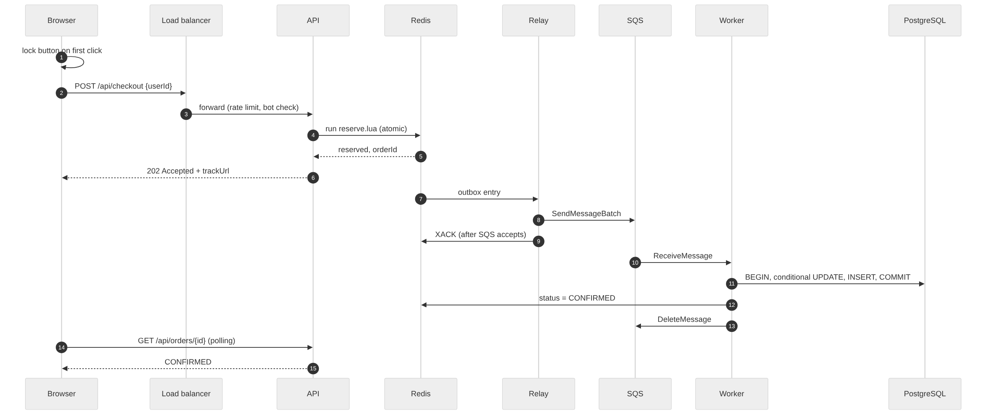
Figure 5. Checkout sequence

7. Inventory Reservation and Concurrency Control
Approach | How it works | Behaviour at 10,000 requests per second
Read, then update (original) | Read stock, compute, write back | Lost updates and overselling (reproduced: 3,000 sold)
Row lock (SELECT … FOR UPDATE) | Lock the row, read, update, commit | Correct, but every request waits for one lock; timeouts
Optimistic version check | Update only if the version is unchanged, otherwise retry | Correct, but nearly every attempt conflicts; retry storm
Conditional update | SET stock = stock - 1 WHERE stock > 0 in one statement | Correct and simple, but still serialised on the hot row
Atomic Redis token (chosen) plus conditional update in the worker | Winners decided in memory atomically; database sees only the winners | Microseconds per decision; 500 uncontended database writes
Table 6. Reservation approaches
Atomic operations alone do not make a design correct. A single Redis DECR is atomic, but on its own it does not stop stock going negative, enforce one phone per customer, or guarantee that every decrement produces an order. Running those as separate commands would recreate a race between them. I therefore placed all of them in one Lua script, which Redis executes to completion before running any other command.
local start = tonumber(redis.call('GET', KEYS[7]) or '0')
if tonumber(ARGV[4]) < start then return {3, tostring(start), 0} end -- sale not open

local existing = redis.call('HGET', KEYS[2], ARGV[1])
if existing then return {2, existing, 0} end -- same user: same order

local stock = tonumber(redis.call('GET', KEYS[1]) or '0')
if stock <= 0 then return {0, '', 0} end -- sold out

local left = redis.call('DECR', KEYS[1]) -- take one phone
redis.call('HSET', KEYS[2], ARGV[1], ARGV[2]) -- remember the buyer
redis.call('HSET', KEYS[3], ARGV[2], 'QUEUED')
redis.call('XADD', KEYS[4], '*', -- outbox entry, same atomic step
'order_id', ARGV[2], 'user_id', ARGV[1], 'product_id', ARGV[3])
return {1, ARGV[2], left}
Listing 2. Reservation script (excerpt from src/reserve.lua, metrics lines omitted)
How Redis and PostgreSQL stay consistent. PostgreSQL is the source of truth. When the API starts, it copies the remaining stock from PostgreSQL into Redis only if Redis has no value (SET … NX), so Redis can always be rebuilt. If Redis ever allowed more reservations than PostgreSQL has stock (for example after losing data), the worker's conditional update affects zero rows and marks the order FAILED_SOLD_OUT rather than overselling. A reconciliation check comparing reserved and confirmed counts would detect any drift.
Assumptions behind "never more than 500". The inventory row starts at 500; orders are created only by the worker transaction; the CHECK (stock >= 0) constraint is in place. Under these assumptions PostgreSQL alone guarantees at most 500 orders, whatever Redis does. Redis makes the common case fast and fair; the database makes the guarantee absolute.

8. Database Design and Transaction Management (Phase C)
CREATE TABLE inventory (
product_id INT PRIMARY KEY,
name TEXT NOT NULL,
stock INT NOT NULL CHECK (stock >= 0) -- stock can never go negative
);
CREATE TABLE orders (
order_id TEXT PRIMARY KEY, -- a redelivered message is saved once
user_id TEXT NOT NULL,
product_id INT NOT NULL REFERENCES inventory(product_id),
status TEXT NOT NULL DEFAULT 'CONFIRMED',
created_at TIMESTAMPTZ NOT NULL DEFAULT now(),
UNIQUE (user_id, product_id) -- one phone per customer
);
Listing 3. Schema (db/init.sql)
Reservations and request deduplication live in Redis (the buyer hash, the status hash and the outbox stream), because they must be decided in microseconds. Confirmed orders live in PostgreSQL. The primary keys and the unique constraint also create the indexes the worker needs: the duplicate check on order_id and the one-per-customer check are index lookups, not table scans. Because the database only receives about 500 writes, no further index tuning is needed on the hot path.
BEGIN;
SELECT 1 FROM orders WHERE order_id = $1; -- already saved? commit and stop
UPDATE inventory SET stock = stock - 1
WHERE product_id = $2 AND stock > 0; -- 0 rows: FAILED_SOLD_OUT
INSERT INTO orders(order_id, user_id, product_id) VALUES ($1, $3, $2)
ON CONFLICT (user_id, product_id) DO NOTHING; -- 0 rows: ROLLBACK (duplicate)
COMMIT; -- then delete the SQS message
Listing 4. Worker transaction (src/worker.js)
ACID in this transaction. Atomicity: the decrement and the insert commit together or not at all. Consistency: the CHECK, UNIQUE and PRIMARY KEY constraints can never be violated. Isolation: under PostgreSQL's default Read Committed level, a concurrent UPDATE on the same row waits for the first to commit and then re-checks stock > 0 against the new value, so two workers cannot both take the last unit. Durability: once committed, the order survives a crash. If anything fails before COMMIT, PostgreSQL rolls back, the SQS message is not deleted, and the order is retried.
Why read-then-write fails. In the original code, two requests both read stock = 1, both compute 0 and both write 0, so two orders exist for one phone. In my test the original endpoint accepted 3,000 orders while the database still showed 474 phones left, because hundreds of updates overwrote each other. The conditional update performs the check and the write in one statement, so this cannot happen.
Which guarantees come from where. PostgreSQL guarantees the stock limit and no duplicate orders. Redis guarantees fast, fair reservation and one active reservation per user. The outbox, relay acknowledgements and SQS retries provide at-least-once delivery between them, and the worker's idempotency check turns that into an exactly-once effect. No single transaction spans Redis, SQS and PostgreSQL.

9. Pessimistic versus Optimistic Concurrency Control
 | Pessimistic locking | Optimistic locking
How it works | Lock the row first (SELECT … FOR UPDATE), then update | Read with a version number; update only if the version has not changed
Advantages | Simple and correct; no retries | No locks held; excellent when conflicts are rare
Disadvantages | Requests queue for the lock; long lock hold times; deadlock risk | Every conflict means a retry; wasted work
Under heavy contention | Throughput collapses to one transaction at a time; timeouts | Almost every attempt conflicts; retry storm
Suitability for a flash sale | Poor on the request path | Poor on the request path
Table 7. Pessimistic and optimistic locking
Both fail for the same reason: they make 100,000 requests fight over one database row. My recommendation is a combination that avoids the fight. A Redis Lua script is safer than SQL "SELECT then UPDATE" at this scale because it has no gap between reading and writing, holds no locks, needs one network round trip instead of several, applies all business rules together, and answers "sold out" in about a millisecond once stock runs out. Behind it, the worker uses a conditional update, which is effectively optimistic control without a retry loop: it either succeeds or reports that stock is gone. Because only about 500 transactions ever reach the row, they do not contend in any meaningful way.

10. End-to-End Checkout Flow
- Click. The button locks and one request is sent. A crash here loses nothing; the user simply retries.
- Validation. NGINX filters bots and rate-limits by IP; the API checks the body size and user ID format. Rejected requests get 400, 403 or 429.
- Reservation. The Lua script checks the start time, the user's existing order and the stock, then decrements, records the buyer and writes the outbox entry atomically. If Redis fails before the script runs, nothing changed and the client receives 503 and retries.
- Durable acceptance. The API replies 202 with the order ID. If the API crashes after the script but before replying, the reservation and outbox entry already exist; the client's retry returns the same order ID.
- Delivery. The relay sends the outbox entry to SQS and acknowledges it only afterwards. If the relay crashes in between, the entry is redelivered; a duplicate message is harmless because of the idempotency check.
- Persistence. A worker commits the conditional update and order insert in one transaction, sets the status to CONFIRMED in Redis and deletes the SQS message. If it crashes before committing, the transaction rolls back and the message reappears after 30 seconds. If it crashes after committing but before deleting, the next attempt finds the order already saved.
- Status. The page polls the tracking URL with backoff and receives live stock updates over Server-Sent Events until it shows Confirmed, Sold out or Failed.

11. Failure Scenarios and Recovery
Failure | Consequence | Detection | Recovery | User impact
Traffic overload | Slower responses | Latency and 429 rates | Rate limits, scheduled scale-up, waiting room | Retries automatically
Redis restart mid-sale | Brief unavailability | 503 count, health check | Append-only file written on every change; stock rebuilt from PostgreSQL if missing | 503, retried (105 such retries in my test)
Database down | Orders not confirmed | Queue depth grows | Orders wait in SQS; workers retry | Reserved, confirmation delayed
Worker crash | Message not deleted | Messages in flight | Reappears after 30 s; idempotent write | Short delay
Relay crash | Outbox entry not delivered | Outbox pending count | Another relay claims it after 15 s | Short delay
Message fails 5 times | Cannot be processed | Dead-letter queue alarm | Manual investigation and replay | Order shows Queued
Duplicate request or message | Possible double order | Duplicate counter | Same order ID from Lua; PRIMARY KEY and UNIQUE | None
Client timeout and retry | Client unsure of result | Repeat requests | Retry returns the same order ID | None
Two buyers, last unit | Race | Not applicable | Lua script serialises; conditional update | One 202, one 409
Redis and PostgreSQL disagree | Reserved but no stock | Reconciliation check | Worker marks FAILED_SOLD_OUT | Told the order failed
Queue itself lost (non-durable local queue) | Accepted orders never processed | Reserved exceeds confirmed | Use durable SQS in production; re-queue orders still QUEUED after a timeout | Order stays Queued
Unpaid reservation (future payment step) | Stock held | Expiry timestamp | Release token after timeout (future work) | Spot released
Table 8. Failures and recovery
The queue-loss row comes from my own testing: restarting LocalStack, which keeps its queue in memory, discarded 500 queued orders. Amazon SQS stores messages redundantly, so this does not apply in production, but it showed why a reconciliation job that re-queues orders stuck in QUEUED is worth adding.

12. Scalability and Performance
The API is stateless, so capacity grows by adding replicas behind the load balancer; flash sales are scheduled, so I would scale up before 8 PM rather than wait for auto scaling to react. Each checkout is one Redis round trip, and a single Redis core runs tens of thousands of these scripts per second. The database receives only about 500 writes regardless of traffic, so its connection pool (20 per API replica, 6 per worker) stays small. Queue capacity is effectively unlimited in SQS, and worker concurrency only affects how quickly confirmations arrive, not correctness.
Target | Measurement | Acceptance criterion | Result
At most 500 orders | k6 + database count | Confirmed ≤ 500 in every run | 500 in every run
No lost requests | k6 http_req_failed | < 0.1% | 0.00%
Response time | k6 95th percentile | < 1 s on one laptop | 736 ms
Throughput | k6 requests per second | 10,000 req/s in production | 1,644 req/s on one laptop (not yet demonstrated at 10,000)
Bundle size | File size | < 200 KB | About 9 KB
Interactive time | Lighthouse / Chrome | < 1.5 s | Largest paint 0.16 s; score 100
Table 9. Performance validation
The laptop result was limited by running 1,000 virtual users, five API replicas, Redis, PostgreSQL, LocalStack and NGINX on one machine. At about 1,600 requests per second with five replicas, reaching 10,000 would need roughly 30 to 40 API event loops on dedicated hardware, with Redis still well within its capacity. This is an estimate and would need to be confirmed with a distributed load test.
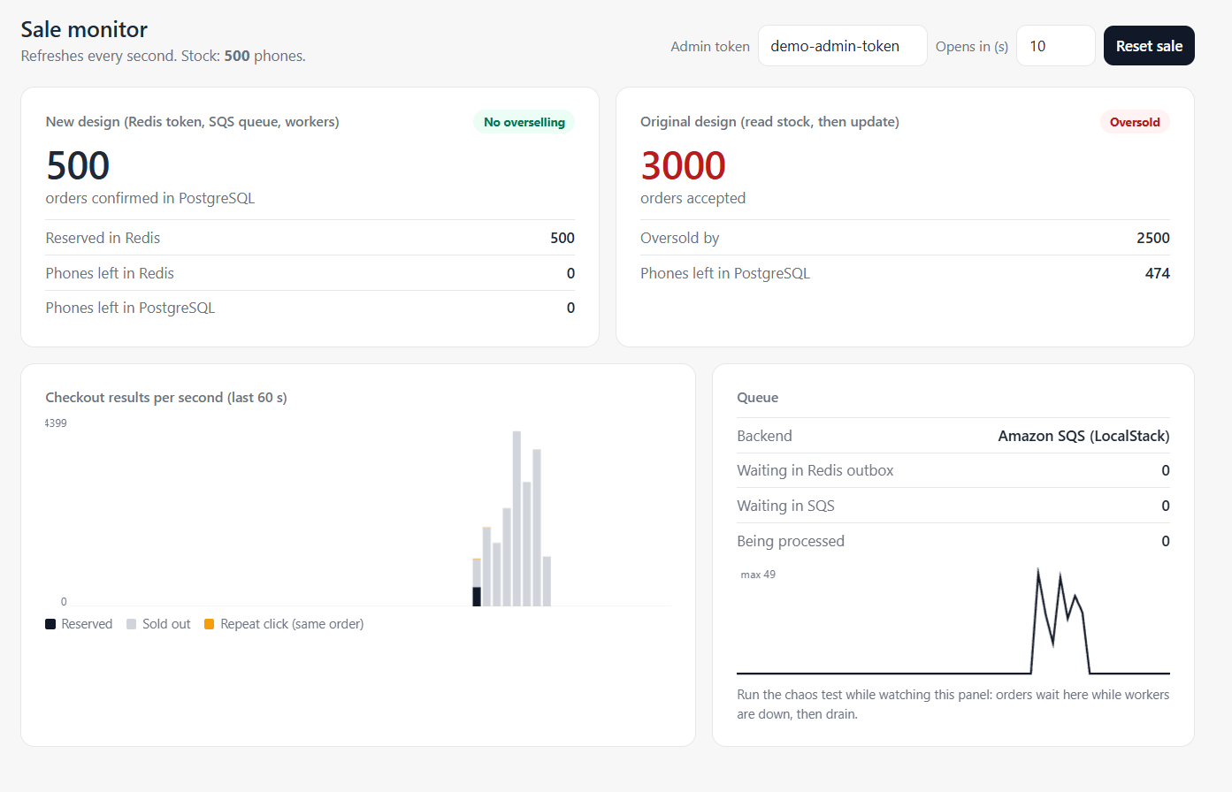
Figure 6. Monitor after both load tests: new design 500, original design 3,000 (oversold by 2,500)
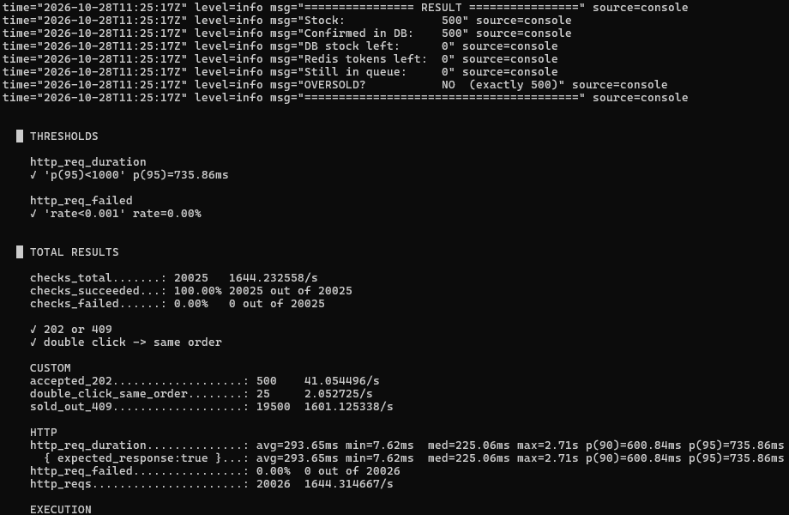
Figure 7. k6 result for the new design: exactly 500, all thresholds passed

13. Testing Strategy
Level | What it checks | How
Unit | Lua outcomes (reserved, duplicate, sold out, not open); input validation | Script run against a test Redis
Integration | API → Redis → relay → SQS → worker → PostgreSQL | Docker Compose stack
API | Status codes and response bodies | curl and PowerShell requests
Concurrency | 20,000 buyers against 500 units | k6: 1,000 virtual users
Duplicates | Same user twice returns the same order | 5% of k6 users click twice
Transactions | Rollback on duplicate; no negative stock | Database constraints and worker paths
Failure injection | Workers killed, Redis restarted mid-sale | k6 chaos script plus Docker commands
Abuse | Rate limit and bot filter | Rapid requests and a scripted User-Agent
Frontend | Size and load speed | File size and Lighthouse
Table 10. Test plan
Acceptance criteria: confirmed orders equal 500 and never exceed it; database stock and Redis tokens both end at 0 with an empty queue; every repeat request from the same user returns the same order ID; failed requests stay below 0.1%. I chose k6 because it scripts realistic concurrent users in JavaScript, reports percentiles, and lets me check the final database state in the same script.
Chaos test. I stopped every worker, started a 40-second rush, restarted Redis while requests were arriving, then restarted the workers. All 500 reservations waited in SQS while no worker was running, 105 requests received "busy, retry" during the Redis restart and succeeded on retry, and once the workers returned the queue drained to exactly 500 confirmed orders.
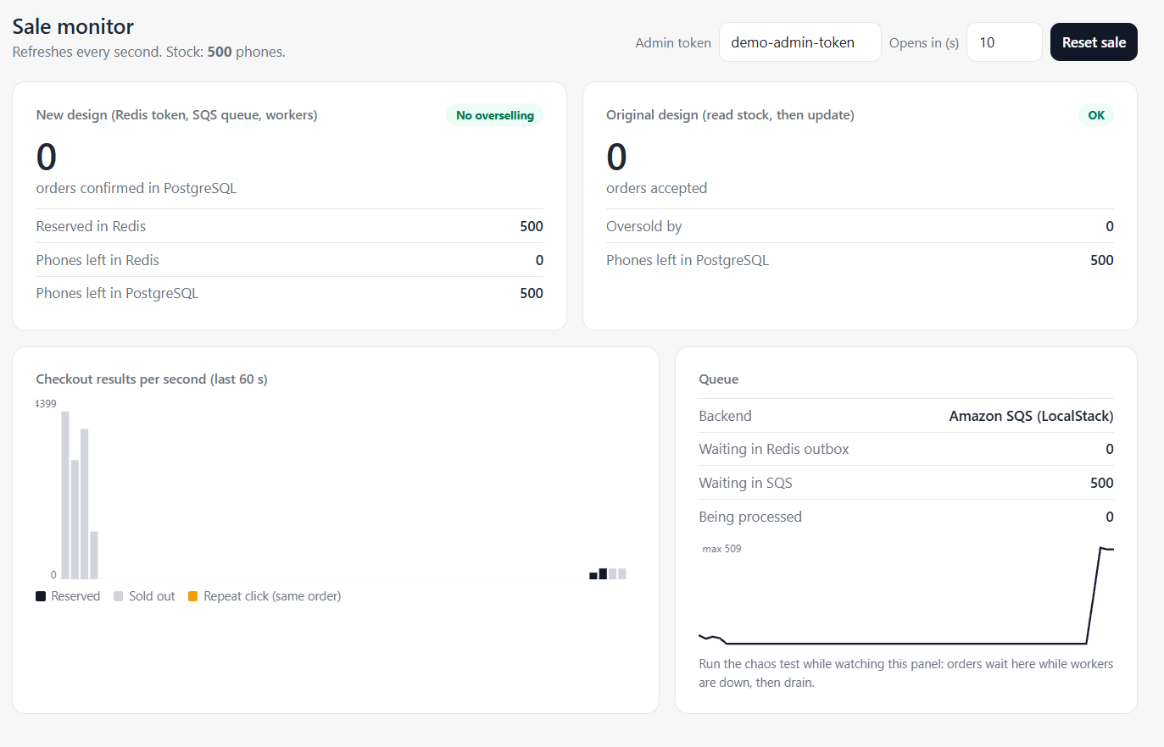
Figure 8. Chaos test: 500 orders waiting in SQS while all workers are stopped
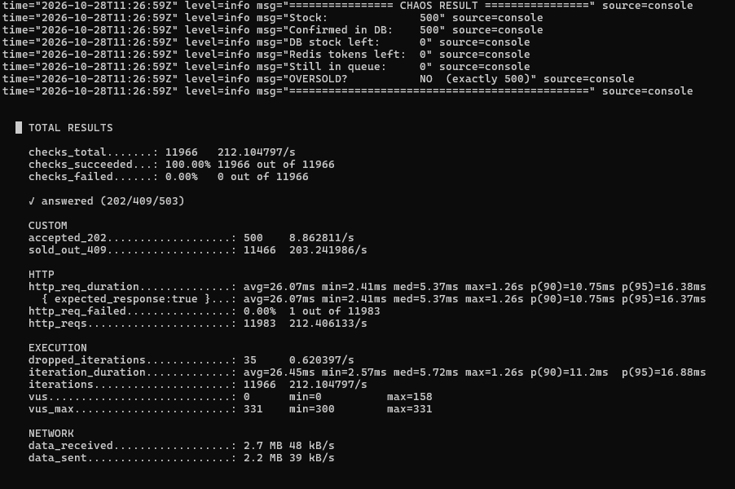
Figure 9. Chaos test result: exactly 500 confirmed, 0% failed

14. Technology Selection and Alternatives
Choice | Purpose and fit | Limitation | Alternatives not chosen
Node.js (Fastify) | I/O-bound API; one event loop per core via node:cluster; every call non-blocking, so thousands of open requests per process | CPU-heavy work would block the loop (none on this path) | Go: equally suitable; Java: heavier for this small service; Python: slower in my measurements
Redis with Lua | Atomic multi-step reservation in memory | Memory-bound; needs persistence and replication | Database-only locking (contention); Memcached (no scripting)
Amazon SQS | Durable, managed queue with visibility timeout and DLQ | At-least-once delivery; small latency | RabbitMQ (cluster to operate); Kafka (oversized)
PostgreSQL | ACID transactions and constraints | One writer for the hot row | MySQL (equally valid); DynamoDB (conditional writes, but weaker relational constraints)
NGINX / AWS ALB | Load balancing, rate limiting, health checks | Per-IP limits can be evaded by distributed bots | Plain DNS round robin (no health checks)
Plain HTML and JavaScript | 9 KB page, nothing to download or parse | Less structure for a large app | React (around 45 KB of framework for one card)
Table 11. Technology choices

15. Monitoring and Observability
Metric | Purpose | Problem it detects
Confirmed orders versus stock | Correctness | Overselling (alert if above 500)
Reserved minus confirmed | Consistency | Stuck or lost orders
Responses per second by status (202, 409, 429, 5xx) | Traffic health | Errors, abuse, sell-out time
95th and 99th percentile latency | User experience | Slow replicas or Redis
Outbox pending, SQS visible and in-flight, DLQ size | Backlog | Slow or crashed workers
Duplicate reservations | Client behaviour | Retry storms, scripted clients
Database connections and transaction time | Database health | Contention or exhaustion
Largest paint and errors from real browsers | Frontend health | CDN or page regressions
Table 12. Metrics
The implementation includes a live monitor page showing confirmed orders, Redis and database stock, queue depth and per-second results (Figures 6 and 8). In production these would feed CloudWatch dashboards and alarms, with structured logs carrying the order ID so one order can be traced from click to commit.

16. Trade-offs and Future Improvements
- Consistency versus availability: if Redis is unavailable, checkout returns 503 rather than guessing. I prefer refusing briefly over risking an oversell.
- Asynchronous confirmation: users see "Reserved, confirming" for under a second instead of an immediate final answer, in exchange for a database that never sees the spike.
- Operational complexity: Redis, a relay, SQS and workers are more moving parts than one database. Each removes a specific failure seen in the trial runs.
- Scaling limit: a single Redis instance and a single inventory row bound the design. For a much larger sale, stock could be split across several Redis keys on different nodes.
Future improvements: a payment step with a ten-minute reservation expiry that returns unpaid phones to stock; a reconciliation job that re-queues orders stuck in QUEUED; AWS WAF Bot Control and an invisible CAPTCHA during the countdown; a virtual waiting room for very large launches; and a distributed load test to confirm 10,000 requests per second.

17. Conclusion
The original system failed because it asked one database row to settle a race between 100,000 requests. My design decides the winners atomically in Redis, replies immediately, and saves the result through a durable queue into a database that enforces the stock limit itself.
- Correctness: no more than 500 orders can be confirmed. This is guaranteed by the PostgreSQL conditional update and CHECK constraint under the assumptions in Section 7, and was confirmed in every load and chaos test.
- Reliability: every 202 response corresponds to an outbox entry that is delivered at least once and saved exactly once, including when workers crash or Redis restarts. This depends on a durable queue in production.
- Performance: the frontend targets were measured and met; zero failed requests and sub-second response times were measured on a laptop; 10,000 requests per second is supported by the design but still has to be demonstrated on production-sized infrastructure.

18. References
[1] Redis: scripting with Lua. https://redis.io/docs/latest/develop/interact/programmability/eval-intro/
[2] Redis Streams. https://redis.io/docs/latest/develop/data-types/streams/
[3] PostgreSQL: transaction isolation. https://www.postgresql.org/docs/current/transaction-iso.html
[4] PostgreSQL: constraints. https://www.postgresql.org/docs/current/ddl-constraints.html
[5] Amazon SQS: visibility timeout. https://docs.aws.amazon.com/AWSSimpleQueueService/latest/SQSDeveloperGuide/sqs-visibility-timeout.html
[6] Amazon SQS: dead-letter queues. https://docs.aws.amazon.com/AWSSimpleQueueService/latest/SQSDeveloperGuide/sqs-dead-letter-queues.html
[7] Transactional outbox pattern. https://microservices.io/patterns/data/transactional-outbox.html
[8] RFC 9110, 202 Accepted. https://www.rfc-editor.org/rfc/rfc9110#name-202-accepted
[9] NGINX rate limiting module. https://nginx.org/en/docs/http/ngx_http_limit_req_module.html
[10] AWS Application Load Balancer. https://docs.aws.amazon.com/elasticloadbalancing/latest/application/introduction.html
[11] Amazon CloudFront. https://docs.aws.amazon.com/AmazonCloudFront/latest/DeveloperGuide/Introduction.html
[12] Node.js cluster module. https://nodejs.org/api/cluster.html
[13] MDN: Server-sent events. https://developer.mozilla.org/en-US/docs/Web/API/Server-sent_events
[14] Grafana k6 documentation. https://grafana.com/docs/k6/latest/
[15] Chrome Lighthouse. https://developer.chrome.com/docs/lighthouse/overview

