**M3R**

**BACHELOR OF TECHNOLOGY**

**IN**

**COMPUTER SCIENCE ENGINEERING - IoT**

SUBMITTED BY

**Arpit Raj (2101331550019) Unnati Mishra (2101331550076)**

**Chhatish Kumar (2101331550024)**

**Avanish Pratap Singh (2101331550021)**

**(GROUP NO: 28)**

Under the Supervision of

**Mr. Mayank Deep Khare**

Head of Department (IoT)



April 2024

**DEPARTMENT OF CSE-IoT**

SCHOOL OF CSE EMERGING TECHNOLOGIES, NIET, GREATER NOIDA

**CERTIFICATE**

This is to certify that the project report entitled **M3R** submitted by **ARPIT RAJ, UNNATI MISHRA, CHHATISH KUMAR** and **AVANISH PRATAP SINGH** to the Department of Computer Engineering, Internet of Things, and NIET as a minor project report for **B.Tech in (Computer Engineering-IoT)** is a *bona fide* record of project work carried out by him/her under my supervision. The contents of this report, in full or in parts, have not been submitted to any other Institution or University for the award of any degree.

Mayank Deep Khare

(HoD-IoT)

Department of Computer Science Engineering (IOT)

Counter signature of HOD with seal

April, 2024

New Delhi

**DECLARATION**

I declare that this project report titled **M3R** submitted as minor project report for B.**Tech in (Computer Engineering-IOT)** is a record of original work carried out by me under the supervision of Supervisor Name, and has not formed the basis for the award of any other degree, in this or any other Institution or University. In keeping with the ethical practice in reporting scientific information, due acknowledgements have been made wherever the findings of others have been cited.

Greater Noida Arpit Raj

May, 2023 Unnati Mishra

Avanish Pratap Singh

**ACKNOWLEDGMENTS**

This project consumed huge amount of work, research and dedication. Its implementation would not have been possible if, i did not have a support of many individuals. Therefore, I would like to extend our sincere gratitude to all of them. First of all, I am thankful to our supervisor **Mr. Mayank Deep Khare** for providing necessary guidance concerning projects implementation.

I place on record, my profound sense of gratitude to **HOD Mayank Deep Khare**, professor & head, department of computer engineering (IOT) to give me an opportunity to enhance my technical skills and valuable suggestions in this project.

I also want to thank to all who directly or indirectly, have lent their helping hand in this project.

Last but not the least, I would like to express my sincere thanks towards volunteer researchers who devoted their time and knowledge in the implementation of this project.

Arpit Raj

Unnati Mishra

Chhatish Kumar

Avanish Pratap Singh

**ABSTRACT**

The M3R is a project that combines the principles of Metering, Monitoring, and Mechanization (3 M’s) to provide an efficient and automated solution for building management. The project utilizes the power of Internet of Things (IoT) and retrofitting techniques to transform traditional buildings into smart, connected structures.

The key components of the system include ESP32 microcontroller, ZMPT101B voltage sensor, SCT013 current sensor, relays, buzzer, LEDs, LCD display, and various other electronic components. These components work together to measure and monitor important parameters such as voltage, current, power, and energy consumption in the building.

The system enables real-time monitoring of energy usage, allowing building owners or facility managers to gain insights into energy consumption patterns and make informed decisions for energy optimization. The data collected from the sensors is transmitted wirelessly to a central control system through the ESP32 microcontroller, which acts as a gateway between the sensors and the internet.

The project also incorporates mechanization aspects by utilizing relays, LEDs, and a buzzer for implementing control actions based on predefined thresholds or user-defined rules. For example, based on the monitored data, the system can automatically switch on or off specific appliances or devices, activate alarms or alerts in case of abnormal conditions, and provide visual indications through LEDs or an LCD display.

The M3R offers several benefits, including improved energy efficiency, reduced costs, enhanced comfort and safety, and increased automation and control over building operations. It provides a scalable and customizable solution that can be adapted to different building types and sizes.

Overall, this project demonstrates the potential of IoT and retrofitting technologies in creating intelligent and efficient building management systems. By combining Metering, Monitoring, and Mechanization, it enables effective energy management, promotes sustainability, and enhances the overall user experience in buildings.

**Keywords –** **IoT, Retrofitting, Building Monitoring, Metering, Monitoring, Mechanization, ESP32, ZMPT101B, SCT013, Relays, Buzzer, LEDs, LCD display, Energy consumption, Real-time Monitoring, Energy optimization, Central Control System, Wireless transmission, Energy efficiency, Cost Reduction, Comfort, Safety, Automation, Control, Scalability, Customization, Sustainability, User experience.**

**TABLE OF CONTENTS**

**CHAPTER 1 ……………………………………………………………………….………..1**

**INTRODUCTION………………………………………………………………….……….1**

**CHAPTER 2 …………………………….………………………………………...……….2**

**Problem Statement …………………………….……………………….……….2**

**CHAPTER 3…………………………….………………………………………...……….3**

**Methodology …………………………….……………………….……….3**

**CHAPTER 4 …………………………….………………………………………...……….6**

**IMPLEMENTATION AND WORKING ….……………………6**

4.1 Literature Survey….…………………………………………………………………6

4.2 Hardware….…………………………………………………………………7

4.3 Software….…………………………………………………………………8

**CHAPTER 5 …………………………….………………………………………...……….10**

**RESULTS ….……………………10**

**CHAPTER 6…………………………….………………………………………...……….12**

**CONCLUSION ….……………………12**

**CHAPTER 7 …………………………….………………………………………...……….13**

**FUTURE SCOPE ….……………………13**

**CHAPTER 8 …………………………….………………………………………...……….15**

**REFERENCES ….……………………15**

**LIST OF FIGURES**

3.1 Smart Energy Monitoring System Circuit.………………………….4

3.2 Wiring in the Circuit…………………………………………………….5

3.3 Prototype of the device………………………………………………….5

**LIST OF TABLES**

4.1 Reference Researches.…………………………………….………………………….6

**CHAPTER - 1**

**INTRODUCTION**

The increasing focus on energy efficiency, cost reduction, and sustainable practices has led to the emergence of IoT-based solutions in various domains. In the context of buildings, monitoring and optimizing energy consumption have become crucial for achieving energy efficiency targets and ensuring occupant comfort and safety. Retrofitting existing buildings with smart technologies offers a viable approach to implement energy-efficient systems without the need for extensive construction or major infrastructure changes.

This project presents an M3R that integrates metering, monitoring, and mechanization to enhance energy management and control in buildings. The primary objective of this project is to create a centralized control system that collects data from different sensors, processes it, and presents it to users in a user-friendly manner. The collected data includes real-time energy consumption, power quality parameters, and other relevant information. By visualizing this data through the LCD display or remotely accessing it through a mobile application, users can monitor their building's energy usage and make informed decisions to optimize energy consumption.

Additionally, the system incorporates mechanisms for automation and mechanization. By using relays, electrical devices such as lighting, HVAC systems, and appliances can be remotely controlled based on predefined rules or user commands. This automation capability enhances convenience, energy efficiency, and comfort for building occupants.

Overall, this M3R offers a comprehensive solution for energy management and control in buildings. By combining Metering, Monitoring, and Mechanization, it empowers users to optimize energy consumption, reduce costs, enhance comfort and safety, and contribute to a sustainable and efficient future.

**CHAPTER - 2**

**Problem Statement**

The current energy management practices in buildings lack real-time monitoring, automation, and optimization capabilities, resulting in inefficient energy consumption, increased costs, and suboptimal occupant comfort. This problem is particularly challenging in existing buildings where implementing energy-efficient systems without major construction or infrastructure changes is difficult. The lack of an efficient and scalable solution for real-time metering, monitoring, and mechanization further increase the issue. Manual utility meter readings, limited data availability, and inadequate automation contribute to inefficient energy consumption and higher expenses.

To address these challenges and optimize energy management in buildings, there is a critical need for an integrated solution. This solution should enable seamless metering, monitoring, and mechanization, leveraging IoT-based technologies. Retrofitting existing buildings with a comprehensive Building Monitoring System that integrates various components, sensors, and remote-control capabilities is essential. Such a solution would facilitate real-time monitoring, automation, and optimization of energy consumption, resulting in improved efficiency, cost savings, and enhanced occupant comfort.

**CHAPTER - 3**

**Methodology**

The methodology of the M3R project involves several key steps and processes. Here is an overview of the methodology:

1. Requirement Analysis: The project begins with a comprehensive analysis of the requirements and objectives. This includes identifying the specific metering, monitoring, and mechanization needs of the building, understanding energy management challenges, and defining the desired outcomes of the project.
2. System Design: Based on the requirements analysis, a system design is created. This involves selecting appropriate hardware components such as ESP32, ZMPT101B, SCT013, relays, LEDs, and LCD display. The design also includes defining the communication protocols, connectivity options, and sensor configurations.
3. Hardware Implementation: The selected hardware components are assembled and integrated according to the system design. This involves connecting sensors, actuators, and other peripherals to the ESP32 microcontroller. Careful attention is given to the wiring, power supply, and physical placement of the hardware components.
4. Software Development: The software part of the project involves developing the firmware for the ESP32 microcontroller. This includes programming the ESP32 to collect data from the sensors, process the data, and control the actuators based on predefined logic and algorithms. The software also includes the integration with the Blynk platform for remote monitoring and control.
5. Testing and Validation: The implemented system is thoroughly tested to ensure its functionality, reliability, and accuracy. This includes validating the sensor readings, verifying the control actions of the actuators, and testing the remote monitoring and control capabilities through the Blynk platform. Any issues or bugs are identified and resolved during this stage.
6. Deployment and Integration: Once the system is tested and validated, it is deployed in the building environment. This involves integrating the system with the existing electrical infrastructure, ensuring proper connections and compatibility. The system is installed and configured to gather real-time data and perform automated control operations.
7. Data Analysis and Optimization: The collected data from the sensors is analyzed to gain insights into energy consumption patterns, identify areas of improvement, and optimize energy management strategies. Data visualization techniques and analytics tools may be used to interpret the data and make informed decisions for energy optimization.
8. Monitoring and Maintenance: The deployed system is continuously monitored to ensure its proper functioning and performance. Regular maintenance activities such as sensor calibration, firmware updates, and hardware inspections are carried out to maintain the system's efficiency and reliability.

Throughout the methodology, considerations for scalability, flexibility, and compatibility with future expansions are taken into account to accommodate future enhancements and developments in the building monitoring system.

By following this methodology, the project ensures a systematic and structured approach to designing, implementing, and deploying the M3R, leading to effective energy management and optimization in buildings.

Fig3.1: Smart Energy Monitoring System Circuit

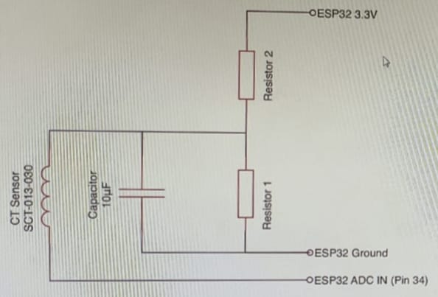

Fig3.2: Wiring in the Circuit

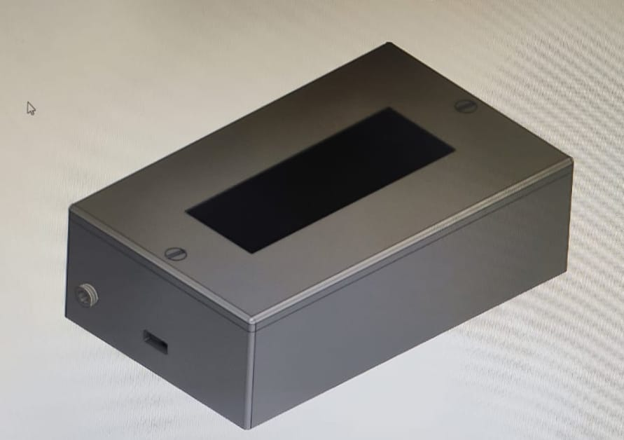Fig3.3: Prototype of the device

**CHAPTER - 4**

**Implementation and Working**

**4.1 Literature Survey**

|  |  |  |  |
| --- | --- | --- | --- |
| **Name** | **Year** | **Publisher** | **Content** |
| Naveed Ul Mustafa et al. | 2017 | A survey on Internet of Things architectures. | It provides a comprehensive review of IoT architectures and their applications in building management systems. It discusses various IoT architecture components, such as sensors, communication protocols, and cloud computing platforms.[1] |
| Arsalan Javed et al. | 2018 | A survey on Internet of Things-based building automation systems. | It focuses on IoT-based building automation systems and their potential to improve energy efficiency, occupant comfort, and safety. It discusses the challenges and opportunities associated with IoT-based building automation, such as security and privacy concerns.[2] |
| Gokulakrishnan Gopalakrishnan et al. | 2018 | A survey on Internet of Things for smart building: Past, present, and future. | *It* reviews the history of smart buildings and their evolution to IoT-based smart buildings. It discusses key components of IoT-based smart buildings, such as sensors, actuators, and communication protocols , highlights challenges and opportunities associated with IoT-based smart buildings.[3] |
| T. H. Nguyen et al. | 2018 | A survey on Internet of Things applications in smart cities. | It provides an overview of IoT applications in smart cities, including building management systems. It discusses the benefits and challenges associated with IoT-based building management systems, such as improved energy efficiency and security concerns.[4] |
| Arijit Roy et al. | 2019 | A survey on Internet of Things-enabled building energy management systems. | It focuses on IoT-enabled building energy management systems and their potential to reduce energy consumption and costs. It discusses the various components of IoT-based energy management systems, such as sensors, data analytics, and control systems.[5] |
| Muhammad Bilal et al. | 2019 | Internet of Things-based smart building: A review of the present and the future. | This survey provides a comprehensive review of IoT-based smart buildings and their potential to improve energy efficiency, occupant comfort, and safety. It discusses the various components of IoT-based smart buildings, such as sensors, actuators, and communication protocols.[6] |
| Yashaswini Anantharamu et al. | 2020 | A survey on Internet of Things-based smart building automation systems. | This survey focuses on IoT-based smart building automation systems and how this will help in betterment of society.[7] |

Table 4.1: Reference Researches

**4.2 Hardware**

1. ESP32: The ESP32 is a powerful microcontroller that serves as the main control unit in the system. It provides Wi-Fi and Bluetooth connectivity, allowing the system to connect to the internet and communicate with other devices.
2. ZMPT101B Voltage Sensor: The ZMPT101B is a voltage sensor used to measure the AC voltage in the building's electrical system. It provides an analog output that can be read by the ESP32 to monitor the voltage levels.
3. SCT013 Current Sensor: The SCT013 is a current sensor that measures the AC current flowing through the electrical circuits. It is a non-invasive sensor that can be clamped around a wire to measure the current. The sensor output is read by the ESP32 to monitor the current consumption.
4. Relays: Relays are used to control electrical devices and appliances in the building. They are connected to the ESP32 and can be switched on or off remotely. The relays enable the automation and remote control of various systems, such as lighting, HVAC, and power outlets.
5. Buzzer: The buzzer is used for audible alerts and notifications. It can be activated by the ESP32 to indicate specific events or alarms, providing feedback to the users.
6. LEDs: LEDs (Light Emitting Diodes) are used as visual indicators in the system. They can be controlled by the ESP32 to display status information, such as power on/off, system status, or alerts.
7. LCD Display: An LCD (Liquid Crystal Display) is used to provide visual feedback and information to the users. It can display various parameters, such as voltage, current, power consumption, and system status, allowing users to monitor the building's energy usage.

These hardware components work together to enable real-time monitoring, automation, and control of the building's energy systems. The ESP32 acts as the central controller, collecting data from sensors, making decisions based on predefined rules or user inputs, and controlling the relays, buzzer, LEDs, and LCD display accordingly. The system facilitates efficient energy management, remote monitoring, and optimization of energy consumption in the building.

**4.3 Software**

The software component of the M3R project plays a crucial role in collecting, analyzing, and managing the data from various hardware components. It enables real-time monitoring, data visualization, automation, and remote-control capabilities.

The software functionalities include:

1. Data Acquisition: The software interacts with the ESP32 microcontroller to collect data from the connected sensors such as the ZMPT101B voltage sensor and SCT013 current sensor. It retrieves the voltage, current, and other relevant measurements at regular intervals.
2. Data Processing and Analysis: The software processes the collected data to calculate power consumption, energy usage, and other derived parameters. It performs data analysis to identify patterns, trends, and anomalies in energy consumption, enabling users to gain insights into their building's energy usage.
3. Real-time Monitoring: The software provides a real-time monitoring interface that displays the current voltage, current, power consumption, and other parameters on a graphical dashboard. Users can visualize the energy usage patterns and monitor the performance of their building's energy systems in real-time.
4. Alarms and Alerts: The software incorporates an alarm and alert system to notify users about critical events or abnormal conditions. For example, it can detect high energy consumption, voltage fluctuations, or system failures and trigger alarms through visual indicators, sound alerts using the buzzer, or notifications on a mobile device.
5. Data Logging and Storage: The software stores the collected data in a database for historical analysis and long-term monitoring. It enables users to access past energy consumption records, generate reports, and identify energy-saving opportunities based on historical trends.
6. Automation and Control: The software allows users to define rules and set automation parameters to optimize energy management. For instance, users can schedule the activation and deactivation of specific devices or appliances using the relays, based on time of day, occupancy, or energy demand.
7. Remote Access and Control: The software enables remote access and control of the building's energy systems. Users can monitor and control the connected devices, such as turning lights on/off, adjusting temperature settings, or managing power outlets, from anywhere using a mobile app or a web interface.

Overall, the software component complements the hardware by providing advanced functionalities for data management, analysis, visualization, automation, and remote control. It empowers users to make informed decisions, optimize energy usage, and improve the overall energy efficiency and comfort of the building.

**CHAPTER - 5**

**Results**

The result of the M3R project is a comprehensive and efficient solution for metering, monitoring, and mechanization in buildings. By implementing this system, several positive outcomes can be achieved:

1. Real-time Energy Monitoring: The project enables real-time monitoring of energy consumption, providing accurate and up-to-date information on voltage, current, power usage, and energy consumption. This empowers users to make informed decisions and take necessary actions to optimize energy usage.
2. Energy Efficiency Optimization: With access to real-time energy data and insights, building owners and operators can identify energy-saving opportunities and implement energy efficiency measures. This can result in reduced energy consumption, lower utility bills, and a smaller carbon footprint.
3. Cost Savings: By optimizing energy usage and implementing energy-efficient practices, the project helps reduce operational costs associated with energy consumption. Building owners can save on electricity expenses and improve their overall financial performance.
4. Enhanced Occupant Comfort: The project's monitoring capabilities enable users to identify comfort-related issues such as temperature fluctuations or inadequate lighting. By addressing these issues, building occupants can enjoy improved comfort and productivity.
5. Remote Control and Automation: The project's software component enables remote control and automation of various building systems. Users can remotely manage devices, adjust settings, and schedule operations, providing convenience and flexibility in building management.
6. Early Detection of Anomalies: The system's alarm and alert functionalities notify users about abnormal conditions such as high energy consumption, voltage fluctuations, or system failures. This enables proactive maintenance and troubleshooting, minimizing downtime and potential damages.
7. Data-driven Decision Making: The project's software provides data logging and storage capabilities, allowing users to access historical energy consumption records and generate reports. This data-driven approach facilitates informed decision-making, energy planning, and performance analysis.

In conclusion, the M3R project delivers tangible results in terms of energy efficiency, cost savings, occupant comfort, and remote management capabilities. It empowers building owners and operators with the tools and insights necessary to optimize energy usage, reduce costs, and enhance the overall performance of the building.

**CHAPTER - 6**

**Conclusions**

In conclusion, the M3R project successfully addresses the challenges faced in energy management practices in buildings. By integrating metering, monitoring, and mechanization capabilities, the project offers a comprehensive solution that enables real-time energy monitoring, optimization, and remote control.

Through the implementation of this system, building owners and operators can achieve significant benefits. These include improved energy efficiency, cost savings, enhanced occupant comfort, and data-driven decision-making. The project empowers users to make informed choices regarding energy consumption, identify energy-saving opportunities, and optimize building systems for optimal performance.

Furthermore, the project highlights the importance of retrofitting existing buildings with smart technologies to overcome the limitations of traditional energy management practices. It demonstrates the potential of IoT and retrofitting solutions in transforming buildings into energy-efficient and sustainable spaces.

Overall, the M3R project contributes to the advancement of energy management practices in buildings and provides a foundation for future research and development in this field. With its successful implementation, it opens doors for further innovation and enhancements in energy efficiency, automation, and remote control capabilities in the built environment.

**CHAPTER - 7**

**Future Scope**

The M3R project offers several potential avenues for future development and expansion.

Some of the key future scopes of this project include:

1. Advanced Data Analytics: The project can be enhanced by implementing advanced data analytics techniques to gain deeper insights into energy consumption patterns, identify trends, and optimize energy management strategies. Machine learning algorithms and predictive analytics can be employed to develop intelligent energy optimization models.
2. Integration with Renewable Energy Sources: The system can be extended to incorporate renewable energy sources such as solar panels or wind turbines. Integration with renewable energy generation systems would enable real-time monitoring of energy production, consumption, and balance, fostering a more sustainable and self-sufficient building environment.
3. Smart Grid Integration: Integration with the smart grid infrastructure can enable bidirectional communication and energy exchange between the building and the utility grid. This integration can facilitate dynamic demand response mechanisms, peak load management, and participation in energy market programs, leading to further energy optimization and cost savings.
4. Energy Demand Forecasting: By incorporating weather data, occupancy patterns, and historical energy consumption data, the system can develop energy demand forecasting models. Accurate demand forecasting can help optimize energy supply, storage, and distribution, ensuring efficient energy utilization and reducing reliance on the grid.
5. User Engagement and Feedback: The project can be expanded to include user engagement features such as energy consumption feedback, personalized energy-saving recommendations, and gamification elements. This would encourage building occupants to actively participate in energy conservation efforts and promote a culture of sustainable behavior.
6. Integration with Building Management Systems (BMS): Integration with existing building management systems can enable seamless control and coordination of various building systems such as HVAC, lighting, and security. This integration would enhance overall building automation and optimization, further improving energy efficiency and occupant comfort.
7. Scalability and Deployment in Smart Cities: The project can be scaled up for deployment in smart city initiatives. By integrating with city-wide infrastructure and data platforms, the system can contribute to the creation of energy-efficient, interconnected urban ecosystems, where buildings actively participate in energy management and grid stability.

These future scopes expand the possibilities for the M3R project, showcasing its potential for ongoing innovation, increased energy efficiency, and sustainable building practices.

**CHAPTER - 8**

**References**

[1] Mustafa, N. U., Javaid, N., Qasim, U., & Alrajeh, N. A. (2017). A survey on Internet of Things architectures. Journal of Communications and Networks, 19(5), 462-480.

[2] Javed, A., Javaid, N., Aslam, S., Qasim, U., & Alrajeh, N. (2018). A survey on Internet of Things-based building automation systems. Journal of Network and Computer Applications, 103, 1-20.

[3] Gopalakrishnan, G., Sundaramoorthy, V., & Krishnamoorthy, K. (2018). A survey on Internet of Things for smart building: Past, present, and future. Journal of Ambient Intelligence and Humanized Computing, 9(1), 141-159.

[4] Nguyen, T. H., Nguyen, H. Q., & Huynh, T. N. (2018). A survey on Internet of Things applications in smart cities. Journal of Computer Science and Cybernetics, 34(2), 95-110.

[5] Roy, A., & Chakrabarti, S. (2019). Internet of Things-enabled building energy management systems: A survey. Sustainable Cities and Society, 49, 101617.

[6] Bilal, M., Nabeel, M., & Al-Fuqaha, A. (2019). Internet of Things-based smart building: A review of the present and the future. IEEE Access, 7, 60730-60743.

[7] Anantharamu, Y., Chaturvedi, A., Mishra, S., & Puthal, D. (2020). A survey on Internet of Things-based smart building automation systems. Journal of Network and Computer Applications, 169, 102735.