**UNNATI MISHRA**

**RA1911033010114**

**EXPERIEMENT 4(LEFT RECURSION):**

**AIM :** ​A program for implementation Of Left Factoring

**ALGORITHM :**

1. Start
2. Ask the user to enter the set of productions
3. Check for common symbols in the given set of productions by comparing with: A->aB1|aB2
4. If found, replace the particular productions with:
5. Display the output
6. Exit

**CODE :**

#include <iostream>

#include <math.h>

#include <vector>

#include <string>

#include <stdlib.h>

using namespace std;

int main()

{

cout<<"\nEnter number of productions: ";

int p;

cin>>p;

vector<string> prodleft(p),prodright(p);

cout<<"\nEnter productions one by one: ";

int i;

for(i=0;i<p;++i) {

cout<<"\nLeft of production "<<i+1<<": ";

cin>>prodleft[i];

cout<<"\nRight of production "<<i+1<<": ";

cin>>prodright[i];

}

int j;

int e=1;

for(i=0;i<p;++i) {

for(j=i+1;j<p;++j) {

if(prodleft[j]==prodleft[i]) {

int k=0;

string com="";

while(k<prodright[i].length()&&k<prodright[j].length()&&prodright[i][k]==prodright[j][k]) { com+=prodright[i][k];

++k;

}

if(k==0)

continue;

char* buffer;

string comleft=prodleft[i];

if(k==prodright[i].length()) {

prodleft[i]+=string(itoa(e,buffer,10));

prodleft[j]+=string(itoa(e,buffer,10));

prodright[i]="^";

prodright[j]=prodright[j].substr(k,prodright[j].length()-k);

}

else if(k==prodright[j].length()) {

prodleft[i]+=string(itoa(e,buffer,10));

prodleft[j]+=string(itoa(e,buffer,10));

prodright[j]="^";

prodright[i]=prodright[i].substr(k,prodright[i].length()-k);

}

else {

prodleft[i]+=string(itoa(e,buffer,10));

prodleft[j]+=string(itoa(e,buffer,10));

prodright[j]=prodright[j].substr(k,prodright[j].length()-k);

prodright[i]=prodright[i].substr(k,prodright[i].length()-k);

}

int l;

for(l=j+1;l<p;++l) {

if(comleft==prodleft[l]&&com==prodright[l].substr(0,fmin(k,prodright[l].length()))) {

prodleft[l]+=string(itoa(e,buffer,10));

prodright[l]=prodright[l].substr(k,prodright[l].length()-k);

}

}

prodleft.push_back(comleft);

prodright.push_back(com+prodleft[i]);

++p;

++e;

}

}

}

cout<<"\n\nNew productions";

for(i=0;i<p;++i) {

cout<<"\n"<<prodleft[i]<<"->"<<prodright[i];

}

return 0; }

OUTPUT:

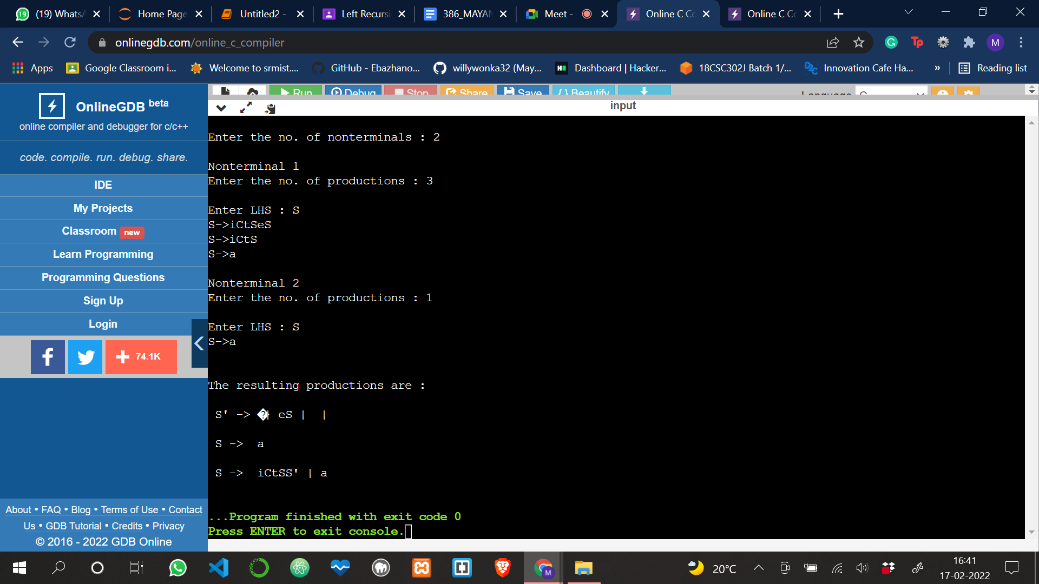

**RESULT :**

​A program for implementation Of Left Factoring was compiled and run successfully