**UNNATI MISHRA**

**RA1911033010114**

**EXPERIMENT 4(LEFT RECURSION)**

**AIM:**​A program for Elimination of Left Recursion.

**ALGORITHM:**

1. Start the program.
2. Initialize the arrays for taking input from the user.
3. Prompt the user to input the no. of non-terminals having left recursion and no. of productions for these non-terminals.
4. Prompt the user to input the production for non-terminals.
5. Eliminate left recursion using the following rules:-
6. After eliminating the left recursion by applying these rules, display the productions without left recursion.
7. Stop.

**PROGRAM:**

#include <iostream>

#include <vector>

#include <string>

using namespace std;

int main()

{

int n;

cout<<"\nEnter number of non terminals: ";

cin>>n;

cout<<"\nEnter non terminals one by one: ";

int i;

vector<string> nonter(n);

vector<int> leftrecr(n,0);

for(i=0;i<n;++i) {

cout<<"\nNon terminal "<<i+1<<" : ";

cin>>nonter[i];

}

vector<vector<string> > prod;

cout<<"\nEnter '^' for null";

for(i=0;i<n;++i) {

cout<<"\nNumber of "<<nonter[i]<<" productions: "; int k;

cin>>k;

int j;

cout<<"\nOne by one enter all "<<nonter[i]<<" productions";

vector<string> temp(k);

for(j=0;j<k;++j) {

cout<<"\nRHS of production "<<j+1<<": ";

string abc;

cin>>abc;

temp[j]=abc;

if(nonter[i].length()<=abc.length()&&nonter[i].compare(abc.substr(0,nonter[i].length()))==0)

leftrecr[i]=1;

}

prod.push_back(temp);

}

for(i=0;i<n;++i) {

cout<<leftrecr[i];

}

for(i=0;i<n;++i) {

if(leftrecr[i]==0)

continue;

int j;

nonter.push_back(nonter[i]+"'");

vector<string> temp;

for(j=0;j<prod[i].size();++j) {

if(nonter[i].length()<=prod[i][j].length()&&nonter[i].compare(prod[i][j].substr(0,nonter[i].length ()))==0) {

string

abc=prod[i][j].substr(nonter[i].length(),prod[i][j].length()-nonter[i].length())+nonter[i]+"'";

temp.push_back(abc);

prod[i].erase(prod[i].begin()+j);

--j;

}

else {

prod[i][j]+=nonter[i]+"'";

}

}

temp.push_back("^");

prod.push_back(temp);

}

cout<<"\n\n";

cout<<"\nNew set of non-terminals: ";

for(i=0;i<nonter.size();++i)

cout<<nonter[i]<<" ";

cout<<"\n\nNew set of productions: ";

for(i=0;i<nonter.size();++i) {

int j;

for(j=0;j<prod[i].size();++j) {

cout<<"\n"<<nonter[i]<<" -> "<<prod[i][j];

}

}

return 0;

}

**OUTPUT:**

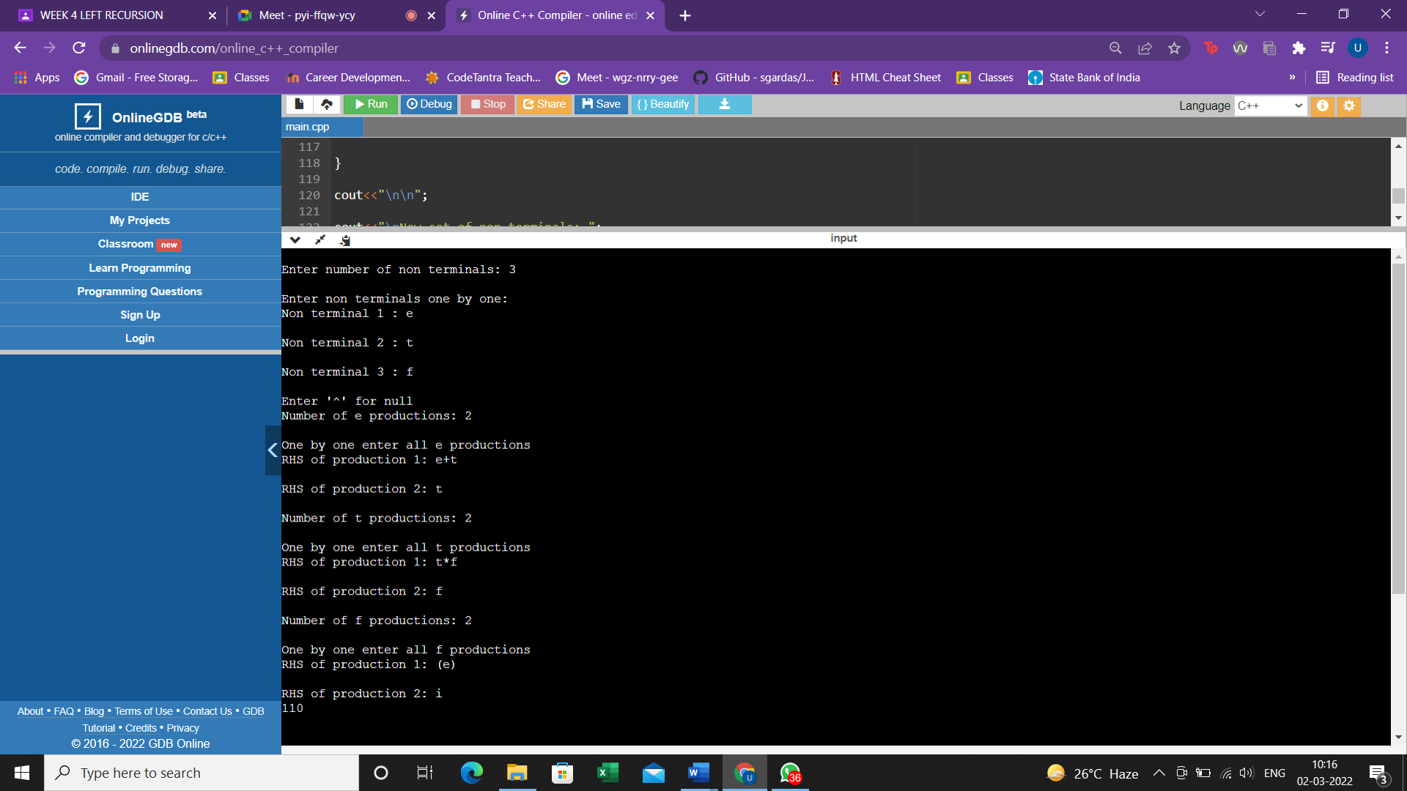

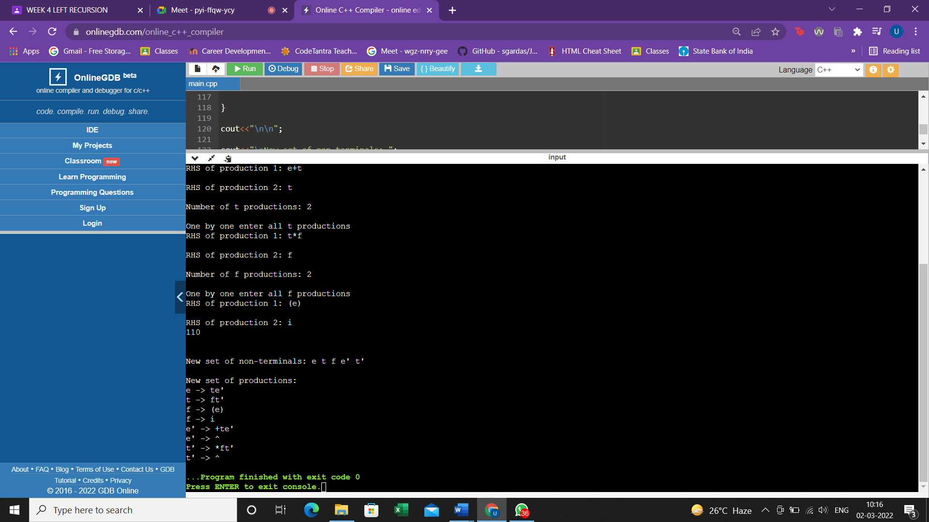

**RESULT:**

A program for Elimination of Left Recursion was run successfully.