Team Tesseract

**The Sustainable Store**

*“A Store towards a green future”*horizontal line

# 

# Introduction:

The Sustainable store is an online platform where the users can earn points by giving out their E-waste to our store officials. The points earned can be used to buy recycled products from our website which is made from e-waste collected from our users.

# Working Principle:

There will be E-waste collection drives from time to time. The user has to give his/her address so that our officials can go and collect the waste from their houses.

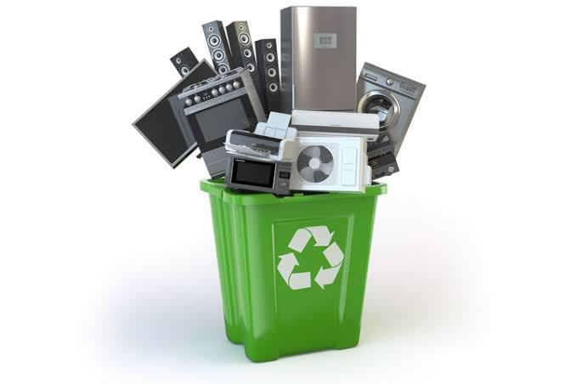

After E-waste collection the users can use the earned points to shop recycled products made from e-waste from our Sustainable store.

# Tools Used:

We have built our website template using an online site builder and worked on its UI so that users are attracted to our website.

We added different features for the user. The user can give their e-waste for collection and buy recycled products made from e-waste.

Link~

<https://6167fe4abd85c.site123.me/>

# Significance of Recycling:

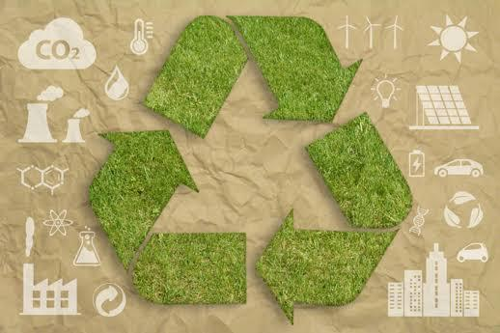

Recycling provides new raw materials and contributes to saving energy. Today the recycling industry provides half of the world's raw materials. Recycled aluminum uses 95% less energy than goods produced from virgin metal.

Our Online store will not only help us manage E-waste but it will also help us fight the climate crisis on a bigger scale. The Sustainable store is a major stepping stone in our fight against the climate crisis. Managing, segregating and recycling our waste will help us achieve a green future.