Introduction
Dairy Delights is a dairy products company involved in the production and sale of a variety of dairy products. The company deals with different products, brands, farm locations, customer locations, and sales channels. The available dataset contains information related to dairy production, product prices, quantities sold, revenue, inventory, and customer locations.
This project focuses on analysing the sales data of Dairy Delights to understand the overall sales performance of the company. The analysis helps in identifying products with higher sales and revenue, understanding customer demand, comparing different sales channels, and analysing inventory levels. By using this data, Dairy Delights can identify important sales trends and make better data-driven business decisions.
Objectives
- To analyse the overall sales performance of Dairy Delights.
- To identify the best-performing dairy products.
- To analyse the quantity of products sold.
- To identify products generating higher revenue.
- To compare sales across different locations.
- To analyse sales through different sales channels.
- To understand customer demand and purchasing patterns.
- To analyse current inventory and stock levels.
- To identify products that may require reordering.
- To support better sales and inventory management decisions.
Dataset Description
The Dairy Delights dataset contains 4,325 records and 23 columns. It provides information about dairy farms, products, sales, revenue, customers, and inventory.

Column Name | Description
Location | Location of the dairy farm
Total Land Area (acres) | Total land area of the farm
Number of Cows | Number of cows present on the farm
Farm Size | Size category of the dairy farm
Date | Date associated with the record
Product ID | Unique identification number of the product
Product Name | Name of the dairy product
Brand | Brand of the dairy product
Quantity (liters/kg) | Quantity of the product
Price per Unit | Price of the product per unit
Total Value | Total value of the product
Quantity Sold (liters/kg) | Quantity of the product sold
Price per Unit (sold) | Selling price per unit
Approx. Total Revenue (INR) | Approximate revenue generated from sales
Customer Location | Location of the customer
Sales Channel | Channel through which the product was sold
Quantity in Stock (liters/kg) | Quantity of product currently available in stock
Minimum Stock Threshold | Minimum stock level to be maintained
Reorder Quantity | Quantity recommended for reordering
Production Date | Date on which the product was produced
Expiration Date | Date on which the product expires
Shelf Life (days) | Number of days the product remains usable
Storage Condition | Recommended storage condition for the product
The dataset can be used to analyse the relationship between production, sales, revenue, and inventory. It provides useful information for identifying high-demand products, understanding sales performance across different locations and channels, and monitoring stock levels.
Overall, the dataset provides a detailed view of the operations and sales activities of Dairy Delights and can be effectively used for sales analysis and business decision-making.
Insights
- Total revenue generated by each product.
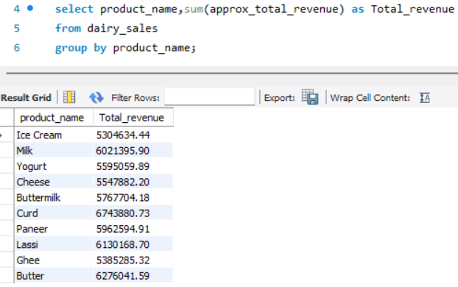

- Give Brand with the highest total revenue
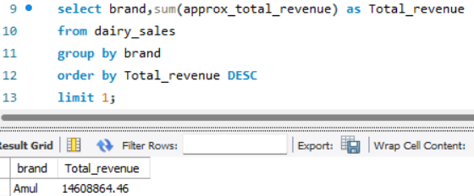

- Give Monthly revenue trend across all products
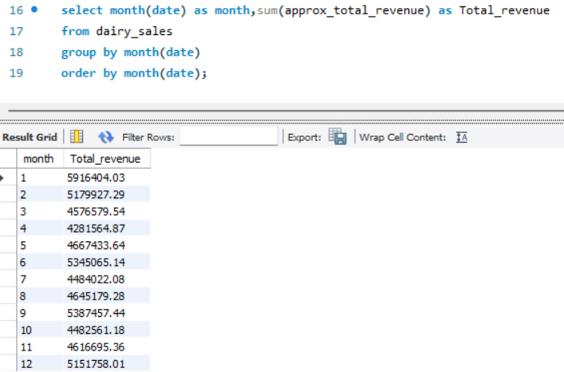

- Products below the minimum stock threshold
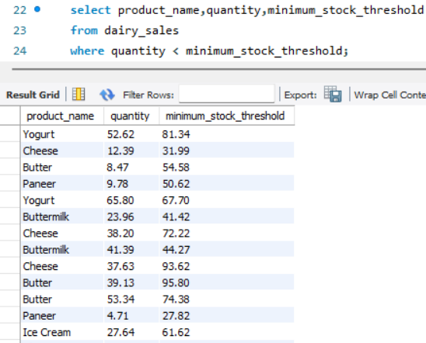

- Total reorder quantity required per product
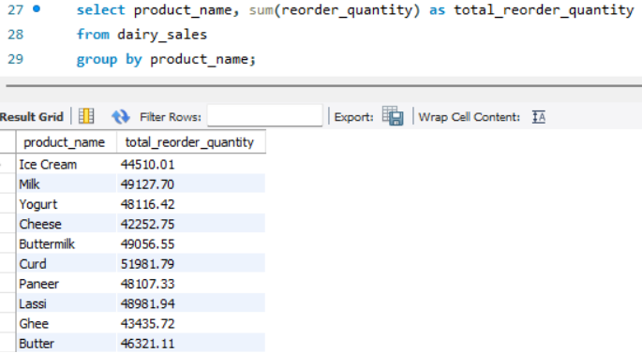
- Which sales channel generates the most revenue
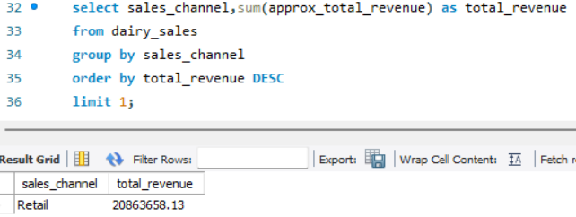
- Top 5 customer locations by purchase volume
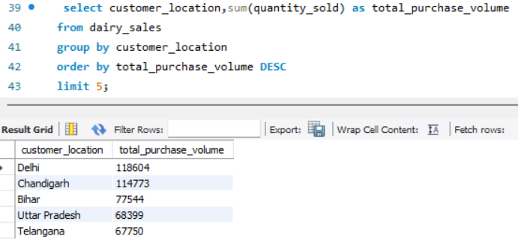

- Average selling price per product
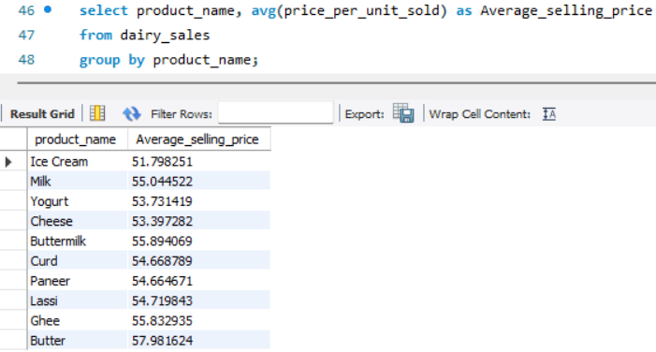
- Compare selling price with listed price
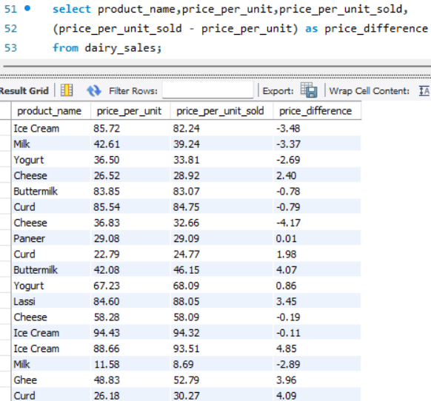

- Products with less than 10 days shelf life remaining
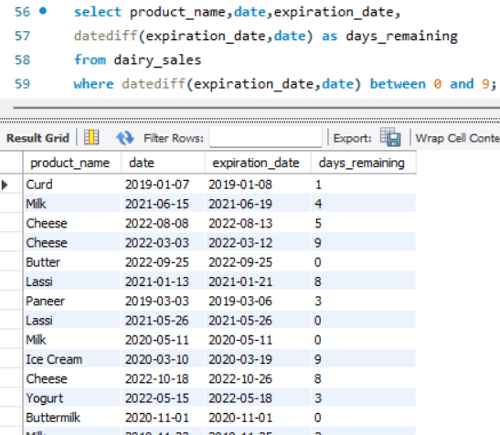
- Average shelf life by product category
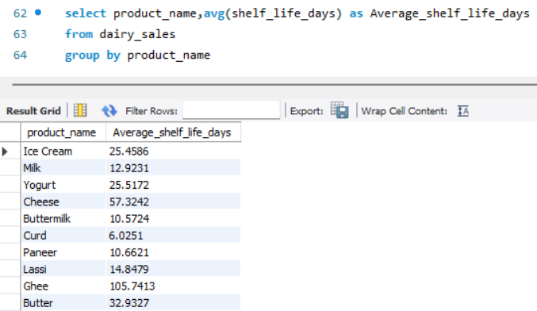

- Average number of cows per farm size category
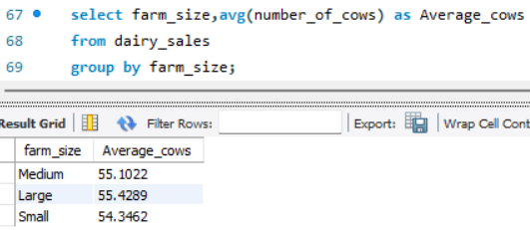
- Location with the largest total land area
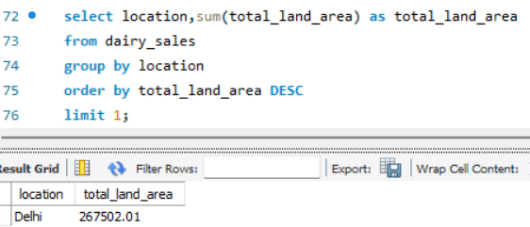
- Top 3 locations by average production quantity
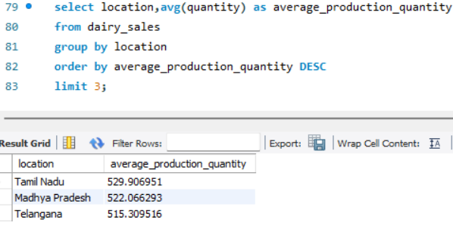

- Calculate profit for each product
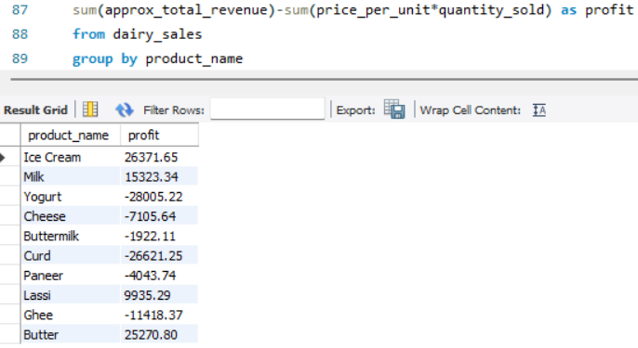
- Most profitable brand overall
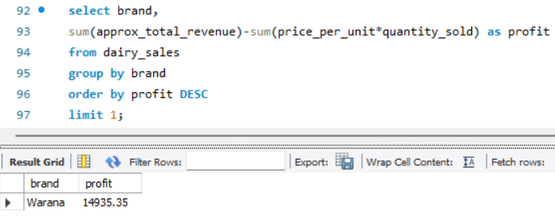
- Yearly revenue growth
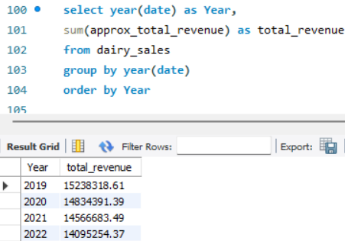

- Best-selling product each year
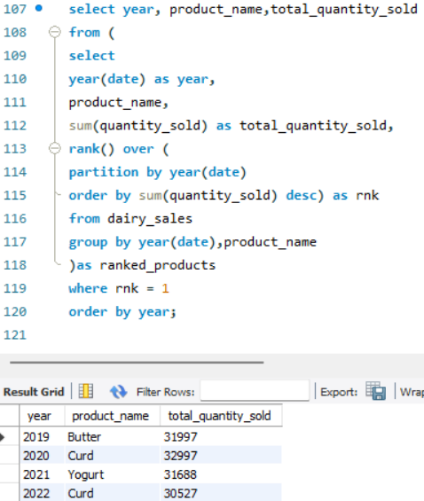

- Products that need immediate restock
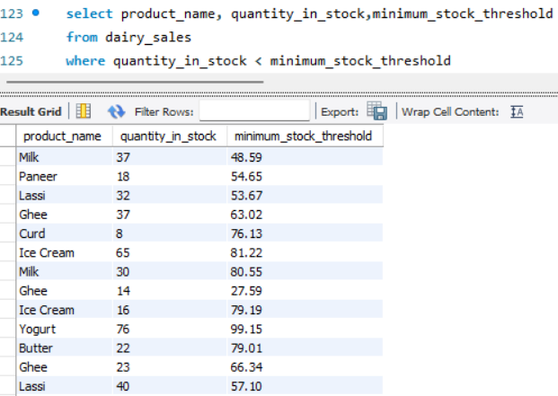

Identify expired products still in stock
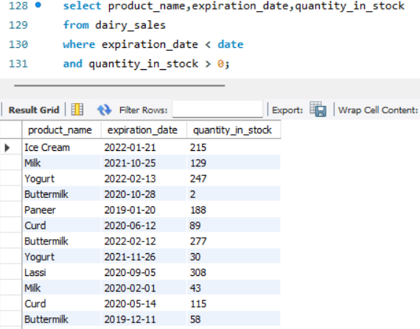

- Average shelf life per brand
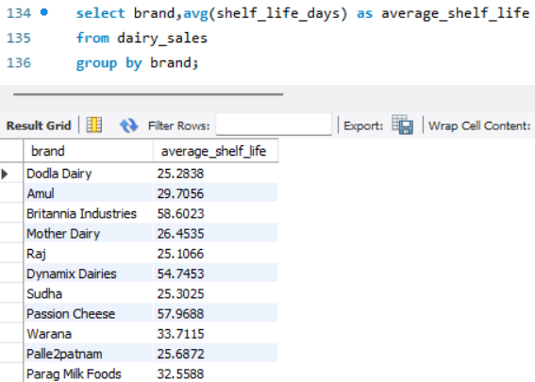

Conclusion
- The product generating the highest total revenue was Curd.
- The brand with the highest total revenue was Amul.
- The sales channel generating the highest revenue was Retail.
- The customer location with the highest purchase volume was Delhi.
- The product with the highest average shelf life was Ghee.
- The location with the largest total land area was Delhi.
- The most profitable brand was Warna.
- The best-selling product in 2019 was Butter, while in 2020 it was Curd.
- The analysis identified 918 products that were below the minimum stock threshold.
- The analysis identified 564 records with less than 10 days of shelf life remaining.

The sales analysis of Dairy Delights provides useful insights into the company's products, sales, revenue, customer locations, and inventory. By analysing the quantity sold and revenue generated, the company can identify its better-performing products and understand product demand.
The analysis of sales channels and customer locations can help Dairy Delights understand where its products perform better. Inventory analysis can also help the company maintain suitable stock levels and avoid shortages.
Overall, the analysis can help Dairy Delights make data-driven decisions, improve sales performance, manage inventory efficiently, and increase overall business growth.

