Lab-06
Write Python code to implement the following. Consider dataset files as “iris.csv” and “diabetes.csv”
1.
Build a KNN classifier to classify IRIS flower dataset. Choose appropriate k value and predict the score ,display confusion matrix and classification report. Use 80% of data for training and 20% for testing. Display accuracy score and confusion matrix of the trained model on test data.
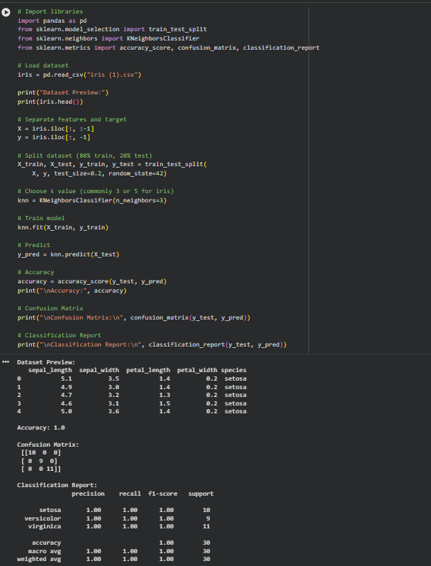

2.
Build a KNN classifier to classify diabetes dataset. Choose k value and perform feature scaling. Use 80% of data for training and 20% for testing.
Display accuracy score and confusion matrix of the trained model on test data.
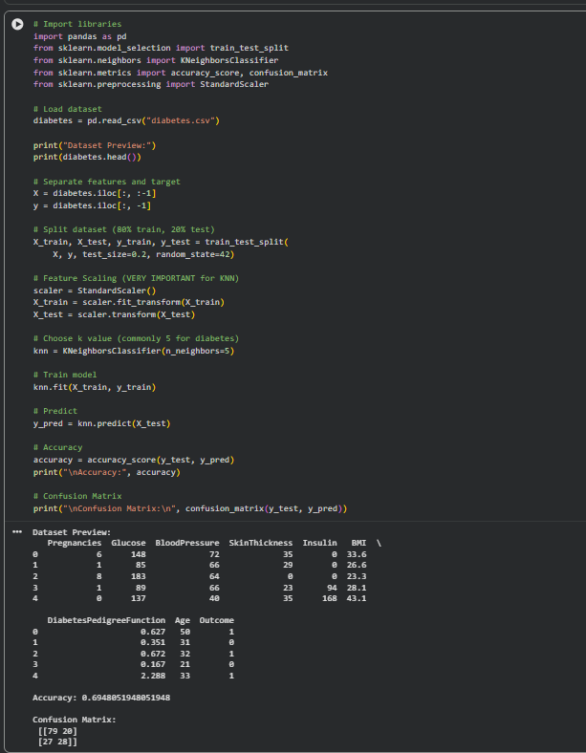

- Using heart.csv dataset and do following
- Classify the target using KNN classifier. You can use different values for k neighbors and need to figure out a value of K that gives you a maximum score.
- Plot confusion matrix
- Plot classification report
