HOUSE PRICE PREDICTION
Executive Summary Report
Task 2 | Machine Learning Internship | InternSpark
Intern Name | Unnati Gupta | Candidate ID | IS-2026-6370
Domain | Machine Learning | Institution | VIT Bhopal University
Mentor | Akash Dubey | Date | May 2026

1. Objective
The objective of this task was to build a Machine Learning regression model capable of accurately predicting house prices based on various features such as location, house age, number of rooms, and population. The California Housing Dataset was used for this task.

2. Dataset Overview
Parameter | Details
Dataset | California Housing Dataset (sklearn built-in)
Total Samples | 20,640 houses
Features | 8 (MedInc, HouseAge, AveRooms, AveBedrms, Population, AveOccup, Latitude, Longitude)
Target Variable | House Price (in $100,000s)
Price Range | $14,999 to $500,001
Missing Values | None

3. Methodology
- Step 1 — Data Loading: Loaded the California Housing Dataset from sklearn and created a structured pandas DataFrame.
- Step 2 — Exploratory Data Analysis: Performed EDA including shape, data types, statistical summary, and missing value analysis.
- Step 3 — Visualization: Created 4 plots — Price Histogram, Scatter Plot (House Age vs Price), Boxplot, and Correlation Heatmap.
- Step 4 — Preprocessing: Split data into 80% training and 20% testing sets. Applied StandardScaler for feature normalization.
- Step 5 — Model Training: Trained a Linear Regression model on the scaled training data.
- Step 6 — Evaluation: Evaluated using R2 Score, MSE, RMSE, MAE, and Actual vs Predicted price plot.

4. Results
Metric | Value
R2 Score | 0.5758 (57.58%)
Mean Squared Error (MSE) | 0.5559
Root Mean Squared Error (RMSE) | 0.7456
Mean Absolute Error (MAE) | 0.5332
Training Samples | 16,512
Testing Samples | 4,128
Key Finding: The Linear Regression model achieved an R2 Score of 0.5758, meaning it explains approximately 57.58% of the variance in house prices. This is a reasonable baseline performance for a linear model on a complex real-world dataset.

5. Tools & Technologies
Tool / Library | Purpose
Python 3 | Programming Language
Pandas / NumPy | Data Loading and Manipulation
Scikit-learn | Model Training, Preprocessing, and Evaluation
Matplotlib / Seaborn | Data Visualization
Joblib | Saving the trained model as .pkl file
Google Colab | Cloud-based Development Environment

6. Deliverables
- Notebook: house_price_prediction.ipynb — Available on Google Colab (link below)
- Model File: house_price_model.pkl — Trained Linear Regression model
- Scaler File: scaler.pkl — Saved StandardScaler for preprocessing
- Screenshots: 5 visualizations saved (histogram, scatter, boxplot, heatmap, actual vs predicted)
- 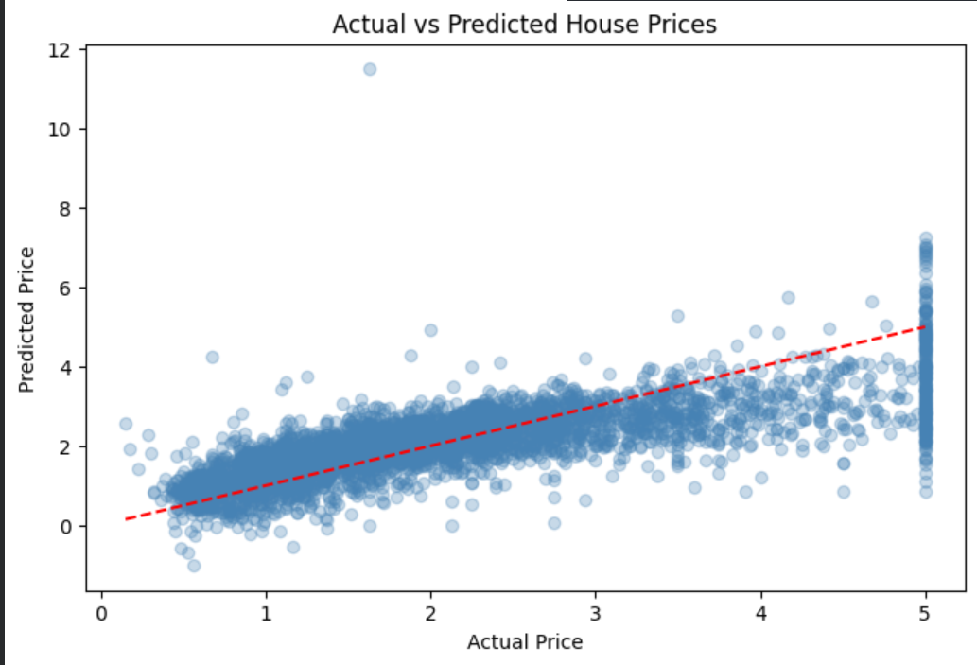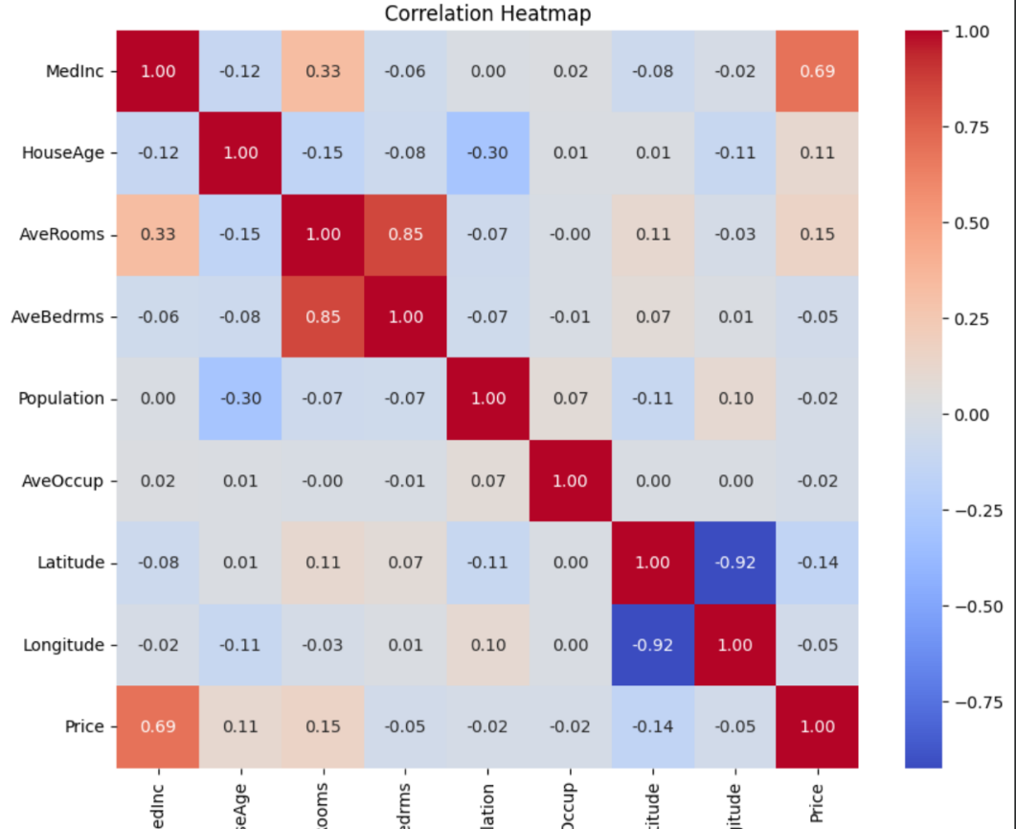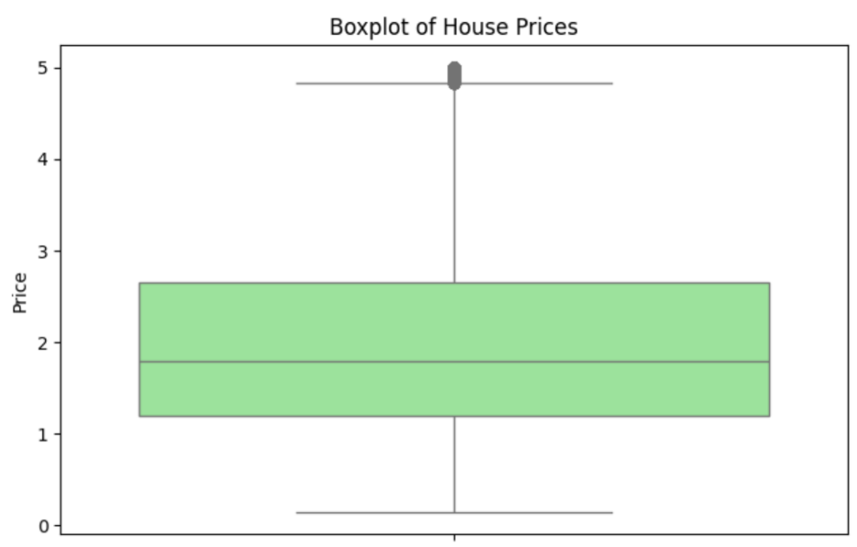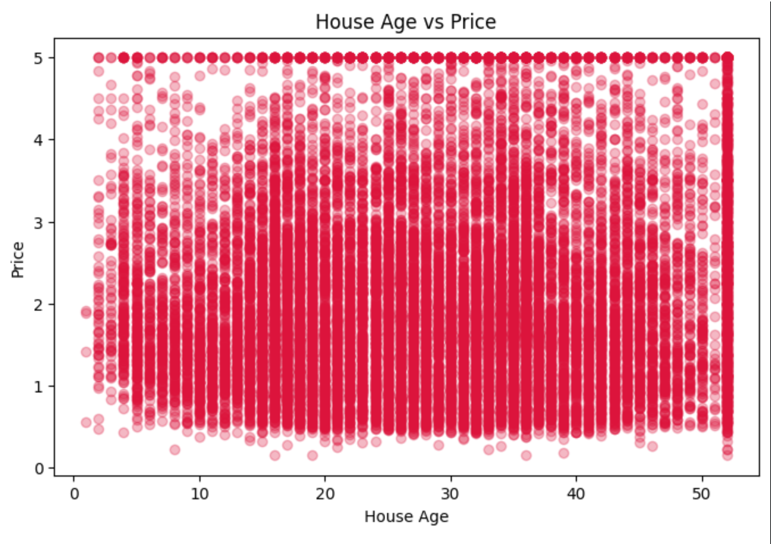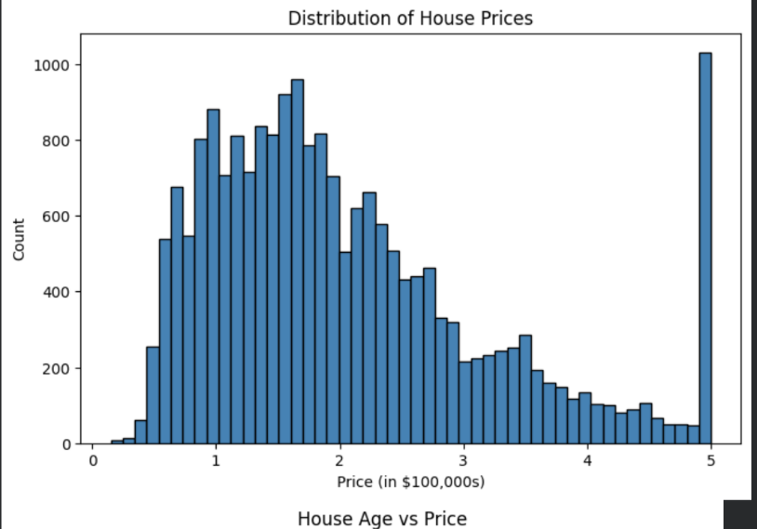
- Report: This executive summary document

7. Submission Links
Resource | Link
Google Colab Notebook | https://colab.research.google.com/drive/1zMJo9xLFsF5U1ECKvV2tfPGtQOIEzLEx?usp=drive_link
GitHub Repository | https://github.com/unnatigpt/-InternSpark-Internship
Model File | house_price_model.pkl (uploaded to GitHub)

