IRIS FLOWER CLASSIFICATION
Executive Summary Report
Task 1 | Machine Learning Internship | InternSpark
Intern Name | Unnati Gupta | Candidate ID | IS-2026-6370
Domain | Machine Learning | Institution | VIT Bhopal University
Mentor | Akash Dubey | Date | May 2026

1. Objective
The objective of this task was to build a Machine Learning classification model capable of accurately identifying the species of an Iris flower based on its physical measurements. The model was trained to classify three species: Iris Setosa, Iris Versicolor, and Iris Virginica.

2. Dataset Overview
Parameter | Details
Dataset | Iris Dataset (sklearn built-in)
Total Samples | 150 flowers
Features | 4 — sepal length, sepal width, petal length, petal width
Target Classes | 3 — Setosa (0), Versicolor (1), Virginica (2)
Class Distribution | 50 samples per class (perfectly balanced)
Missing Values | None

3. Methodology
- Step 1 — Data Loading: Loaded the Iris dataset from sklearn and created a structured pandas DataFrame with clean column names.
- Step 2 — Exploratory Data Analysis: Performed EDA including shape, data types, statistical summary, and missing value analysis.
- Step 3 — Visualization: Created 4 plots — Histogram, Scatter Plot, Boxplot, and Pairplot to understand feature distributions and class separability.
- Step 4 — Preprocessing: Split data into 80% training and 20% testing. Applied StandardScaler for feature normalization.
- Step 5 — Model Training: Trained a Logistic Regression classifier on the scaled training data.
- Step 6 — Evaluation: Evaluated using accuracy score, classification report (precision, recall, F1), and confusion matrix heatmap.

4. Results
Metric | Setosa | Versicolor | Virginica | Overall
Precision | 1.00 | 1.00 | 1.00 | 1.00
Recall | 1.00 | 1.00 | 1.00 | 1.00
F1-Score | 1.00 | 1.00 | 1.00 | 1.00
Support (Samples) | 10 | 9 | 11 | 30
Accuracy | - | - | - | 100% (1.0)
Key Finding: The Logistic Regression model achieved 100% accuracy, correctly classifying all 30 test samples. The Iris dataset is well-structured and linearly separable, making it an ideal dataset for a baseline classification task.

5. Tools & Technologies
Tool / Library | Purpose
Python 3 | Programming Language
Pandas / NumPy | Data Loading and Manipulation
Scikit-learn | Model Training, Preprocessing, and Evaluation
Matplotlib / Seaborn | Data Visualization
Joblib | Saving the trained model as .pkl file
Google Colab | Cloud-based Development Environment

6. Deliverables
- Notebook: iris_classification.ipynb — Available on Google Colab (link below)
- Model File: iris_model.pkl — Trained Logistic Regression model
- Screenshots: 5 visualizations saved (histogram, scatter, boxplot, pairplot, confusion matrix)
- 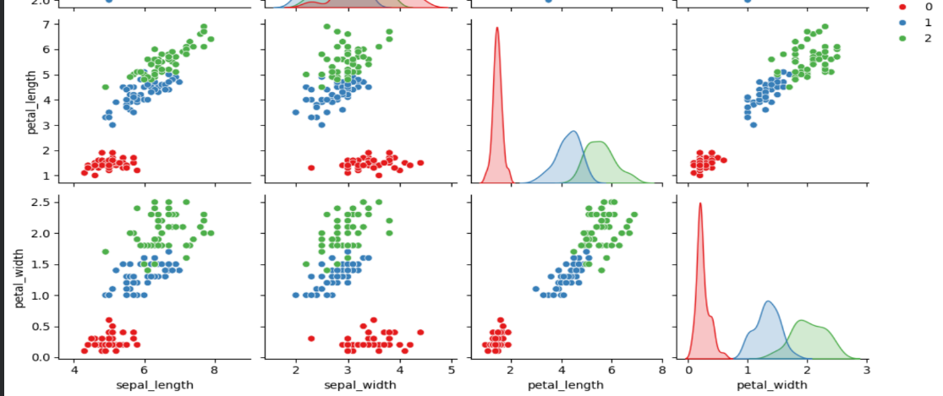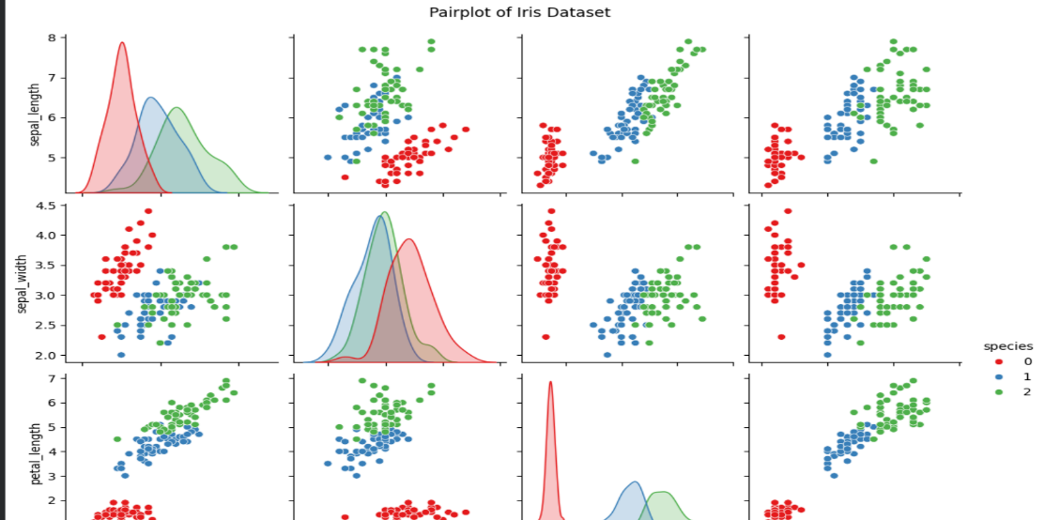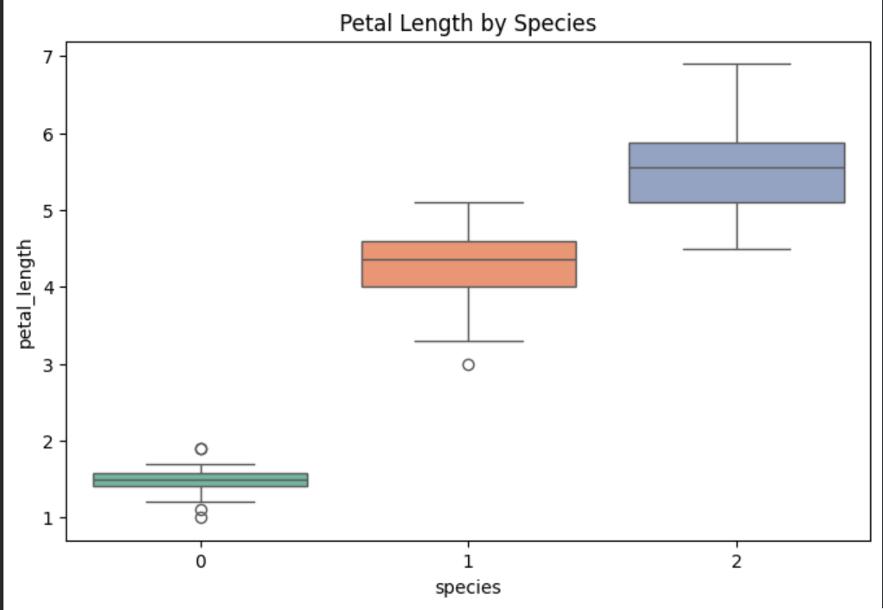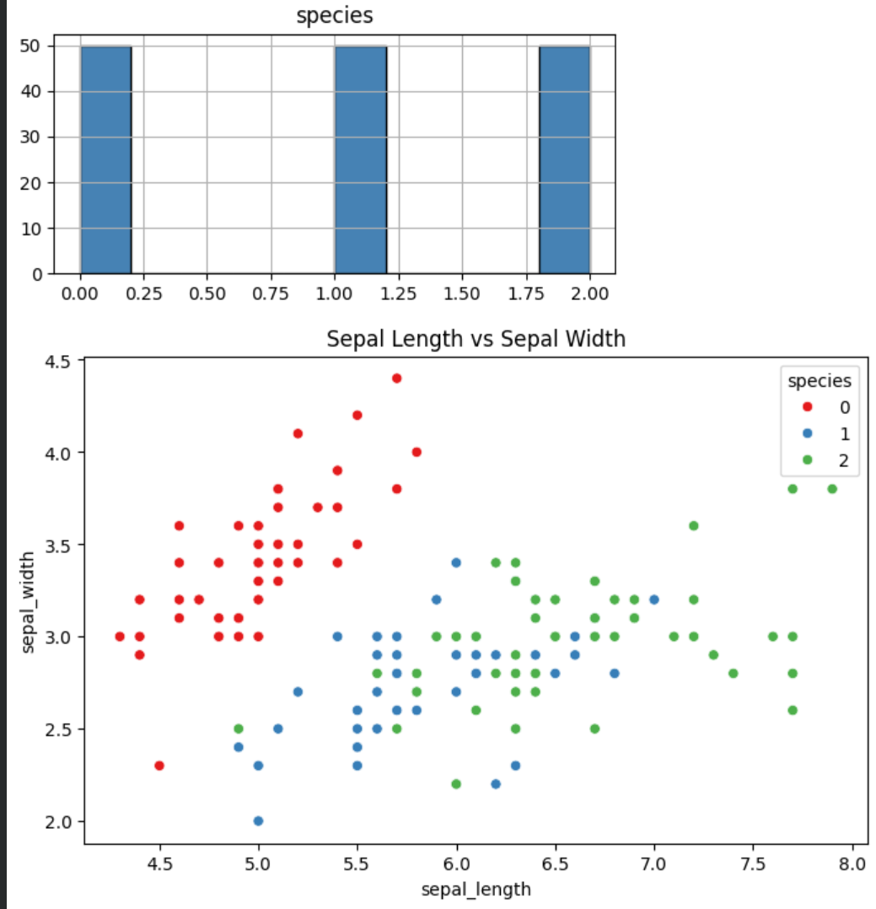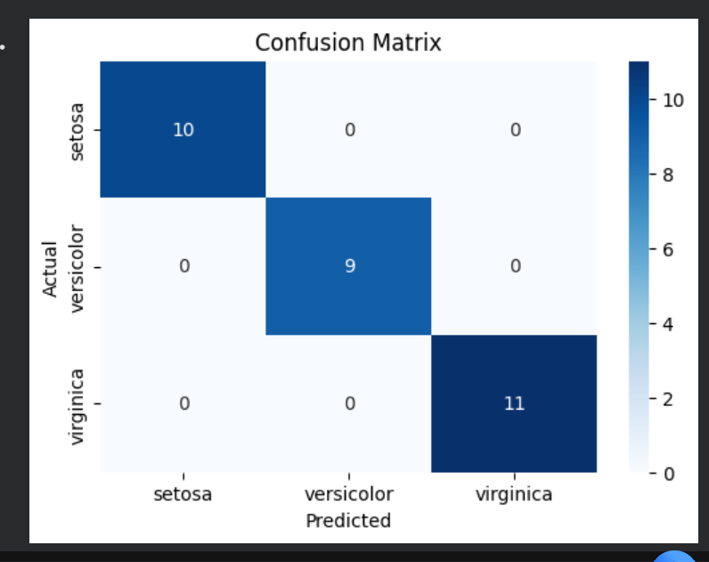
- Report: This executive summary document

7. Submission Links
Resource | Link
Google Colab Notebook | https://colab.research.google.com/drive/1De_hF_VhiWZ-AATMeyH3u2tJWncHqes4?usp=drive_link
GitHub Repository | https://github.com/unnatigpt/-InternSpark-Internship
Model File | iris_model.pkl (uploaded to GitHub)

