TITANIC SURVIVAL PREDICTION
Executive Summary Report
Task 3 | Machine Learning Internship | InternSpark
Intern Name | Unnati Gupta | Candidate ID | IS-2026-6370
Domain | Machine Learning | Institution | VIT Bhopal University
Mentor | Akash Dubey | Date | May 2026

1. Objective
The objective of this task was to build a Machine Learning classification model to predict whether a Titanic passenger survived or not, based on features such as passenger class, gender, age, fare, and embarkation port.

2. Dataset Overview
Parameter | Details
Dataset | Titanic Dataset (datasciencedojo/datasets)
Total Samples | 891 passengers
Features Used | Pclass, Sex, Age, SibSp, Parch, Fare, Embarked
Target Variable | Survived (0 = No, 1 = Yes)
Class Distribution | 549 Not Survived, 342 Survived
Missing Values Handled | Age (mean), Embarked (mode), Fare (mean)

3. Methodology
- Step 1 — Data Loading: Loaded the Titanic dataset from GitHub URL into a pandas DataFrame.
- Step 2 — Exploratory Data Analysis: Performed EDA including shape, data types, statistical summary, and missing value analysis.
- Step 3 — Data Cleaning: Filled missing Age with mean, Embarked with mode, and Fare with mean.
- Step 4 — Visualization: Created 4 plots — Survival Count, Survival by Gender, Age Histogram, and Survival by Class.
- Step 5 — Preprocessing: Encoded Sex and Embarked columns. Dropped PassengerId, Name, Ticket, Cabin. Split 80/20 train/test. Applied StandardScaler.
- Step 6 — Model Training: Trained a Logistic Regression model with liblinear solver.
- Step 7 — Evaluation: Evaluated using accuracy score, classification report, and confusion matrix heatmap.

4. Results
Metric | Not Survived (0) | Survived (1)
Precision | 0.82 | 0.76
Recall | 0.84 | 0.74
F1-Score | 0.83 | 0.75
Support | 106 | 73
Overall Accuracy: 80% (0.7989) — The Logistic Regression model correctly predicted survival for 8 out of every 10 passengers in the test set.

5. Tools & Technologies
Tool / Library | Purpose
Python 3 | Programming Language
Pandas / NumPy | Data Loading and Manipulation
Scikit-learn | Model Training, Preprocessing, and Evaluation
Matplotlib / Seaborn | Data Visualization
Joblib | Saving the trained model as .pkl file
Google Colab | Cloud-based Development Environment

6. Deliverables
- Notebook: titanic_survival_prediction.ipynb — Available on Google Colab (link below)
- Model File: titanic_model.pkl — Trained Logistic Regression model
- Scaler File: titanic_scaler.pkl — Saved StandardScaler for preprocessing
- Screenshots: 5 visualizations saved in screenshots folder
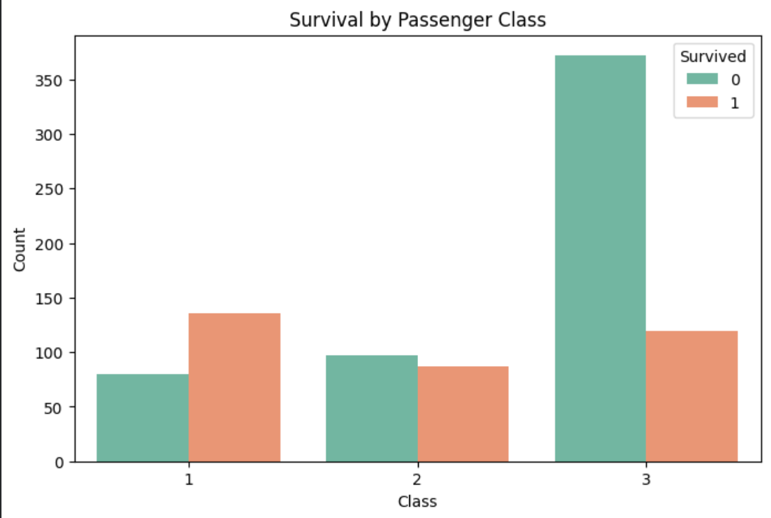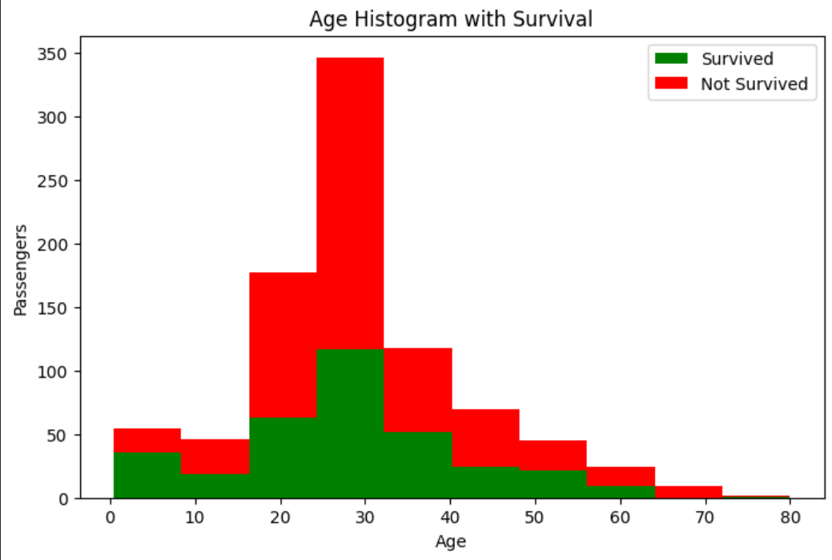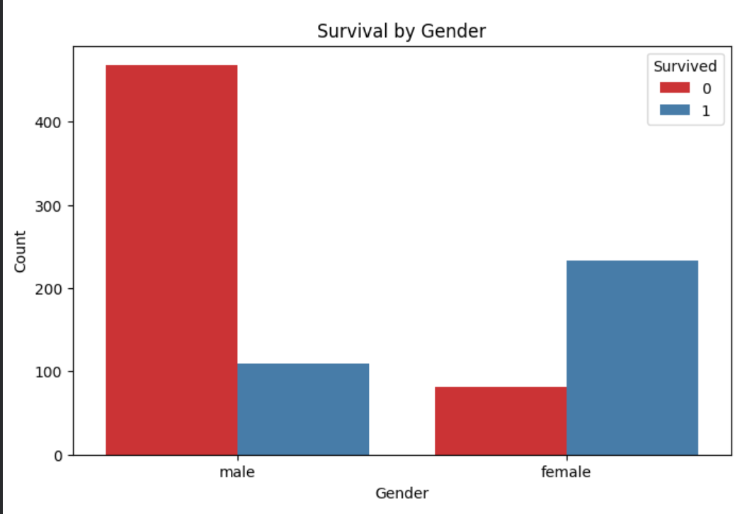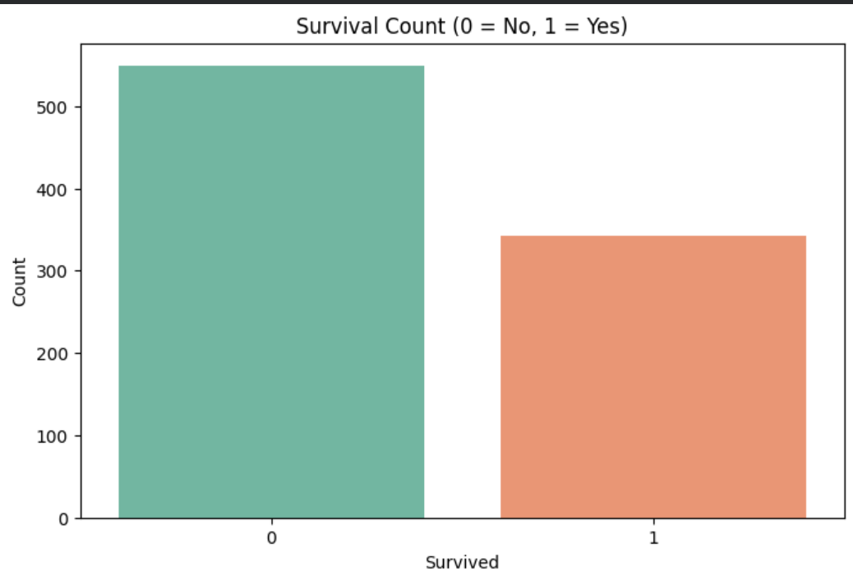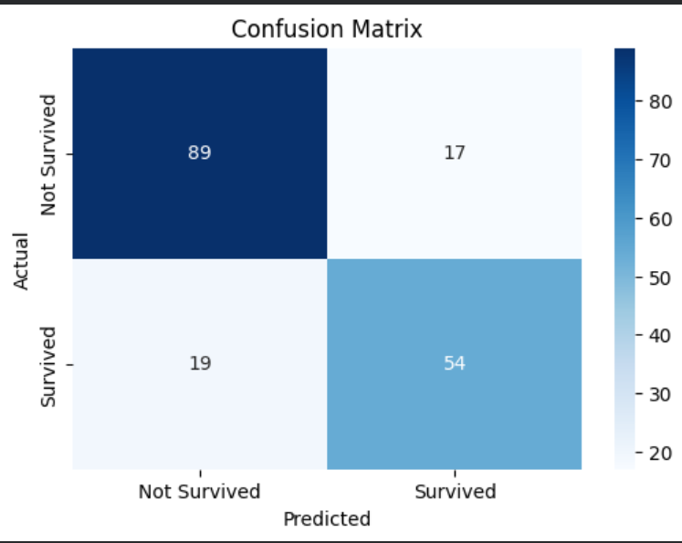
- Report: This executive summary document

7. Submission Links
Resource | Link
Google Colab Notebook | https://colab.research.google.com/drive/1ZBi8TWCVCPqVT8ww_q_bxl2y60vo24Ox?usp=drive_link
GitHub Repository | https://github.com/unnatigpt/-InternSpark-Internship
Model File | titanic_model.pkl (uploaded to GitHub)

