**About the Visualization:**

**Introduction:** Welcome to the *interactive slideshow visualization* on the Carbon Footprint of the world. Attempted to visualize the Carbon footprint of 123 countries with the data from the period 2000-2018.

**URL of the visualization:** Hosted from GitHub pages, the URL of the visualization is:

<https://unnatihasija1.github.io/>.

**Messaging:**

Global Greenhouse gas emissions are had hit all-time in 2019. A growing number of companies assess and address the potential threats and opportunities of climate change for their business. They measure the greenhouse gas (GHG) emissions generated by their activity and assess their exposure to physical climate change impacts as well as changing market conditions and consumer preferences as a consequence of climate change. In this project, I’ve attempted to visualize the relationship between Total Greenhouse Gas (GHG) emissions with population, different sources that contribute to the total greenhouse gas emissions, and how the total greenhouse gases have changed in the last 20 years. This can help companies to take meaningful decisions on how to control the emissions of GHG.

**Visual Structure:**

This visualization of Carbon Footprint is composed of three scenes.

The entry point to the visualization shows the relationship between Total GHG and Population. As the carbon footprint is the total amount of greenhouse gases (including carbon dioxide and methane) that are generated by our actions, the increase in the population of different countries and in turn the world is increasing the total GHG.

Scene 1:

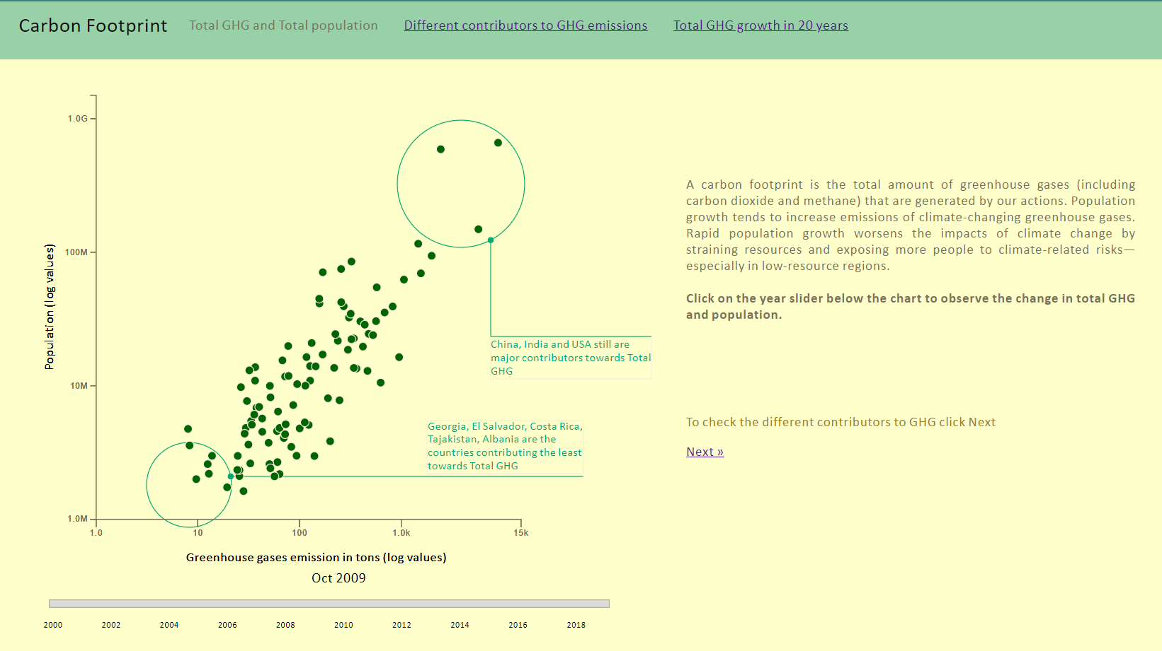

**Structure:** This is depicted as a scatterplot, with X axis as Total GHG and Y axis as population.

Both X and Y scale are taken in logarithmic scale where X starts from 1 and Y starts from 1M . Countries with populations less than 3,000,000 are filtered out since they have very little value for the total GHG

**Highlight**: Using Callout annotations, the most and the least GHG emitting countries are highlighted.

As you hover on the circles on the scatterplot, the circle enlarges to almost double the size and highlights the information on GHG, population, GDP.

**Transition:** One can transition to the next slide either from top or using the next button on the right part of the screen.

The next scene shows the contributing gases to total GHG like CO2 produced by the burning of Coal, Oil, and Gas; Methane, and Nitrous Oxide. Though for every country, the contributing factor is different, and over the last 20 years, that factor may or may not have changed.

Scene 2:

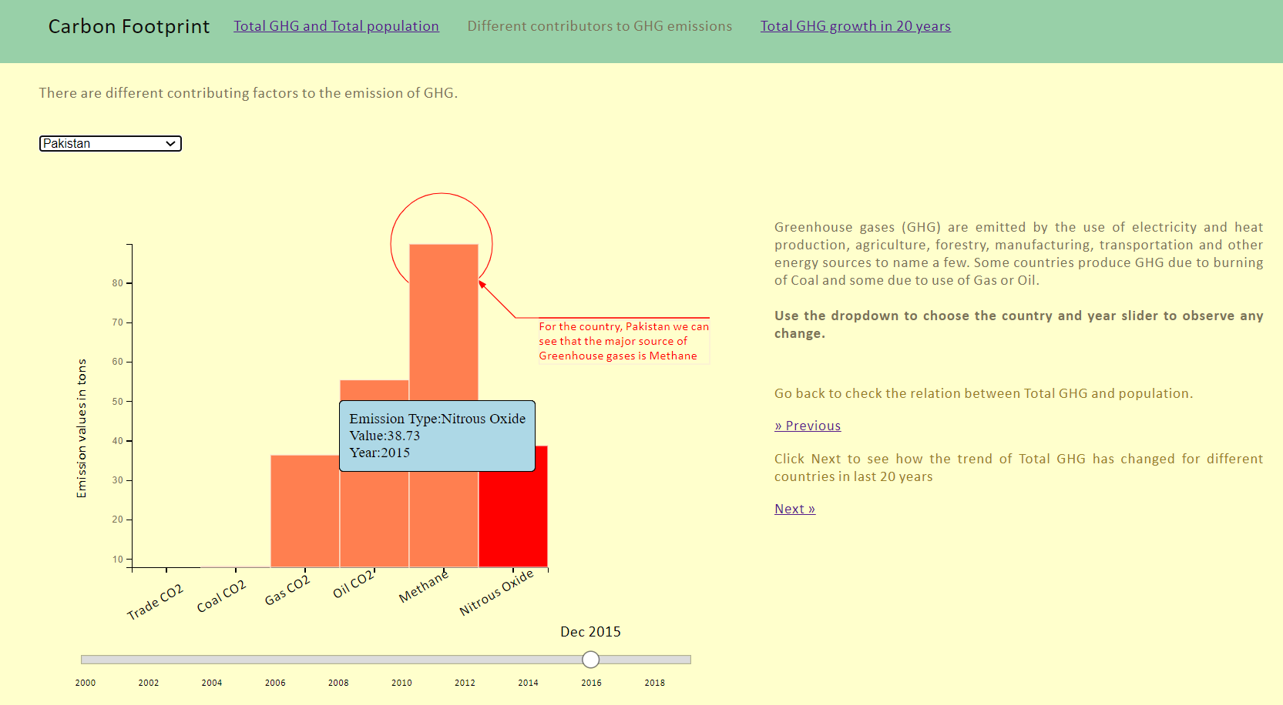

**Structure:** This graph is plotted as a bar chart. Different bar charts starting from the same 0th mark which helps in understanding that one bar is greater than the other.

**Highlight:** For a country, what’s the major contributing factor is highlighted.

As you hover on any of the bar charts, you see what type of emission and the exact value represented by that bar. It changes the color to red to distinguish the selected bar.

**Transition:** One can transition from this slide to the previous or next using the ‘Previous’, ‘Next’ buttons available on the right or from the navigation bar above.

The last scene gives an idea about the trend or change in Total GHG over the last 20 years.

Scene 3:

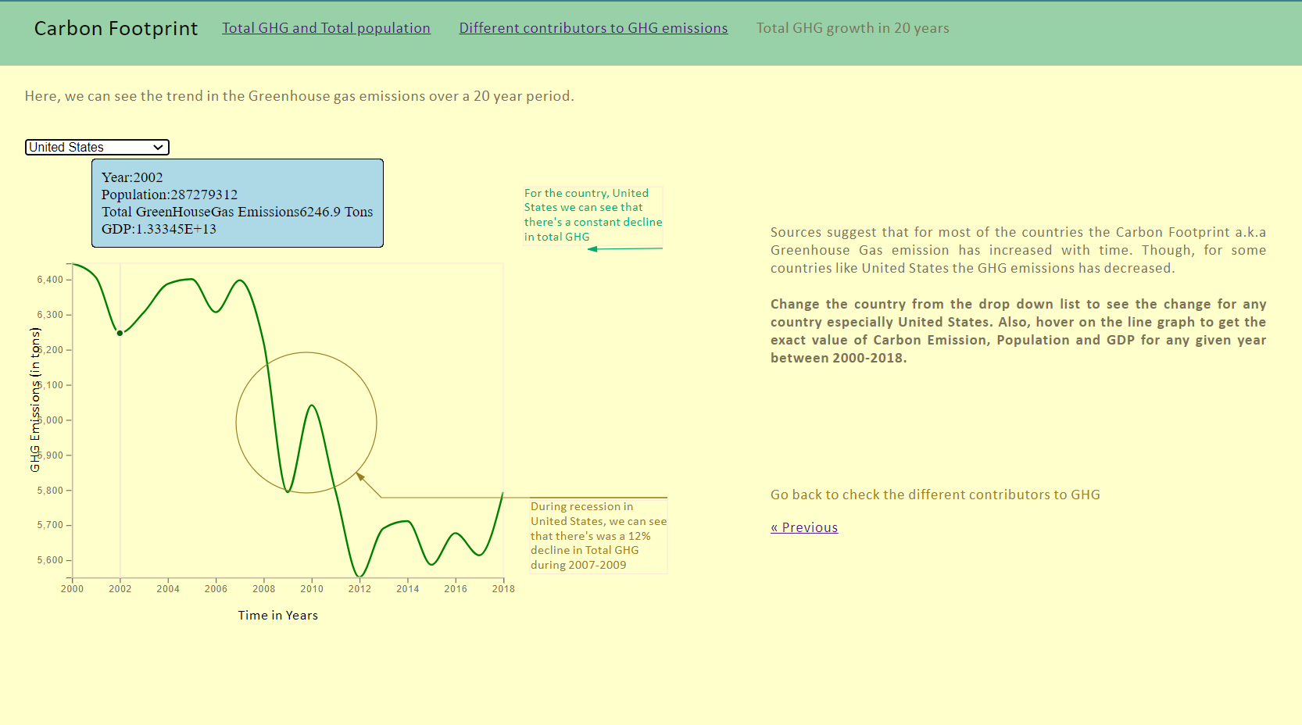

**Structure:** Since, this graph involves time line, this is plotted as a line graph.

**Highlight:** For a given country, highlights are added to show whether there was an increase or a decline in total GHG and if there’s any specific reason to the same: for example: country US, recession from 2007-2010 shows decline in GHG emissions

One can click anywhere on the line and the tooltip shows for the nearest year, the value of Population, Total GHG and GDP.

**Transition:** One can transition from this slide to previous one: bar chart using the previous button and any slide using the navigation bar on the top.

**Narrative Structure:**

**Scenes:** Created three different visualizations:

**Scene 1:** Shows scatter plot representing the relationship total greenhouse gases and population. We can see that the countries that maximum population like India and China are seen on the right top of the scatter plot indicating a high correlation between the two.

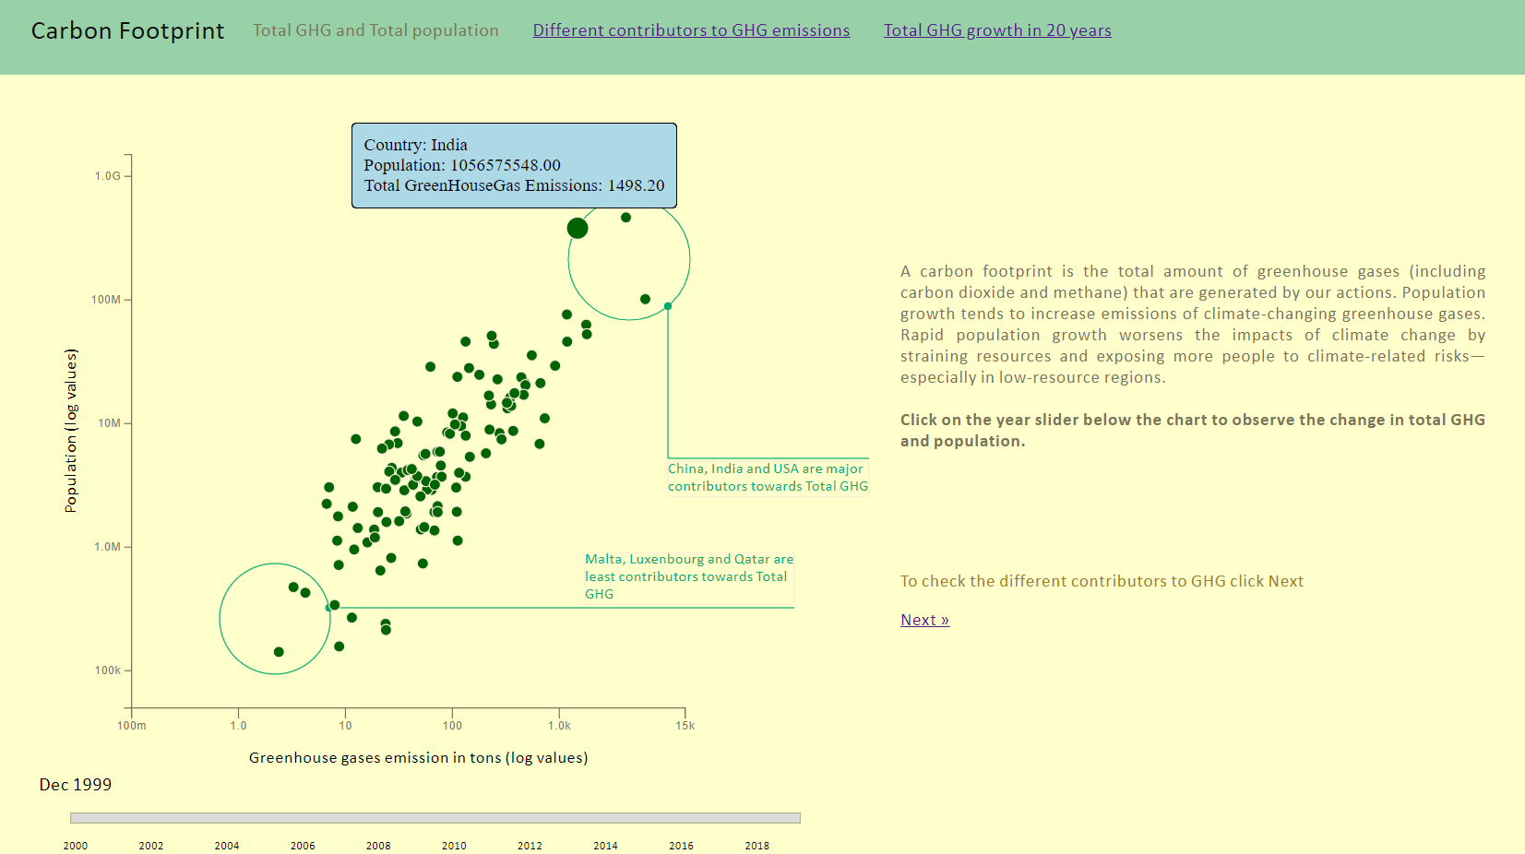

The slider is set to January 2000 and during this time we can see that India, China, United States are the top contributors towards total GHG, whereas small countries like Malta, Gambia and Mauritius are contributing the least. Also, interesting to observe here, that countries like Luxembourg and Qatar, though they have lesser population than Gambia and Mauritius, they are contributing more towards total GHG.

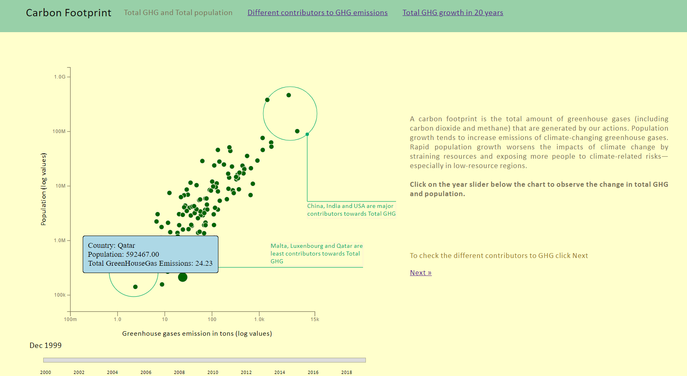

As we move the slider further to 2007, we observe that now more countries have joined the existing countries with population more than 3,000,000. One example of the same is Panama, Albania who’s population became greater than 3,000,000

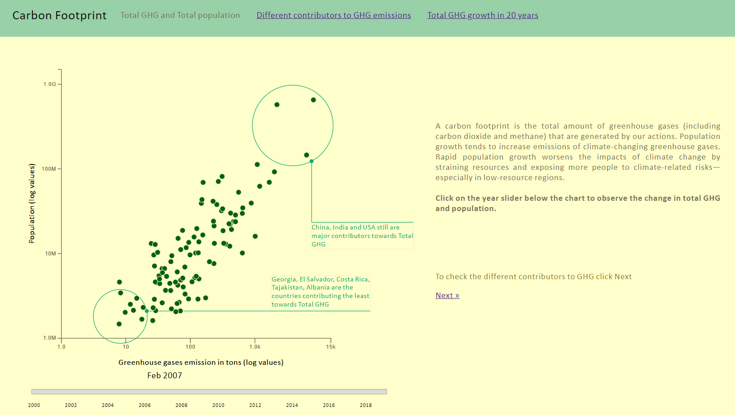

Moving further to 2014, we see that’s there’s a slight decline in GHG emission from USA.

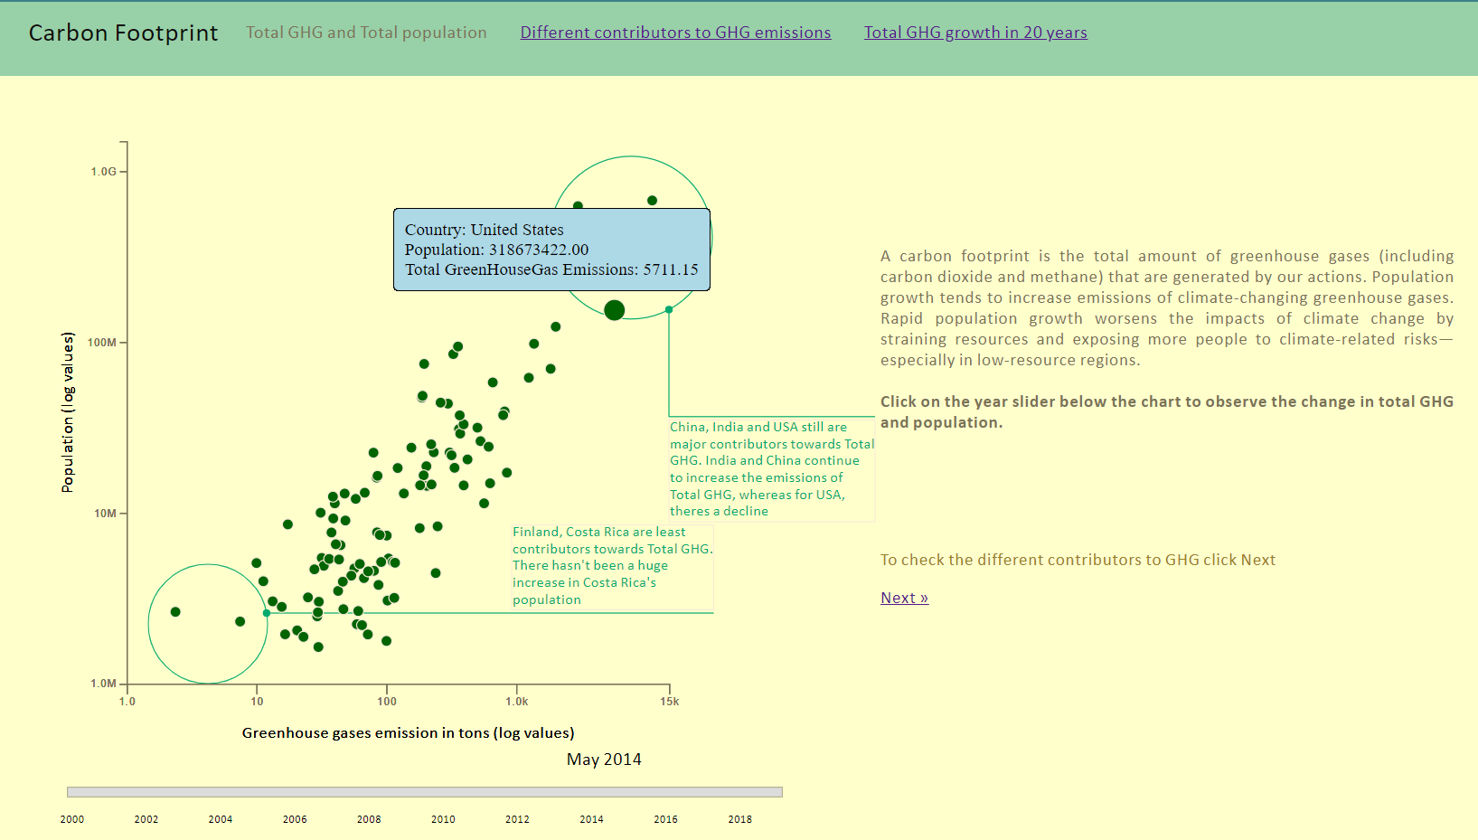

**Scene 2:** The next scene talks about the different sources that contribute to the emission of greenhouse gases like Coal, Oil, Methane, etc. From the visualization, we can see that for countries like India, Pakistan, Afghanistan, the major contributor is Methane, whereas are for countries like United States, Mexico, Costa Rica, the major contributor is Oil. This helps in understanding some of the similarities between the countries and their economies.

Afghanistan in 2000:

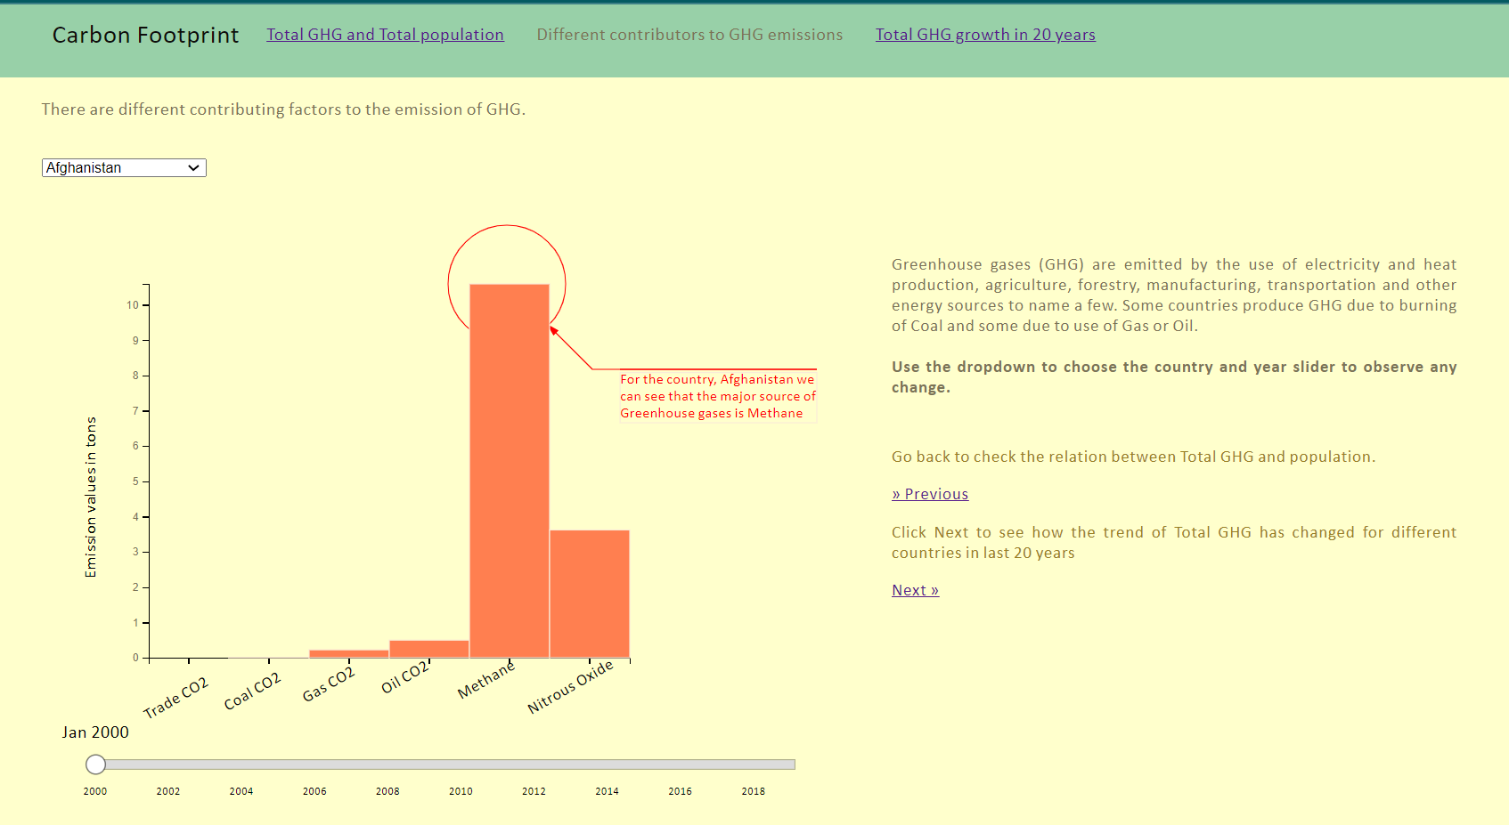

Afghanistan in 2015:

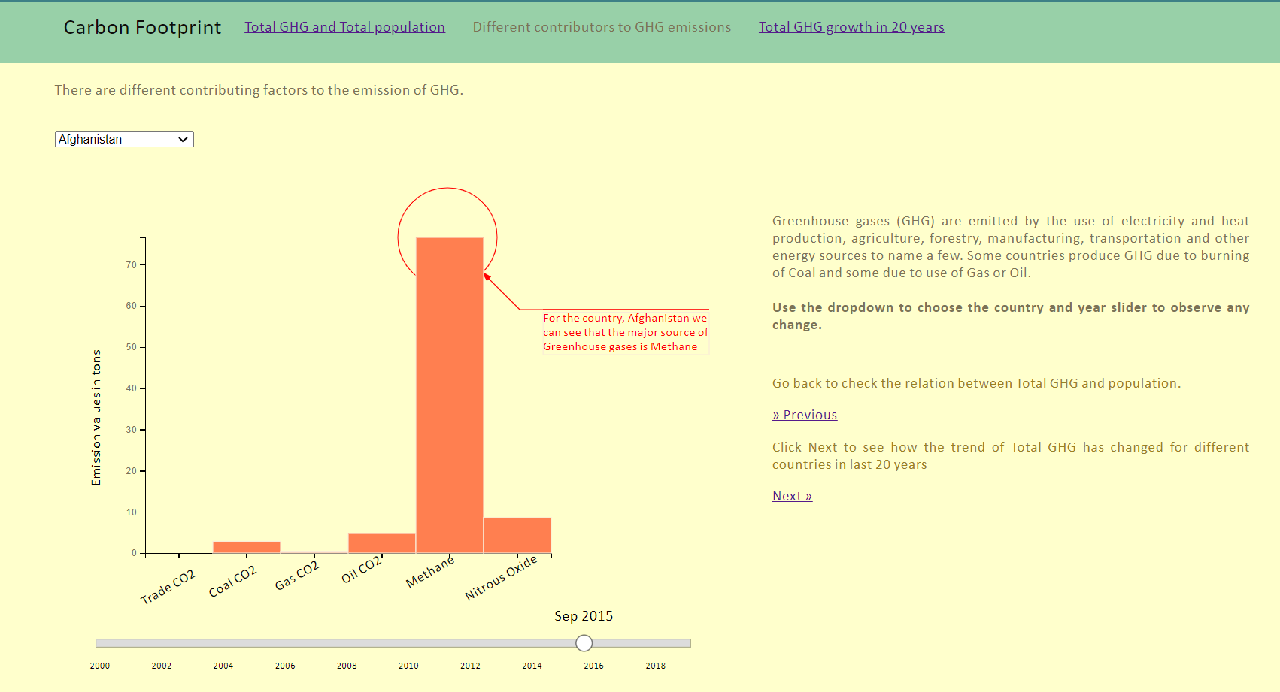

United States:

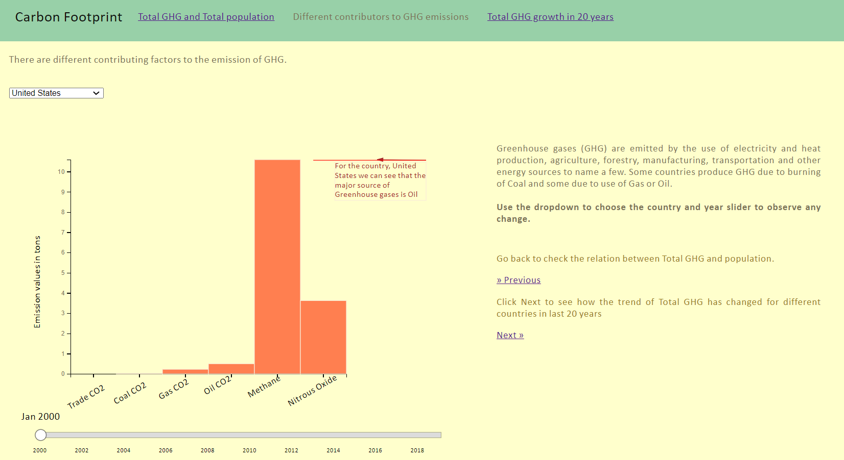

**Scene 3:** This scene shows the trend of the greenhouse gases emissions. For example for India and Bangladesh, there has been a linear increase in the GHG emissions whereas for United States, we see that there has been a decline from 2007-2009, that’s when the great recession also happened.

Linear GHG increase for India

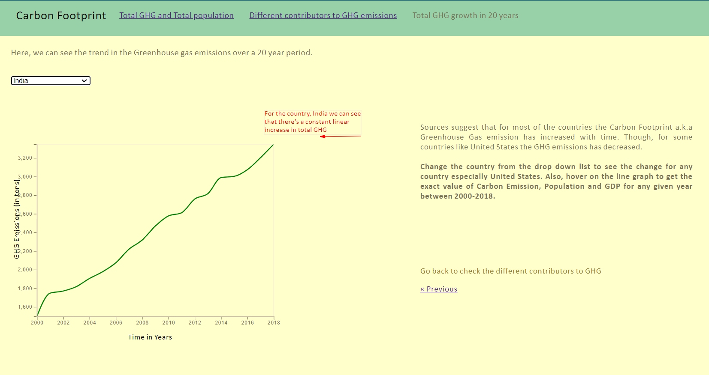

Decline for USA during recession.



**Annotations:**

* First scene: annotations are added on each of the screens to highlight the facts. For example in relationship between Total GHG and population, the annotation shows the top GHG emitting countries and the least GHG emitting countries between 2000-2018. Callout annotations are used to highlight the subject.
* Show the largest GHG emitter and lowest GHG emitter during different times like 2000,2004, 2011, 2015, etc.
* In the second scene, the annotations are added to highlight the major contributors to GHG emissions for a given country.
* Third scene: Annotations are added to show whether there was an increase or a decline in total GHG and if there’s any specific reason to the same: for example: country US, recession from 2007-2010 shows decline in GHG emissions. Both callout and label annotations are used. Callout annotations are used to highlight the subject.

**Transition**:

* One can navigate to scene 2 and 3 from the navigation bar at the top.
* One can also navigate to the next scene (scene 2) using the Next button.

**Tooltips:**

* Scene 1: On hover, the circle enlarges to almost double it’s size and shows details like which country are they representing and the value of population, GDP and GHG.
* Scene 2: On hover on the bar, the color of the bar changes to red and shows the exact value the bar is representing in a ‘div’ with the type of emission.
* Scene 3: On hover on the line, a ‘div’ appears and shows the value of population, total GHG and closest year where the user has hovered.

**Parameters and States**:

* Scene 1: On changing the slider (trigger), the parameter Year is changed and the data is shown for that ‘state’ or screen is filtered for that year.
* Scene 2: On changing the slider or the dropdown for the country (triggers), the parameters Year and Country are changed and the data shown on the screen is filtered for that Country/year. Annotation are also adapted.
* Scene 3: On changing the dropdown of the country (trigger), the graph is refreshed with data for that country (parameter).

**Triggers:**

* There are triggers on first 2 scenes. On the first scene: you can change the year to see change in total GHG and the tooltip gives further information on GDP also for the country.
* On the second scene, you can change the country from the drop to see the major GHG emitter and also change the year to see if that changed over time.
* On third scene, you can change the country from the drop down.