**OUTPUT** Data fidelity 🗹 K.L divergence 🗹

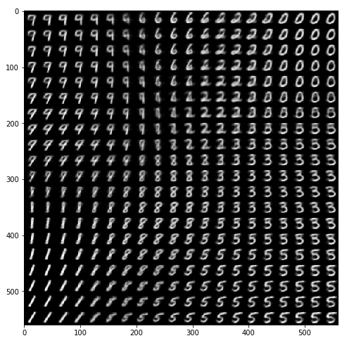

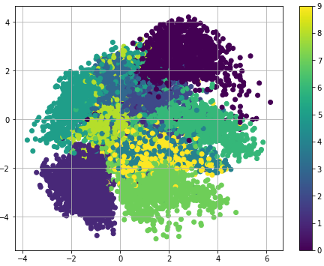

**OUTPUT** Data fidelity 🗹 K.L divergence 🗷

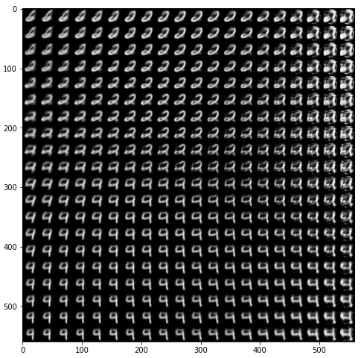

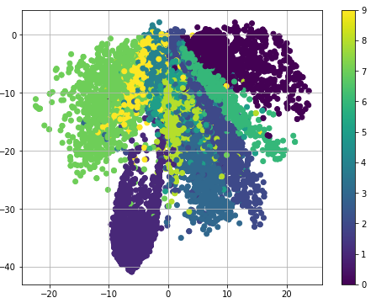

**OUTPUT** Data fidelity 🗷 K.L divergence 🗹

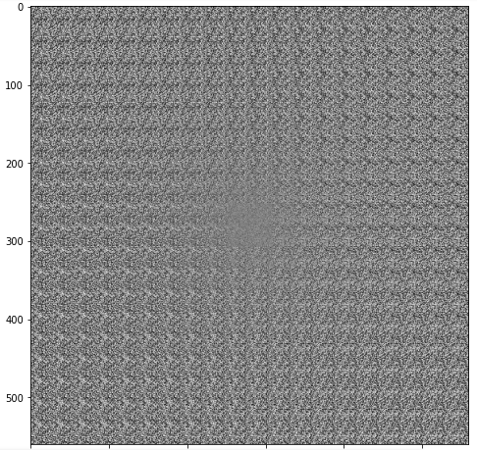

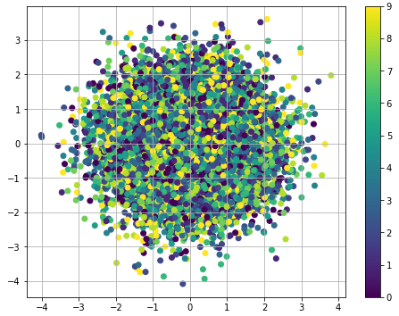

**OUTPUT : When FREY FACE dataset is used**

