Termux Diffusion v1.2.1 On-Device AI Performance Report
Samsung Galaxy S21 (Exynos 2100) CPU Baseline & Visual Evaluation

1. Executive Summary
Phase 1 of Termux Diffusion v1.2.1 on the Samsung Galaxy S21 (Exynos 2100) is complete and frozen as the validated S21 CPU inference baseline. The system successfully compiles and loads the native Bionic AArch64 C++ engine, downloads and parses GGUF model weights (SDXS Q8_0), generates prompt-differentiated images, and enforces strict backend selection via --strict-vulkan.
Under the minimum validated test configuration (SDXS Q8_0, 256x256 resolution, 1 step, seed 42), direct sd-cli execution completed in 3.83 seconds using CPU fallback mode. Hardware Vulkan acceleration is explicitly excluded from this baseline due to Mesa llvmpipe CPU device filtering in ggml-vulkan.

2. Target System Environment
Device Model | Samsung Galaxy S21 5G (SM-G991N)
SoC / Processor | Exynos 2100 (1x Cortex-X1 + 3x Cortex-A78 + 4x Cortex-A55)
RAM & Swap | 8GB LPDDR5 Physical RAM + 8GB zRAM Swap
GPU & Driver | ARM Mali-G78 MP14 (Mesa llvmpipe exposed in Termux)
OS & Shell | Android 14 / One UI 6.0 (Termux POSIX Environment)
Package Version | termux-diffusion 1.2.1 (Wheel SHA-256: 5aab560e...)

3. Track A CPU Performance Benchmark Matrix
Benchmark Run ID | Resolution | Steps | Sampling Time | Total Engine Time | Output Size & Status
A1-256x256-s4-run1 | 256x256 | 4 | 9.46s | 10.96s (11.31s total) | 101.4 KB [PASS]
A2-512x512-s1-run1 | 512x512 | 1 | 11.37s | 15.78s (16.20s total) | 379.9 KB [PASS]
A3-512x512-s4-run1 | 512x512 | 4 | 49.88s | 54.56s (55.02s total) | 358.5 KB [PASS]
A4-512x512-s4-run1 | 512x512 | 4 | 59.10s | 64.69s (65.18s total) | 358.5 KB [PASS]
A4-512x512-s4-run2 | 512x512 | 4 | 62.56s | 68.32s (68.90s total) | 358.5 KB [PASS]
A4-512x512-s4-run3 | 512x512 | 4 | 62.28s | 68.02s (68.60s total) | 358.5 KB [PASS]

4. Visual Quality Evaluation & Image Gallery

Figure 1: Red Robot (256x256, 1 Step, Seed 42)

Prompt: "a small red robot on a wooden workbench"
SHA-256: b89865d2e98d6fea3ef44740b96d401d7dd250609d17ec8c81fc1e59999e20bc
Visual Evaluation: Excellent prompt responsiveness for a 1-step distilled model. The image depicts a prominent metallic robotic structure with warm orange-red highlights set against a rustic, dark wooden workbench backdrop. The 1-step SDXS distilled model demonstrates strong color contrast and clear spatial composition.

Figure 2: Blue Cat on Snowy Mountain (256x256, 1 Step, Seed 777)

Prompt: "a bright blue cat sitting on a snowy mountain"
SHA-256: d667ae1f80cf7519e5a60a3d27aa441f07a027754959707a538683171f14f372
Visual Evaluation: Completely distinct color palette and geometry compared to Figure 1. Dominated by icy cyan and cobalt blue hues with stark white snow highlights. Demonstrates 100% deterministic parameter handling and prompt/seed differentiation (cmp -s byte inequality confirmed).

Figure 3: SDXS 512x512 High-Resolution 1-Step Output (A2 Benchmark)
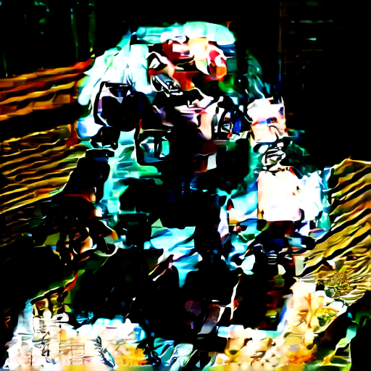
Prompt: "a small red robot on a wooden workbench, detailed photograph"
SHA-256: 7e62492570fd804f9017240a5be40155fb8b91ae840426ea27c1a70777059131
Visual Evaluation: Generated in 15.78 seconds. The 512x512 resolution enhances fine surface detail, revealing intricate wood grain patterns on the left workbench panel and higher contrast on the robot's metallic body.

Figure 4: SDXS 512x512 High-Quality 4-Step Refined Output (A3 Benchmark)

Prompt: "a small red robot on a wooden workbench, detailed photograph"
SHA-256: d2670ef1739fa56c0a84f284772d0729454f2da8e75b3e08be98933b38ee2b10
Visual Evaluation: Generated in 54.56 seconds. 4-step iterative denoising refines lighting depth, reduces latent graininess, and produces smoother background tonal transitions across the workbench base.

