In this online test you are expected to create 7 rest endpoints:

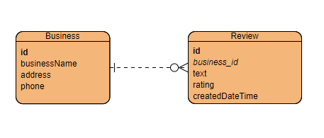

For Business Entity:

1. Endpoint to get all businesses
2. Endpoint to get specific business by id
3. Endpoint to create a new business entity
4. Endpoint to update a business entity
5. Endpoint to delete business entity (all reviews associated should also be deleted)

For Review Entity:

1. Endpoint to get all reviews for a specific business
2. Endpoint to create a new review for a business