
TR-069 Engine Design

TR-069 Engine Design

Internal Documentation

History:

Version | Date | Author | Description
0.1.0 |  | Mohamed KALLEL | First Edition
0.1.1 | 24/11/11 | Mohamed KALLEL | Design updates

Main Schema
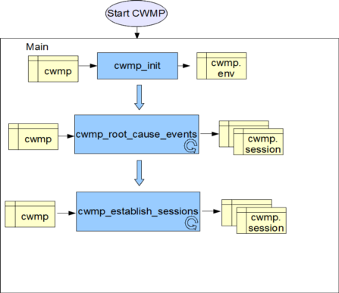
Struct cwmp:
Object | Type | Description
env | struct env | Structure containing the runnig configuration parameters. The argvs parameters are loaded in this structure
head_session_queue | struct list_head | head on the list of session queue.
mutex_session_queue | pthread_mutex_t | Mutex on session queue list. The mutex should be locked when editing a session in the list or when removing/removing a session from the list or when adding a session in the list
session_send | struct session * | Pointer to the session we want to establish. This session should be moved to the session_send from session queue pointer before starting the establishment of the session. The session queue should be treated as a FIFO queue.
mutex_session_send | pthread_mutex_t | Mutex on the current established session
head_event_container | struct list_head | Pointer to the event container list. The event container structure should contain all events as a linked list because they should be present in the same inform (standard §3.7.1.5 and §A.3.3.1).Only one session in the queue should have a pointer to this event container. If the session is moved to session_send pointer, the event container list should be moved.  If the session is moved back to the session queue, the event container of this session should be concatenated with the cwmp event container list  to get the session handler of the event container we can use the container_of macro.

Struct conf:
Object | Type | Description
acs_url | char[256] | The acs url as defined in the config file.  This parameter should be equal to NULL if there is no url defined in the config file or when we are using DHCP.
confFile | const char[] | cwmp config file path (ini file). Should be defined in the make config as a constant macro.
bkp_session_file | char[64] | File containing only the acs rpc not already sent to the acs and confirmed by rpc response.  This file also contains other backup parameters like the last runnin acs url

Struct env:
Object | Type | Description
acs_url | Char * | Back-up acs url. It's got from the bkp_session_file. It contains the last running acs url. This parameter is used to be compared with acs_url in order to detect any local modification of the acs. It's a dynamic buffer and it should be free after the comparison
boot | Unsigned short (8bits) | The boot flag should be equal to 0. if the cwmp application is launched in the boot then it should be equal to 1.  CWMP_START_BOOT = 1;

Struct session:
Object | Type | Description
acs_url | char[256] | The acs url used for the communication with the acs. This address is copied from the env structure when creating the session.
head_event_container | struct list_head | Pointer to the event container.  Only one session in the queue should have a pointer to the event container list defined in the cwmp structure. If the session is moved to session_send pointer. The event container list should be removed from cwmp.  If the session is moved back to the session queue, the event container list of the session should be concatenated with the event container list of cwmp.  to get the session handler of the inform container we can use the container_of macro.
single_event_flag | Unsigned int 32 | Unsigned int containig flag of possible events to send
int | error | An error flag should contain the error type (if it happens) in session process between the acs and the cpe
list | struct list_head | Contains pointers for the session queue list
head_rpc_acs | struct list_head | Pointer to the linked list of acs rpc.  acs rpc is the rpc to send to the acs like inform.
head_rpc_cpe | Struct list_head | Pointer to the linked list of cpe rpc  cpe rpc is the received rpc by the acs to execute in the cpe
mutex_rpc_acs | pthread_mutex_t | Mutex on rpc_acs list. The mutex should be locked when waiting finsh create rpc by the event threads threads. When the mutex is locked the shcedule session thread should waith the unlock of the mutex before starting processing rpc.
head_session_end_func | Struct list_head | List head to a function linked list. These functions should be executed at the end of the session (like reboot function and like cleaning session malloc...)  theses functions should have as input parameters: cwmp strcucture
hold_request | boolean | Hold send rpc request to the acs

struct rpc_acs:
Object | Type | Description
method_data | Void * | the request data could be filled by many function thread in the cwmp application and the rest should be filled by the method_data_init function before sending
(*method_data_init)(struct cwmp *cwmp,void *data) | int //function pointer | Complete the Filling of the method_data before sending the method request
(*method_remote_call)(struct cwmp *cwmp, void *data) | int //function pointer | Pointer to the function to execute to send the method request to the acs via soap
method_response_data | void * | The response data and the method_response function should filled by the receiver (GSOAP) after receivin the method response from the acs
(*method_response)(struct cwmp *cwmp, void *data) | int //function pointer | Pointer to a function to execute after receiving a response from the acs. This function should use as input parameter the method_response_data
(*method_end)(struct cwmp *cwmp, void *data) | int //function pointer | Pointer to a function to execute after finishing the receive the response from the acs. This function could be free all data and the mother structure
soap | struct soap * | Pointer to the soap. The soap should be created (malloc) in the session process function.
soap_header | struct SOAP_ENV__Header | Header used in the soap message. This header should contain the session id
id | Int | Id for the rpc_acs. Useful when save the rpc in the bkp_session_file
list | struct list_head | Contains pointers for the rpc_acs list

struct rpc_cpe:
Object | Type | Description
method_data | Void * | The request method_data should filled by the receiver (GSOAP functions) before executing the rpc on the cpe. The method_data contains the request data from the acs
(*method)(struct cwmp *cwmp, void *data) | int //function pointer | Pointer to the method function to execute as defined in the request soap from the acs. This method should fill the method_response function to execute and its correspondent method_response_data before sending the response to the acs
method_response_data | Void * | The response data should filled by the receiver method before executing the function related to the rpc response on the cpe
(*method_response_data_init)(struct cwmp *cwmp, void *data) | int //function pointer | Complete the Filling of the method_data before sending the method response
(*method_response)(struct cwmp *cwmp, void *data) | int //function pointer | Pointer to the function to execute to send the response.
(*method_response_end)(struct cwmp *cwmp, void *data) | int //function pointer | Pointer to a function to execute after finishing the send of the response to the acs. This function could be free all data and the mother structure
soap | struct soap * | Pointer to the soap. The soap should be created (malloc) in the session process function.
soap_header | struct SOAP_ENV__Header | Header used in the soap message. This header should contain the session id
list | struct list_head | Contains pointers for the rpc_cpe list

struct session_end_func:
Object | Type | Description
(*session_end_func)(struct cwmp *cwmp) | int //function pointer | Pointer to a function to call at the end of the session
list | struct list_head | Contains pointers for the session_end_func list

struct event_container:
Object | Type | Description
event | struct cwmp1__EventStruct | static event structure as defined in the GSOAP
param_container_list | struct list_head | Pointer to a linked list parameters container which contain only parameters related to the event (useful for the value change event).
id | Int | Id for the rpc_acs. Useful when save the event in the bkp_session_file
list | struct list_head | Contains pointers for the event_container list

struct param_container:
Object | Type | Description
paramater | struct cwmp1__ParameterValueStruct | Static parameter structure as defined in the GSOAP
list | struct list_head | Contains pointers for the event_container list

Functions:
Function | Input/Output parameters | Description
cwmp_intit | Input:  struct cwmp  Output:  int error | Load parameters from the local config file (ini file) to the cwmp->conf  copy argvs to cwmp->env  initialization cwmp->env parameters
cwmp_bckp_sessions | Input:  struct cwmp  Output:  int error | Load saved sessions (session in process and sessions in queue) from a local files  there is 2 files for both saved queue sessions and for the session in process.  The sessions are loaded in the linked list of session
cwmp_root_cause_events | Input:  struct cwmp  Output:  int error | Start all events such boot event, bootstrap event, periodic event, scheduled event, value change event and connection request event  bootstrap event: normal function  boot event: normal function  periodic event: thread function  scheduled event: thread function  value change event: thread function  connection request: thread function
cwmp_scheduler_sessions | Input:  struct cwmp  Output:  int error | A thread function  go over the session queue in order to treat sessions one by one (FIFO). The function move the session to be treated from the queue to the session_send pointer and start the session process. If the session is failed, it should moved back to the queue.

cwmp_init:

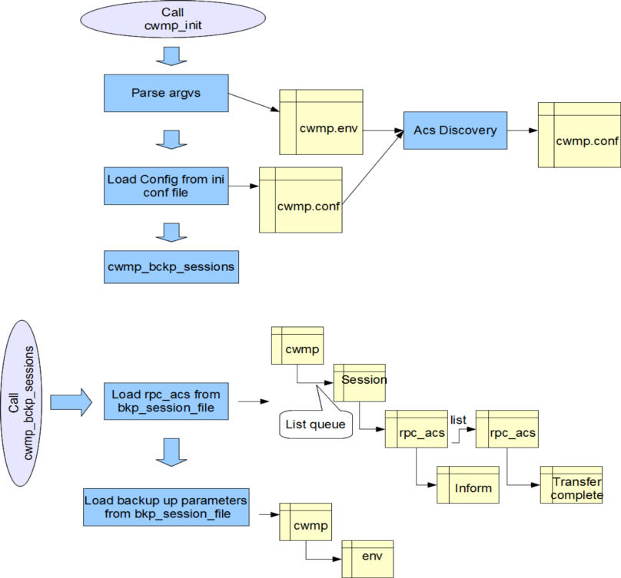

Application restart : load all events

CPE restart : load only the events, and the other events should be removed from the file
- 0 BOOTSTRAP
- 2 PERIODIC
- 3 SCHEDULED
- 7 TRANSFER COMPLETE
- 9 REQUEST DOWNLOAD
-10 AUTONOMOUS TRANSFER COMPLETE
- M Reboot
- M ScheduleInform
- M Download
- M Upload

All event should be removed from memory and from bkp file if the acsurl is modified

All event should be saved in the bckp file when ceating them

Event which should be removed from the memory and from the bcp file after sending (without waiting response) :
- 6 CONNECTION REQUEST
The other event should be kept saved in the memory and in the bkp file

Any chage of the cwmp config file and restart of te application
And if the change value exist in the data model, the application should send a 4 value change

bkp session file model

[ACS] ; as defined in the config
Acsurl = "address"
Login = "login"
Passwd ="password"

[ENV]
anyEnvParam = "any" ; env paramaters not defined in the config

[EVENT 4 VALUE CHANGE <id>]
CommandKey = ""
Object.path.value = "any"

[EVENTM REBOOT <id>]
CommandKey = "any command"
Object.path.value = "any"

[RPC TRANSFER COMPLETE <id>]
CommandKey = "any command"
FaultStructure = "fault1,fault2"
StartTime = "time1"
CompleteTime ="time2"

EVENT constants definition in the C source
Typedef struct CONSTEVENTSTRUCT {
String *EVENTCODE ;
Unsigned int FLAG ;
Unsined short TYPE ;
Unsigned short REDELIVER
} CONSTEVENTSTRUCT

REDELIVER is a flag :
(bin)001 : REDELIVER_AFTER_TRANSMIT_FAIL
(bin)010 : REDELIVER_AFTER_REBOOT
(bin)100 : REDELIVER_AFTER_BOOTSTRAP

const struct CONSTEVENTSTRUCT CONST_EVENT {
{"0 BOOTSTRAP", BOOTSTRAP_FLAG, SINGLE_EVENT, REDELIVER_AFTER_TRANSMIT_FAIL|REDELIVER_AFTER_REBOOT}
}

cwmp_root_cause_events:

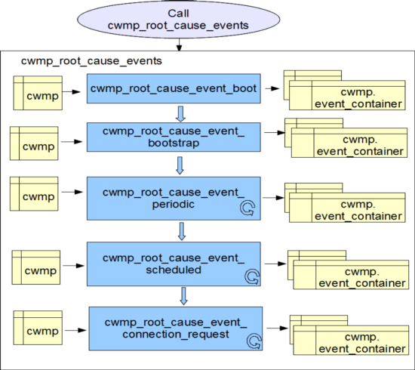

Functions:
Function | Input/Output parameters | Description
cwmp_root_cause_event_boot | Input:  struct cwmp  Output:  int error
cwmp_root_cause_event_bootstrap | Input:  struct cwmp  Output:  int error
cwmp_root_cause_event_periodic | Input:  struct cwmp  Output:  int error
cwmp_root_cause_event_scheduled | Input:  struct cwmp  Output:  int error
cwmp_root_cause_event_connection_request | Input:  struct cwmp  Output:  int error
cwmp_root_cause_value_change | Input:  struct cwmp  Output:  int error | When addin event we should check if the value change already exist and we have to check if the parameter is already exist in the parameter list array

Check the boot flag
cwmp_add_inform_event
Call
cwmp_root_cause_event_boot
env->boot=1
env->boot=0
CommandKey= ""
Event= "1 BOOT"
Return OK
Return OK
cwmp_root_cause_event_boot

for the boot requested from the acs require the add of M reboot
The M reboot should be added by the reboot rpc in the bkp session file before the reboot

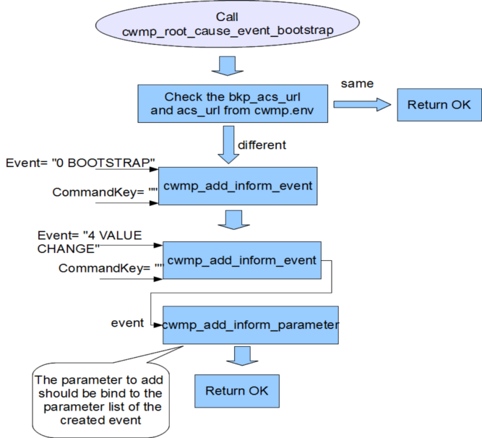

The save of event in the bckp_session_file should be done in the cwmp_add_inform_event. And to save the related parameter list, it should be done in the cwmp_add_inform_parameter

cwmp_scheduler_sessions

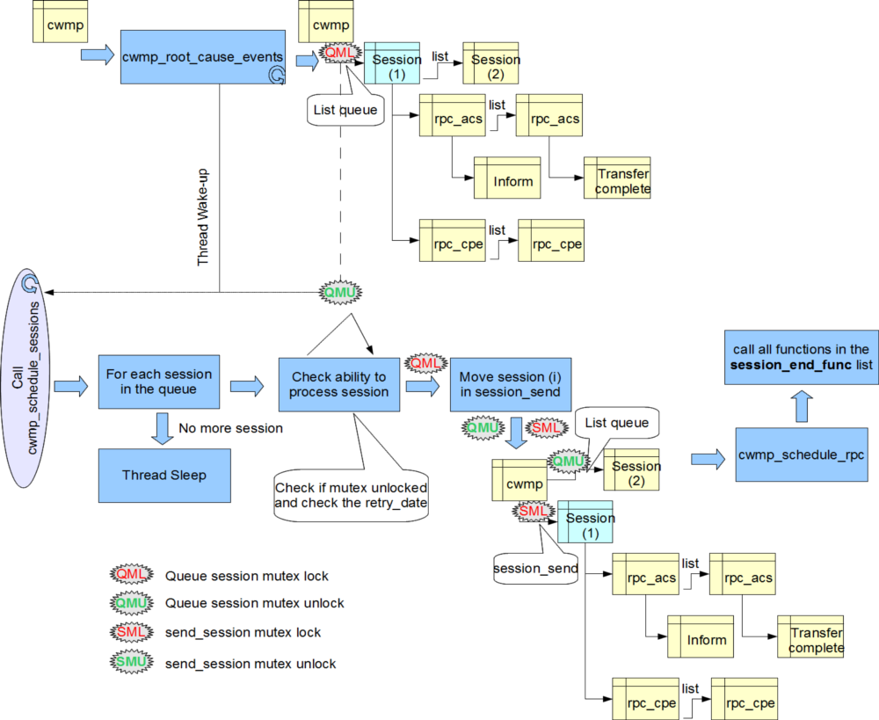

Retry a failed session after waiting for an interval of time specified in the belowTable or when a new event occurs, whichever comes first.
Choose the wait interval by randomly selecting a number of seconds from a range given by the post-reboot session retry count
Reboot CPE (ONLY)==> reset retry_date and retry_count to 0
NewEvent ==> no reset retry_date and retry_count
Beginning with the tenth post-reboot session retry attempt, we should choose from a range between 2560 and 5120 seconds. We should continue to retry a failed session until it is successfully terminated. Once a session terminates successfully, the CPE MUST reset the session retry count to zero and no longer apply session retry policy to determine when to initiate the next session
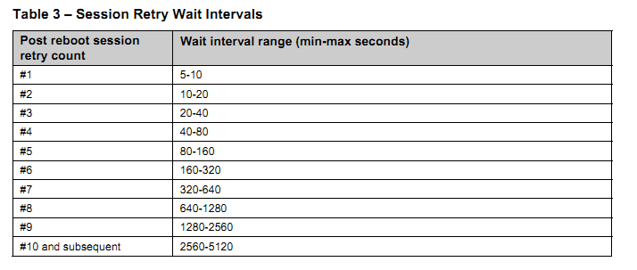

cwmp_scheduler_rpc

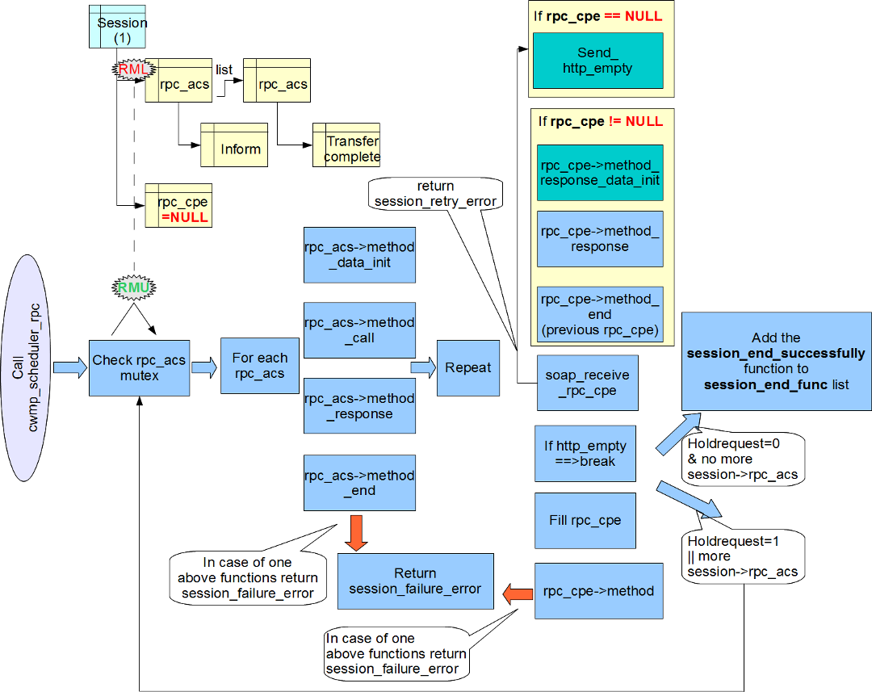

Note : the session_end_successfully function should update the retry_date and the retry_count variable in the cwmp structure

The rpc_acs->method_end should remove the rpc_acs from the bkp_session_file file
3.7.1.4 session terminated successfully

If and only if all of the following conditions are met :
1) The ACS has no further requests to send the CPE. The CPE concludes this if and only if the most recent HTTP response from the ACS was empty.
2) The CPE has no further requests to send to the ACS and the CPE has issued an empty HTTP POST to the ACS while HoldRequests is false (which indicates to the ACS that the CPE has no further requests for the remainder of the session). As defined in Table 6, if this condition has not been met but the CPE has no further requests or responses, it MUST send an empty HTTP POST, which will then fulfill this condition.
3) The CPE has received all outstanding response messages from the ACS.
4) The CPE has sent all outstanding response messages to the ACS resulting from prior requests

3.7.1.4 session terminated unsuccessfully (==> close current and Retry new session)

1) If has received no HTTP response from an ACS for a locally determined time period of not less than 30 seconds.
2) If the CPE receives a SOAP-layer fault in response to an Inform request with a fault code other than “Retry request” (fault code 8005).
3) If the CPE receives an HTTP response from the ACS for which the XML is not well-formed, for which the
SOAP structure is deemed invalid, that contains a SOAP fault that is not in the form specified in section 3.5, or for which the CPE deems that the protocol has been violated.
4) If the CPE receives an HTTP response from the ACS with a fault status code (a 4xx or 5xx status code) that is not otherwise handled by the CPE. Note that while the CPE would accept an HTTP response with a “401 Unauthorized” status code as part of the normal authentication process, when the CPE subsequently attempts to authenticate, if the resulting HTTP response contains a “401 Unauthorized” status code, the CPE MUST consider the session to have terminated unsuccessfully.
5) 3.7 Transaction Session Procedures
§1 retransmit an Inform request due to an HTTP “401 Unauthorized” status code received as part of the HTTP authentication process
§1 retransmit an Inform request due to an HTTP 3xx status code received as part of an HTTP redirect

Note :
If the CPE receives a SOAP-layer fault response as defined in section 3.5 with a fault code other than “Retry request” (fault code 8005) in response to any method other than Inform, the CPE MUST continue with the remainder of the session. That is, a fault response of this type MUST NOT cause the session to unsuccessfully terminate.
In a fault condition, it is entirely at the discretion of the ACS whether its fault response is a SOAP-layer fault, which would cause the session to continue, or an HTTP-layer fault, which would cause the session to terminate unsuccessfully.
If one or more messages exchanged during a session results in the CPE needing to reboot to complete the requested operation, the CPE MUST wait until after the session has cleanly terminated based on the above criteria before performing the reboot.

3.4 Use of HTTP.
§6 HTTP redirection. used only for current session
The CPE MUST allow redirection to occur at any point during a session

3.4.4 Authentication.
§3 authentication at any stage of the session

If the CPE receives a successful Inform response in which the namespace identifier indicates that the ACS supports only v1.0 of the CPE WAN Management Protocol, the CPE MUST revert to v1.0 for the remainder of the session. This behaviour could be added in the inform response method calld by rpc_acs->method_resonse

rpc_acs->method_call Template

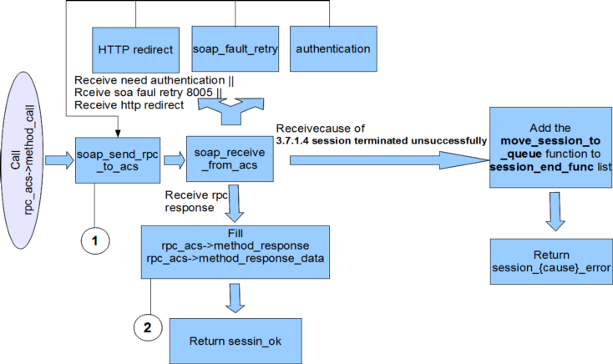

1: if the rpc is an inform rpc then calling the event_remove function in order to remove event (with flag (000)) related to current session from event list and from the bkp file.

2: f the rpc is an inform rpc then calling the event_remove function in order to remove all event related to current session from event list and from the bkp file.

soap_receive_rpc_cpe

Note : the move_session_to_queue function should add inform rpc to the rpc_acs list if there is no rpc_acs in the session and if there is no session in the session queue
Note : the move_session_to_queue function should update the retry_date and the retry_count variable in the cwmp structure
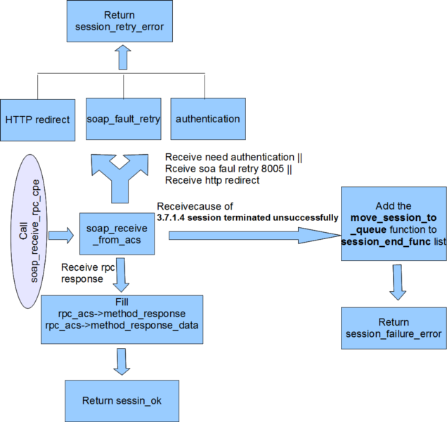

Interaction between the TR069 engine and data models engine:

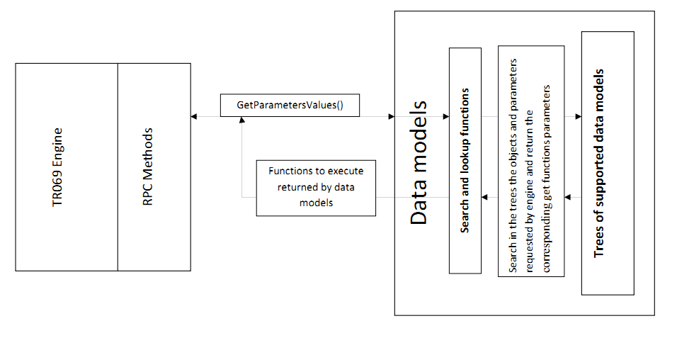
There are two propositions for design the data model
1/ proposition 1: In this method of designing all the objects and settings in a tree with each leaf of this tree has a brother "brother", the first son "first_child" which is connected with his brothers "brother" and probably functions "set" and "get" for each parameter and this according to the access rights associated
Explanation:
The tree is as follows:
F1 – F2
| |
| F21 – F 22
F11 – F12 – F13 – F14
| |
| F121 – F122
F111 – F112 – F113
Each node of this tree is represented by the following structure:
struct node {
char *object_name;
void *set_fn;
void *get_fn;
struct node *first_child;
struct node *brother;
};
The tree is represented by an explicitly as follows:
const struct node dm_samples[] =
{"F1",NULL,NULL, /* without the setter and getter fonctions*/
{"F11",set_F11,get_F11,
{"F111",set_F111,get_F111,NULL,
{"F112",set_F112,get_F112,NULL,NULL}},
{"F12",set_F12,get_F12,
{"F121",set_F121,get_F121,NULL,
{"F122",set_F122,get_F122,NULL,NULL}},
{"F13",set_F13,get_F13,NULL,
{"F14",set_F14,get_F14,NULL,NULL}}}},
{"F2",NULL,NULL,
{"F21",set_F21,get_F21,
{"F22",set_F22,get_F22,NULL,NULL}}
}};
2/ proposition 2: The data models will be represented in tree:
The data models are represented as a tree, adding each object separately with all these parameters and then it will be attached to the shaft of the corresponding data model.
All trees will eventually be tied to a tree that contains all the main data models.

/* Example : Object DeviceInfo */
CREATE_OBJECT( o_device_info, "DeviceInfo", get_device_info);
ADD_PARAM( o_device_info, p_device_manufacturer, "Manufacturer", get_device_summary);
ADD_PARAM( o_device_info, p_device_manufacturer_oui, "ManufacturerOUI", get_device_summary);
ADD_PARAM( o_device_info, p_device_modep_name, "ModelName", get_device_summary);
ADD_PARAM( o_device_info, p_device_description, "Description", get_device_summary);
ADD_PARAM( o_device_info, p_device_seriap_number, "SerialNumber", get_device_summary);
ADD_PARAM( o_device_info, p_device_hardware_version, "HardwareVersion", get_device_summary);
ADD_PARAM( o_device_info, p_device_software_version, "SoftwareVersion", get_device_summary);
ADD_PARAM( o_device_info, p_device_spec_version, "SpecVersion", get_device_summary);
ADD_PARAM( o_device_info, p_device_provisioning_code, "ProvisioningCode", get_device_summary);
ADD_PARAM( o_device_info, p_device_uptime, "UpTime", get_device_summary);
ADD_PARAM( o_device_info, p_device_log, "DeviceLog", get_device_summary);
ADD_OBJECT( o_device_info); /*to be added to InternetGatewayDevice tree*/

3/ The source code will be generated by the binary “dm2c”.
