3.5 Use of SOAP

Table 4 – SOAP Header Elements (page 29)

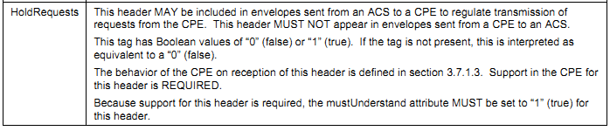

Below is an example of a message showing the use of all of the defined headers:
<soap:Envelope
xmlns:soap="http://schemas.xmlsoap.org/soap/envelope/"
xmlns:cwmp="urn:dslforum-org:cwmp-1-0">
<soap:Header>
<cwmp:ID soap:mustUnderstand="1">1234</cwmp:ID>
<cwmp:HoldRequests soap:mustUnderstand="1">0</cwmp:HoldRequests>
</soap:Header>
<soap:Body>
<cwmp:Action>
<argument>value</argument>
</cwmp:Action>
</soap:Body>
</soap:Envelope>

3.7.1.3 Outgoing Requests (page 31)

While in a session (after the session was successfully initiated, but before the session termination criteria described in 3.7.1.4 have been met), if the CPE has one or more requests to send to the ACS, the CPE MUST send one of these requests in the next HTTP POST if and only if all of the following conditions are met:
• The most recently received HTTP response from the ACS did not contain a SOAP request.
• The ACS has indicated that HoldRequests is false (see section 3.5). This condition is met if and only if the most recently received HTTP response from the ACS contained one of the following:
o A SOAP envelope with the HoldRequests header set to a value of false.
o A SOAP envelope with no HoldRequests header.
o No SOAP envelope (an empty HTTP response).
• At any prior time during the current session, the CPE has not sent an empty HTTP POST at a time that the ACS had indicated that HoldRequests is false (as described above).
If the CPE has more than one request pending when the above criteria are met, the choice of which request to send is at the discretion of the CPE unless otherwise specified. While in a session, if any of the above conditions are not met or if the CPE has no requests to send to the ACS, and if the most recent HTTP response from the ACS did not contain a SOAP request, the CPE MUST send an empty HTTP POST. Once the CPE has sent an empty HTTP POST when the most recent HoldRequests was false (see section 3.5), the CPE MUST NOT send any further requests for the remainder of the session. In this case, if the CPE has additional requests to send to the ACS, the CPE MUST wait until a subsequent session to send these requests.
Table 6 summarizes what the CPE MUST send to the ACS as long as the session is in progress (after the session was successfully initiated, but before the session termination criteria described in 3.7.1.4 have been met).

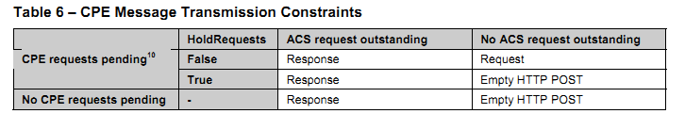
10
The CPE can have requests pending only if the CPE has not already sent an empty HTTP POST when the most recent HoldRequests was false. Otherwise, the CPE is considered to have no requests pending.

3.7.1.4 Session Termination (p32)
The CPE MUST terminate the transaction session when all of the following conditions are met:
1) The ACS has no further requests to send the CPE. The CPE concludes this if and only if the most recent HTTP response from the ACS was empty.
2) The CPE has no further requests to send to the ACS and the CPE has issued an empty HTTP
POST to the ACS while HoldRequests is false (which indicates to the ACS that the CPE has no further requests for the remainder of the session). As defined in Table 6, if this condition has not
been met but the CPE has no further requests or responses, it MUST send an empty HTTP POST,
which will then fulfill this condition.

3.7.2.2 Incoming Requests (p 38)
While in a session (after the session was successfully initiated, but before the session termination criteria described in 3.7.2.4 have been met), on reception of a SOAP request from the CPE, the ACS MUST respond to that request in the next HTTP response sent to the CPE.
If the ACS wishes to prevent the CPE sending requests during some portion of the session, it MAY do so by setting the HoldRequests header to true in each envelope transmitted to the CPE until the ACS again wishes to allow requests from the CPE. The ACS MUST allow CPE requests before completion of a session (this MAY be done either explicitly via the HoldRequests header or implicitly by sending an empty HTTP response).

3.7.2.4 Session Termination (p39)
Since the CPE is driving the HTTP connection to the ACS, only the CPE is responsible for connection initiation and teardown.
The ACS MUST consider the session terminated when all of the following conditions are met:
1) The CPE has no further requests to send the ACS. The ACS concludes this if and only if it has
received an empty HTTP POST from the CPE while HoldRequests is false.
2) The ACS has no further requests to send the CPE and the most recent HTTP response the ACS
sent to the CPE was empty (which indicates to the CPE that the ACS has no further requests).

3.7.3 Transaction Examples (p41)

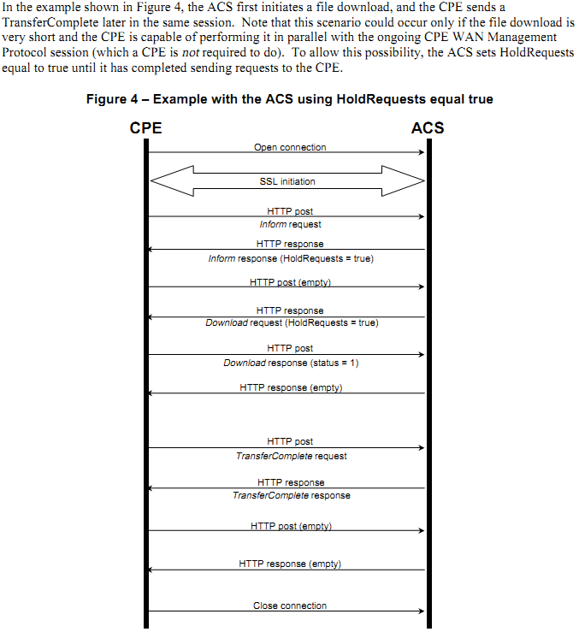

A.3.3.2 TransferComplete (p66)

This method informs the ACS of the completion (either successful or unsuccessful) of a file transfer
initiated by an earlier Download or Upload method call. This MUST be called only when the associated Download or Upload response indicated that the transfer had not yet completed at that time (indicated by a non-zero value of the Status argument in the response). In such cases, it MAY be called either later in the same session in which the transfer was initiated or in any subsequent session. Note that in order for it to be called within the same session in which the transfer was initiated, the CPE will have been sent the InformResponse and Download request while HoldRequests was true. When used, this method MUST be called only after the transfer has successfully completed, and in the case of a download, the downloaded file has been successfully applied, or after the transfer or apply has failed. If this method fails, the CPE MUST NOT regard the ACS as having been informed of the completion of the file transfer, and MUST attempt to call the method again, either in the current session or in a new session, subject to the event delivery rules of section 3.7.1.5. The calling arguments for this method are defined in Table 38. The arguments in the response are defined in Table 39.

