Scala Lab Practical File
Module 1 and Module 2: Questions, Code and Output
Each question below is followed by its Scala code, the output and a short explanation. Programs use a fixed random seed or fixed data, so you get the same output every time you run them.

Module 1

Q1. Set up Scala and SBT on your system
Question
Set up Scala and SBT on your system.
Commands
# 1. Check Java (need JDK 11 or 17)
java -version

# 2. Install Coursier, then Scala + sbt
# Windows : download cs-x86_64-pc-win32.zip from https://get-coursier.io
# Linux/Mac:
curl -fL https://github.com/coursier/launchers/raw/master/cs-x86_64-pc-linux.gz | gzip -d > cs
chmod +x cs
./cs setup # installs scala, scalac and sbt

# 3. Create the project folders
mkdir -p scala-lab/src/main/scala && cd scala-lab
build.sbt (project root)
ThisBuild / scalaVersion := "2.13.14"

lazy val root = (project in file("."))
.settings(
name := "scala-lab",
libraryDependencies ++= Seq(
"org.scalanlp" %% "breeze" % "2.1.0",
"org.scalanlp" %% "breeze-viz" % "2.1.0",
"org.apache.spark" %% "spark-sql" % "3.5.1"))
src/main/scala/Hello.scala
object Hello extends App {
println("Hello, Scala!")
}
Output
$ sbt run
[info] running Hello
Hello, Scala!
[success] Total time: 3 s
How it works
- Scala runs on the JVM, so Java (JDK 11 or 17) must be installed first.
- Coursier (cs) installs Scala and sbt for you in one command.
- build.sbt tells sbt the Scala version and which libraries (Breeze, Spark) to download.

Q3. Mean, median and mode
Question
Calculate mean, median, and mode of a list of numbers.
Code (Scala)
object MeanMedianMode extends App {
val nums = List(4, 8, 15, 16, 23, 42, 8, 15, 8)

// Mean
val mean = nums.sum.toDouble / nums.size

// Median
val sorted = nums.sorted
val n = sorted.size
val median =
if (n % 2 == 1) sorted(n / 2).toDouble
else (sorted(n / 2 - 1) + sorted(n / 2)) / 2.0

// Mode
val mode = nums.groupBy(identity).maxBy(_._2.size)._1

println(s"Numbers : $nums")
println(f"Mean : $mean%.2f")
println(s"Median : $median")
println(s"Mode : $mode")
}
Output
Numbers : List(4, 8, 15, 16, 23, 42, 8, 15, 8)
Mean : 15.44
Median : 15.0
Mode : 8
How it works
- Mean = sum of all numbers divided by how many there are.
- Median = the middle value after sorting (average of the two middle values if the count is even).
- Mode = the number that appears most often (found with groupBy).

Q4. Variance and standard deviation of random data
Question
Generate a random data set of 10 numbers and calculate variance & standard deviation.
Code (Scala)
import scala.util.Random

object VarianceStd extends App {
val rnd = new Random(42) // fixed seed
val data = List.fill(10)(rnd.nextInt(100)) // 10 numbers from 0 to 99

val mean = data.sum.toDouble / data.size
val variance = data.map(x => math.pow(x - mean, 2)).sum / data.size
val stdDev = math.sqrt(variance)

println(s"Data : $data")
println(f"Mean : $mean%.2f")
println(f"Variance : $variance%.2f")
println(f"Standard deviation : $stdDev%.2f")
}
Output
Data : List(30, 63, 48, 84, 70, 25, 5, 18, 19, 93)
Mean : 45.50
Variance : 841.05
Standard deviation : 29.00
How it works
- Random(42) uses a fixed seed, so you get the same numbers every run.
- Variance = average of the squared distance of each number from the mean.
- Standard deviation = square root of the variance (population formula, divide by n).

Q6. Random matrix, transpose and determinant (Breeze)
Question
Generate a random matrix using Breeze and compute its transpose and determinant.
Code (Scala)
import breeze.linalg._

object MatrixOps extends App {
val rnd = new scala.util.Random(42)
// 9 random digits -> 3x3 matrix (Breeze stores data column by column)
val m = new DenseMatrix(3, 3, Array.fill(9)(rnd.nextInt(10).toDouble))

def show(mat: DenseMatrix[Double]): Unit =
for (i <- 0 until mat.rows)
println((0 until mat.cols).map(j => f"${mat(i, j)}%6.1f").mkString)

println("Matrix:"); show(m)
println("Transpose:"); show(m.t)
println(f"Determinant: ${det(m)}%.2f")
}
Output
Matrix:
0.0 4.0 5.0
3.0 0.0 8.0
8.0 5.0 9.0
Transpose:
0.0 3.0 8.0
4.0 0.0 5.0
5.0 8.0 9.0
Determinant: 223.00
How it works
- A 3x3 matrix is filled with random digits (seed 42, so the result is repeatable).
- m.t flips rows and columns (transpose).
- det(m) gives the determinant; it needs a square matrix.

Q9. Read a CSV file and calculate basic statistics
Question
Read a CSV file and calculate basic statistics for each numeric column.
students.csv (save in the project folder)
name,age,marks,fees
Asha,20,78,45000
Ravi,22,85,52000
Meena,21,92,48000
Karan,23,67,50000
Sneha,20,88,46000
Arjun,22,74,51000
Divya,21,95,47000
Rohit,24,59,53000
Code (Scala)
import scala.io.Source

object CsvStats extends App {
val lines = Source.fromFile("students.csv").getLines().toList
val header = lines.head.split(",").map(_.trim)
val rows = lines.tail.map(_.split(",").map(_.trim))

for ((col, idx) <- header.zipWithIndex) {
val values = rows.map(_(idx))
if (values.forall(_.toDoubleOption.isDefined)) { // numeric column?
val nums = values.map(_.toDouble)
val mean = nums.sum / nums.size
val std = math.sqrt(nums.map(x => math.pow(x - mean, 2)).sum / nums.size)
println(f"$col%-8s count=${nums.size} min=${nums.min}%.1f " +
f"max=${nums.max}%.1f mean=$mean%.2f std=$std%.2f")
}
}
}
Output
age count=8 min=20.0 max=24.0 mean=21.62 std=1.32
marks count=8 min=59.0 max=95.0 mean=79.75 std=11.77
fees count=8 min=45000.0 max=53000.0 mean=49000.00 std=2738.61
How it works
- Read every line, split on commas, and treat the first line as the header.
- A column is numeric only if every value can be converted to a number (the name column is skipped).
- For each numeric column: count, min, max, mean and standard deviation are printed.

Q12. Tokenize a text file and count word frequency
Question
Write a program to tokenize and count the frequency of words in a text file.
sample.txt (save in the project folder)
Scala is fun. Scala runs on the JVM. Spark is written in Scala and Spark is fast.
Code (Scala)
import scala.io.Source

object WordCount extends App {
val text = Source.fromFile("sample.txt").mkString
val words = text.toLowerCase.split("[^a-z]+").filter(_.nonEmpty) // tokenize

val counts = words
.groupBy(identity)
.view.mapValues(_.length)
.toList
.sortBy { case (word, c) => (-c, word) } // most frequent first

println(s"Total words: ${words.length}")
counts.foreach { case (word, c) => println(f"$word%-8s $c") }
}
Output
Total words: 17
is 3
scala 3
spark 2
and 1
fast 1
fun 1
in 1
jvm 1
on 1
runs 1
the 1
written 1
How it works
- Convert the text to lower case so 'Scala' and 'scala' count as the same word.
- split("[^a-z]+") breaks the text at every non-letter (spaces, dots) - this is tokenizing.
- groupBy(identity) collects equal words together and the group size is the frequency.

Q14. Scatter plot with labelled axes and custom colour (Breeze-viz)
Question
Create a scatter plot of random data using Breeze-viz. Label the axes and customize color.
Code (Scala)
import breeze.linalg._
import breeze.plot._
import java.awt.Color

object ScatterPlot extends App {
val rnd = new scala.util.Random(42)
val x = DenseVector.fill(30)(rnd.nextDouble() * 100)
val y = DenseVector.fill(30)(rnd.nextDouble() * 100)

val fig = Figure("Scatter")
val p = fig.subplot(0)
p += scatter(x, y, _ => 1.5, _ => Color.RED) // size 1.5, red dots
p.xlabel = "X axis (random values)"
p.ylabel = "Y axis (random values)"
p.title = "Scatter plot of random data"
fig.saveas("scatter.png")
}
Output
Creates scatter.png - the plot below (30 red points, labelled axes):
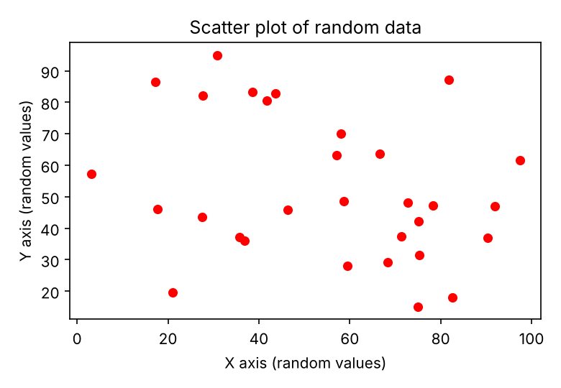
How it works
- 30 random x values and 30 random y values (0 to 100) are generated.
- scatter(...) draws one dot per (x, y) pair; the colour function makes every dot red.
- xlabel, ylabel and title name the plot; saveas writes it to a PNG file.

Q15. Histogram with different bin sizes (Breeze-viz)
Question
Generate a histogram of a dataset using Breeze-viz. Experiment with different bin sizes.
Code (Scala)
import breeze.linalg._
import breeze.plot._

object HistogramPlot extends App {
val rnd = new scala.util.Random(7)
val data = DenseVector.fill(200)(rnd.nextInt(100).toDouble)

for (bins <- Seq(5, 10, 20)) {
val fig = Figure(s"Histogram - $bins bins")
val p = fig.subplot(0)
p += hist(data, bins)
p.xlabel = "Value"
p.ylabel = "Frequency"
p.title = s"$bins bins"
fig.saveas(s"hist_$bins.png")
}
}
Output
Creates hist_5.png, hist_10.png and hist_20.png - shown side by side below:
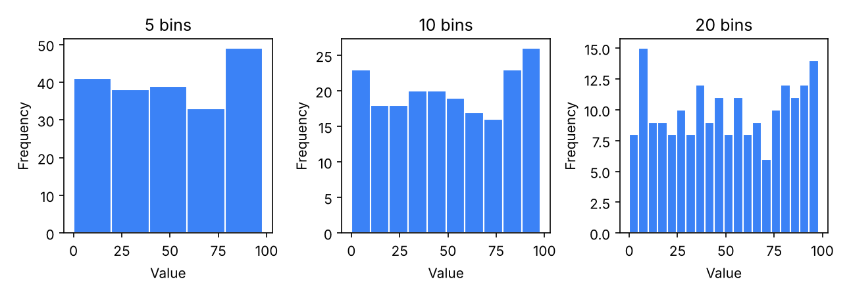
How it works
- 200 random numbers between 0 and 99 are the dataset.
- hist(data, bins) splits the range into equal 'bins' and counts values in each.
- Few bins (5) give a rough shape; many bins (20) show more detail but look noisier.

Q16. Scatter and line plot combined (Breeze-viz)
Question
Combine two plots (scatter and line plot) in a single visualization using Breeze-viz.
Code (Scala)
import breeze.linalg._
import breeze.plot._
import java.awt.Color

object CombinedPlot extends App {
val rnd = new scala.util.Random(21)
val x = DenseVector((1 to 15).map(_.toDouble).toArray)
val y = x.map(v => 3 * v + rnd.nextInt(15)) // noisy data
val trend = x.map(v => 3 * v + 7) // straight line

val fig = Figure("Combined")
val p = fig.subplot(0)
p += scatter(x, y, _ => 0.3, _ => Color.RED, name = "Data points")
p += plot(x, trend, '-', "blue", name = "Trend line y = 3x + 7")
p.xlabel = "x"
p.ylabel = "y"
p.title = "Scatter + line in one plot"
p.legend = true
fig.saveas("combined.png")
}
Output
Creates combined.png - the plot below:
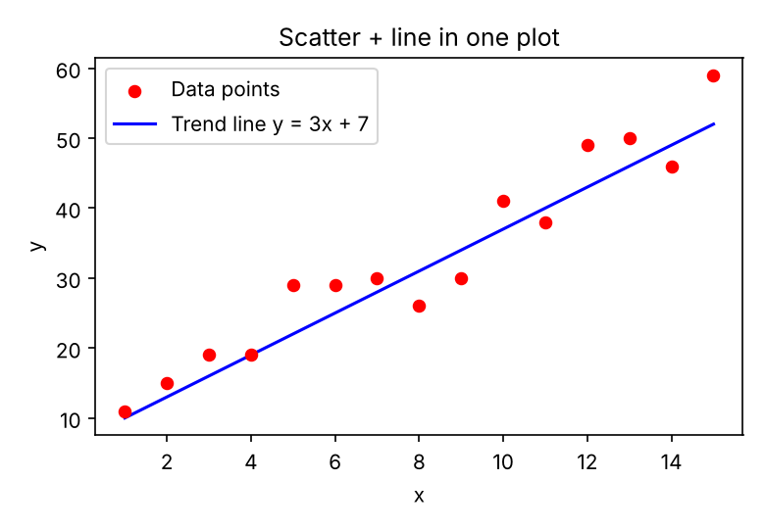
How it works
- Both plots are added to the same subplot with += so they share the same axes.
- The red dots are the data; the blue line is the trend line y = 3x + 7.
- Giving each plot a name lets Breeze draw a legend.

Module 2

Q4. Sort a dataset by a column and extract the top 5 rows
Question
Sort a dataset by a specific column and extract the top 5 rows.
Code (Scala)
import org.apache.spark.sql.SparkSession
import org.apache.spark.sql.functions._

object TopFive extends App {
val spark = SparkSession.builder()
.appName("TopFive").master("local[*]").getOrCreate()
import spark.implicits._

val df = Seq(
("Asha", "IT", 65000), ("Ravi", "HR", 48000),
("Meena", "IT", 82000), ("Karan", "Sales", 55000),
("Sneha", "HR", 51000), ("Arjun", "Sales", 61000),
("Divya", "IT", 74000), ("Rohit", "Finance", 69000)
).toDF("name", "dept", "salary")

df.orderBy(desc("salary")).limit(5).show()
spark.stop()
}
Output
+-----+-------+------+
| name| dept|salary|
+-----+-------+------+
|Meena| IT| 82000|
|Divya| IT| 74000|
|Rohit|Finance| 69000|
| Asha| IT| 65000|
|Arjun| Sales| 61000|
+-----+-------+------+
How it works
- The dataset is a Spark DataFrame of employees with a salary column.
- orderBy(desc("salary")) sorts from highest to lowest salary.
- limit(5) keeps only the first 5 rows, i.e. the top 5.

Q2. Moving average of a time series (Scala collections)
Question
Calculate the moving average of a time series data using Scala collections.
Code (Scala)
object MovingAverage extends App {
val series = List(10, 12, 13, 12, 15, 16, 18, 17, 19, 21)
val window = 3

val movingAvg = series.sliding(window).map(w => w.sum.toDouble / window).toList

println(s"Series : $series")
println(s"3-day moving avg:")
movingAvg.zipWithIndex.foreach { case (avg, i) =>
println(f" Day ${i + window}%2d -> $avg%.2f")
}
}
Output
Series : List(10, 12, 13, 12, 15, 16, 18, 17, 19, 21)
3-day moving avg:
Day 3 -> 11.67
Day 4 -> 12.33
Day 5 -> 13.33
Day 6 -> 14.33
Day 7 -> 16.33
Day 8 -> 17.00
Day 9 -> 18.00
Day 10 -> 19.00
How it works
- The list holds one value per day (a time series).
- sliding(3) creates overlapping windows of 3 values: (10,12,13), (12,13,12), ...
- The average of each window is the 3-day moving average; it smooths out the ups and downs.

Q1. Pearson correlation coefficient
Question
Find the correlation between two lists of numbers. Implement the formula for Pearson correlation coefficient.
Code (Scala)
object Pearson extends App {
def pearson(x: List[Double], y: List[Double]): Double = {
val n = x.size
val sx = x.sum
val sy = y.sum
val sxy = x.zip(y).map { case (a, b) => a * b }.sum
val sx2 = x.map(a => a * a).sum
val sy2 = y.map(b => b * b).sum

(n * sxy - sx * sy) / math.sqrt((n * sx2 - sx * sx) * (n * sy2 - sy * sy))
}

val x = List(1.0, 2.0, 3.0, 4.0, 5.0)
val y = List(2.0, 4.0, 5.0, 4.0, 5.0)

println(s"X = $x")
println(s"Y = $y")
println(f"Pearson correlation = ${pearson(x, y)}%.4f")
}
Output
X = List(1.0, 2.0, 3.0, 4.0, 5.0)
Y = List(2.0, 4.0, 5.0, 4.0, 5.0)
Pearson correlation = 0.7746
How it works
- Formula: r = (nΣxy - ΣxΣy) / √[(nΣx² - (Σx)²)(nΣy² - (Σy)²)]
- r is always between -1 and +1: near +1 means both lists rise together, near -1 means one rises while the other falls, near 0 means no linear relation.
- Here r is about 0.77, a fairly strong positive correlation.

Q11. GroupBy and aggregate with a Spark DataFrame
Question
GroupBy and Aggregate with Spark DataFrame.
Code (Scala)
import org.apache.spark.sql.SparkSession
import org.apache.spark.sql.functions._

object GroupByAgg extends App {
val spark = SparkSession.builder()
.appName("GroupByAgg").master("local[*]").getOrCreate()
import spark.implicits._

val df = Seq(
("Asha", "IT", 65000), ("Ravi", "HR", 48000),
("Meena", "IT", 82000), ("Karan", "Sales", 55000),
("Sneha", "HR", 51000), ("Arjun", "Sales", 61000),
("Divya", "IT", 74000), ("Rohit", "Finance", 69000)
).toDF("name", "dept", "salary")

df.groupBy("dept")
.agg(
count("*").as("employees"),
sum("salary").as("total_salary"),
round(avg("salary"), 2).as("avg_salary"),
max("salary").as("max_salary")
)
.orderBy("dept")
.show()

spark.stop()
}
Output
+-------+---------+------------+----------+----------+
| dept|employees|total_salary|avg_salary|max_salary|
+-------+---------+------------+----------+----------+
|Finance| 1| 69000| 69000.0| 69000|
| HR| 2| 99000| 49500.0| 51000|
| IT| 3| 221000| 73666.67| 82000|
| Sales| 2| 116000| 58000.0| 61000|
+-------+---------+------------+----------+----------+
How it works
- groupBy("dept") puts all rows of the same department together.
- agg(...) calculates several summary values for each group: head-count, total, average and highest salary.
- orderBy("dept") sorts the result alphabetically so the output order is stable.

