Southland College Payroll System

A Project Paper

Presented to the Faculty of the

School of Engineering, Computer Studies, and Architecture

Southland College

In Partial Fulfillment

of the Requirements for the Degree

Bachelor of Science in Information Technology

by

Hope M. Obina

Princess O. Campillanos

Samuel Mar T. Muchuelas

2016

CHAPTER I

INTRODUCTION

Information Technology has revolutionized the lives of human beings and made easier by the various kinds of applications. It contains the capability to do something different through computerization. Nowadays, almost all of the business industries are shifting to computer-based systems. Computers and information systems are essential parts of every business today. It helps a lot in such a way that it makes work more progressive and productive. Like accounting and legal, every business needs to invest in technology to compete. Technology is both a cost of doing business and an opportunity to do more business. The business value of information technology lies in the automation of business processes, provision of information for decision making, connecting business with their customers, and the provision of productivity tools to increase efficiency.

The computer nowadays is a basic need for businesses or companies. It helps a lot in such a way that it makes work more progressive and productive. It is an important thing that a company or small business should have a Payroll System because it helps a lot in many ways such as organizing, storing and manipulating data. Having computer programs may help a company grow bigger and be competitive in the flow of the business world. The companies nowadays use computer literate and very competitive in the business.

The proposed system is entitled “Southland College Payroll System”. This system will cater a program that will run through a computer for payroll record with an integration of biometric fingerprint scanner for time keeping. It is supposed to calculate the monthly salaries for two different types of employees: Part-Time and Full Time. The different payment methods are calculated by the school accounting payroll staff. Regular deduction such as tax withholdings, medical insurance, is then categorized and subtracted.

* 1. Organizational Background

Southland College (SC) or Southland College of Kabankalan, Inc. is a private, non-sectarian and co-educational institution located in the fast progressive City of Kabankalan, Negros Occidental, Philippines. Southland College began humbly in March of 2009, offering only a handful of programs and relying on the generosity of the others to help provide the facilities and resources to make sure the school launched without complications. From 2009 till today, Southland has been blessed with tremendous growth.

The current payroll system of Southland College is using Microsoft Excel in calculating the employee’s salary. For the employee’s attendance, the institution is using the biometric fingerprint scanner for their ins and outs. The employees can apply for their loans at the accounting office but the institution is using paper to let the employees fill up the forms.

* 1. Organization Mission/Vision

Vision

A premier learner-centric educational institution that empowers each individual to be globally competitive and driven.

Mission

Southland College is committed to enable learners to actualize their full potentials for holistic development.

* 1. Organizational Unit Description

Figure 1 is an organizational chart of Southland College wherein the president is in-charge for the approval of all the transactions of the institution. The vice president for finance and advancement, treasury in-charge and the Human Resource has a full access to the system.

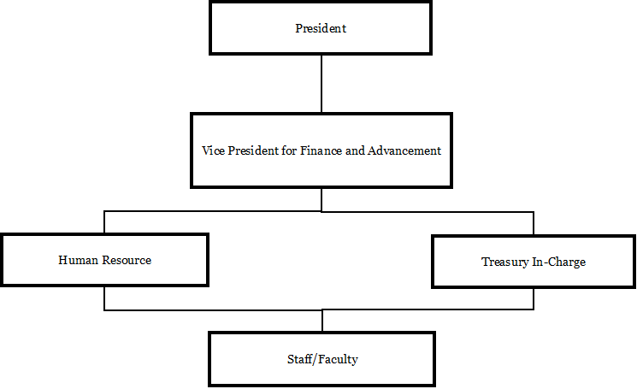

Figure 1. Organizational Chart of Southland College

1. President – is in-charge for the approval of the payroll
2. Vice President for Finance and Advancement – is in-charge for the verification of the payroll that is to be approved by the president.
3. Human Resource – is in-charge for the validation of the daily time record and check for the employee’s deductions and charges.
4. Treasury in-charge – is in-charge to reflect deductions and is the one who prepares the payroll.
5. Staff/Faculty – is the one who receives the pay slip
   1. Current System Description

Payroll System is the heart of any Human Resource System of an organization. It is understood that most people are tired of managing thousands of odd papers, pay slips, payroll reports and salary details and so on. Imagine that an institution/company has a payroll processing system which will generate our pay slips and payroll reports within seconds. The solution has to take care of the calculation of salary as per rules of the company, income tax calculation and various deduction to be done from the salary including statutory deduction like Income tax and provident fund deduction. It has to generate pay-slip, monthly, yearly and semester.

Figure 2 that is on the next page is the context DFD; it is a data flow diagram with only one massive central process that subsumes everything inside the scope of the system. It shows how the system will receive and send data flows to the external entities involved. The context diagram shows how the main scope of the system where the employee will login and the system will read the information entered by the employee. The human resources manage the employee’s details including the reports coming from the accountant who computes payroll transaction that will reflect on employee’s pay slip.

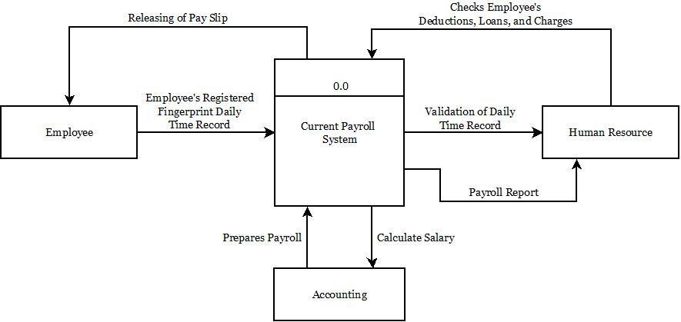

Figure 2. Context DFD of Southland College Payroll System.

Figure 3 that is on the next page is a graphical representation of the "flow" of data through an information system, modeling its process aspects. It is often a preliminary step used to create an overview of the system which can later be elaborated. It also shows what kind of data will be input to and output from the system, where the data will come from and go to, and where the data will be stored. Data flow diagram shows the step by step procedure that is more complicated on how the system will work, for example, an employee registers and it will validate the fingerprint automatically, the input information going through the database that computes the time record, gross pay and net pay that generates the deduction one by one. It is much easier compared to the manual procedure which is time.

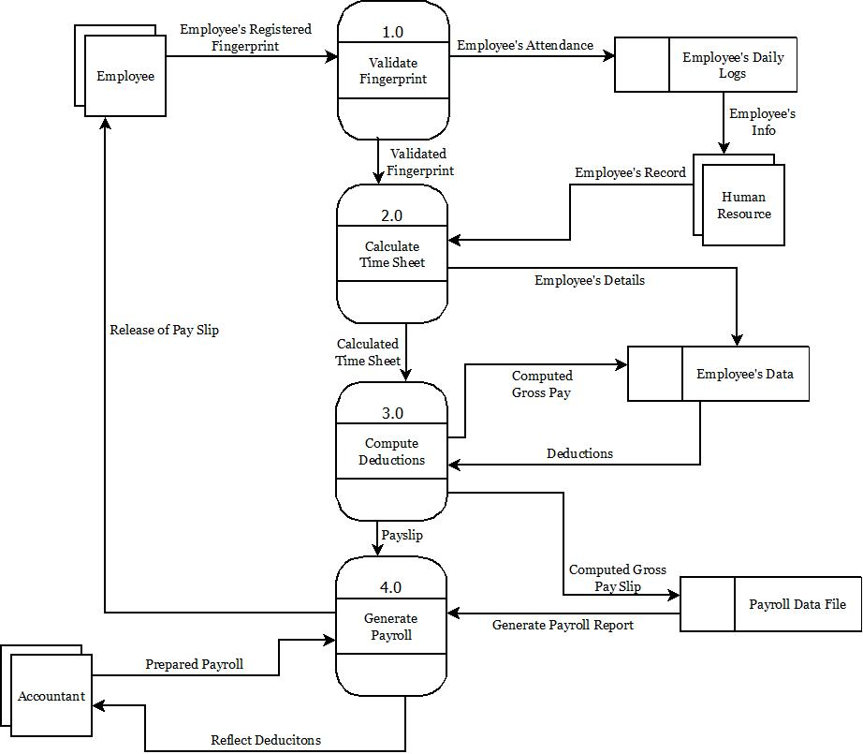

Figure 3. First Explosion DFD of Southland College Payroll System.

CHAPTER II

RELATED LITERATURE

**International Studies**

**YGK Payroll System**

According to Lee Ling Ling (2012), the main purpose of this project is to provide admin of YGK Jewellery Sdn. Bhd. the easiest way to calculate the target commission, count the total salary and produce a detail salary slip and produce a total monthly commission report and whole year total report in details. This project is carried out to solve the problem face by the admin of YGK Jewellery Sdn. Bhd. such as waste a lot of time in calculating the commission and target commission of each employee since the rate of commission and target commission of supervisor and sales assistants are different. With this project, the admin can count the total salary of each employee easily and also can produce the salary slip and a whole year total report in details. With this, it will save a lot of time and also easy the work of admin in payroll calculation activity.

This Payroll Management System is being developed using Visual Basic 6.0,

Oracle 8.0, Active X and Windows 98 or Windows 95 to take care of day to day

Attendance of All Employees. Its activities include are keeping the details of day In, Out, OD and others. Moreover, the master and transaction activities are divided into the module to easy the operation of activities. The data of this Payroll Management System can be taken and restore effectively as a backup [1]. The features of this Payroll Management System are:

- Manage the daily attendance of employee

- Date wise reports

- Maintainable and updateable

- Timing setter

- Shift wise attendance entry

- Multi-level attendance entry and reports

- Easy to handle

- Secure and reliable

**Project Report on Payroll System**

According to Asmau Sani Mohammed (2007), The Software engineering course that we took this semester placed emphasis on the paradigm of eXtreme Programming (XP) techniques. Extreme programming is a programming technique that bases its values on simplicity, communication, feedback, and courage. It encourages team work and constant communication with the client. The objective of this project is to put into practice the teachings that we have learnt about XP.

When we were first given this project, we met to determine how we were to carry out the task assigned to us. We drew up a time-line, discussed the programming language to use to carry out the task, how the GUI would look like and also make sure that we understood what was assigned to us. We finally settled for Visual Basic (VB) as our programming language. We got more information on what we were to do and set about completing our task, making use of the new ideas taught in class, and especially spikes.

The software was built using Visual Basic and it can run on computers that have the .NET Framework installed. We divided the whole project into five main modules: employee data, payroll records, rates, ledger, and help.

When a data is saved, the data gets written into an XML file. Keeping in line with making the software platform-independent, XML is also a highly platform-independent format for storing data. This is where all the data of the employee is stored, along with each month’s payroll data for the employee. There is also a separate XML file for storing current rates. For an employee data or payroll data to be saved to the file, it has to be serialized. Getting any data from the file will require the data to first be deserialized before it can be used. Serialization and deserialization helped make the data storage very simple.

We also used the object-oriented paradigm to code and organize our program. This ensured code reuse, and efficient updating of the code later on.

**Computerized Payroll System for Derf’s Manpower and General Services Phils, Inc.**

According to Raihana S. Dandamun (2013), Derf’s Manpower and General Services, Phils., Inc. is a private corporation duly registered with the Securities and Exchange Commision (SEC), Bureau of Internal Revenue (BIR), and the Department of Labor and Employment (DOLE).

Derf’s Manpower and General Services, Phils., Inc. had been the priority of the developers in creating a computerized payroll system for the benefit of the company and its employees, as well as to provide a payroll system that offers fast transactions, generates reports and lessens the time consumed in preparing the payroll. The objective is to develop a Computerized Payroll System for Derf’s Manpower and General Services, Phils., Inc. that provides fast transactions, minimize the manual checking of employees daily time record, monitors previous employee loans, cash advances and charges, and can generate essential reports.

It covers the time-in and time-out of employees through biometrics, specifically through a fingerprint scanner technology. It also covers the process of preparing the pay slip of each employee, monitors loans, cash advances, charges, keeping the records and easily computes the basic pay, regular overtime pay, overtime with night differential pay, pay during day off, special legal holiday pay, gross pay, SSS contributions, PhilHealth contributions, Pag-IBIG Contributions, admin fee, cash bond, loans and cash advances, charges deductions and net pay.

**Odyssey Payroll System**

Odyssey Payroll System is using IBM mainframe for the payroll system. It focuses on Time and Attendance of the employee. This payroll system is computer language based environment. There is no button to click but put the cursor to the related word and press Enter or type the related word to enter the system. It is divided into many menus to easy the operation of the activities. The function menus of Odyssey Payroll System includes are Employee Demographics menu, Position Control menu, Classification and Assignment menu, Time and Attendance menu, Benefits and Deductions menu, Employee Reviews and Awards, Applicant Tracking, Codes File Maintenance, Payroll On-line menu, Reports menu and College Specific menu. This system also gives authorized to the preparer and the authorizer to access the specific menu and specific function from the menu.

**Titus Information Payroll System**

A Payroll System designed to produce payroll checks with appropriate withholdings, benefits, allowances, and deductions for employees in multiple companies, departments, and/or sub-departments. It has been designed to handle up to 1,000,000 employees in 100 companies, 1,000 departments in each company, and 36 sub-departments in each department.

Some of the features and benefits of the Payroll System are multiple cost centers for payroll reporting, will handle special non-taxable benefits for ministers, flexible withholding capability, ability to split payroll expense between different cost centers, complete governmental reporting; FICA, FUTA, SUTA, Workman's Compensation, W-2's, and 1099's, Payroll check reversal, One check capability, Salaried, hourly, and contract employees in the same payroll run, Combined processing for weekly, bi-weekly, semi-monthly, or monthly, Taxable and non-taxable benefits and deductions, Multiple hourly rates for each employee, General ledger interface, Check list UFD file for check reconciliation, Extensive personnel information for each employee, Accrual of sick, vacation, and holiday hours, Flexible federal, state, and local taxation, Multiple company, department, and sub-department capability, Flexible benefit and deduction capability, Easy federal, state, and local tax table maintenance, Split income over multiple companies, departments, sub-departments, Payroll accrual/reversal capabilities, Time card data entry function, Special message function for printing on check stubs.

**Local Studies**

**Payroll System with Loan Management**

According to Hubert P. Bragas (2010), the term ‘payroll’ encompasses every employee of a company who receives a regular wage or other compensation. Some employees may be paid a fixed salary while others are paid for hours worked or based on the number of items they produced. The pay is computed by a payroll specialist using these payment methods after which the appropriate pay checks are issued. Companies often use objective measuring tools such as timecards or timesheets completed by supervisors to determine the total amount of payroll due each payroll period. The Macromedia Flex eXtensible Mark-up Language (MXML) is a new programming language which has a nice Graphical User Interface (GUI) and consists of a lot of new features which is more suitable for the proponents proposed payroll system with loan management. In this document, the proponents focused on the problem regarding the payroll system of RODSY marketing and how the proponents applied solutions which could solve their payroll-related problems. By properly analyzing the current structure of the company’s payroll system, the proponents have developed a new system which was properly customized to fit the functional requirements of the company. By developing this new system thru following the common payroll functions in coordination with the payroll-in-charge, the proponents have solved the problems of Rodsy Company.

**AHNEX Builders Network Based Payroll System**

Dayrit, 2007, AHNEX Builder Network ² Based Payroll System was designed for the newly set-up AHNEX Builders. The company is currently using Microsoft Excel in computing net pay which is time consuming. This proposed system will help in the work of the users in an easier process. Visual basic 6, Microsoft Access, and Crystal Report 9 were used for designing and creating the system. This was designed to meet the requirements of the company for a better and more enhanced system. Keeping track of record of employees, computing the salary and wages of each employee and generating reports were included in the proposed system.

**Computerized Payroll System of Department of Health (DOH)**

The Computerized Payroll System is a window based program especially designed to facilitate and simplify the monthly preparation of general payroll and related reports such as Standard computerized payroll system for use in all DOH offices, Allows faster and more accurate computation of monthly gross income, deductions and net salary, Faster and less-resource-consuming generation of General Payroll and other payroll related reports, Security and integrity of payroll data and information. The Features of computerized payroll system of DOH are Graphical User Interface, Interactive and menu-driven program, Systematic maintenance and retrieval of employee records, Flexible as it provides options to include additional fields for other compensation and deductions unique to an office or unit, Automatic computation of monthly net income, GSIS, PAG-IBIG, Withholding Tax and other deductions, Y2K compliant, Fast and easy generation of the General Payroll and all other payroll related reports which include Monthly reports like GSIS and PAG-IBIG remittances, Denominations Report and Leave Credits Report and annual Year-end Tax Reports, Password security to ensure the integrity of data. General payroll reports such as Payroll Summary sheet, Pay slip, Leave Credits Report, Withholding Tax Statement (W-2), BIR Remittance Reports, GSIS Remittance Reports, PAG-IBIG Remittance Reports, Other User-defined Reports (PERA, ACA, PNB).

**Payroll System (Service Management System)**

According to Myriz Janine C. Ricardo, April D. Giera, Maria Richel M. Dalanon, Jovelyn C. Pimienta, Michael Angelo V. Mendoza (October 7, 2014), in this new generation, the technology must have been upgraded. When it comes to the business world, they are also facing the rapid change of the technology. They are more competitive in business. Most of them are using some of the high technology. As part of the business, Payroll is one of the important bodies in the company. A systematized payroll system will help manage the wage of the employees. It could lessen the time of the bookkeepers to compute the salary of each employee in the company. Having a Computerized Payroll System will improve the business process and it can also avoid some minor problems that the company encountered. Basically, this is to provide an accurate computation of salary of the employee and to ensure that employee will receive the right amount.

The system needs to access the list of employee record from the recruitment system to view the information of an employee. It needs to be obtained because it is one of the essential information and include it in our main transaction. Payroll systems need get the summary of employee’s time record from monitoring personnel since they are monitoring the employee’s attendance information. The payroll system needs that time record in order to compute employee salary. In terms in salary deduction like SSS, Pag-ibig, Philheath and tax are deducted to each employee according to their different range of their income or compensation. There is an official table that needs to follow upon deduction. Different ranges of income have a different amount of contribution and withholding tax. Employee’s salary is computed according to the number days they have work. It could increase by overtime, night differential, holiday, allowance bonus. There are also corresponding amounts to be deducted such as SSS, Pag-ibig, Philheath, withholding tax, late and under time. If the person applies for a loan it also is added to his salary deductions.

The payroll system can generate reports such as:

• Semi Monthly and monthly payroll reports

• Statutory reports such as SSS, Pag-ibig, Philhealth and withholding tax.

• Allowance report

• Bonus and 13 Moth pay report

• Incentive leave reports

• Loan payment reports

The payroll system can generate and print employee’s pay slips to be distributed to the employees. In pay slips, it states the summary of employee’s compensation such as gross pay, total deduction, and net pay. When hiring a new employee, renewing a contract/appointment, or making a change to a contract/appointment the following submission deadlines apply. If the renewal is not processed and completed in HR PeopleSoft before the expiry date of the appointment, the termination process will be initiated. The cut-off will be 15th of the month and 30th day.

The Payroll Management System will provide a secured database on which the user could retrieve and save data and information at ease with the use of MS SQL database. Developing this payroll software will process payroll in a timeliness manner, it is efficient and reduces cost since it does not need a lot of payroll master in computing employee’s salary. This software is develop using Java language, mySql for database and connector/J for the connection.

**Timekeeping and Payroll System of Blanco Family Academy**

The proposed system Time Keeping and Payroll System for Blanco Family Academy covers many aspects of time keeping and payroll process. This includes the capture of information based on the employee’s work schedule, daily time worked and daily time rendered. The payroll process encompasses all activities necessary to report employees’ time worked. The system will convert the current company’s time keeping and payroll into Visual Basic Program.

* The system will have a file management where it covers the records of employee and system transaction log.
* The system also covers the Payroll Processing and Reporting which includes the pay calculation of salary slip and time off tracking.
* The employee will use biometrics to time-in and time-out for the recording of timekeeping.
* The system will have a report consist of a summary of the time sheet, a summary of Payroll Computation, Summary of Tax Refund and 13th Month Pay, Withholding Tax, SSS, and Pag-IBIG Contributions.

The Database of this system is uploaded also to MediaFire every end of the day to back-up the record file of this system. The admin of the system is assinged to update back-up. The Proponents use Microsoft Visual Basic 2008 Express edition the system can be updated with the latest Microsoft Visual Basic programming language by the programmer when it’s necessary.

CHAPTER III

PROJECT CHARTER

This chapter was based on the research and on the interview that the team had conducted at the Accounting office of Southland College about the Payroll System. The office is having a hard time in manually checking and monitoring previous loan, taxes, deductions and preparing essential reports due to unorganized employee records. The office solely depends on the printed records and reports wherein it is unorganized. In the case of data loss, the office is expected to start from scratch and even difficult for them to know the employee’s payroll history. The chances to make an error are high and arduous for them to understand why an error occurred. Therefore this project proposal on automating the payroll process will eventually help the office.

3.1 Project Objectives

The project team aims to create a system that could provide the necessary database for all the payroll records and the systems expected storage consumption. It is because the system must be able to cope to all data bulk the payroll system needs to receive and store.

1. To calculate the salary of the employees accurately
2. To provide shorter time for information retrieval
3. To produce a detailed pay slip
4. To secure the records of employees

3.2 Project Conception

As the organization grows, the demands on business operations guarantee the institution/company to hire employees and pay salaries based on their services and rates. Automation of the current payroll process is a suitable need for business. In the accounting department, there is a lot of different task like handling payroll, managing employee’s loans, and much more. This is one of the reasons why the project team comes up with this idea. It will greatly benefit the institution in terms of the efficiency of generating payrolls and monitoring the employee’s leaves, absences, and withholding tax. The automation will help the payroll staff secure the records and operate conveniently.

This payroll system is flexible and will be able to meet some of the most demanding needs of the institution. It is a system that successfully deals with all phase of labors including tax reporting, complex ledger updates, wage compliance, payroll reports, benefit/deduction eligibility, and alternate types of pay. In addition, the system contains the employee’s record to generate payroll transaction. It can update employee information, file leave, access control and also the calculation of 13th month pay and withholding tax.

3.3 Problem Statement

After the research and interview that the team had made with the people in-charge at Southland College, we’ve found out that “Southland College Payroll System” should be developed. This is because the old system is outdated and no longer adequately manages the payroll process and the entry of employee time card information. Therefore, manual intervention is required to process the payroll.

1. Inaccuracy in calculating of salaries
2. Unorganized employee details
3. The chances of making an error are high
4. It has no security mechanism

3.4 Initial Scope of the Project

This three people who are involved in this process that can access the system are the Human Resource who validates the time records and check the employee’s deduction. The accounting and finance who reflect deductions, prepare payroll and verify the payroll data for the president’s approval. These are the people who keep access and manage the system.

The study was designed to develop a Payroll System for Southland College. This study will cover the process of preparing the pay slip of each employee, monitors loans, cash advances, keeping the records safe and computing the exact wages of each employee, deductions, and net pay. It covers the time-in and time-out of employees through biometrics, specifically through a fingerprint scanner technology. It also includes the report list such as monthly salary, basic salary, gross payment, withholding tax, SSS, PhilHealth, and Pag-ibig Contribution. The proposed Payroll System for Southland College is expected to generate Pay slip of employees, loan reports, and employee reports.

3.5 Project Vision

If this proposed system will be approved some of the expected improvements are the protection of the company which provides both the employer and employee accuracy of their wages payment. This will help decrease the expenses of the company which can be used in other expenses. It will also be easy for the accounting personnel to do their task considering that there is an assurance that the time keeping and salary figures are secure. For the employees, it will be to transact about their time records and monitor their loans, leaves, and absences.

After the system installation, it would be fast and easy for the personnel to handle transactions such as report making and monitoring time entries. An automated payroll system will be a big help to the institution.

3.6 Business Constraints

The business restriction that constricts the system proposal/development is the institution’s confidentiality; it’s hard for the team to get the details because the information is limited. Due to the in-charge hectic schedule, the team has to wait in line to conduct an interview.

The funds that the project team has are only limited considering that each member does not have a source of income to support the expenses in the process of developing the system. Nevertheless, these constraints will never an issue for the team to pursue the objectives of the Southland College Payroll System.

3.7 Technology Constraints

The project team has two options on the hardware that will be going to use in developing the system, the RFID, and the Biometric Fingerprint Scanner. There are lots of constraints in using RFID in terms of securing employee’s daily time record, RFID use tags which can be exchanged among employees compared to the biometric fingerprint scanner who uses fingerprints which can’t be share. A biometric fingerprint scanner is much more effective and secure than the RFID it is because a RFID scans automatically and is, therefore, running all the time while the biometric fingerprint scanner is only activated when the employee scans their registered fingerprint. Another difference is that biometric scanner has low chances of time theft, whereas the RFID has a lot of chances that the situations like that may occur.

These differences will surely cost the company a lot of money. The last constraint of using RFID is that it does not have a notification whether you’ve successfully scan your ID, unlike Biometric Fingerprint Scanner it has notifications regarding mistimed ins and outs. However, there are limitations in using biometric fingerprint scanner like the biometric data; it can be copied, delete, stolen and it may have a high rate of reading failure and misreading but these constraints will not be a hindrance for the team in creating this system.