Republic of the Philippines

Carlos Hilado Memorial State College – Binalbagan Campus

Binalbagan, Negros Occidental

MIDTERM EXAM  
IT 112

(Computer Applications)

Name: _________________________________ Year & Section: ______________ Score: ____________

1. Identification

Write your answers on the space provided.

_______________________ 1. It enables you to view individual clips or an entire project. _______________________ 2. It lists the common tasks that you may need to perform when making a movie, including importing files, editing, and publishing your movie.

________________________ 3. It captures the image in digital form and then transfers the data to a PC.

________________________ 4. It is a program designed to run other programs on a computer. ________________________ 5.It produces a hard copy version of processed data such as documents and photographs.

________________________ 6. It is a data that has been processed into a meaningful form.

________________________ 7. These are the people who use computer to obtain information.

________________________ 8. It is a type of computer used in large organization.

________________________ 9. It is a programmable, electronic device that accepts data input, performs processing operation on that data and outputs the results.

________________________ 10. It shows how the document will look when you print it.

________________________ 11.It reverses the last command, use pull-down menu to undo several steps ________________________ 12. It is used by the user to move a pointer around the screen and clicks its buttons to make selections.

________________________ 13. It enables a computer to recognize the human.

________________________ 14. It is an instruction or computer program that is used to tell a computer what it should be done.

________________________ 15. It is the default view in Windows Movie Maker.

________________________ 16. It shows clips, effects, or transitions you're working with while you create your movie, depending on the view you're working with.

________________________ 17. It displays the address of the current active cell where you work in the worksheet.

________________________ 18. This area contains all the cells of the current worksheet identified by column headings, using letters along the top, and row headings, using numbers along the left edge with tabs for selecting new worksheets.

________________________ 19. It is a feature that enables you to create home movies and slide shows on your computer, complete with professional-looking titles, transitions, effects, music, and even narration.

________________________ 20. It is a monitor usually use LCD or plasma to create output.

________________________ 21. It is an instruction or computer program that is used to tell a computer what it should be done.

________________________ 22. He developed World Wide Web.

________________________ 23. It is the largest and most well-known computer network in the world.

1. Multiple Choice

Write your answers on the space provided.

|  |  |  |  |  |
| --- | --- | --- | --- | --- |
| A | B | C | D |  |
| http://www.internet4classrooms.com/word_but_tab.gif | http://www.internet4classrooms.com/word_but_format.gif | http://www.internet4classrooms.com/word_but_print.gif | http://www.internet4classrooms.com/word_but_save.gif | 24. You have made a change to the active document and want to make certain that those changes are saved. |
| http://www.internet4classrooms.com/word_but_print.gif | http://www.internet4classrooms.com/word_but_art.gif | http://www.internet4classrooms.com/word_but_undo.gif | http://www.internet4classrooms.com/word_but_ss.gif | 25. The document had been checked for spelling errors, it has been saved, and now you are ready to print. |
| http://www.internet4classrooms.com/word_but_save.gif | http://www.internet4classrooms.com/word_but_new.gif | http://www.internet4classrooms.com/word_but_spell.gif | http://www.internet4classrooms.com/word_but_open.gif | 26. A document which has been saved into a folder on your computer is to be opened so changes can be made. |
| http://www.internet4classrooms.com/word_but_column.gif | http://www.internet4classrooms.com/word_but_preview.gif | http://www.internet4classrooms.com/word_but_ss.gif | http://www.internet4classrooms.com/word_but_cut.gif | 27. The document had been checked for spelling and has been saved. Before sending it to the printer you want to see how it will look. |
| http://www.internet4classrooms.com/msword_but_high.gif | http://www.internet4classrooms.com/msword_but_bold.gif | http://www.internet4classrooms.com/msword_but_tcolor.gif | http://www.internet4classrooms.com/msword_but_jus.gif | 28. You wish to call attention to a statement in your document by making the text bold. |
| http://www.internet4classrooms.com/msword_but_cen.gif | http://www.internet4classrooms.com/msword_but_left.gif | http://www.internet4classrooms.com/msword_but_jus.gif | http://www.internet4classrooms.com/msword_but_rt.gif | 29. A flyer is to be prepared inviting parents to a performance. You want the headline to be centered on the page. |
| http://www.internet4classrooms.com/msword_but_bord.gif | http://www.internet4classrooms.com/msword_but_unin.gif | http://www.internet4classrooms.com/msword_but_size.gif | http://www.internet4classrooms.com/msword_but_high.gif | 30. Another way to call attention to a block of text is to place a border around it. |
|  |  |  |  |  |
|  |  |  |  |  |

1. Labelling

Label at least (ten) 10 parts of Microsoft Excel Window. (20 points)

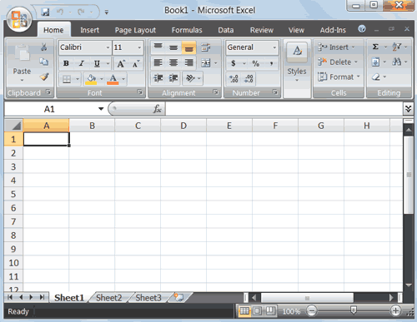

1. Enumeration

1-4 Types of Computer

4-8 Examples of Output Devices

8-12 Examples of Input Devices

12-20 Shortcut Keys and corresponding tasks

Good Luck!!!

*Prepared by: Philamae V. Yula*