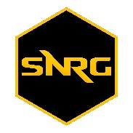South Negros Riders’ Group

Kabankalan City, Negros Occidental

April 2019

____________________

____________________

____________________

Greetings!

The South Negros Riders’ Group is a non-profit motorcycle club that promote brotherhood and unity through community-related services as well as passion in safe riding.

The group also cunducts school drives and social welfare support services including gift giving activities and ushers school, public and private sectors activities.

We are writing this letter on behalf of South Negros Riders’ Group in anticipation for your valuable donation as we participated in a Basketball League to aid our expenses in our uniform in the said activity.

We hope that you take this opportunity to support us, as your donation will do so much for the group.

Thank you very much! God bless!

Respectfully yours,

Joelita D. Carian

SNRG President