Gustavo Cereceres
.NET Engineer
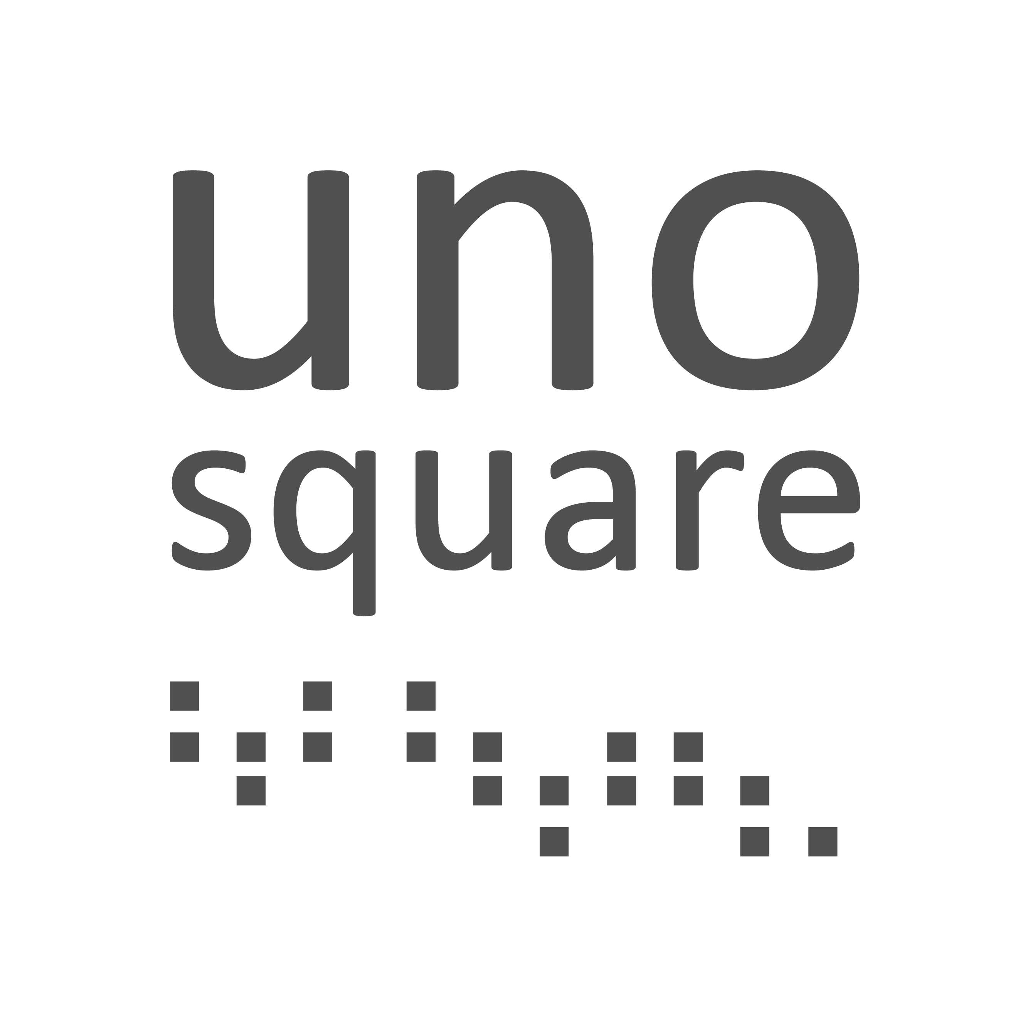

PROFILE

.NET Engineer with over 14 years of experience specializing in backend and full-stack development. Proficient in C#, .NET Core, Entity Framework, and various databases, including SQL Server and MySQL. Experienced in building REST APIs and microservices and integrating systems with cloud platforms like Google Cloud Platform, Azure, and Terraform. Adept in developing and maintaining features, performing bug fixes, and enhancing code quality with comprehensive unit and integration tests using tools like MSTest, XUnit, and Moq. Proven ability to work in Agile environments (Scrum, Kanban). Previously worked on diverse projects across industries, including banking, e-commerce, education, and construction project management. Always committed to producing clean, maintainable code and improving infrastructure while ensuring top-notch service integration and delivery.

TECHNICAL SKILLS

TECHNOLOGIES: | METHODOLOGIES:
- C#,  - .NET Core  - Asp.Net Core (REST API)  - Entity Framework  - HTML, CSS, JavaScript  - Bootstrap  - Angular2+  - Typescript  - Node.js  - Angular.js  - Identity Server  - JWT Tokens  - SQL Server  - MySQL  - xUnit, NUnit, MS Test  - Moq  - Autofixture  - Git  - GCP Pub/Sub  - GCP Storage  - GCP Logging  - GCP BigQuery  - GCP Workloads  - Azure SQL  - Azure Storage  - Azure Servers  - Terraform  - Microservices | - Scrum  - Kanban

WORK EXPERIENCE

UNOSQUARE Medxoom (JUN 2022 – DEC 2024)
Backend Developer

Responsible for developing new features and providing ongoing support for existing services while collaborating on integrating new clients into the platform. Key responsibilities include analyzing stakeholders' feature requirements and translating them into actionable tasks. This involves ensuring high-quality implementation, writing detailed unit and integration tests to achieve optimal test coverage, and making necessary infrastructure adjustments using Terraform. Additional tasks include testing and troubleshooting in lower environments and monitoring system performance with Google Cloud Platform (GCP) tools. Also tasked with identifying and resolving bugs by thoroughly investigating root causes, replicating issues, and implementing fixes. Every fix is followed by comprehensive testing to prevent the recurrence of the problem.
Tools and technologies: C#, ASP.NET Core, HTML, Entity Framework Core, Refit, MSTest, MySQL, Google Cloud Platform (Pub/Sub, Storage, Logging, BigQuery, Workloads), Terraform, Moq, Autofixture.

UNOSQUARE Axos Bank( AUG 2020 – MAY 2022)
Backend Developer

Development and support of core services related to user credentials for user-facing applications. My primary responsibilities included development and support tasks related to user and identity management, such as new logins, JWT, 2FA, Security questions, and Biometric verification. Increase code coverage from around 50% to 80% on the leading service under our responsibility.

Tools and technologies: C#, .NET Core, ASP.NET Core, Entity Framework, MSTest, xUnit, SQL Server, Moq, Autofixture, JWT, Identity Server.

NEARSHORE TECHNOLOGY (JUN 2018 – JAN 2020)
Full stack Developer

Supported and developed a solution to consolidate multiple databases into a single cloud and created a user-facing web application to present analytics based on the consolidated data. My primary responsibility was to design and generate REST APIs to send/receive data from client systems to the cloud servers to consolidate data into the cloud servers. Ensure performance by adding tests and developing a custom app for stress testing on the server side.

Tools and technologies: C#, ASP.NET Core, Entity Framework, MSTest, MSSQL, Moq, Autofixture, Angular 2+, HTML, CSS, Bootstrap. D3.js.

NEARSOFT (APR 2015 – DEC 2018)
Full stack Developer

Supported and developed web applications and managed school documents (test results, parent letters, reports). Develop and support custom US school districts web applications based on .NET stack. .NET 4.6, dotnet core, Azure SQL, Angular (1.x and 2). Prepare a custom application to integrate new school districts into the application by adjusting and creating forms for test result reports and parent letters, among other features. This involved working on the front end (Angular) and the back (C#, AzureSQL). Once the adjustments were done, deploying and testing on the designed Azure instance for the district.

Tools and technologies: C#, MVC, Entity Framework, .NET 4.6, ASP.NET Core, Azure (SQL, Storage, Server), HTML, CSS, Bootstrap, JavaScript, Angular.js, Angular 2+.

SPECTRUM MERCADOTECNIA (JAN 2013 – MAR 2015)
Software Developer

Support and development of e-commerce platform. Support and development of both internal and user-facing applications. Part of the team in charge of renovating legacy pieces of internal and user-facing components such as shopping cart modules, both front end and back end.

Tools and technologies: C#, VB.NET, ASP.NET, ASP, MVC, Entity Framework, .NET 4.6, MSSQL, Knockout.js, jQuery, HTML, JavaScript.

BUILDBINDER (JAN 2013 – NOV 2013)
Full stack Developer

Development of construction project management web application. Develop and support new modules required by stakeholders, from adding new widgets into the app front end to improving security by implementing password encryption.

Tools and technologies: MVC3, ASP.NET, C#.NET, LINQ, Entity Framework, Azure SQL, jQuery, Ajax, HTML.

AZUR SYSTEMS (OCT 2011 – JAN 2013)
Software Developer

Development of desktop applications and console applications for creating, validating, and managing Invoices for Mexican companies. My primary responsibility was implementing changes required by new invoice versions, adding new fields, schema validation, and implementing web service communication with the Mexican treasury department to validate and sign newly created invoices.

Tools and technologies: C#.NET, ASP.NET, LINQ, Entity Framework, MSSQL, SharePoint, SOAP.

Education
Universidad Autónoma de Chihuahua, Chihuahua, México. Computer Systems Engineer (2011)

