Christopher Raleigh

Summer University 2013 Quiz Application

# Main Menu

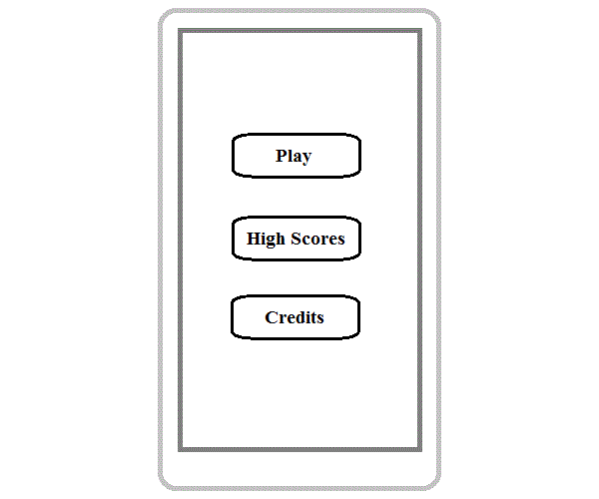

* The **Play** button goes to the **Game Modes** screen.
* The **High Scores** button goes to the **High Scores Menu** screen.
* The **Credits** button goes to the **Credits** screen.

# Game Modes

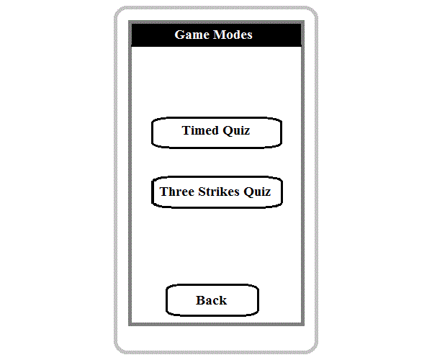

* The **Timed Quiz** button goes to the **Timed Quiz Description** screen.
* The **Three Strikes Quiz** button goes to the **Three Strikes Quiz Description** screen.
* The **Back** button goes to the **Main Menu** screen.

# Timed Quiz Description

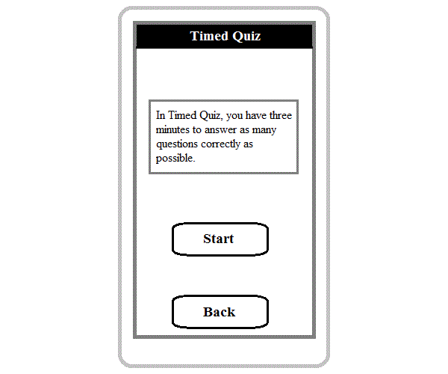

* The **Start** button goes to the **Timed Quiz** screen.
* The **Back** button goes to the **Game Modes** screen.

# Timed Quiz

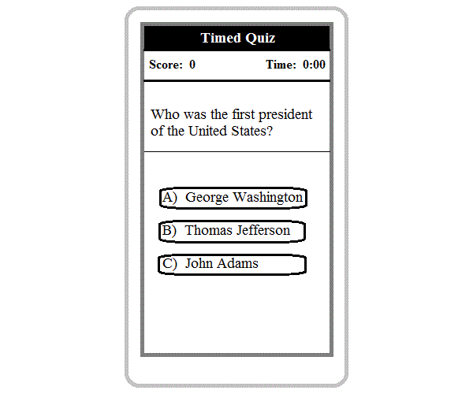

* The **score** starts from 0 and increases by 1 for each correct answer.
* The **time** starts from 3:00 and counts down to 0:00 over 3 minutes.
* Once the time is up, a popup message notifies the player that the game is over and returns them to the main menu, recording their score if it is in their top 10.
* Questions should be chosen randomly from a database, making sure that no question is given twice per game.

# Three Strikes Quiz Description

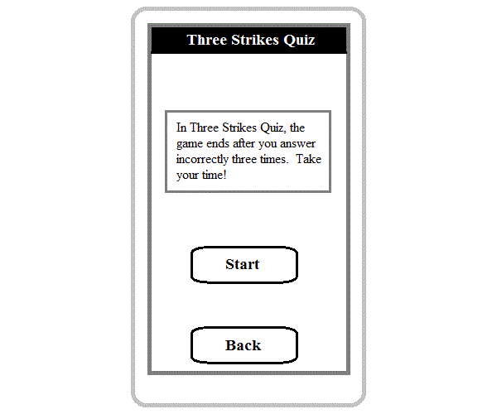

* The **Start** button goes to the **Three Strikes Quiz** screen.
* The **Back** button goes to the **Game Modes** screen.

# Three Strikes Quiz

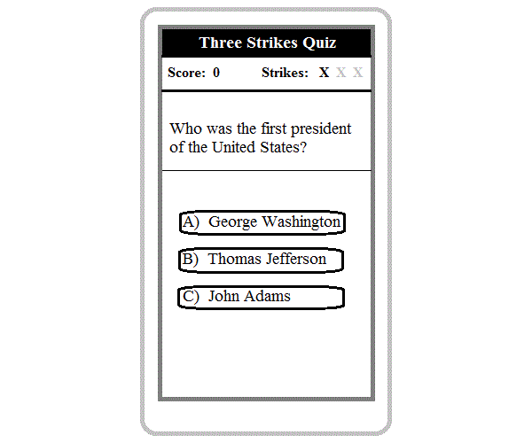

* The **score** starts from 0 and increases by 1 for each correct answer.
* The **strikes** start with three light X’s. Each incorrect answer darkens an X.
* Once all 3 X’s are darkened, a popup message notifies the player that the game is over and returns them to the main menu, recording their score if it is in their top 10.
* Questions should be chosen randomly from a database, making sure that no question is given twice per game.

# High Scores Menu

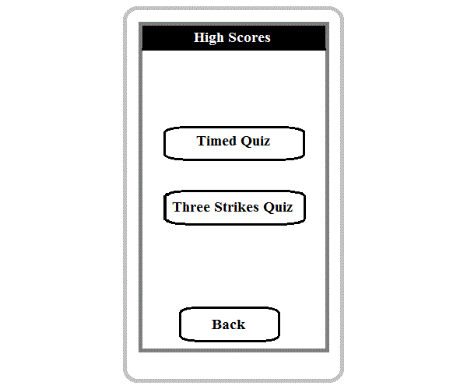

* The **Timed Quiz** button goes to the **High Scores Timed Quiz** screen.
* The **Three Strikes Quiz** button goes to the **High Scores Three Strikes Quiz** screen.
* The **Back** button goes to the **Main Menu** screen.
* Both game modes have their separate high scores.

# High Scores Timed Quiz

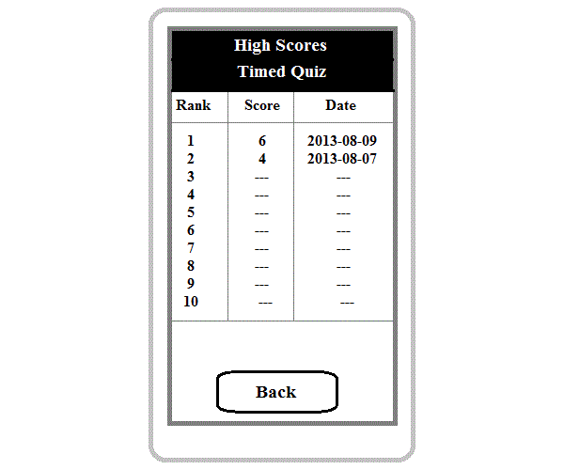

* The top 10 scores for the **Timed Quiz** mode are shown.
* Dates should be formatted automatically as per the user’s phone settings.
* These scores are of the individual user only. Global scores are not shown.
* The **Back** button goes to the **High Scores Menu** screen.

# High Scores Three Strikes Quiz

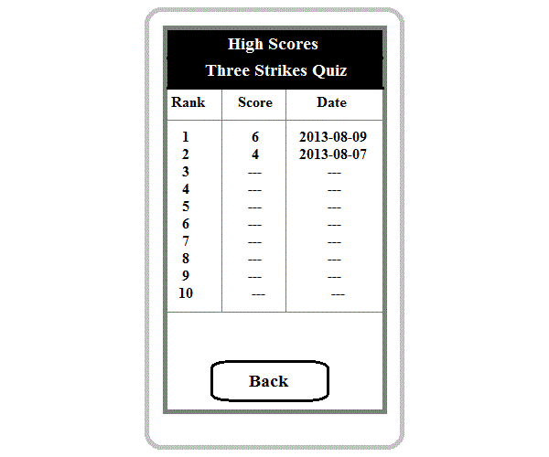

* The top 10 scores for the **Three Strikes Quiz** mode are shown.
* Dates should be formatted automatically as per the user’s phone settings.
* These scores are of the individual user only. Global scores are not shown.
* The **Back** button goes to the **High Scores Menu** screen.

# Credits

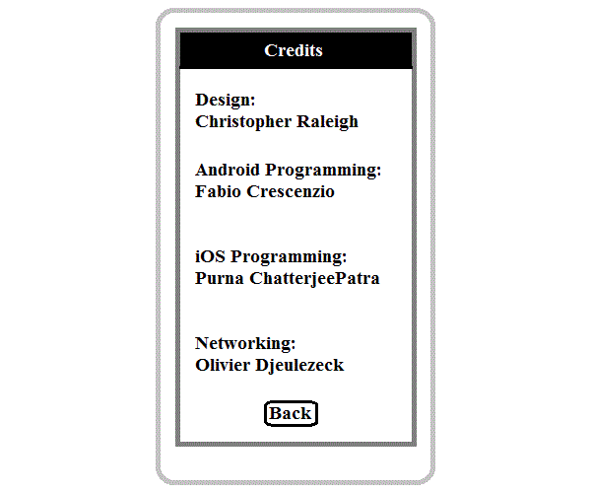

* The **Back** button goes to the **Main Menu** screen.