INSY 4315
Assignment 2

- Download the zipped file from Assignment 2 and save it to a folder where you want to use as local root folder for your website. Unzip the file and extract the folder \HW2 which contains the needed graphic elements and a body text file.
- Create a new html file. You will need to upload it to your student web folder created in Assignment 2 and submit the URL to the Blackboard site.
- Page layout is shown and described below. You can use either table or CSS layers to design the layout:
  - Change the title of the page (to be shown in the title bar of the web browser) to: “Your name, HW#2” (your actual name).
  - The whole page will have a width of 735 pixels, plus 5 pixels of padding all around, in white (for content area) over medium grey (for remaining screen area).
  - Page content elements will fall into either of the two columns: left column has a width of 470 pixels, right column 240 pixels, with a margin of 10 pixels between the two columns.
  - Hints for CSS: essentially, there is a division for the whole page; nested inside that division are two other divisions for the left and right “columns”; all content elements (graphics, text, etc.) must be placed inside either one of these two (left/right) divisions.
  - Hint for using table for layout: one table with two columns; inside each column, add additional tables as needed.
- On the left hand side:
  - At the top, place the main graphic: electronics470x170.jpg; you may like to add about 5 pixels of spacing (margin) around the graphic.
  - Next is a top navigational bar. It contains 3 “phony” hyperlinks (that actually do not link to any web address) as shown. Use CSS to restyle the hyperlinks so that they are NOT underlined; be sure to add the necessary “padding” all around to give the needed space.
  - Below the navigational bar is the main text area (you can create it yourself or copy and paste the text from the bodyText.txt file. It has a border all around (the color choice is yours), and a title “Industry News” in white text over dark background as shown (CSS hint: you will need to define a new “class” for this)
  - Take 3 paragraphs of lorem ipsum text; break them up into several shorter ones. Use some short phrases as headings. All text styling must use CSS; no credit given otherwise.
    - Use “Arial, Helvetica, san serif” font families for all the text
    - “Paragraph” text has a height of 0.9 ems
    - There will be two “Heading1” and two “heading 2”. They are in bold and bold italic, respectively, and in a larger size; “Heading 1” also has an underline running across the column.
  - Take a short phase to be used as the pull quote as shown (larger text in italic, floating to the right)
- On the right hand side:
  - At the top is text section “Savings on Shopping”. It has a border all around (the color choice is yours), and a title “Savings on Shopping” in white over dark background as shown (CSS hint: re-use the classes defined earlier). There are three names of retailers; need to provide hyperlink to only one of them, (Amazon.com, target.com or jcpenny.com).
  - Below it, placed two banner ads: “ad234x60.gif” and “ad240x400.gif”; be sure to add about 5 pixels in vertical space between them
Replace this with your name

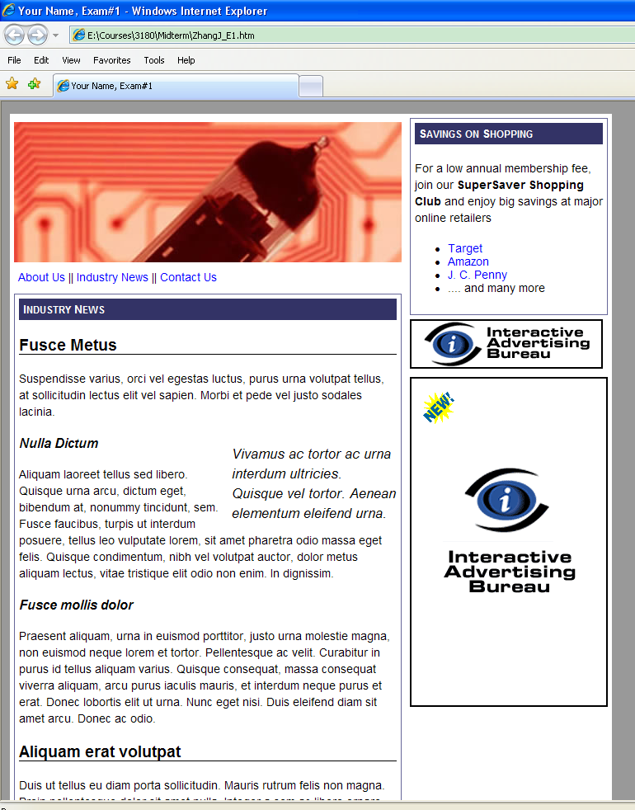
Image: electronics470X170.jpg
Image:
Ad234x60.gif
Image:
Ad240x400.gif
Pull quote
Page with medium gray background
White “title” text on dark background
Heading 1
Heading 2
Heading 2
Heading 1

