Hoang Tuan Anh – C4E21 – Session 2 Assignments.

1. Boolean value is either **True or False** (in Python). Example expressions:
   1. 6 < 3 (False)
   2. 2 is 2 (True)
   3. 7 in range(9) (True)
2. A flowchart is a type of diagram that represents an algorithm, workflow or process, showing the steps as boxes of various kinds, and their order by connecting them with arrows

if name == “Huy be":

   print(“Hand some")

elif name == “Huy big":

   even_more_handsome = True

else:

   webbrowser.open(“<https://www.youtube.com/watch?v=04854XqcfCY>”)

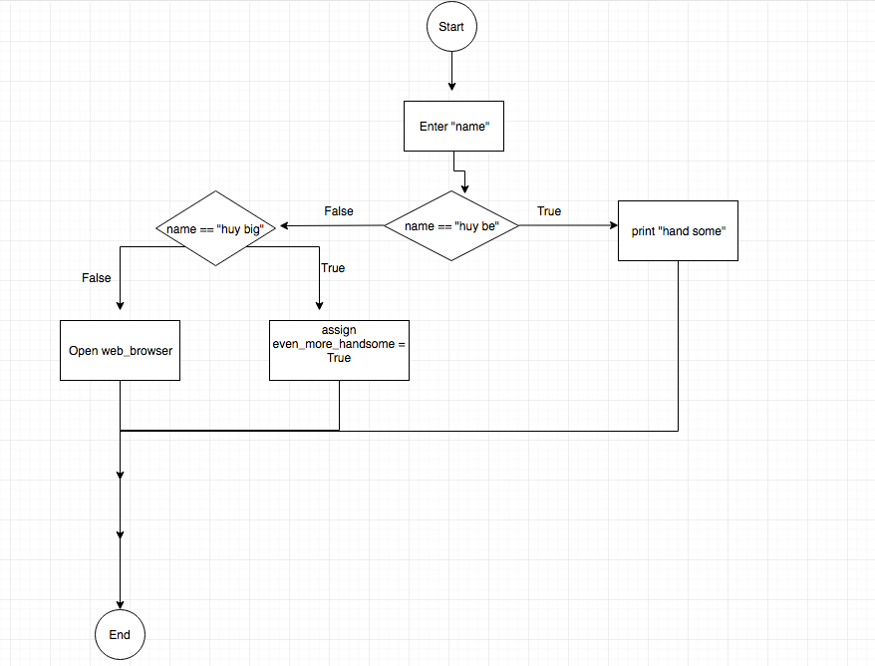

1. Nested conditionals: a situation when you want to check for another condition after a condition resolves to true

You can have an if...elif...else construct inside another if...elif...else construct.

Example:

*num = float(input("Enter a number: "))*

*if num >= 0:*

*if num == 0:*

*print("Zero")*

*else:*

*print("Positive number")*

*else:*

*print("Negative number")*