**Project Title:** Weather Data Analysis for Nigeria States For Agriculture

**BY**

**ISRAEL OLUWASEGUN KOLAWOLE**

**Introduction:** this project involves analyzing comprehensive weather data specific to various states in Nigeria to derive actionable insights for agricultural decision-making. By exploring key meteorological parameters across different locations and time periods, we aim to uncover patterns, trends, and anomalies that can inform and optimize agricultural practices.

**Dataset:** The weather data for this analysis is sourced from NASA's POWER (Prediction of Worldwide Energy Resource) Data Access Viewer. This dataset provides detailed meteorological information, including parameters such as temperature, humidity, wind speed, precipitation, and solar irradiance, among others. The data is essential for understanding the climatic conditions that affect agricultural productivity in different states of Nigeria.

**Client:** The ideal end user of the analysis findings are those in the Agricultural field and those needing any information related to Agriculture in Nigeria. This executive is responsible for optimizing agricultural practices to enhance crop yields, manage resources efficiently, and ensure sustainable farming across the states of Nigeria.

**Abstract**

This project focuses on analyzing weather data from various states in Nigeria to provide actionable insights for agricultural decision-making. By leveraging a comprehensive dataset from NASA's POWER Data Access Viewer, we explore key meteorological parameters such as temperature, humidity, wind speed, precipitation, and solar irradiance. Our analysis aims to uncover patterns, trends, and anomalies that significantly impact agricultural productivity.

Utilizing Excel for initial data cleaning and exploratory analysis, we employed What-If analysis tools such as Scenario Manager and Goal Seek to evaluate different scenarios and their potential outcomes on agricultural practices. Further, we performed advanced data analysis using SQL to generate insights and create visualizations in PowerBI that highlight key trends and correlations in the weather data.

Our findings offer valuable insights into the climatic conditions affecting agriculture in Nigeria, providing the Agricultural Development Officer (ADO) and other stakeholders with data-driven recommendations to optimize resource management, enhance crop yields, and ensure sustainable farming practices. This comprehensive approach combines the strengths of various analytical tools to deliver a robust and detailed analysis of weather patterns critical to agricultural success

****Project Title:** Weather Data Analysis for Nigeria States For Agriculture**

**Introduction:** Our project focuses on the comprehensive analysis and visualization of weather data sourced from NASA's POWER Data Access Viewer. This dataset encompasses a wide array of meteorological parameters crucial for understanding climate dynamics, including temperature, humidity, wind speed, precipitation, and solar irradiance. By exploring these datasets, we aim to uncover trends, patterns, and anomalies in regional climates over multiple years .

**Dataset Overview:** The weather dataset consists of detailed measurements across various parameters recorded at different locations over time. These measurements are essential for climate scientists, environmental researchers, and policymakers to formulate effective strategies for climate adaptation and mitigation.

**Tools and Techniques:**

* **Excel:** Used for initial data cleaning, transformation, and basic analysis.
* **SQL:** Employed for querying, aggregating, and filtering data to derive insights through structured queries.
* **Python:** Utilized for advanced statistical analysis, machine learning models, and exploratory data analysis (EDA).
* **Power BI:** Chosen for interactive and dynamic visualization of insights, facilitating intuitive data exploration and presentation.

**Objectives:**

1. **Data Cleaning and Preparation:** Ensure data integrity and consistency across all parameters and locations.
2. **Exploratory Data Analysis (EDA):** Identify trends, correlations, and anomalies in weather patterns.
3. **Statistical Analysis:** Perform statistical tests and modeling to uncover deeper insights into climate variability.
4. **Visualization:** Create interactive visualizations to communicate findings effectively to stakeholders.

## Key Metrics

### Summary Statistics

1. **Average Temperature Variation by State:**

Analyze the average temperature fluctuations across different states in Nigeria to understand regional climate patterns crucial for agricultural planning.

1. **Annual Precipitation Trends**

Explore annual precipitation levels and variability by state to assess water availability for agricultural purposes and potential drought risks.

1. **Humidity Levels Over Time**

Investigate humidity trends across months and years to determine optimal planting and harvesting seasons for various crops.

### Frequency Counts

1. **Distribution of Wind Speed**

Evaluate the frequency distribution of wind speeds to assess potential for wind energy utilization and its impact on agricultural operations.

1. **Cloud Cover Analysis**

Examine cloud cover frequency to understand its influence on solar radiation availability for crop growth and solar energy generation.

### Climate Extremes

1. **Extreme Weather Events**

Identify occurrences of extreme weather events such as storms, heatwaves, or prolonged dry spells that could impact agricultural productivity and infrastructure.

1. **Temperature Extremes**

Investigate instances of unusually high or low temperatures to assess their frequency and potential implications on crop yields and livestock health.

### Seasonal Variations

1. **Seasonal Rainfall Patterns**

Study seasonal variations in rainfall patterns to optimize irrigation scheduling and water management practices in agriculture.

1. **Temperature Fluctuations by Season**

Analyze temperature fluctuations across seasons to determine suitable crops and farming techniques for specific climatic conditions.

.

Certainly! Here’s a draft for the "Data Analysis" section focusing on your weather data analysis for Nigeria states:

# Data Analysis

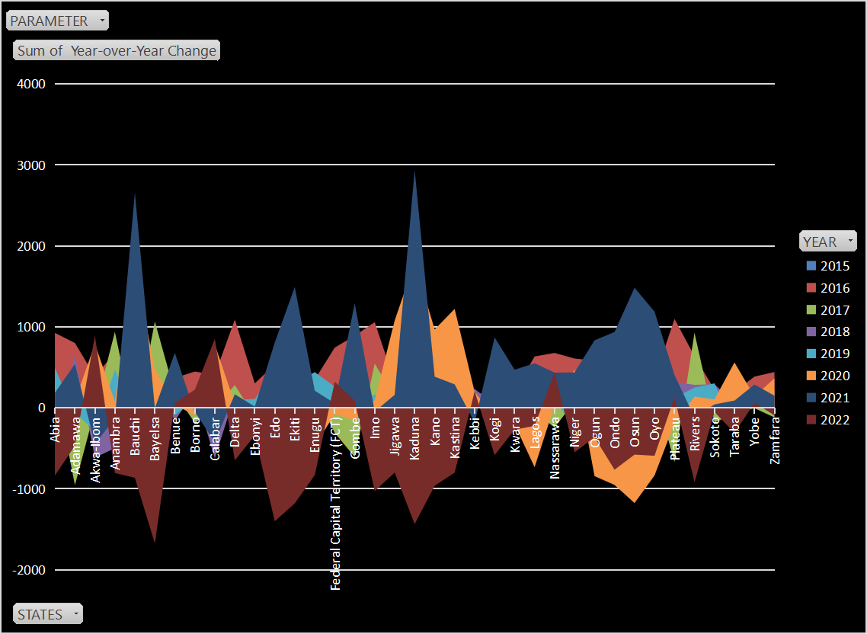

## Temperature Analysis

### ****Average Temperature Trends****

* Utilize historical temperature data to analyze average monthly and annual temperature trends across different states in Nigeria.
* Identify regions with significant temperature variations and their potential impact on agricultural practices.

1. **Temperature Extremes**

* Investigate occurrences of extreme temperatures (both high and low) to understand their frequency and implications for crop growth and livestock management.

## Precipitation Analysis

1. **Annual Precipitation Patterns**

* Evaluate annual precipitation levels and variability across Nigeria states to assess water availability for agriculture and potential drought risks.
* Compare seasonal precipitation patterns to identify optimal planting and harvesting periods.

1. **Rainfall Distribution**

* Analyze the distribution of rainfall events (intensity and frequency) to optimize irrigation strategies and water resource management in agriculture.

## Humidity and Wind Analysis

1.**Humidity Trends**

* Study humidity levels over time to determine suitable agricultural practices and mitigate risks associated with fungal diseases and plant stress.

2.**Wind Speed and Direction**

* Examine wind speed and direction data to assess their impact on crop pollination, wind erosion, and potential for wind energy utilization.

## Solar Radiation and Cloud Cover

1. **Solar Radiation Availability**

* Evaluate solar radiation data to understand its seasonal variation and impact on crop photosynthesis and solar energy generation.

1. **Cloud Cover Analysis**

* Analyze cloud cover frequency and duration to assess its influence on solar radiation and crop growth patterns.

## Climate Extremes and Variability

1. **Extreme Weather Events**

* Identify and analyze occurrences of extreme weather events (e.g., storms, heatwaves, droughts) to prepare adaptive strategies for agricultural resilience.

1. **Seasonal Climate Variability**

* Study seasonal variations in climate parameters (temperature, precipitation, humidity) to optimize agricultural planning and resource allocation.

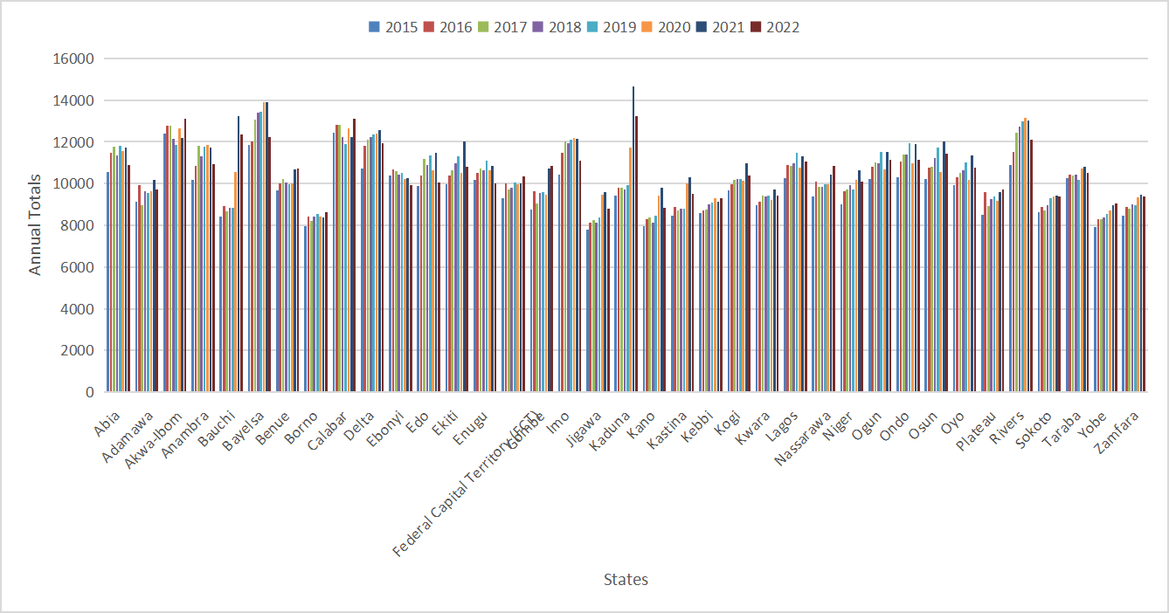

### Documenting the SQL Code and Insights

**Viewing the Data**

SQL Query: SELECT * FROM tableName;

Insight: Understand the structure and content of the table.

**Summarizing Annual Totals by State**

SQL Query: SELECT states, SUM(annual_total) as total_annual_total FROM tableName GROUP BY states;

Insight: Identify states with the highest and lowest total values.

**Average Monthly Values by Parameter**

SQL Query: SELECT parameter, AVG(monthly_average) as avg_monthly_average FROM tableName GROUP BY parameter;

Insight: Understand typical conditions for each parameter.

**Maximum Year-over-Year Change by State**

SQL Query: SELECT states, MAX(year_over_year_change) as max_change FROM tableName GROUP BY states;

Insight: Highlight states with significant changes.

**Trend Analysis for a Specific State**

SQL Query: SELECT year, annual_total FROM tableName WHERE states = 'California' ORDER BY year;

Insight: Visualize trends for California.

**States with Increasing Year-over-Year Changes**

SQL Query: SELECT states, COUNT(*) as increase_count FROM tableName WHERE year_over_year_change > 0 GROUP BY states;

Insight: Identify states with consistent growth.

**Correlation Between Monthly Average and Annual Total**

SQL Query: SELECT CORR(monthly_average, annual_total) as correlation FROM tableName;

Insight: Understand the relationship between monthly averages and annual total.

**Yearly Summary Statistics**

SQL Query: SELECT year, AVG(monthly_average) as avg_monthly, SUM(annual_total) as total_annual, AVG(year_over_year_change) as avg_change FROM tableName GROUP BY year;

Insight: Overview of yearly performance.

**Top 5 States with Highest Annual Totals**

SQL Query: SELECT states, SUM(annual_total) as total_annual FROM tableName GROUP BY states ORDER BY total_annual DESC LIMIT 5;

Insight: Highlight leading states.

**Monthly Average Trends Over Time**

SQL Query: SELECT year, AVG(monthly_average) as avg_monthly FROM tableName GROUP BY year ORDER BY year;

Insight: Identify trends in monthly averages over time.

# Recommendations

Based on the SQL analysis and the insights derived from the weather data for Nigerian states, here are actionable recommendations for optimizing agricultural practices:

1. **Adjust Planting and Harvesting Schedules**

Recommendation: Use the average monthly values by parameter (Insight 3) to adjust planting and harvesting schedules to align with favorable weather conditions.

Implementation Strategy: Create a calendar for each state indicating the best months for planting and harvesting based on parameters like temperature, humidity, and precipitation.

1. **Develop Irrigation Plans**

Recommendation: Utilize the insights on states with increasing year-over-year changes in precipitation (Insight 6) to develop efficient irrigation plans that address periods of insufficient rainfall.

Implementation Strategy: Implement water conservation techniques and invest in irrigation infrastructure in states experiencing less precipitation.

1. **Enhance Pest and Disease Management**

Recommendation: Monitor parameters like temperature and humidity (Insight 3) that significantly impact pest and disease outbreaks, and adjust pest management strategies accordingly.

Implementation Strategy: Use real-time weather data to predict and prevent pest and disease outbreaks, and adjust pesticide applications based on weather forecasts.

1. **Optimize Crop Selection**

Recommendation: Based on the correlation between monthly averages and annual totals (Insight 7), select crops that are best suited to the specific climate conditions of each state.

Implementation Strategy: Develop a crop suitability map for each state and promote crop diversification to reduce the risk of crop failure.

1. **Plan for Climate Change Adaptation**

Recommendation: Utilize maximum year-over-year change insights (Insight 4) to identify states that are experiencing significant climatic changes and develop long-term adaptation strategies.

Implementation Strategy: Invest in research and development of climate-resilient crop varieties and promote sustainable agricultural practices.

1. **Implement Soil Management Practices**

Recommendation: Use the annual total precipitation data (Insight 2) to inform soil management practices such as mulching, cover cropping, and soil conservation techniques to maintain soil moisture levels.

Implementation Strategy: Train farmers on soil management practices that enhance water retention and reduce erosion, particularly in regions with variable precipitation patterns.

1. **Improve Data Accessibility and Usage**

Recommendation: Make weather data and insights accessible to farmers through mobile apps or local agricultural extension services to facilitate data-driven decision-making.

Implementation Strategy: Develop user-friendly platforms that provide farmers with real-time weather data, forecasts, and tailored agricultural advice.

1. **Support Government and Policy Makers**

Recommendation: Provide the insights on average monthly values and annual trends (Insights 2, 3, 5, 8) to government bodies and policy makers to support the development of policies aimed at improving agricultural productivity and sustainability.

Implementation Strategy: Collaborate with government agencies to integrate weather data into agricultural planning and policy-making processes, ensuring support for initiatives that enhance food security.

1. **Promote Sustainable Agricultural Practices**

Recommendation: Use insights from the trends in monthly averages over time (Insight 10) to promote sustainable agricultural practices that adapt to changing weather patterns.

Implementation Strategy: Educate farmers on sustainable practices such as crop rotation, agroforestry, and organic farming to build resilience against climate variability.

**Integration of Recommendations**

**Placement**: Integrate each recommendation immediately after the corresponding insight or analysis summary in your document. For instance, after discussing "Average Monthly Values by Parameter," introduce the recommendation related to adjusting planting and harvesting schedules.

**Implementation Strategy:** Clearly outline how each recommendation can be implemented, specifying actions, responsible parties, and timelines.

**Visual Support:** Consider using charts or visualizations to support recommendations, such as trend graphs or geographic maps depicting regional insights.

**Value Proposition**

Our weather data analysis for Nigerian states offers significant value to stakeholders involved in agriculture, climate research, and policy-making. By leveraging comprehensive insights derived from robust SQL analysis, we provide actionable recommendations that enhance decision-making and operational efficiency across various domains.

**Key Value Propositions:**

**Enhanced Agricultural Decision-Making:**

Utilize detailed insights on monthly averages, annual trends, and year-over-year changes to optimize planting schedules, irrigation strategies, and crop selection.

Empower farmers with real-time weather data to mitigate risks associated with climate variability and improve crop yield and quality.

**Climate Resilience and Adaptation:**

Support climate change adaptation efforts by identifying states experiencing significant climatic shifts and recommending adaptive strategies.

Facilitate the development of resilient agricultural practices that withstand extreme weather events and ensure sustainable food production.

**Policy Support and Government Initiatives:**

Provide data-driven evidence to policymakers and government agencies to inform agricultural policies, resource allocation, and disaster management planning.

Foster collaboration between research institutions, NGOs, and governmental bodies to implement effective climate resilience programs.

**Scientific Research Advancement:**

Serve as a valuable resource for researchers and scientists conducting studies on climate dynamics, agricultural sustainability, and environmental impacts.

Contribute to the advancement of climate science by offering access to high-quality, localized weather data and analytical insights.

**Business and Economic Impact:**

Enable businesses in the agricultural sector to make informed decisions on resource allocation, market strategies, and risk management.

Enhance economic outcomes by promoting efficient agricultural practices, reducing production costs, and improving market competitiveness.

**Community Engagement and Education:**

Engage local communities and stakeholders through educational initiatives on climate-smart agriculture and sustainable land management practices.

Empower farmers with knowledge and tools to adapt to changing climate conditions and improve livelihoods.