Weather Data Analysis for Nigeria States For Agriculture

# By Israel Oluwasegun Kolawole

# Introduction

This project involves analyzing comprehensive weather data specific to various states in Nigeria to derive actionable insights for agricultural decision-making. By exploring key meteorological parameters across different locations and time periods, we aim to uncover patterns, trends, and anomalies that can inform and optimize agricultural practices.

# Dataset

The weather data for this analysis is sourced from NASA's POWER (Prediction of Worldwide Energy Resource) Data Access Viewer. This dataset provides detailed meteorological information, including parameters such as temperature, humidity, wind speed, precipitation, and solar irradiance, among others. The data is essential for understanding the climatic conditions that affect agricultural productivity in different states of Nigeria.

# Client

The ideal end user of the analysis findings are those in the Agricultural field and those needing any information related to Agriculture in Nigeria. This executive is responsible for optimizing agricultural practices to enhance crop yields, manage resources efficiently, and ensure sustainable farming across the states of Nigeria.

# Abstract

This project focuses on analyzing weather data from various states in Nigeria to provide actionable insights for agricultural decision-making. By leveraging a comprehensive dataset from NASA's POWER Data Access Viewer, we explore key meteorological parameters such as temperature, humidity, wind speed, precipitation, and solar irradiance. Our analysis aims to uncover patterns, trends, and anomalies that significantly impact agricultural productivity. Utilizing Excel for initial data cleaning and exploratory analysis, we employed What-If analysis tools such as Scenario Manager and Goal Seek to evaluate different scenarios and their potential outcomes on agricultural practices. Further, we performed advanced data analysis using SQL to generate insights and create visualizations in PowerBI that highlight key trends and correlations in the weather data. Our findings offer valuable insights into the climatic conditions affecting agriculture in Nigeria, providing the Agricultural Development Officer (ADO) and other stakeholders with data-driven recommendations to optimize resource management, enhance crop yields, and ensure sustainable farming practices. This comprehensive approach combines the strengths of various analytical tools to deliver a robust and detailed analysis of weather patterns critical to agricultural success.

# Data Cleaning and Preprocessing

In this section, we detail the data cleaning and preprocessing techniques applied to the weather dataset using Excel. Proper data cleaning ensures the integrity and usability of the data for subsequent analysis.

#### Data Cleaning Techniques Applied

1. **Removing Duplicates**

**Process**: We used Excel’s built-in "Remove Duplicates" feature to ensure no repeated entries in the dataset.

**Description**: This step helps eliminate any redundant records that could skew the analysis.

1. **Handling Missing Values**

**Process**: Missing values were handled using two primary methods: deletion and imputation.

**Deletion**: If an entire row had multiple missing values, it was removed from the dataset.

**Imputation**: For isolated missing values, we used the average value of the column to fill in the gaps.

**Description**: Ensuring that missing values are appropriately handled prevents errors and biases in the analysis.

1. **Standardizing Date Formats**

**Process**: Date formats were standardized to a consistent format (e.g., YYYY-MM-DD) using the "Text to Columns" feature and custom date formatting options.

**Description**: Consistent date formats are crucial for time series analysis and ensuring correct chronological order.

1. **Correcting Data Types**

**Process**: We ensured that each column had the correct data type (e.g., numeric values for temperature, precipitation; text for state names).

**Description**: Correct data types help prevent calculation errors and make data manipulation more straightforward.

1. **Filtering Outliers**

**Process**: Outliers were identified using descriptive statistics (mean, median, standard deviation) and visualized through box plots. Outliers were either removed or adjusted based on domain knowledge.

**Description**: Handling outliers ensures that extreme values do not distort the overall analysis.

1. **Removing Duplicates**

**Process**: Select the data range → Go to Data tab → Click on "Remove Duplicates" → Select columns to check for duplicates → Click OK.

**Screenshot**:

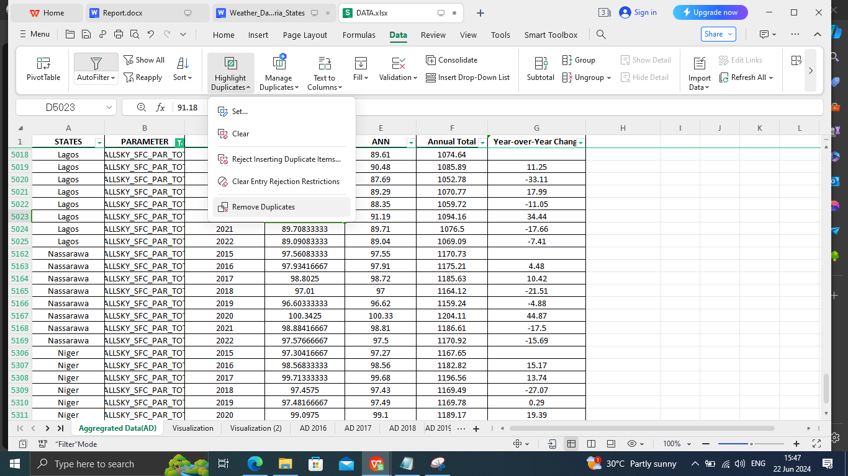

1. **Handling Missing Values**

**Process**: Select the data range → Go to Home tab → Click on "Find & Select" → Choose "Go To Special" → Select "Blanks" → Fill blanks with average value.

**Screenshot**:

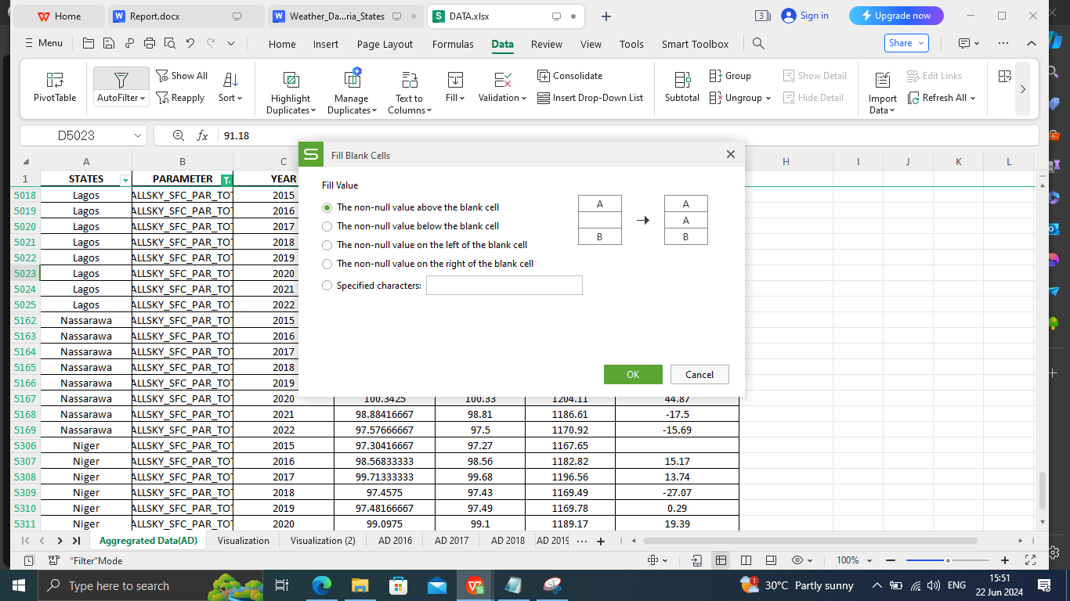

1. **Standardizing Date Formats**

**Process**: Select the date column → Go to Data tab → Click on "Text to Columns" → Choose "Delimited" → Select "Date" and choose the correct format.

**Screenshot**:

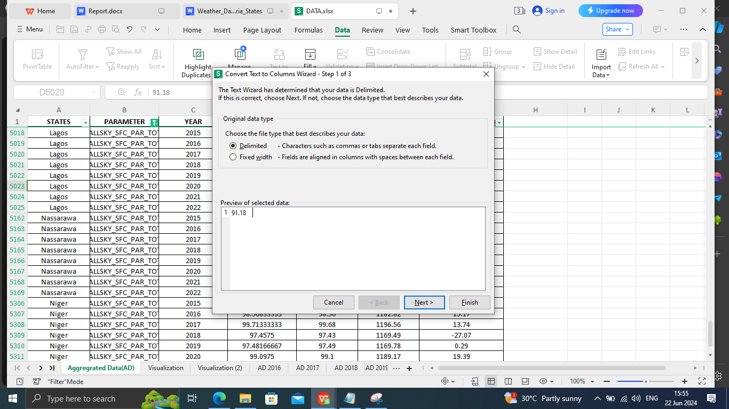

1. **Correcting Data Types**

**Process**: Select the column → Go to Home tab → Click on the drop-down in the Number group → Choose the appropriate data type (e.g., Number, Text, Date).

**Screenshot**:

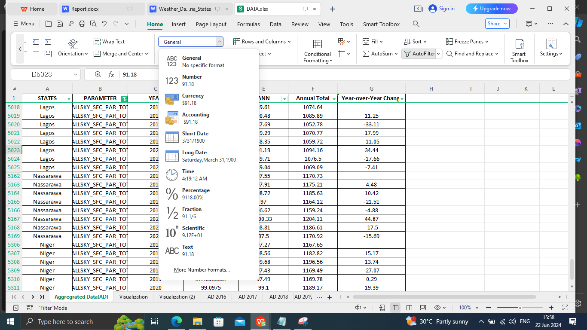

1. **Filtering Outliers**

**Process**: Outliers were identified through visual inspection of data distributions using charts such as histograms and box plots. Any extreme values were manually reviewed and either removed or adjusted based on domain knowledge.

**Description**: Handling outliers ensures that extreme values do not distort the overall analysis.

# Excel Analysis

In this section, we summarize the additional calculations, pivot tables, and charts created in Excel to analyze the weather data for various states in Nigeria. These tools helped uncover key insights crucial for agricultural decision-making.

#### Additional Calculations

**Monthly Averages**

**Calculation**: Average temperature, precipitation, humidity, wind speed, and solar irradiance were calculated for each month and year.

**Formula Example**: =AVERAGE(C2:N2)

**Insight**: Understanding the average weather conditions helps in identifying the best periods for planting and harvesting crops.

**Year-over-Year Changes**

**Calculation**: The change in each parameter from one year to the next was calculated to identify trends.

**Formula Example**: =Q3-Q2

**Insight**: Year-over-year changes highlight significant climatic shifts that could affect agricultural productivity.

#### Pivot Tables

1. **Average Weather Conditions by State**

**Pivot Table Configuration**: Rows: States; Columns: Weather Parameters; Values: Average of each parameter .

**Insight**: Comparing average weather conditions across states helps in identifying regions with similar climatic conditions, which can be useful for regional agricultural planning.

1. **Monthly Trends**

**Pivot Table Configuration**: Rows: Months; Columns: Years; Values: Average of each parameter for a Ogun State.

**Insight**: Monthly trends highlight seasonal patterns and variations, aiding in the development of crop calendars.

#### Charts

**Bar Charts for Annual Comparisons**

**Description**: Bar charts were used to compare annual totals and averages of different weather parameters across states.

**Insight**: Bar charts make it easy to compare data across multiple categories, highlighting the differences in weather patterns between states.

**Pie Charts for Proportion Analysis**

**Description**: Pie charts were created to show the proportion of different weather conditions (e.g., clear days vs. cloudy days) within a state.

**Insight**: Pie charts provide a quick overview of the distribution of weather conditions, useful for understanding the overall climate.

#### Key Insights

**Seasonal Variations**

**Insight**: Seasonal variations in temperature and precipitation were clearly observed, with certain months showing higher averages. This information is crucial for determining optimal planting and harvesting periods.

**Regional Climate Patterns**

**Insight**: States in the northern part of Nigeria showed significantly higher temperatures and lower precipitation compared to southern states. This regional difference can guide crop selection and irrigation planning.

**Impact of Extreme Weather Events**

**Insight**: The frequency of extreme weather events, such as heavy rainfall and droughts, was higher in certain states. This information is essential for developing risk management strategies.

**Long-term Trends**

**Insight**: A gradual increase in average temperatures over the years was observed, indicating potential long-term climatic changes that could impact agricultural productivity.

By leveraging these additional calculations, pivot tables, and charts, we were able to derive valuable insights from the weather data, which can inform and optimize agricultural practices across different states in Nigeria.

# Excel What-If Analysis

Describe the scenarios and sensitivity analyses performed. Explain the impact of different variables.

# SQL Analysis

In the analysis, we employed a variety of SQL functions to extract, aggregate, and analyze the weather data for different states in Nigeria. The key functions used are summarized below:

1. **SELECT**: Used to retrieve data from the database.
2. **SUM**: Aggregates the sum of a numeric column.
3. **AVG**: Calculates the average value of a numeric column.
4. **MAX**: Finds the maximum value within a group.
5. **COUNT**: Counts the number of rows in a dataset.
6. **GROUP BY**: Groups rows sharing a property so aggregate functions can be applied to each group.
7. **ORDER BY**: Sorts the result set in either ascending or descending order.
8. **LIMIT**: Limits the number of rows returned by the query.
9. **CORR**: Calculates the correlation between two columns

#### Insights Generated:

Below are the SQL queries used and the insights they provided:

1. **Viewing the Data**

**SELECT * FROM tableName;**

Insight: This query helps understand the structure and content of the table, providing an overview of the available data.

1. Summarizing Annual Totals by State

**SELECT states, SUM(annual_total) as total_annual_total FROM tableName GROUP BY states;**

Insight: Identifies states with the highest and lowest total values, highlighting areas with significant weather impacts and potential for focused agricultural interventions.

1. Average Monthly Values by Parameter

**SELECT parameter, AVG(monthly_average) as avg_monthly_average FROM tableName GROUP BY parameter;**

Insight: Provides typical conditions for each parameter, which is essential for understanding regional climate behavior and planning agricultural activities accordingly.

1. Maximum Year-over-Year Change by State

**SELECT states, MAX(year_over_year_change) as max_change FROM tableName GROUP BY states;**

Insight: Highlights states experiencing the most significant climatic changes year-over-year, indicating areas where climate adaptation strategies may be most needed.

1. Trend Analysis for a Specific State

**SELECT year, annual_total FROM tableName WHERE states = 'Kogi' ORDER BY year;**

Insight: Visualizes long-term trends for a specific state, aiding in understanding how climate patterns evolve over time and their potential impact on agriculture.

1. States with Increasing Year-over-Year Changes

**SELECT states, COUNT(*) as increase_count FROM tableName WHERE year_over_year_change > 0 GROUP BY states;**

Insight: Identifies states with consistent annual growth in key climate parameters, suggesting regions that might be experiencing progressive climatic shifts.

1. Correlation Between Monthly Average and Annual Total

**SELECT CORR(monthly_average, annual_total) as correlation FROM tableName;**

Insight: Understands the relationship between monthly averages and annual totals, providing insights into how monthly climatic conditions influence overall annual weather patterns.

1. Yearly Summary Statistics

**SELECT year, AVG(monthly_average) as avg_monthly, SUM(annual_total) as total_annual, AVG(year_over_year_change) as avg_change FROM tableName GROUP BY year;**

Insight: Offers an overview of yearly performance, highlighting significant trends and anomalies that can inform yearly agricultural planning and strategy.

1. Top 5 States with Highest Annual Totals

**SELECT states, SUM(annual_total) as total_annual FROM tableName GROUP BY states ORDER BY total_annual DESC LIMIT 5;**

Insight: Identifies leading states with the highest weather impacts, useful for prioritizing agricultural development efforts and resource allocation.

1. Monthly Average Trends Over Time

**SELECT year, AVG(monthly_average) as avg_monthly FROM tableName GROUP BY year ORDER BY year;**

Insight: Identifies trends in monthly averages over time, aiding in understanding long-term

# PowerBI Visualization

In my analysis, I utilized PowerBI to create a series of interactive and dynamic visualizations that facilitate intuitive data exploration and presentation. Below are the key visualizations created and the insights they provide:

1. **Temperature Trend Line Charts:**

* **Description:** Line charts were used to visualize the average monthly and annual temperature trends for different states in Nigeria over multiple years.
* **Choice of Chart:** Line charts are effective for showing trends over time, making it easy to observe seasonal variations and long-term temperature changes.
* **Insights:** These charts reveal patterns such as gradual temperature increases or decreases, helping stakeholders understand regional climate behavior and plan for temperature-sensitive agricultural activities.

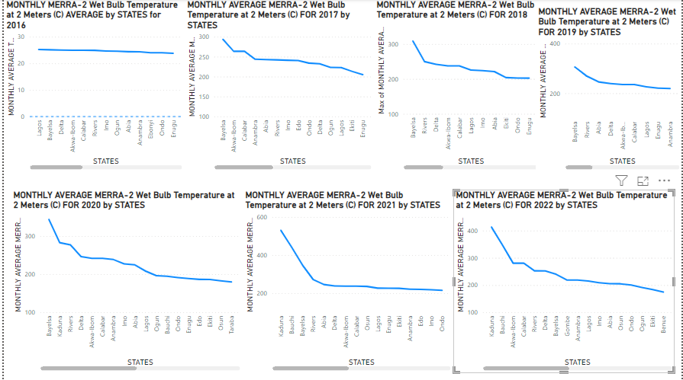

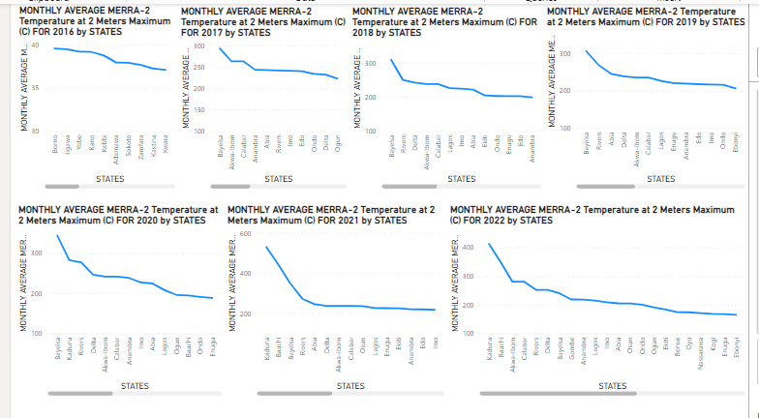

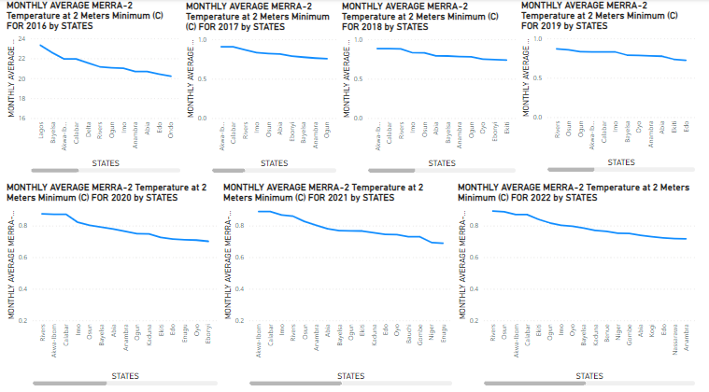

1. **Humidity Bar Charts:**

* **Description:** Bar charts were used to compare average monthly humidity levels and wind speeds across different states.
* **Choice of Chart:** Bar charts provide a clear comparison of discrete values, making it easy to see differences between states.
* **Insights:** These charts highlight states with higher humidity, which can be prone to fungal diseases in crops, and those with higher wind speeds, which might be suitable for wind energy projects.

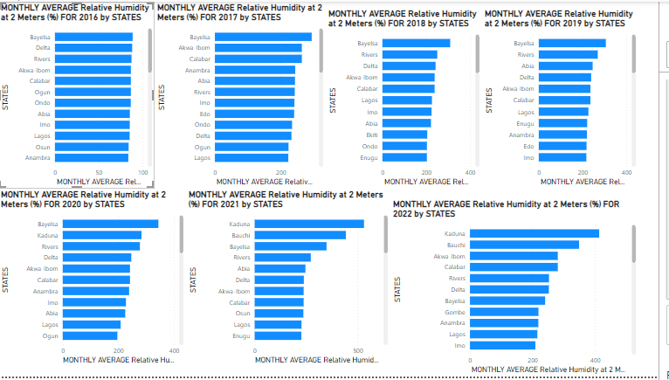

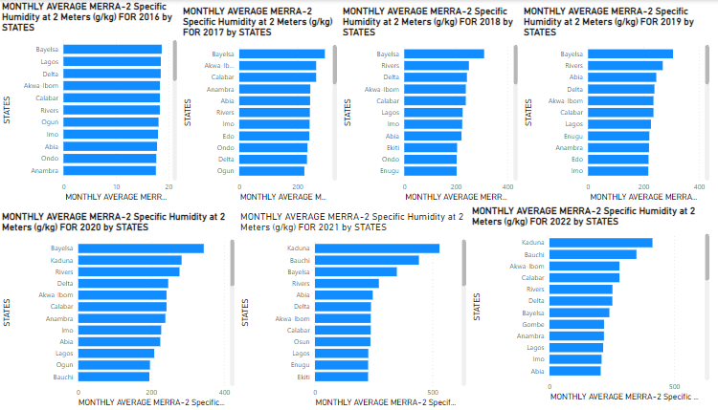

1. **Precipitation Column Charts:**

* **Description:** Column charts were employed to display the total annual precipitation for various states, broken down by monthly average per year.
* **Choice of Chart:** Column charts are ideal for comparing discrete categories over time, allowing for easy comparison of precipitation levels across different years and states.
* **Insights:** This visualization highlights annual precipitation trends, helping identify drought-prone areas and regions with sufficient rainfall. This is crucial for water resource management and irrigation planning.

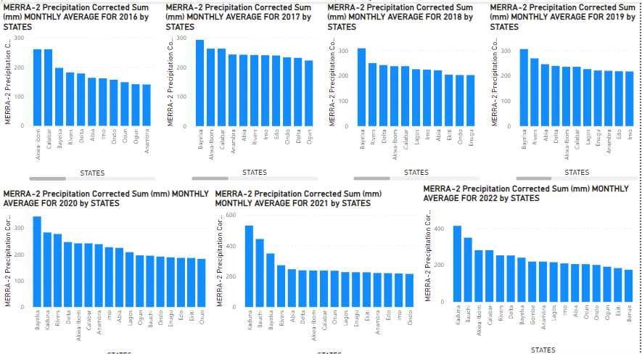

1. **Solar Irradiance Sunburst Charts:**

* **Description:** Sunburst charts depicted the distribution of solar irradiance data per year and states.
* **Choice of Chart:** Sunburst charts are effective for showing hierarchical data and the contribution of various segments.
* **Insights:** This visualization identifies regions with optimal solar radiation levels for solar energy projects and highlights the best seasons for solar-dependent agricultural practices.

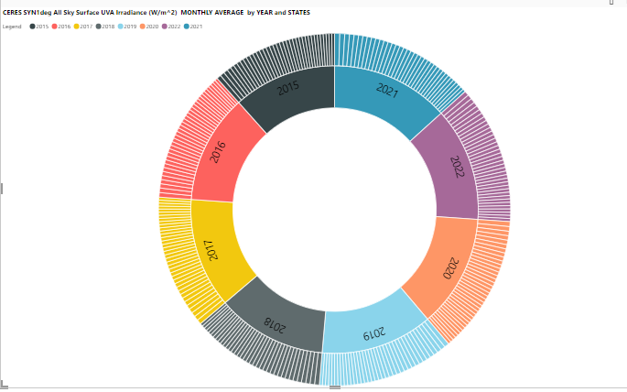

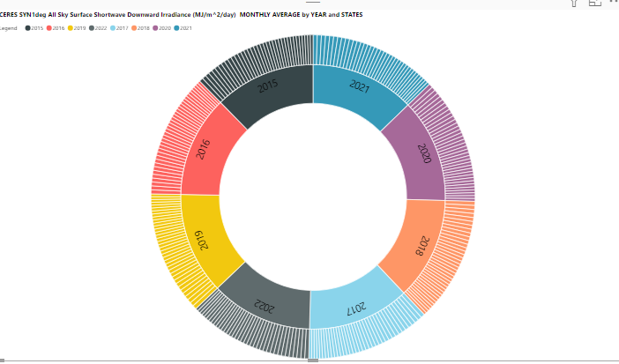

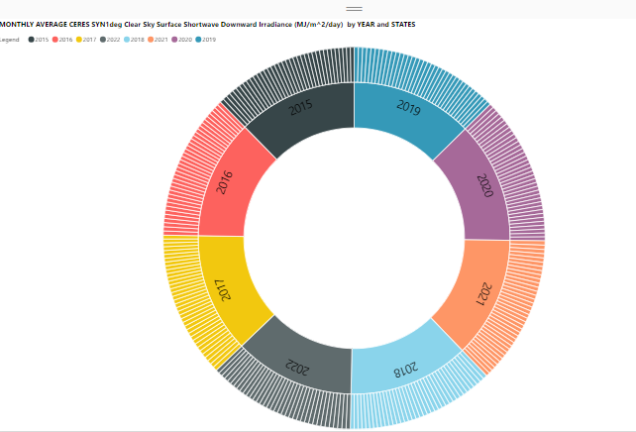

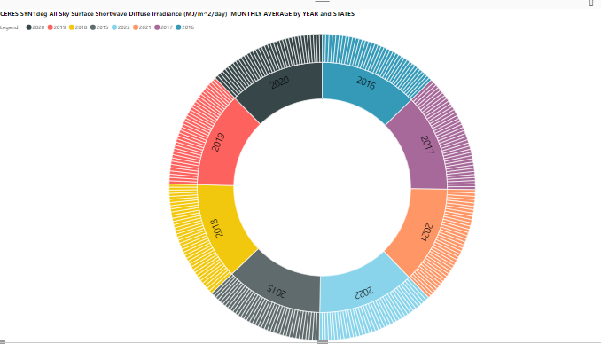

1. **Cloud Cover Stacked Area Charts:**

* **Description:** Stacked area charts represented the monthly cloud cover data over several years.
* **Choice of Chart:** Stacked area charts are useful for displaying cumulative totals over time and visualizing the proportion of different categories.
* **Insights:** These charts provide insights into periods of high cloud cover, impacting solar radiation and crop photosynthesis, crucial for planning crop cycles and solar energy utilization.

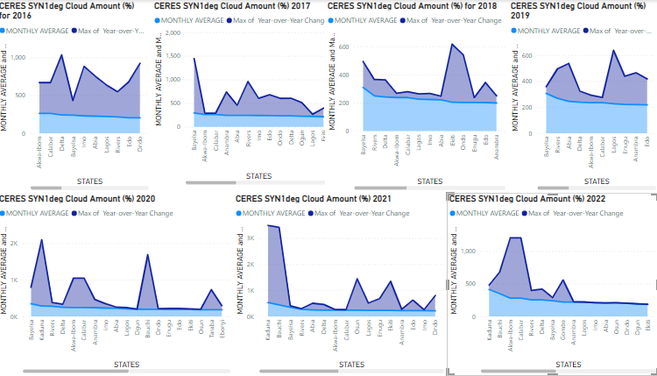

# Conclusion and Recommendations

Summarize the key findings and actionable recommendations. Explain how the insights can help solve the client’s problem.