MERIDIAN TECHNOLOGIES
Investor Day Positioning Memo | March 11, 2026 | CONFIDENTIAL
From: Catherine Park, CEO
Executive Summary
Meridian will declare itself the agentic work platform built for the enterprise — the only platform where AI agents operate under the governance, auditability, and compliance controls that regulated industries require. Project management is the surface we started with; the agent framework acquired through Helio is the platform we are becoming. This memo sets out the competitive rationale for that choice, the three risks we are accepting, and the three commitments we are making to investors to hold us accountable. The board has been briefed. The internal communications team has nine days to build Investor Day materials around this position.
Our Position
“Meridian is the agentic work platform built for the enterprise — the only platform where agents run with the governance, auditability, and compliance controls that regulated industries require.”
Why This Position
Four inputs drive this decision, all pointing the same direction:
- Customer demand. 18 of 22 enterprise advisory board sessions in the last 90 days raised agent governance unprompted — auditability, role-based agent permissions, model pinning, data residency. Customers are already thinking in agent terms. They want Meridian to govern those agents, not to be a faster PM tool.
- Competitive white space. Asana and Monday are moving agentic but have thin governance. Atlassian is the most committed agentic platform but is software-team-shaped and cannot serve pharma, banking, or federal. Smartsheet has governance but has explicitly rejected the agentic frame. The intersection — enterprise governance for an agentic platform — is unoccupied.
- The Helio acquisition. We paid $78M for an agent framework. The Helio team did not join Meridian to build AI features for a PM tool. Choosing Option A creates immediate retention risk on the most important technical talent we have acquired.
- Financial capacity. $506M in liquidity, $250M estimated M&A capacity, $55M AI R&D already budgeted. The hiring pivot Option B requires is affordable. Option B’s 2028 upside scenario is $900M at 25% growth; the downside scenario is still $550M — a narrower range than it appears because Option A’s $700M ceiling assumes a PM category that is already commoditizing.
Competitive Landscape
 | AI Positioning | Pricing Posture | Latest Flagship  Announcement | Closer to  Meridian…
Asana | "Work management  platform with AI  built in" — moving  toward agent OS  language | AI bundled into  Advanced+ tiers;  no consumption  pricing | AI Studio + Smart  Workflows bundled  (Nov 2025) | Option B  (thin governance)
Monday.com | "Work OS,  supercharged  with AI" — AI as  a layer, not a  separate product | AI Agents bundled  into Pro+ tiers;  no consumption  pricing | monday AI Agents  GA (Jan 2026) | Option A framing,  Option B execution
Atlassian | "Agentic enterprise  platform" — most  explicit agentic  commitment;  Rovo brand | Hybrid: per-seat  + consumption  (only competitor  with consumption  live today) | Rovo Studio  agent builder  (Jan 2026) | Option B  (direct peer;  differentiate  on verticals)
Smartsheet | "Enterprise work  platform you can  trust with AI" —  explicitly rejected  "agentic" | AI bundled in  Business/Enterprise;  Compliance Pack  add-on ~$15/seat | AI Compliance  Pack (Dec 2025) | Option A  (direct peer;  slowing growth)

Positioning Matrix
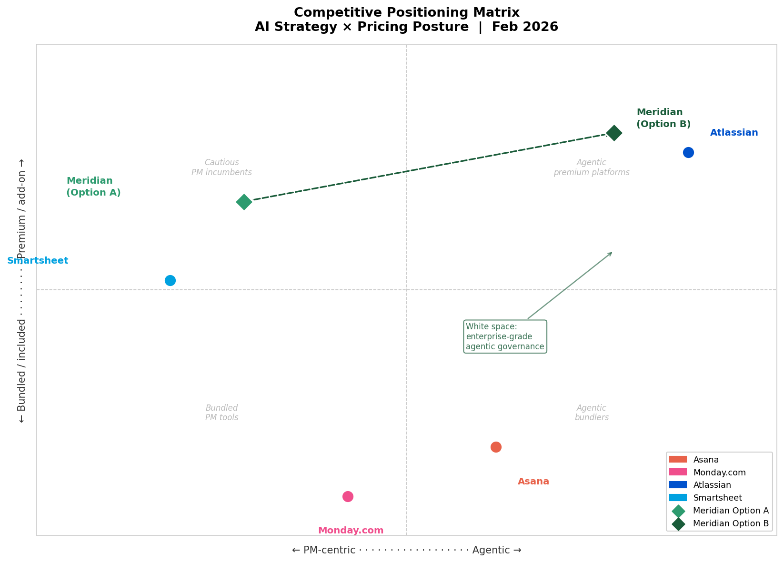
Figure 1. Competitive positioning: X-axis PM-centric → Agentic; Y-axis Bundled → Premium. Meridian Option B (dark diamond) occupies the enterprise agentic governance white space. Dashed arrow shows the strategic move from Option A.
Three Risks We Are Accepting
- Revenue air gap. We are declaring an agentic platform with $3.5M of AI ARR. Consumption pricing launches H2 2026; enterprise adoption typically runs 6–12 months behind plan. We are setting guidance conservatively to create room to beat it. If consumption ramps slower than planned, we have a narrative gap in Q3–Q4 2026.
- Atlassian execution risk. Atlassian is already in the top-right quadrant with live consumption pricing and Rovo Studio in market. If Rovo matures beyond dev teams into general PM before we establish regulated-industry anchor wins, investors will ask why they own Meridian instead of Atlassian. Our answer is verticals — pharma, banking, federal — and we must demonstrate it with logos, not slides.
- Model-lab consolidation. If Anthropic, OpenAI, or Microsoft ships enterprise agent governance natively — audit logs, role-based agent permissions, data residency — our governance moat shrinks. Mitigation: position Meridian as the model-neutral governance layer that works across any approved model. We do not partner exclusively with any one lab.
Three Commitments to Investors
- Regulated-industry anchor wins by Q3 2026. We will name at least three enterprise customers running production agent workloads on Meridian in a regulated industry (financial services, life sciences, or federal) on our Q2 2026 earnings call. If we cannot, we will say so directly and explain why.
- Consumption pricing live in H2 2026. We will launch consumption-based agent pricing by September 30, 2026. We will report agent consumption ARR as a separate line beginning Q3 2026, giving investors a direct measure of platform adoption.
- Governance as the measurable differentiator. We will publish a public enterprise governance framework for AI agents — covering auditability, role-based permissions, model selection, and data residency — within 60 days of Investor Day. This is the claim we are making; it will be verifiable.

Prepared for Meridian Technologies Investor Day, March 11, 2026. Internal and confidential. Do not distribute without CEO approval.

