MERIDIAN TECHNOLOGIES — BOARD OF DIRECTORS
Annual Strategic Review | Confidential
Meridian is profitable and focused — now we must decide what we're building, or the window to re-accelerate closes.
Catherine Park, CEO · Opening Remarks · 5 Minutes

WHERE WE STAND
My first full year as CEO is complete. Meridian closed 2025 at $400M revenue, $413M ARR, a 12.4% operating margin, and $463M in cash with no debt. These are real achievements. They are also the floor of what this company can be — not the ceiling. ARR growth ended the year at 10%, the slowest in our public history. The chart below shows the full picture: profitability has nearly tripled since 2022, and growth has been cut in half. The trade is done. What comes next is the question before this board today.

ISSUE 1 — Growth deceleration is structural, not cyclical.
We have been trading growth for margin. That trade is now fully captured: S&M has come down from 40% to 32% of revenue; G&A from 12% to 9.5%. There is no more easy efficiency to harvest. The deceleration is being driven by three forces that will not self-correct:
- SMB is in managed decline: $52M ARR at year-end, down from $68M a year ago (–23% YoY). NRR of 84%. This segment is self-funded under the new P&L structure and will continue to shrink. That is approximately $30M of headwind baked into 2026 guidance.
- Mid-market is plateauing: NRR compressed from 115% (2022) to 102% (Q4 2025). Our largest segment by ARR ($194M, 47% of total) is barely expanding on a net basis. Customers are demanding AI features bundled into renewals at no cost.
- Sales efficiency is deteriorating: Magic number fell from 1.20 (Q1 2024) to 0.92 (Q4 2025). CAC payback extended from 18 to 22 months. We are spending more than $1 in sales and marketing to generate $1 of net new ARR.
The bull case for re-acceleration is AI Copilot. The evidence so far: 710 paying seats, $3.5M in 2025 ARR, 44% attach rate on Q4 enterprise renewals. That is a real proof point. It is also a very small base for a company that needs to add $40–55M in ARR to hit the top of 2026 guidance.

ISSUE 2 — We have not yet ratified what Meridian is.
On the Q4 earnings call I said: 'This is the year we decide what Meridian is.' That decision is before this board. The choice is not subtle:
- Option A: A project management platform with AI features added. Copilot is a $40/seat add-on. The core product is PM. R&D optimizes for mid-market feature parity.
- Option B: An agentic work platform where PM is one surface. Copilot becomes the core product. Pricing shifts to consumption. R&D optimizes for the enterprise governance and agent-builder roadmap.
Our actions in 2025 — the Helio acquisition, the agentic-experiences group reporting to me, the 2026 roadmap — already signal Option B. But signal is not ratification. The internal damage from the unresolved question is measurable: 28% of salespeople said in the October survey they can no longer crisply differentiate Meridian from Asana with AI. Roadmap thrash was the #1 theme in engineering (31% of responses). Every renewal contested while this is unresolved is being fought at a disadvantage.

ISSUE 3 — Engineering capacity is the binding constraint on either answer.
The 2026 roadmap requires 80 net new engineers in H1. At 15% annual attrition, we will net approximately 25. Three specific risks:
- Helio retention cliff: The $68M in retention equity underpinning our agent architecture vests over four years — but cash compensation cliffs hit in 2026. If the Helio team unwinds, the agent-builder roadmap is directly exposed. Twenty-six of twenty-eight are still with us today.
- Senior engineering compensation: 27% of senior engineers cited pay in the October survey — the highest concentration of any function. Specific ask: equity refresh for tenured employees whose grants vested before the 2025 stock decline.
- Opportunity cost of inaction: R&D is already at 25.4% of revenue — the highest since IPO. We are spending more than ever on engineering while flagging we may not have enough engineers to execute the plan. The CPO has asked the board to treat hiring as a strategic priority, not an HR line item.

MY ONE ASK OF THIS BOARD
Ratify the strategic identity: Meridian is an agentic work platform. Project management is our strongest surface and our enterprise moat — it is not the ceiling of what we build.
That ratification unlocks three decisions I need to make immediately: (1) approve the senior engineering compensation refresh before we lose the people the roadmap depends on; (2) authorize the consumption-based pricing model as a CFO/CRO-owned workstream for H2 2026; and (3) greenlight continued M&A diligence on the two AI-native targets currently in early process.
Investor Day is March 11. I will make this case publicly then. I want this board's alignment before I do.

SUPPORTING EXHIBIT — ARR Growth vs. Operating Margin, Q1 2022–Q4 2025
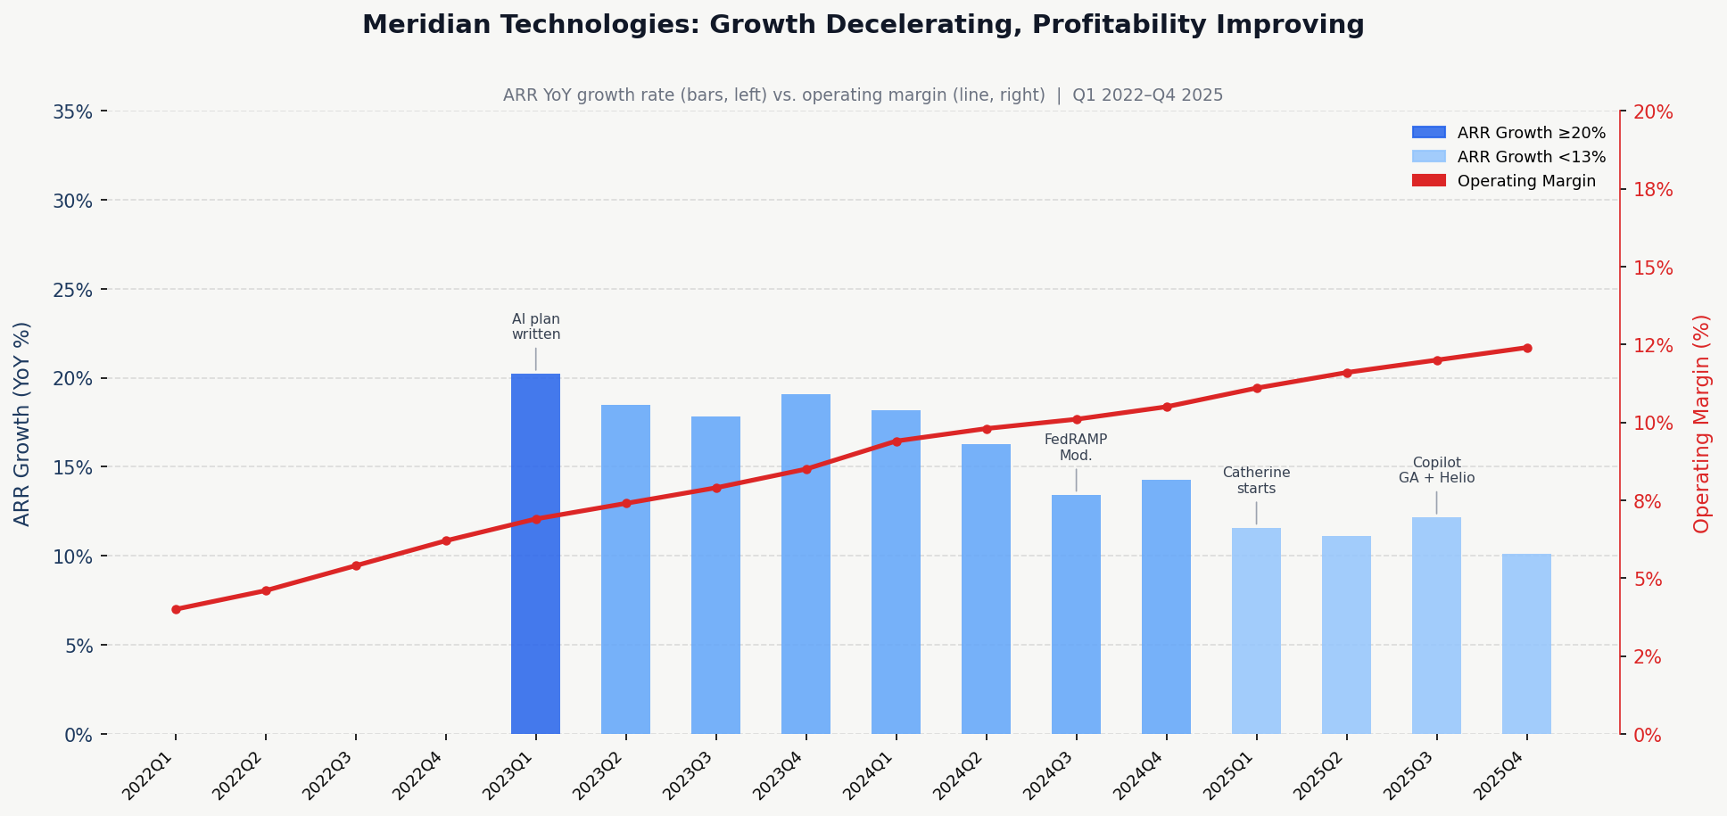
Bars (left axis): ARR YoY growth rate. Line (right axis): operating margin. Growth has fallen from ~20% to 10%; margin has risen from 4% to 12.4%. The efficiency gains are captured. Re-acceleration requires a new driver.

