Documentation &

Project Diary

Innovation Lab 1

Year 2021/2022

Project: Visitor-Counter (the Observer)

Team: **Group 29**

1. General Information

**Project name:** Visitor-Counter (the Observer)

**Supervisor:** Lukas Rohatsch, MSc

Innovation Lab 1, 20212022

**Projectteam:**

Varga Lukas, if20b167@technikum-wien.at, project manager

Düx Stefan, if20b245@technikum-wien.at,

Görög Jessica Isabella, if20b094@technikum-wien.at,

Grabner Dominic, if20b219@technikum-wien.at,

Tscheppen Rebekka, if20b164@technikum-wien.at,

**Management Summary of the Project**

This project is about setting up a camera module at the entry of the Presentation Lab (located: Bx.yz) to count visitors and deliver data categorized to different data packages (total, daily, current and so forth). To deliver this project, hardware is necessary to be set up correctly (central processing unit, camera, body, holding), combined with efficient software (control the hardware) and a webpage to enable access of the data. Furthermore, this project shall serve as a preparation for more advanced projects like analyzing traffic data, rate of flow and similar purposes.

**Framework Conditions and Project Environment**

Programming languages:

The project assignment demands to use python for processing the data. As a commonly used programming language, currently no other programming language is considered for further use regarding data processing. For the webpage the team will use the framework Angular.

Usability:

There are 2 access points for the client and / or users. The webpage is enabled for open access which includes all users with access to the internet. Therefore, the usability aims for beginner-level access. The local access directly connected to the visitor counter will be especially designed for the client.

Interfaces:

Data transfer by JSON.

wait for details regarding webspace

Standards:

It is necessary to respect the data protection rules as we enable open access to the collected data by our built webpage. Therefore, a livestream of the set up camera will only be accessible at the local console, where the module is located. The webpage will only display the processed data without any pictures or livestreams.

Using own made videos or demo videos to test or logic programming.

Deadlines:

Prototype für Ende Semester #4 gestalten (Demo-Version des Projektes)

currently no further details identified

**Semester-Roadmap**

|  |  |
| --- | --- |
| **1. semester** | Focus: Raspberry Pi  1. sprint  install Raspberry Pi OS and configure packages, install camera module  2. sprint  ensure requirements (python and required packages), Raspberry Pi Case 3D model planning  3. sprint  expand python libraries  Raspberry Pi Case 3D model printing  4. sprint  implement system for visitor counter  5. sprint  final capture of visitors  6. sprint  prepare presentation |
| **2. semester** | Focus: Raspberry Pi / Interface  1. sprint  Testphase der letzten Streams / Zeitbuffer für Bugfixes  2. sprint  Camera Stream über HDMI ausgeben  3. sprint  Erfassung der Besucher aktiv vor Ort testen  4. sprint  install and configure mqtt  5. sprint  Interface bereitstellen und testen  6. sprint  prepare presentation |
| **3. semester** | Focus: Interface / Webpage  1. sprint  Website planen und Webserver installieren  2. sprint  Website umsetzen  3. sprint  Webseite <-> Raspberry Pi Verbindung finalisieren  4. sprint  bugfixes  5. sprint  bugfixes  6. sprint  prepare presentation / end project |

**Collaboration & Tooling**

Communication: Discord & Zoom

[FH Technikum Wien - Moodle](https://moodle.technikum-wien.at/mod/zoom/view.php?id=856605)

  Documentation: Jira Software  
[https://visito-counter29.atlassian.net/jira/software/projects/TO29/boards/1](https://visito-counter29.atlassian.net/jira/software/projects/TO29/boards/1" \o "https://visito-counter29.atlassian.net/jira/software/projects/TO29/boards/1)

  Timetable: Google Sheets  
[https://docs.google.com/spreadsheets/d/1ep5FswrHorSOHT6Ck-h5r6ZSO9rwkWMd2KY0pQrVxrQ/edit#gid=26059217 - Connect to preview](https://docs.google.com/spreadsheets/d/1ep5FswrHorSOHT6Ck-h5r6ZSO9rwkWMd2KY0pQrVxrQ/edit" \l "gid=26059217)

  Tracking Work: Jira Software

[https://visito-counter29.atlassian.net/jira/software/projects/TO29/boards/1](https://visito-counter29.atlassian.net/jira/software/projects/TO29/boards/1" \o "https://visito-counter29.atlassian.net/jira/software/projects/TO29/boards/1)

Source Code Management: GitHub

[GitHub - unravelet/theObserver: Innovation Lab Project - Visitor Counter](https://github.com/unravelet/theObserver)

  Screen Prototyping: Mockplus

placeholder

  Modelling: Modelio

placeholder

**Remarks**

*--*

1. **Brief Description of the Project**

The **main object** for the project is a visitor counter which will be located at the “Presentation Lab” room to count the number of visitors. For the counting a camera module will be used in combination with a software to detect and count people from a livestream. This functionality can be used as an example to display or even regulate a maximum number of people inside for health (Covid) or security reasons (events).

As the **biggest challenge**, the project group will face the needs of learning the necessary skills (logic programming with python) and mechanical capabilities (working with hardware like Raspberry Pi, camera module and 3D printer).

The **usability object** will be the easy access to the data and controlling the interfaces at beginner level (local livestream or processed data via webpage).

The **non-objective** of the project is involving face recognition and tracking.

As for the **scope**, the project covers the functionality to process data from a livestream to calculate the number of people (staying inside a room or entering/leaving) and to display it on a local console + webpage with free access. For implementing the software, we need to know about the specifications necessary for the Raspberry Pi and will orientate on similar projects / products. Additionally, we need to learn about video-recognition software to get the necessary skills.

**ORDER model questions:**  
**Opportunity** - Development of visitor counter for room “Presentation Lab” of campus FH Technikum Wien featuring people recognition to count visitors and displaying data via webpage and local livestream.

**Resources** - Hardware / Webspace / Software (Libraries)

Raspberry Pi + camera module (sponsored)

display for local livestream (sponsored)

host + domain (sponsored)

python libraries

**Decision Process** - guaranteed anonymity

**Exact Solution** - High complexity implies risk of failing the project.

**Relationship** - Project is happening.

1. **Specification of the Solution**

Sprint Requirements (Sprint #1 - #6):

**#########################**

**Sprint 1**

**Basic description of sprint #1:**

For the first sprint, all group members will check the hardware for existing problems or damage and functionality. Fitting software / operating system will be chosen and installed. An official name for the project is going to be set by brainstorming to use it for the GitHub repository and the webpage domain later on. The trello board will be filled up with tasks and an IDE chosen.

**Time:**

**start (sprint #1): 12.10.2021, 17:40:00**

**deadline (protocol): 10.11.2021, 23:59:00**

**deadline (sprint #1): 11.11.2021, 16:09:59**

**Content:**

**bug fixes [#1reqID]**

no bugs at start

**software [#1reqID]**

#1 check installed OS and think about need of alternative OS

#2 install packages (SSH)

#3 test camera module by live recording

#4 choose and set up IDE

**hardware [#1reqID]**

#5 check quality of all hardware components

#6 test functionality of all hardware components

**documentation [#1reqID4_]**

#7 fill trello board with tasks (backlog)

#8 specify name of project in preparation for GitHub repository + web domain

#9 add “3D print” as task in semester roadmap

#10 generate 3D model of PresentationLab for overview

#11 add pictures to notes

#12 plan switch to Jira Collaboration Tool

**Assignment:**

Dominic, Jessi + Lukas => documentation (total)

Stefan + Rebekka => software (total)

whole team=>hardware (total)

###################

**Sprint 2**

**Basic description of sprint #2:**

For the second sprint the group will ensure requirements, try out to use Jira collaboration tool (past sprint has shown potential of difficult information handling by Google Docs and Trello for a project volume of 1,5 years. A repository will be generated + domain name for webpage defined in documentation and the 3D case print for the Raspberry Pi (camera module inclusively) planned.

**Time:**

**start (sprint #2): 11.11.2021, 17:40:01**

**deadline (protocol): 24.11.2021, 23:59:00**

**deadline (sprint #2): 25.11.2021, 16:09:59**

**Content:**

**bug fixes [#2reqID1_]**

#1 swap PoE because of malfunctions

**software [#2reqID2_]**

#2 install chosen IDE

#3 search for suitable packages / libraries

#4 install new packages

#5 test new packages

**hardware [#2reqID3_]**

**documentation [#2reqID4_]**

#6 update Trello tasks

#7 create GitHub repository

#8 upload all documentation and other elements to repository

#9 determine constant date for weekly sprint meeting

#10 embed Jira

#11 3D model case Raspberry Pi planning (+ PoE, + camera module)

#12 create Milestones for Trello

**Assignment:**

Rebekka (GitHub + Trello tasks, Milestones)

Dominic + Lukas (3D Planung + Jira)

Jessica + Stefan (Packages + Libraries)

Team (IDE, Libraries)

###

**Sprint 3**

**Basic description of sprint #3:**

For the third sprint the group will expand the python libraries, proceed with the planning and realizing of the 3D model case. Furthermore, the change in documentation from Google Docs and Trello to Jira will be realized and every team member uses the sprint to get in touch with the different collaboration tool.

**Time:**

**start (sprint #3): 25.11.2021, 17:40:01**

**deadline (protocol): 08.12.2021, 23:59:00**

**deadline (sprint #3): 09.12.2021, 16:09:59**

**Content:**

**bug fixes [#3reqID1_]**

#01 clarify status of replacement for PoE module

**software [#3reqID2_]**

#02 adapt missing libraries / packages

#03 test adapted libraries / packages

#04 tutorium of first steps for rest of team members

#05 test and use new packages (no hardware necessary for testing with dummy data

#06 generate test video for dummy data in PresentationLab

**hardware [#3reqID3_]**

#07 print 3D hardware case

**documentation [#3reqID4_]**

#08 update Jira tasks

#09 connect GitHub repository

#10 continue communication with ProjectKitchen

#11 start plan and execute printing process for 3D case

**Assignment:**

Jessica + Stefan (02, 03, 04)

Dominic + Rebekka + Lukas (07, 10, 11)

Lukas (01)

Rebekka (08)

Alle (04, 05, 06, 09)

###

**Sprint 4**

**Basic description of sprint #4:**

For the fourth sprint the group will implement the system for visitor counter, decide and plan next steps for 3D print. First thoughts about final phase of semester will be topic in discussions and planning on what to do for the upcoming sprints regarding the end of semester #3.

**Time:**

**start (sprint #4): 09.12.2021, 16:45:01**

**deadline (protocol): 15.12.2021, 23:59:00**

**deadline (sprint #4): 16.12.2021, 16:09:59**

**Content:**

**bug fixes [#3reqID1_]**

#01 library PIL could not be installed

**software [#3reqID2_]**

#02 use demo videos and generate data from it

#03 test / use new packages in team

**hardware [#3reqID3_]**

**documentation [#3reqID4_]**

#04 update Jira tasks

#05 update GitHub repository

#06 discuss next steps with supervisor for 3D print

#07 answer ProjectKitchen about next steps for 3D print

#08 discussions about what to do in preparation for end of semester #3

**Assignment:**

Team (02, 03, 08)

Rebekka, Lukas, Dominic (06, 07)

Rebekka (04)

Jessi, Stefan (01)

####

**Sprint 5**

**Basic description of sprint #5:**

For the fifth sprint the group will take time to focus on the main functionality of recognizing people from pre-defined videos. Additional software to adapt from computervision.zone will be used and python project added to the repository. An additional version to use person recognition from livestream will be tried to implement. Furthermore a prototype will be generated to use for the final presentation of the semester.

**Time:**

**start (sprint #5): 16.12.2021, 16:45:01**

**deadline (protocol): 12.01.2022, 23:59:00**

**deadline (sprint #5): 13.01.2022, 16:09:59**

**Content:**

**bug fixes [#3reqID1_]**

#01 fix problem with current person recognition in terms of speed

#02 fix problem with current person recognition in terms of recognition

**software [#3reqID2_]**

#03 adapt software for better recognition

#04 adapt software for useful display of output (text in video)

#05 improve software by adding from computervision.zone (gestic recognition etc)

**hardware [#3reqID3_]**

**documentation [#3reqID4_]**

#06 update Jira tasks

#07 update GitHub repository

#08 add python project to repository

#09 create branches on repository to work with the team

#10 remind ProjectKitchen of email communication to clarify current status of 3D print

**Assignment:**

Team (03, 04, 05)

Rebekka (06, 08, 09)

Lukas und Dominic (10)

Jessica und Stefan (01, 02)

######

**Sprint 6**

**Basic description of sprint #6:**

The sixth and final sprint for the semester will focus on documentation only. After the documents are summarized to one project diary, a video of the documentation and working python project will be generated and uploaded.

**Time:**

**start (sprint #6): 13.01.2022, 16:00:01**

**deadline (protocol): 19.01.2022, 23:59:00**

**deadline (sprint #6): 20.01.2022, 15:14:59**

**Content:**

**bug fixes [#3reqID1_]**

#01 print correct number of people detected

#02 adapt position of camera for full recognition of software

**software [#3reqID2_]**

**hardware [#3reqID3_]**

**documentation [#3reqID4_]**

#03 update Jira tasks

#04 update GitHub repository

#05 answer ProjectKitchen for 3D print in presence

#06 generate video for “final” presentation (including documentation + python code)

#07 edit/sum up documentation for “final” hand-in

**Assignment:**

Stefan, Jessica, Dominic (#04, #06)

Rebekka, Lukas (#01, #02, #03, #05, #07)

1. **Delivery**

GitHub Repository to include all documentation, source code and other ressources: <https://github.com/unravelet/theObserver.git>

1. **Our Project Diary**

###  
Notizen 07.10.2021

Folge Termine werden so wie das erste Treffen stattfinden (im Break-Out-Room warten)

Deutsch oder Englisch als Entscheidung für die Dokumentation steht frei zu wählen

Self Study C umsetzen bis zum nächsten Mal (kommenden Dienstag)

Presentation Lab B5.xx (Lifte links) => Ausstellungsraum für Projekte

Projekt Kitchen + 3D Drucker möglicher Zugang für das Projekt (=> Gehäuse für Raspberry Pi + Drucker anfertigen [Planung + Ausdruck])

Datenschutz => keine ganzen Bilder direkt über die Webpage abfangen => nur ausgewertete Daten

(2 verschiedene Anzeigen => lokal der Stream [nicht webpage sondern interne Lösung], über Webpage mit öffentlichem Zugang reine Datenauswertung)

=> webpage soll “schön” für Kundenzugang hergerichtet werden

Dokumentation kann von IT-Projekt aus Semester #2 verwendet werden (timetable + project schedule etc)

bei Sprint Zusammenfassung ähnlich wie Semester #2 + Fehleranalyse (grob) in schriftlicher Form

Montag, 11.10.2021, 14:30 5ter Stock A Gebäude rechts nach den Liften, Durchgang zum kleinen Meeting Raum (nicht Studiengangsassistenz) => Hardware Ausgabe (1 Set für Gruppe)

Exact Solution => Zeitabschätzung wie gewohnt

Namens-Gebung überlegen (Github Rep, Webpage => [name.w3.cs.technikum-wien.at](http://name.w3.cs.technikum-wien.at/" \o "http://name.w3.cs.technikum-wien.at))

Kamera soll am Eingang positioniert werden (Vektoren verfolgen für +/-) oder permanent den ganzen Raum filmen (auf Eingang oder in den Raum ausgerichtet?)

Links:

[Search Thingiverse - Thingiverse](https://www.thingiverse.com/search?q=raspberry&type=things&sort=relevant)

zur Verwendung in ProjectKitchen: PrusaSlicer (Aufteilung von Masse und Materialnutzung) => .gcode (File Extension) => auf die SD Karte (beim Drucker vorhanden) spielen und für den 3D Drucker verwenden

office@htw.wien + project kitchen adresse  wegen Schritte für 3D Druck ansprechen (Hochschulvertretung FH) => office@htw.wien ins CC setzen, project kitchen priorisieren

###  
Notizen 08.10.2021

Entscheidung für Positionierung => sollte in den Raum blicken für ständige Zählung durch geplanten 2ten Eingang

Management-Survey Text ausbessern für die Positionierung der Kamera

Donnerstag, 14.10.2021, B5.xx Presentation Lab Begehung 10:30/35

Ende Semester 4 muss Live Demo + Video (5 min) gemacht werden mit Aussicht über noch ausstehende Aufgaben

Ende Semester 5 Werbevideo mit voll funktionsfähigem Produkt anbieten

Grafana / InfluxDB / noteRed => zur Verwendung für Webpage (googlen)

###  
Notizen 14.10.2021

Begehung von Presentation Lab (Raum für die Durchführung des Visitor Counter)

es wurde bestätigt, dass wir als Entwicklungsteam KEINE Zugangsrechte zum Raum bekommen => nur durch das Beisein von Supervisor möglich

Maße des Raums genommen (9x20 Meter)

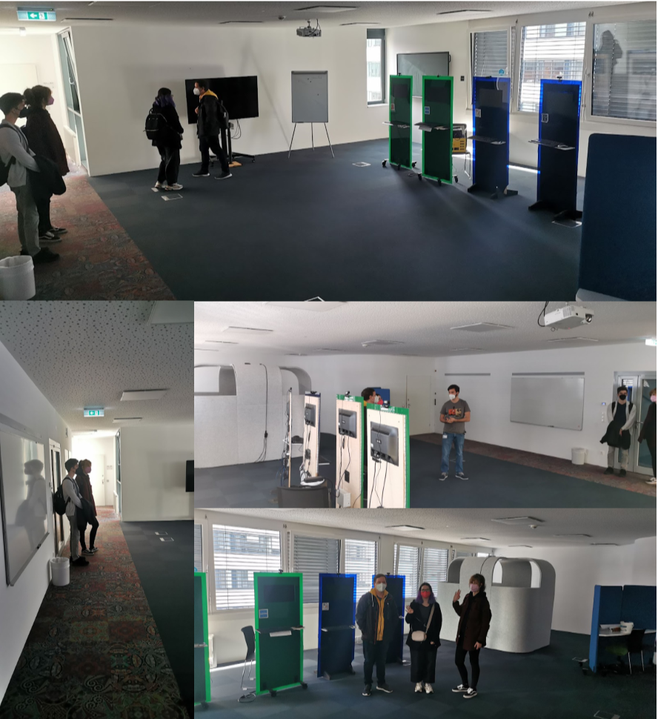

###  
Notizen 03.11.2021

gemeinsames Meeting (Hardware wurde kontrolliert auf Funktionalität + Beschaffenheit)

erstmalige Nutzung von Raspberry Pi 4 durch Stromkabel ergab volle Funktionsfähigkeit

erstmalige Nutzung durch PoE (Power over Ethernet) musste abgebrochen werden aufgrund von Brandgefahr => genauere Verwendung wird in Dokumentation nachgelesen und bei erneuter Brandgefahr wird Supervisor wegen fehlerhafter Funktionalität kontaktiert

restliche Aufgaben von Sprint #1 wurden verteilt (siehe Abschnitt Sprint#1)

erste Ausgabe des Livestreams des Pis über HDMI mittels den Befehl raspivid -t 10000

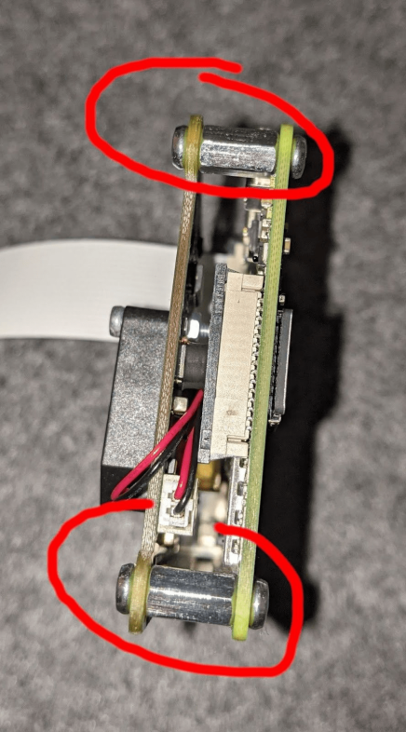

weitere Erkenntnisse im Laufe des Abends (Dominic):

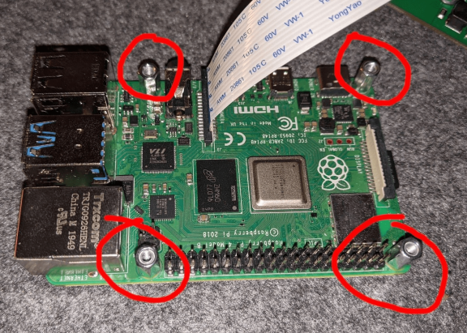

nach ausführlicher Recherche und genauer Installation (mittels beigefügten Spacers, siehe Foto) funktioniert der PoE Hat weiterhin nicht, vermutlich war dieser bereits bei Auslieferung defekt

weitere Überlegung bevor die Semester Roadmap adaptiert wird und die Trello Tasks gepflegt werden:

sollten wir, da sich dieses Projekt über mehrere Semester streckt, eine Art Trello Guideline erstellen, wie die Tasks bei der Erstellung auszusehen hat sowie Handhabung der Tasks?

**Erstellung der Tasks**

z.B. Tags wie “Sprint 1.2”, erstes 1 für erstes Projektsemester, 2 für den zweiten Sprint des Semesters, dadurch könnten wir dynamische Listen erstellen, Task wie “Bug”, “Feature” etc.

**Handhabung der Taks**

z.B. Gegencheck eines anderen Projektmitglieds bevor der Task unter Done abgelegt wird

zusätzlich sollten wir das Case für den Raspberry Pi (Achtung auf die Kompatibilität des Kamera Moduls sowie dem PoE hat) bereits in den ersten zwei Sprints mit einplanen, da Transport sowie Lagerung (Staub) schädlich für den Raspberry Pi sein könnte

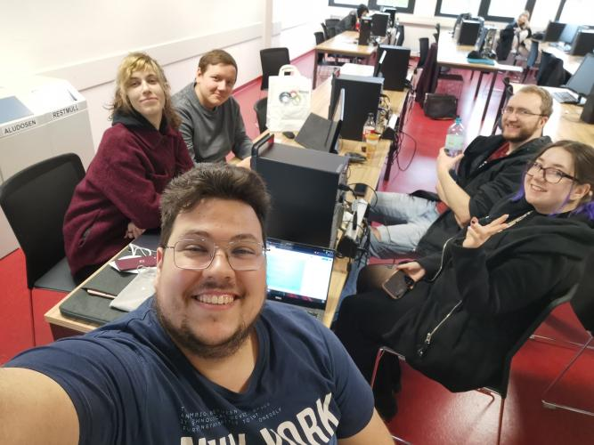

###  
Notizen 09.11.2021

Erstellung eines 3D Modells vom “PresentationLab” zur späteren Orientierung und weiteren Handhabung.

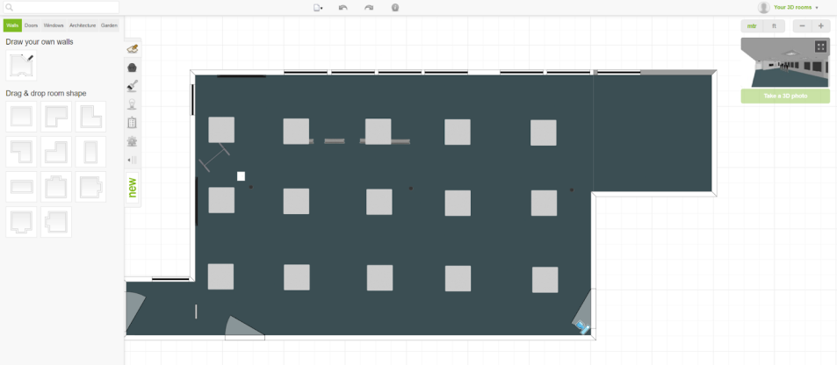

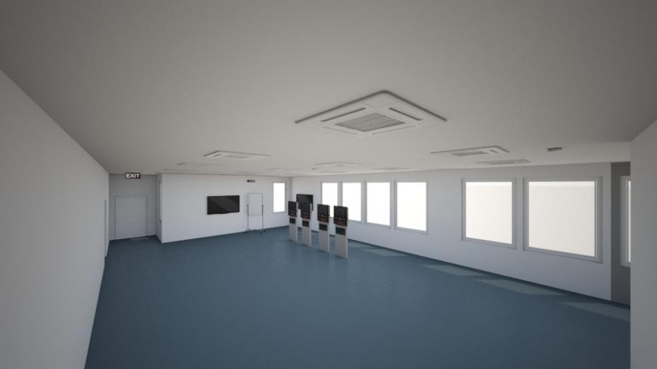

###  
Notizen 10.11.2021

Namensvorschläge (Domain / GitHub Repository)

|  |  |
| --- | --- |
| **GitHub** | **Domain** |
| visitorCounter | [www.visitorCounter.at](http://www.visitorcounter.at/" \o "http://www.visitorCounter.at) |
| studentStalker | [www.studentStalker.at](http://www.studentstalker.at/" \o "http://www.studentStalker.at) |
| mysticEye | [www.mysticEye.at](http://www.mysticeye.at/" \o "http://www.mysticEye.at) |
| **theObserver** | [theObserver.w3.cs.technikum-wien.at](http://theobserver.w3.cs.technikum-wien.at/" \o "http://theObserver.w3.cs.technikum-wien.at) |
| secretEye | [www.secretEye.at](http://www.secreteye.at/" \o "http://www.secretEye.at) |
| studentCounter | [www.studentCounter.at](http://www.studentcounter.at/" \o "http://www.studentCounter.at) |
| TW-studentCounter | [www.TW-studentCounter.at](http://www.tw-studentcounter.at/" \o "http://www.TW-studentCounter.at) |

###  
Notizen 24.11.2021

Check filaments for 3D print:

ABS - **Acrylnitril-Butadien-Styrol** (2nd most popular filament; Terpolymer => Polymer consisting of 3 different Monomers; popular in the 1950’s; easy handling; tough & heat resistent)

ASA - **Acryl-Styrol-Acrylnitrit** (high quality, but less usable & tough in comparison to ABS)

PLA - **Polylactid Acid** (renewable resources (corn), biodegradable, easy to use for printing, might melt by heat)

PETG - **Polyethylenterephthalat** (recyclable, not biodegradable (contains oil), heat resistent)

###  
Notizen 25.11.2021

Meeting with Supervisor:

[https://towardsdatascience.com/how-to-detect-objects-in-real-time-using-opencv-and-python-c1ba0c2c69c0](https://towardsdatascience.com/how-to-detect-objects-in-real-time-using-opencv-and-python-c1ba0c2c69c0" \o "https://towardsdatascience.com/how-to-detect-objects-in-real-time-using-opencv-and-python-c1ba0c2c69c0)

(link for further information of using recognizing software)

Infill

75-80% would be optimal for a resistent use of raspberry pi case

Filament - ABS

we are allowed to do the printing by our own

###  
Notizen 06.12.2021

Configure OpenCV on Raspberry Pi

First make sure your Pi is using the full SD card

$sudo raspi-config

-choose “Advanced Options”

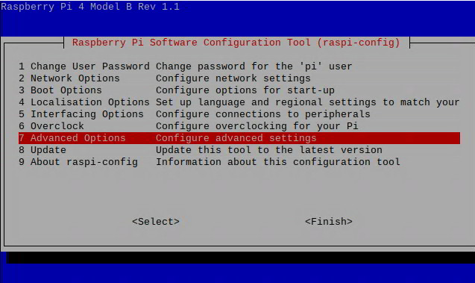

-choose **"Expand Filesystem"**

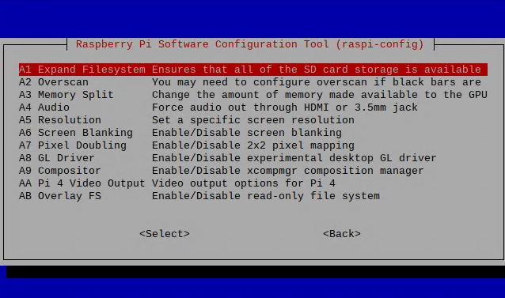

**Reboot the machine**

**$sudo reboot**

**Check space**

**$df -h**

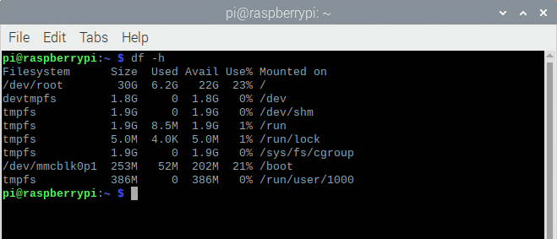

**Update the system**

**$sudo apt-get update && sudo apt-get upgrade**

**Get Pip and Install OpenCV**

**$mkdir ~/src && cd ~/src**

**$wget https://bootstrap.pypa.io/get-pip.py**

**$ sudo python3 get-pip.py**

**There are two ways to install OpenCV. It is possible to install it for the whole system or use a Python Virtual Environment (which is more recommended)**

**Install OpenCV for the Whole System**

**#$pip install --upgrade pip setuptools wheel**

**sudo pip install opencv-contrib-python**

**Install OpenCV in a Python Virtual Environment**

**Install the venv module for Python virtual environments - this need to be done only once for all future projects**

**sudo apt-get install python3-venv**

**Create a new Python project in a virtual environment**

**cd ~ python3 -m venv test**

**This will create a new folder called test that you should change to**

**cd ~/test**

**List the folder contents - you should see a file called pyvenv.cfg**

**cat pyvenv.cfg**

**You should see a result like this (though your version my vary):**

**test= /usr/bin**

**include-system-site-packages = false**

**version = 3.7.3**

**The include-system-site-packages = false line indicates that this program will not use any external packages installed elswhere on your system. The idea is to create a program in an isolated environment. That way it can be run on other systems without having to worry about external dependencies.**

**Switch to the test folder and activate the virtual enviromnent**

**cd ~/hello source bin/activate**

**Your prompt should change to something like this (your user and hostname may be different)**

**(test) pi@pi4:~/test $**

**Install OpenCV**

**pip install --upgrade pip setuptools wheel**

**pip install opencv-python**

**Create a new Python file called main.py**

**touch main.py**

**Edit the file using the nano editor:**

**nano main.py**

**Paste some text there and save the file**

**import sys**

**import cv2**

**print("Hello World")**

**From within the virtual environment, run this**

**python main.py**

**You should get a response like this:**

**Hello World**

**You know everything worked fine if you dont have an error message that cv2 coudnt be found or something else related to import cv2.**

**In order to deactivate the virtual environment and return to the main operating system command line**

**deactivate**

**Remove a Python virtual environment**

**cd ~**

**rm -rf test**

### **Sources**

[How to Install OpenCV on a Raspberry Pi](https://www.jeremymorgan.com/tutorials/raspberry-pi/how-to-install-opencv-raspberry-pi/)

[Headless Raspberry Pi Python Virtual Environment Setup](https://desertbot.io/blog/raspberry-pi-headless-python-venv-setup)

###  
Notizen 08.12.2021

discussion about current topics:

fill in current sprint review protocoll (review#3)

don’t forget meta data

are there tasks not done in the current sprint?

requirements next sprint?

semester roadmap says “implement system for visitor counter” what is exactly meant?

common administration tasks

communication with ProjectKitchen

next steps regarding 3D print

discuss with team if print will be done together in January or contact person does without any of us by himself in the next days due to construction inside ProjectKitchen

next usage of opencv (regarding videos)

<https://www.tensorscience.com/object-recognition/person-detection-in-video-streams-using-python-opencv-and-deep-learning> Person detection in video streams using Python, OpenCV and deep learning

<https://data-flair.training/blogs/python-project-real-time-human-detection-counting/>

<https://www.youtube.com/watch?v=oXlwWbU8l2o> OpenCV Course - Full Tutorial with Python

<https://www.computervision.zone/projects/> (Tipp Supervisor)

###  
Notizen 10.12.2021

