

Customer Portal Security Assessment
Web application and API penetration test

Client | Brightwater Logistics (fictional)
Engagement ID | UNR-2026-014
Version | 1.0
Date | 2026-10-28
Testing period | 2026-10-19 – 2026-10-23
Researcher(s) | Unravel Networks | Offensive security team
CONFIDENTIAL

Contents
Executive summary
Engagement details
Scope
How findings are rated
Findings summary
Retest and next steps
Findings
UNR-2026-014-1 Password reset token disclosed in API response
UNR-2026-014-2 Customers can read and change other customers' invoices
UNR-2026-014-3 Stored cross-site scripting in support tickets
UNR-2026-014-4 User export returns password hashes and personal data
UNR-2026-014-5 No protection against password guessing on login
UNR-2026-014-6 Outdated TLS protocols and ciphers enabled
UNR-2026-014-7 Detailed error messages reveal internal information
UNR-2026-014-8 Security headers missing

Executive summary
Unravel Networks tested the Brightwater customer portal and its API between 19 and 23 October 2026, as a customer with ordinary access would use it.
The most serious problem is that the password reset service returns the reset token in its own response. Anyone who knows a user's email address can take over that account, including finance staff accounts, without any interaction from the victim.
Customers can also open and change other customers' invoices by changing a number in the address, and the user export returns password hashes and contact details for every portal user.
We found 8 issues: 1 critical, 2 high, 2 medium, 2 low and 1 informational. The critical and high issues should be fixed before the portal's planned November release. A retest is included in this engagement.

Engagement details
Engagement ID | UNR-2026-014
Researcher(s) | Offensive security team
Customer | Brightwater Logistics (fictional)
Customer contact | Dana Levi, IT Security Manager (dana.levi@brightwater.example)
Testing period | 2026-10-19 – 2026-10-23
Scope summary | Customer portal, REST API v2 and support agent console (3 hosts)
Analysed data | Two test customer accounts (10233, 20981), one support agent account, API documentation v2.4, 1,412 captured requests
Methodology | OWASP Web Security Testing Guide 4.2 and OWASP API Security Top 10 (2023), manual testing supported by an intercepting proxy
Limitations | Testing used the staging environment with production-like data. Rate-limit tests were capped at 500 requests per endpoint at the client's request.

Scope
In scope:
- https://portal.brightwater.example (customer portal, authenticated as two test customers)
- https://portal.brightwater.example/api/v2 (REST API used by the portal and mobile app)
- https://agent.brightwater.example (support agent console, one test agent account)
Out of scope: payment provider pages, corporate network, denial-of-service testing and social engineering.

How findings are rated
Each finding has a Severity rating that the tester assigns from the evidence, weighing how easily the issue can be exploited and what an attacker would gain. It is a judgment, not a calculated score.
- Critical: can be exploited easily, typically without special access, and gives control of a system or broad access to sensitive data. Fix immediately.
- High: has serious impact, such as access to other users' data or accounts, but needs a precondition such as an account or user interaction. Fix as a priority.
- Medium: has limited impact, or serious impact that depends on conditions that are hard to meet. Fix in the normal release cycle.
- Low: has little direct impact or is impractical to exploit, but adds risk in combination with other issues. Fix when convenient.
- Informational: is not a vulnerability in itself, but a hardening or good-practice observation.
CVSS 3.1 Base is the score calculated from the finding's CVSS version 3.1 Base metrics, shown with its vector. It describes the issue's technical severity and does not include environmental or business factors. Scores map to these bands:
- Critical: 9.0 to 10.0
- High: 7.0 to 8.9
- Medium: 4.0 to 6.9
- Low: 0.1 to 3.9
- None: 0.0
A finding without a vector is shown as Unscored.

Findings summary
ID | Finding | Severity | CVSS 3.1 Base | Status | Classification
UNR-2026-014-1 | Password reset token disclosed in API response | Critical | 9.1 | Open | Weak password recovery (CWE‑640)
UNR-2026-014-2 | Customers can read and change other customers' invoices | High | 8.1 | Open | Broken object level authorization (CWE‑639)
UNR-2026-014-3 | Stored cross-site scripting in support tickets | High | 7.6 | Partly fixed | Stored cross-site scripting (CWE‑79)
UNR-2026-014-4 | User export returns password hashes and personal data | Medium | 6.5 | Open | Excessive data exposure (CWE‑200)
UNR-2026-014-5 | No protection against password guessing on login | Medium | 5.3 | Risk accepted | Missing brute-force protection (CWE‑307)
UNR-2026-014-6 | Outdated TLS protocols and ciphers enabled | Low | 3.7 | Fixed | Weak TLS configuration (CWE‑327)
UNR-2026-014-7 | Detailed error messages reveal internal information | Low | Unscored | Open | Information disclosure in error messages (CWE‑209)
UNR-2026-014-8 | Security headers missing | Informational | Unscored | False positive | Missing security headers (CWE‑693)

Severity | Critical | High | Medium | Low | Informational | Total
Findings | 1 | 2 | 2 | 2 | 1 | 8

CVSS 3.1 Base | Critical | High | Medium | Low | None | Unscored | Total
Findings | 1 | 2 | 2 | 1 | 0 | 2 | 8

Status | Open | Fixed | Partly fixed | Risk accepted | False positive | Total
Findings | 4 | 1 | 1 | 1 | 1 | 8

Counts include every finding in this report, whatever its status.

Retest and next steps
Brightwater plans to fix the critical and high findings before the portal's November release. We recommend this order:
- Remove the reset token from the API response and invalidate tokens issued since the debug field was introduced.
- Add object-level authorization checks to the invoice and export endpoints.
- Encode note content on output and add a Content Security Policy.
A retest of the fixed findings is included in the engagement and can be scheduled once the fixes reach the staging environment. The retest will update each finding's status in a new version of this report.

Findings

UNR-2026-014-1 Password reset token disclosed in API response
ID | UNR-2026-014-1
Severity | Critical
CVSS 3.1 Base | 9.1  CVSS:3.1/AV:N/AC:L/PR:N/UI:N/S:U/C:H/I:H/A:N
Status | Open
Vulnerability type | Weak password recovery
CWE | CWE-640
Back to findings summary

Affected assets
POST https://portal.brightwater.example/api/v2/auth/password-reset

Description
When a password reset is requested, the API returns a "debug" object containing the one-time reset token that is also sent by email. The endpoint does not require authentication, so anyone who knows or guesses a user's email address receives a valid token for that account.
The debug object appears to be left over from development and is returned for every account, including staff accounts.

Additional details
1. Request a password reset for a staff account. No authentication is needed:
POST /api/v2/auth/password-reset HTTP/1.1
Host: portal.brightwater.example
Content-Type: application/json

{"email":"finance.lead@brightwater.example"}
2. The response contains the reset token in a "debug" object:
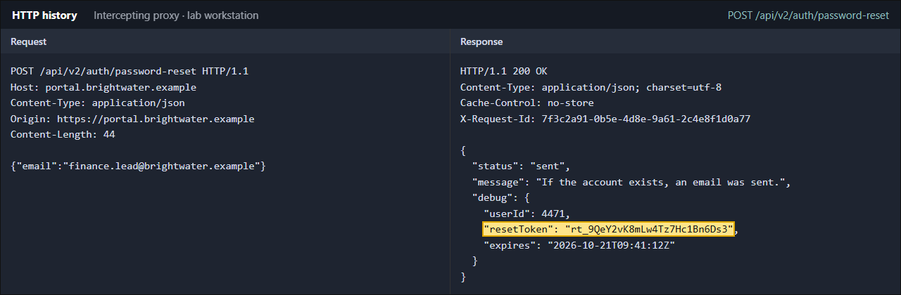
Figure 1 Reset request for a staff account returns the reset token in the response body
3. Use the token to set a new password:
POST /api/v2/auth/password-reset/confirm HTTP/1.1
Host: portal.brightwater.example
Content-Type: application/json

{"token":"rt_9QeY2vK8mLw4Tz7Hc1Bn6Ds3","password":"<new password>"}

HTTP/1.1 204 No Content
The tester then signed in as the staff user with the new password. The account owner received no notification.

Impact
Complete takeover of any portal account whose email address is known, without the victim noticing until they next try to sign in. Finance and staff accounts can approve invoices and change bank details.

Threat
An external attacker collects staff email addresses from public sources, requests resets and takes over finance accounts to redirect payments. The attack is fully automatable and leaves only normal-looking reset events in the logs.

Recommendations
- Remove the debug object from all API responses and confirm no other endpoint returns it.
- Invalidate all reset tokens issued since the debug field was introduced.
- Review reset and login logs for resets that were completed from unusual IP addresses.
- Add an automated test that fails if a response contains a reset token.

References
OWASP WSTG: Testing for weak password change or reset functionalities
https://owasp.org/www-project-web-security-testing-guide/
OWASP Forgot Password Cheat Sheet
https://cheatsheetseries.owasp.org/cheatsheets/Forgot_Password_Cheat_Sheet.html

UNR-2026-014-2 Customers can read and change other customers' invoices
ID | UNR-2026-014-2
Severity | High
CVSS 3.1 Base | 8.1  CVSS:3.1/AV:N/AC:L/PR:L/UI:N/S:U/C:H/I:H/A:N
Status | Open
Vulnerability type | Broken object level authorization
CWE | CWE-639
Back to findings summary

Affected assets
GET/PUT https://portal.brightwater.example/api/v2/invoices/{id}
https://portal.brightwater.example/invoices/{id}

Description
The invoice API checks that the user is signed in, but not that the invoice belongs to the user's account. Invoice numbers are sequential, so a customer can open any invoice by changing the number in the address bar or the API request.
The same missing check applies to PUT requests, which allowed the test account to change the billing reference of another customer's invoice.

Additional details
1. Sign in as customer account 10233 and open one of your own invoices.
2. Change the invoice number in the address bar to 48213, which belongs to account 20981. The invoice opens:
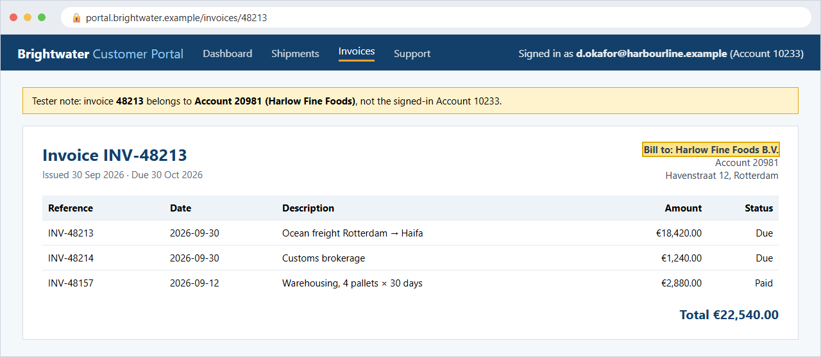
Figure 2 Invoice of another customer (account 20981) opened while signed in as account 10233
3. The API behind the page returns the full invoice, including the other customer's bank details:
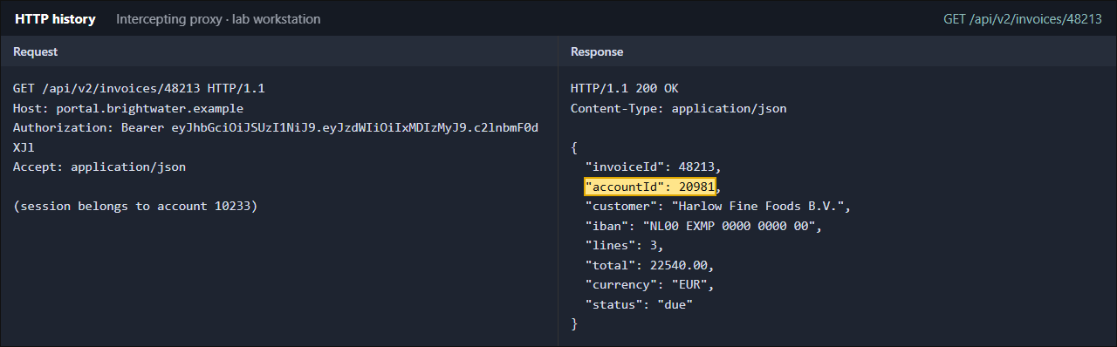
Figure 3 API response for the same invoice shows the other account's ID and bank details
4. The same request with PUT and a changed "reference" field also succeeds, and account 20981 sees the change:
PUT /api/v2/invoices/48213 HTTP/1.1
Host: portal.brightwater.example
Authorization: Bearer <token of account 10233>
Content-Type: application/json

{"reference":"TEST-UNR-2026-014"}

HTTP/1.1 200 OK

Impact
Disclosure of every customer's invoices, addresses and bank details, and unauthorised changes to billing data. This affects all customers of the portal and is likely a reportable personal-data breach.

Threat
A competitor or malicious customer enumerates invoice numbers to collect pricing and customer lists, or changes payment references to disrupt reconciliation.

Recommendations
- Enforce an ownership check on every invoice read and write, on the server side, based on the signed-in account.
- Apply the same check to other object types with sequential IDs (shipments, documents, tickets).
- Add authorisation tests that use two customer accounts.

References
OWASP API Security Top 10 2023: API1 Broken Object Level Authorization
https://owasp.org/API-Security/editions/2023/en/0xa1-broken-object-level-authorization/
CWE-639: Authorization Bypass Through User-Controlled Key
https://cwe.mitre.org/data/definitions/639.html

UNR-2026-014-3 Stored cross-site scripting in support tickets
ID | UNR-2026-014-3
Severity | High
CVSS 3.1 Base | 7.6  CVSS:3.1/AV:N/AC:L/PR:L/UI:R/S:C/C:H/I:L/A:N
Status | Partly fixed
Vulnerability type | Stored cross-site scripting
CWE | CWE-79
Back to findings summary

Affected assets
https://portal.brightwater.example/support (ticket comments)
https://agent.brightwater.example/console/tickets/{id}

Description
Comments added to support tickets are shown to support agents without HTML encoding. A customer can add a comment containing HTML and JavaScript, which runs in the agent's browser when the ticket is opened in the agent console.

Additional details
1. As a customer, open ticket #3302 in the portal and add this comment:
<img src=x onerror="alert('XSS: '+document.domain)">
2. Sign in to the agent console as a support agent and open the ticket. The script in the comment runs in the agent's session:
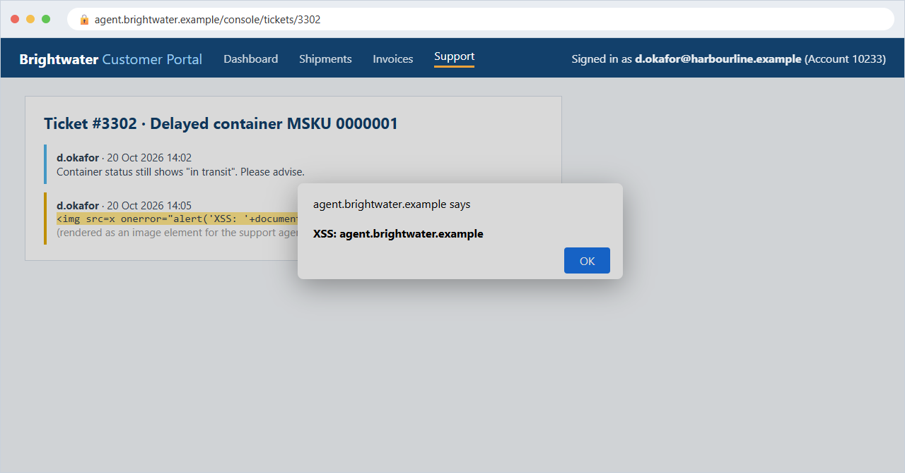
Figure 4 Script from a customer comment runs in the support agent console
The same comment is stored and runs again every time any agent opens the ticket.

Impact
Script runs with the support agent's session, which can view all customers' tickets and shipments and reset customer passwords.

Threat
An attacker opens a ticket with a malicious comment and waits for an agent to read it, then uses the agent session to access other customers' data.

Recommendations
- Encode all user-supplied content when displaying it in the agent console.
- Add a Content-Security-Policy that blocks inline scripts.
- Mark the agent session cookie HttpOnly and SameSite=Strict.

References
OWASP Cross Site Scripting Prevention Cheat Sheet
https://cheatsheetseries.owasp.org/cheatsheets/Cross_Site_Scripting_Prevention_Cheat_Sheet.html
CWE-79: Improper Neutralization of Input During Web Page Generation
https://cwe.mitre.org/data/definitions/79.html

UNR-2026-014-4 User export returns password hashes and personal data
ID | UNR-2026-014-4
Severity | Medium
CVSS 3.1 Base | 6.5  CVSS:3.1/AV:N/AC:L/PR:L/UI:N/S:U/C:H/I:N/A:N
Status | Open
Vulnerability type | Excessive data exposure
CWE | CWE-200
Back to findings summary

Affected assets
GET https://portal.brightwater.example/api/v2/users/export

Description
The user export endpoint, intended for customer administrators, is available to any signed-in customer and returns all portal users across all customers, including their bcrypt password hashes, phone numbers and last login dates.

Additional details
Signed in as a standard customer (account 10233), the tester requested the user export, which the API documentation describes as an administrator function:
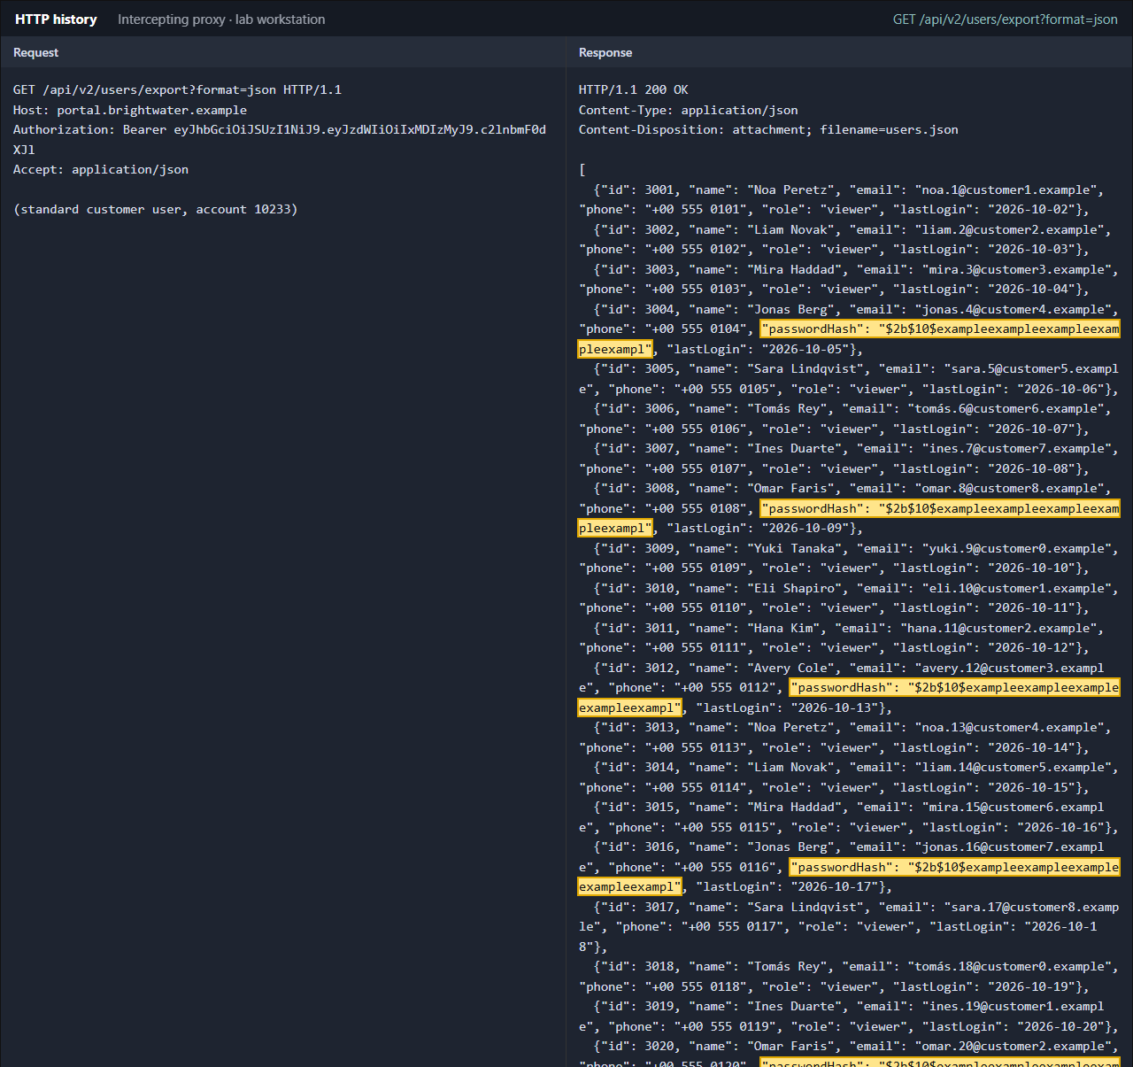
Figure 5 User export response for a standard customer, shown in full (part 1 of 3)
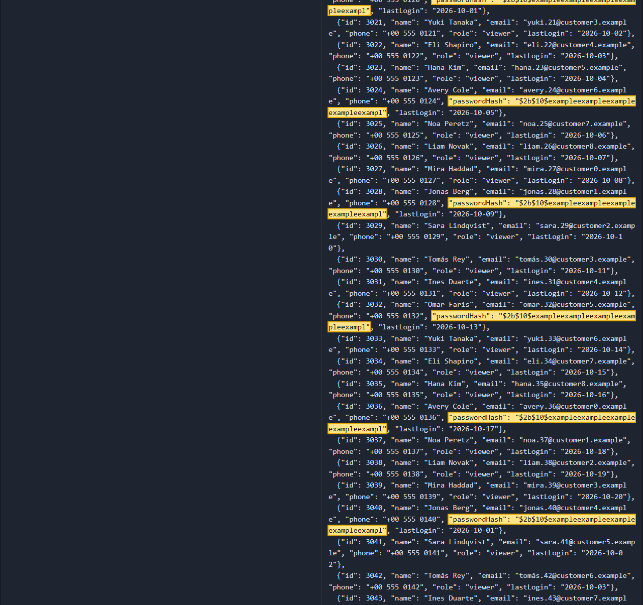
Figure 5 User export response for a standard customer, shown in full (part 2 of 3)
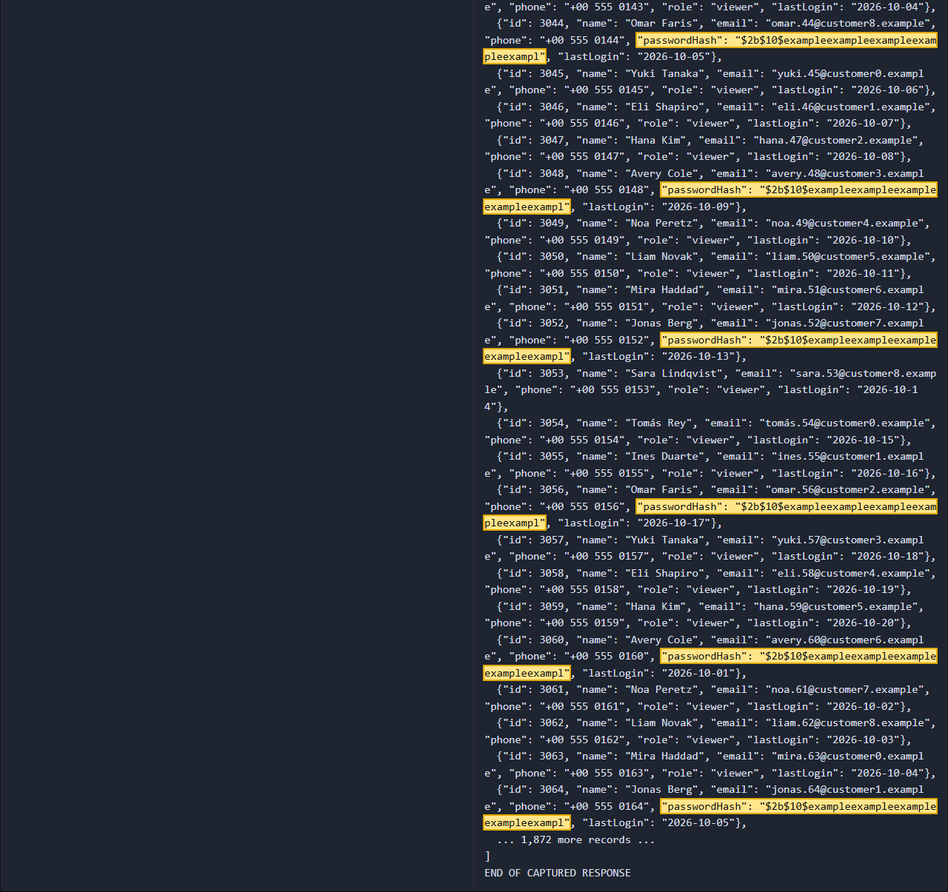
Figure 5 User export response for a standard customer, shown in full (part 3 of 3)
The full response contained 1,936 user records across all customers. Every fourth record shown includes a bcrypt password hash. Hashes were not cracked as part of this test.

Impact
Exposure of personal data for every portal user. The bcrypt hashes slow down, but do not prevent, offline password guessing for weak passwords.

Threat
A malicious customer downloads the export and uses the contact details for targeted phishing, or cracks weak passwords offline.

Recommendations
- Restrict the export to customer administrators and to their own account's users.
- Never include password hashes in API responses.
- Reduce the exported fields to what administrators need.

References
OWASP API Security Top 10 2023: API3 Broken Object Property Level Authorization
https://owasp.org/API-Security/editions/2023/en/0xa3-broken-object-property-level-authorization/

UNR-2026-014-5 No protection against password guessing on login
ID | UNR-2026-014-5
Severity | Medium
CVSS 3.1 Base | 5.3  CVSS:3.1/AV:N/AC:L/PR:N/UI:N/S:U/C:L/I:N/A:N
Status | Risk accepted
Vulnerability type | Missing brute-force protection
CWE | CWE-307
Back to findings summary

Affected assets
POST https://portal.brightwater.example/api/v2/auth/login

Description
The login endpoint accepted 500 failed attempts against a single account in under 100 seconds without slowing down, showing a CAPTCHA or locking the account. The correct password still worked immediately afterwards.

Additional details
The tester ran 500 login attempts with a synthetic word list against the tester's own account, with the client's approval:
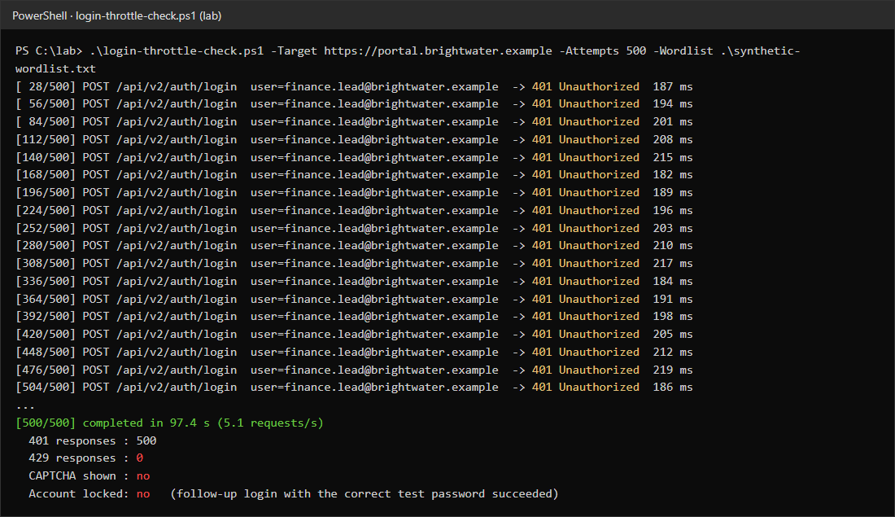
Figure 6 500 failed login attempts with no throttling, CAPTCHA or lockout
No attempt was slowed down or blocked, and a login with the correct password succeeded immediately afterwards.

Impact
Accounts with weak or reused passwords can be guessed. Combined with the user export, an attacker has a ready list of valid usernames.

Threat
Credential-stuffing attacks using passwords leaked from other services.

Recommendations
- Add per-account and per-IP rate limiting with increasing delays.
- Offer multi-factor authentication, and require it for staff and finance users.
- Alert on high volumes of failed logins.

References
OWASP Authentication Cheat Sheet
https://cheatsheetseries.owasp.org/cheatsheets/Authentication_Cheat_Sheet.html

UNR-2026-014-6 Outdated TLS protocols and ciphers enabled
ID | UNR-2026-014-6
Severity | Low
CVSS 3.1 Base | 3.7  CVSS:3.1/AV:N/AC:H/PR:N/UI:N/S:U/C:L/I:N/A:N
Status | Fixed
Vulnerability type | Weak TLS configuration
CWE | CWE-327
Back to findings summary

Affected assets
portal.brightwater.example:443
agent.brightwater.example:443

Description
Both hosts accept TLS 1.0 and TLS 1.1, which are deprecated, and offer Triple DES and CBC-mode cipher suites.

Additional details
A protocol and cipher scan of both hosts shows TLS 1.0 and 1.1 still enabled:
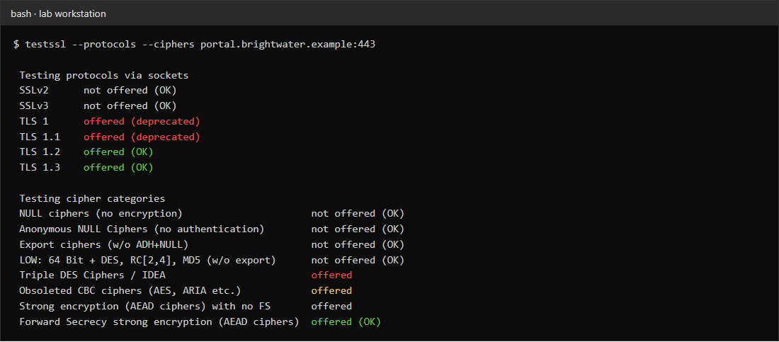
Figure 7 Protocol and cipher scan of portal.brightwater.example
A TLS 1.0 connection was confirmed manually:
openssl s_client -connect portal.brightwater.example:443 -tls1
...
Protocol : TLSv1
Cipher : ECDHE-RSA-AES256-SHA

Impact
Older clients may negotiate weaker encryption. Practical attacks are difficult but these settings fail most compliance baselines (PCI DSS, ISO 27001 controls).

Threat
A network-positioned attacker downgrading connections from legacy clients.

Recommendations
- Disable TLS 1.0 and 1.1.
- Remove 3DES and CBC cipher suites and prefer TLS 1.3 / AEAD suites with forward secrecy.

References
OWASP Transport Layer Security Cheat Sheet
https://cheatsheetseries.owasp.org/cheatsheets/Transport_Layer_Security_Cheat_Sheet.html

UNR-2026-014-7 Detailed error messages reveal internal information
ID | UNR-2026-014-7
Severity | Low
CVSS 3.1 Base | Unscored
Status | Open
Vulnerability type | Information disclosure in error messages
CWE | CWE-209
Back to findings summary

Affected assets
https://portal.brightwater.example/api/v2/shipments

Description
Invalid input causes the API to return a full .NET stack trace, including source file paths, the server name, runtime version and database name.

Additional details
Requesting the shipments API with an invalid date returns HTTP 500 with the full exception:
GET /api/v2/shipments?from=2026-13-45 HTTP/1.1
Host: portal.brightwater.example
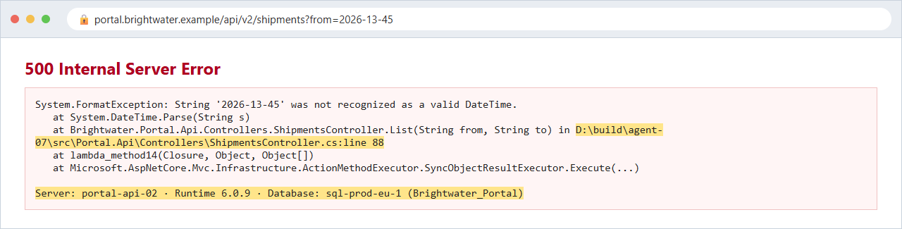
Figure 8 Stack trace returned for an invalid date parameter
Other malformed parameters (non-numeric page sizes, unknown sort fields) produce similar traces from different controllers.

Impact
Helps an attacker map the internal environment and target known weaknesses in specific versions.

Threat
An attacker uses the disclosed server names, file paths and runtime version to plan further attacks and to identify unpatched components.

Recommendations
- Return a generic error message and a reference ID to clients.
- Log full details on the server only.

References
CWE-209: Generation of Error Message Containing Sensitive Information
https://cwe.mitre.org/data/definitions/209.html

UNR-2026-014-8 Security headers missing
ID | UNR-2026-014-8
Severity | Informational
CVSS 3.1 Base | Unscored
Status | False positive
Vulnerability type | Missing security headers
CWE | CWE-693
Back to findings summary

Affected assets
https://portal.brightwater.example
https://agent.brightwater.example

Description
The applications do not set common browser security headers (HSTS, Content-Security-Policy, X-Content-Type-Options, Referrer-Policy) and disclose server software versions.

Additional details
The response headers of the portal home page, the API base path and the agent console login page were checked. All three lack the same headers:
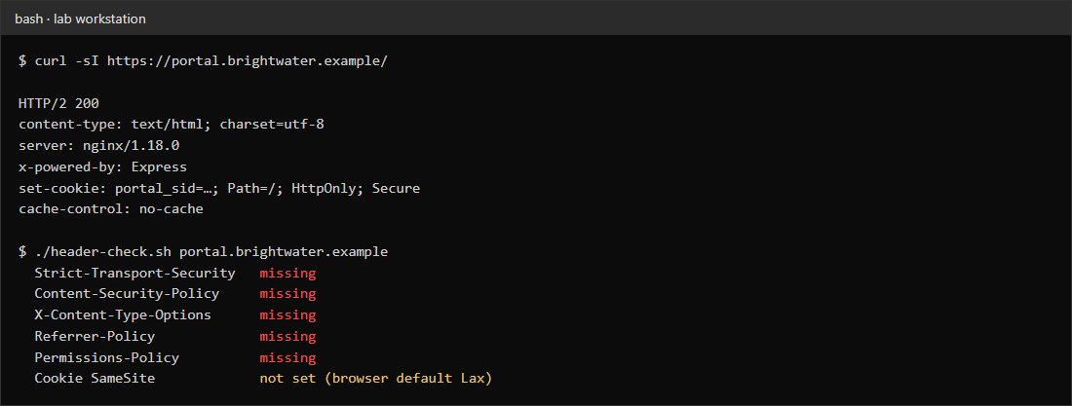
Figure 9 Response headers of the portal home page

Impact
No direct vulnerability, but these headers limit the impact of issues such as finding 3.

Threat
An attacker exploiting a script injection issue (such as finding 3) faces fewer browser-side barriers, and users on hostile networks can be downgraded to HTTP on their first visit.

Recommendations
- Add HSTS, a Content-Security-Policy, X-Content-Type-Options: nosniff and a Referrer-Policy.
- Remove the Server and X-Powered-By version details.

References
OWASP HTTP Security Response Headers Cheat Sheet
https://cheatsheetseries.owasp.org/cheatsheets/HTTP_Headers_Cheat_Sheet.html

