EECE 5644

Assignment 1

Dhanush Balakrishna

Due Date: 2/21/23

**Problem 1**

To solve this issue, a 10000 sample, 3-dimensional, real-valued random vector called X was created: p(x) = p(x|L=0) P(L=0) + p(x|L=1), where L is the real class label of the PDF that produced the data, p(L=1). If m is the mean vector and C is the covariance matrix, the class conditional PDFs are defined as p(x|L=0) = g(x|mo, Co) and p(x|L=1) = g(x|m1, C1). The distributions' parameters and priors are displayed below. In Figure 1, a plot of the vector X produced by these parameters is displayed.

Figure 1: X with True Labels for Problem 1

Part 1: ERM Classification Using Knowledge of True Data

1. Minimum expected risk classification rule in the form of a likelihood-ratio test

To minimize probability of misclassifications the cost for incorrect classifications should be 1 and the cost for correct classifications should be 0 which results in the gamma equal to 0.538.

1. The classifier was implemented for multiple values of gamma and the ROC curve is shown in Figure 2 below. The locations of the theoretical minimum errors as well as the minimum error determined by a parametric sweep of gamma are marked on the plot.

Figure 2: ROC Curve for ERM Classification with Known Data Distributions

1. Table 1 contains the theoretical and estimated gamma values that result in the minimum probability of error. As can be seen the two values closely align providing confidence in the estimated value.

|  |  |  |
| --- | --- | --- |
|  | γ | Min. Perror |
| Theoretical | 0.54 | 0.0891 |
| Estimated from Data | 0.44 | 0.0883 |

Table 1: Comparison of Gammas to find minimum errors.

Figure 3 shows a plot of the probability of errors versus the gamma parameters. The location of the minimum error is marked. Additionally, as the gamma parameter approached its limits at 0 and +∞ the probability of error asymptotes to the priors for the two distributions. That is when the γ is set to its minimum value all the data points will be classified as class 1 so the overall error will be the proportion of data in class 0 which is equivalent to its prior. Similarly, when gamma is at +∞ all the data points will be classified as class 0 and so all of the class 1 data will be misclassified, and the probability of error is equivalent to the prior for class 1.

Figure 3: Probability of Error vs In(Gamma) for ERM Classification

Part B: Naïve Bayesian Classifier

In part two the same data was analyzed using a Naïve Bayesian approach in which the covariance of the data is to be classified is assumed to be the best represented by an identity matrix. Figure 4 below shows a representation of the data being analyzed with the assumed identity covariances. Note that this is just a representation of the assumed data being analyzed while the actual data being analyzed is what is shown in Figure 1. This figure is included to show the difference between the actual and assumed data distributions.

Figure 4: Assumed Distributions for Naïve Bayesian Classification

1. Minimum expected risk classification rule in the form of a likelihood-ratio test. These values are unchanged from the analysis performed in part 1. To minimize the probability of the misclassifications the cost for incorrect classification should be 1 and the cost for correct classifications should be 0 which results in a gamma equal to 0.538.
2. The classifier was implemented for multiple values of gamma and the ROC curve is shown in Figure 5. The location of the minimum error determined by a parametric sweep of gamma is marked on the plot.

Figure 5: ROC Curve for Naïve Bayesian Classification

1. Table 2 shows a comparison between minimum achievable errors when the covariance of the underlying data is known versus when the covariance is assumed to be best represented by an identity matrix. Both approaches yielded similar results. This is due to the overlap of the two datasets not being significantly altered by the assumption of identity covariance matrices. As can be seen in Figure 6, in both the actual data and the data when represented with identity covariance matrices only the tails overlap. Consequently, the accuracy of classification is only marginally impacted by the lack of the true statistics of the data being classified. In other instances where the means of the data are closer to each other this assumption can result in much worse classification performance.

|  |  |  |
| --- | --- | --- |
|  | γ | Min. Perror |
| Known Covariance | 0.44 | 0.0883 |
| Naïve Bayesian | 0.43 | 0.1089 |

Table 2: Comparison of Classification Results

Figure 6: Comparison of Actual Distribution with Naïve Bayesian Assumption

Figure 7 shows the probability of error versus the gamma parameter. The curve has a similar shape to be the one generated in part 1 illustrating the similarity in the two approaches for this set of data and classes.

Figure 7: Probability of Error vs. In(Gamma) for Naïve Bayesian Classification

Part C: Fisher Linear Discriminant Analysis (LDA)

In the part 3 classification was performed by using a Fisher LDA approach. In this approach the two datasets being classified are projected into a single dimension. The projection maximizes the ratio of the difference in their means to their variances. This minimizes the overlap between the two datasets aiding the classifications process. In this implementation the analysis was performed using the sample mean and covariances of the two sets of data.

1. Data from projection using Fisher LDA is shown in Figure 8 below. The tau that minimizes the probability of error is also marked. Figure 9 shows the ROC curve. The location of the minimum error determined by a parametric sweep of tau are marked on the plot.

Figure 8: Fisher LDA Projection

Figure 8: Fisher LDA Projection

Figure 9: ROC Curve for Fisher LDA

1. A comparison of the probability of errors for the three methods of classification that were performed is shown in Table 3. As can be seen in this table the Fisher LDA performed roughly comparable to the Naïve Bayesian approach. The minimum probability of error was slightly larger than both the theoretical and analytical estimates of probability of error generated using the ERM with known covariances method and was comparable to the results obtained using the Naïve Bayesian approach.

|  |  |
| --- | --- |
| Method | Min. Perror |
| ERM Theoretical | 0.0891 |
| ERM Known Covariance | 0.0883 |
| ERM Naïve Bayesian | 0.1089 |
| Fisher LDA | 0.0969 |

Table 3: Probability of Error for All Classification Methods

Figure 10 shows a plot of probability of error versus the tau parameter. The shape of this curve is similar to the curves for both of the ERM based approaches.

Figure 10: Fisher LDA Probability of Error vs. Tau

**Problem 2**

The class parameters and priors are as follows:

The mean and covariance matrix values given in Question 2 were used to first generate 10000 samples pictured in Figure 11 below.

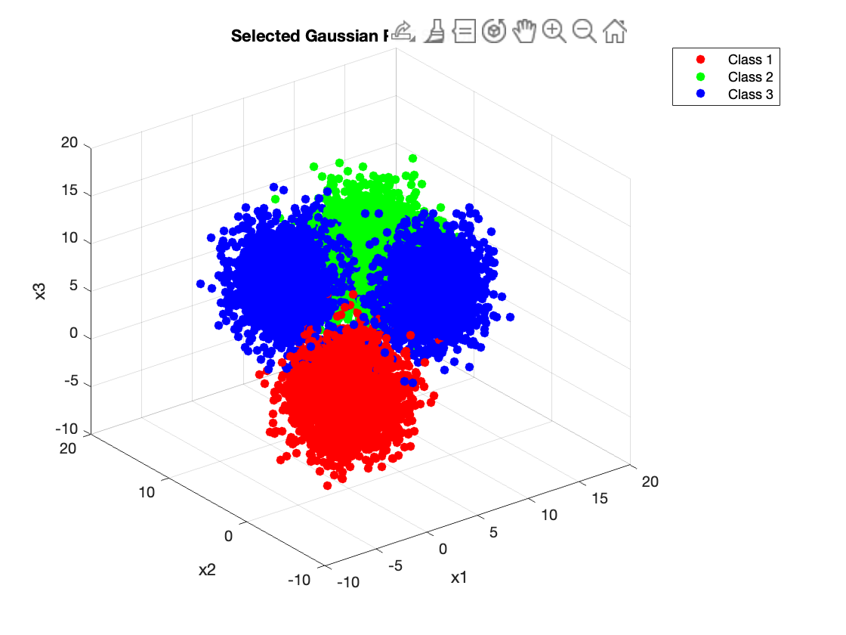

Figure 11: Question 2 Class Distributions

A decision rule that achieves the min. probability of error is the 0-1 loss which is a special case decision rule as:

Figure 12 shows the confusion matrix of how the samples were classified according to this decision rule.

Figure 12: Confusion matrix over the true classification with 0-1 loss

Figure 13 shows the visualization of the data.

Figure 13: Data Visualization with 0-1 Loss

Part B

1. Decision Rules:

When L=3, Figure 14, and Figure 15 show how the samples were classified according to this decision rule and the confusion matrix when the given decision cares 10 times.

Figure 14: Classification correctness of loss matrix A10

Figure 15: Confusion Matrix of Loss matrix A10

Figure 16 and Figure 17 show how the samples were classified according to this decision rule and the confusion matrix when the given decision rule cares 100 times.

Figure 16: Confusion Matrix of Loss matrix A100

Figure 17: Classification correctness of loss matrix A100

Insights:

The classifier will make more mistakes when the loss matrix is changed and the Class 3 with higher risk is classified. More data will be categorized as Class 3 when the updated matrix is A10 and L=3. The classification accuracy of a single class is displayed in a fusion matrix. The accuracy of Class 3 will not greatly increase when the loss matrix is A100 as opposed to A10. The decisions from categories 1 and 2 will also be added to Class 3 at the same time by the classifier. A significant percentage of data will be classed as Class 3 when A100 is used due to which more inaccurate classifications are observed in Classes 1 and 2.

**Problem 3**

In this Problem, we can see that the White Wine Dataset is far more classified than the HAR Dataset, whose classification is highly overlapped. We can see the classification with the help of the Fisher LDA plots of both the datasets. (Figure 18 and Figure 19).

Figure 18: Classification in HAR Dataset

Figure 19: Classification for White Wine Dataset

The Confusion Matrices for both the datasets are as shown below:

Figure 20: Confusion Matrix for HAR Dataset

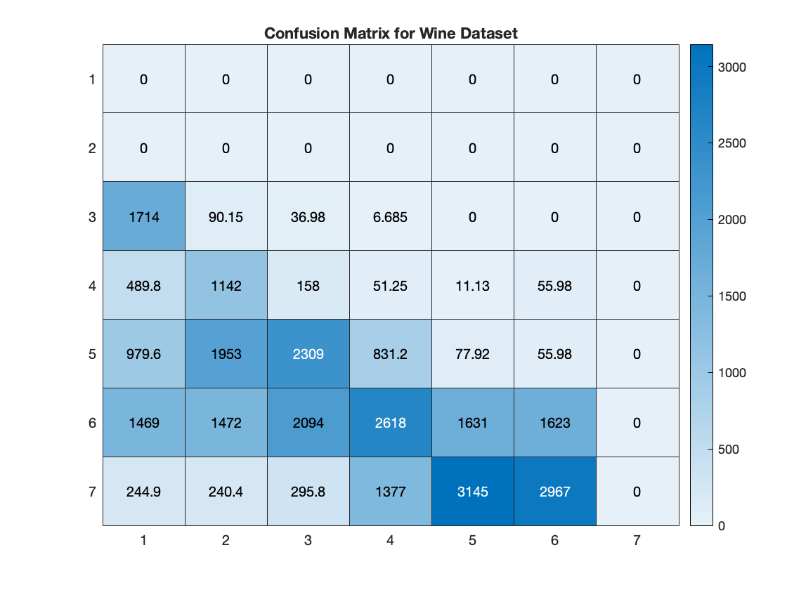

Figure 21: Confusion Matrix for Wine Dataset

The Confusion Matrices clearly depict that the algorithm well classified the Wine dataset than the HAR Dataset.

Appendix:

Codes for all the questions can be found here.

Question 1:

clear; close all;

%Initialize Parameters and Generate Data

N = 10000; %Number of data points

n=4; %Dimensions of data

p0 = 0.35; %Prior for label 0

p1 = 0.65; %Prior for label 1

u = rand(1,N)>=p0; %Determine posteriors

%Create appropriate number of data points from each distribution

N0 = length(find(u==0));

N1 = length(find(u==1));

N=N0+N1;

label=[zeros(1,N0) ones(1,N1)];

%Parameters for two classes

mu0 = [-1/2;-1/2;-1/2;-1/2];

Sigma0 = [2,-0.5,0.3,0;

-0.5,1,-0.5,0;

0.3,-0.5,1,0;

0,0,0,2];

mu1 = [1;1;1;1];

Sigma1 = [1,0.3,-0.2,0;

0.3,2,0.3,0;

-0.2,0.3,1,0;

0,0,0,3];

%Generate data as prescribed in assignment description

r0 = mvnrnd(mu0, Sigma0, N0);

r1 = mvnrnd(mu1, Sigma1, N1);

%Plot data showing two classes

figure;

plot3(r0(:,1),r0(:,2),r0(:,3),'.b','DisplayName','Class 0');

axis equal;

hold on;

plot3(r1(:,1),r1(:,2),r1(:,3),'.r','DisplayName','Class 1');

axis equal;

hold on;

xlabel('x_1');ylabel('x_2');zlabel('x_3');

grid on;

title('Class 0 and Class 1 Data');

legend 'show';

%Combine data from each distribution into a single dataset

x=zeros(N,n);

x(label==0,:)=r0;

x(label==1,:)=r1;

%Part 1: ERM Classification with True Knowledge

discScore=log(evalGaussian(x' ,mu1,Sigma1)./evalGaussian(x' ,mu0,Sigma0));

sortDS=sort(discScore);

%Generate vector of gammas for parametric sweep

logGamma=[min(discScore)-eps sort(discScore)+eps];

for ind=1:length(logGamma)

decision=discScore>logGamma(ind);

Num_pos(ind)=sum(decision);

pFP(ind)=sum(decision==1 & label==0)/N0;

pTP(ind)=sum(decision==1 & label==1)/N1;

pFN(ind)=sum(decision==0 & label==1)/N1;

pTN(ind)=sum(decision==0 & label==0)/N0;

%Two ways to make sure I did it right

pFE(ind)=(sum(decision==0 & label==1) + sum(decision==1 & label==0))/N;

pFE2(ind)=(pFP(ind)*N0 + pFN(ind)*N1)/N;

end

%Calculate Theoretical Minimum Error

logGamma_ideal=log(p0/p1);

decision_ideal=discScore>logGamma_ideal;

pFP_ideal=sum(decision_ideal==1 & label==0)/N0;

pTP_ideal=sum(decision_ideal==1 & label==1)/N1;

pFE_ideal=(pFP_ideal*N0+(1-pTP_ideal)*N1)/(N0+N1);

%Estimate Minimum Error

%If multiple minimums are found choose the one closest to the theoretical

%minimum

[min_pFE, min_pFE_ind]=min(pFE);

if length(min_pFE_ind)>1

[~,minDistTheory_ind]=min(abs(logGamma(min_pFE_ind)-logGamma_ideal));

min_pFE_ind=min_pFE_ind(minDistTheory_ind);

end

%Find minimum gamma and corresponding false and true positive rates

minGAMMA=exp(logGamma(min_pFE_ind));

min_FP=pFP(min_pFE_ind);

min_TP=pTP(min_pFE_ind);

%Plot

figure;

plot(pFP,pTP,'DisplayName','ROC Curve','LineWidth',2);

hold all;

plot(min_FP,min_TP,'o','DisplayName','Estimated Min. Error','LineWidth',2);

plot(pFP_ideal,pTP_ideal,'+','DisplayName',...

'Theoretical Min. Error','LineWidth',2);

xlabel('Prob. False Positive');

ylabel('Prob. True Positive');

title('Mininimum Expected Risk ROC Curve');

legend 'show';

grid on; box on;

fprintf('Theoretical: Gamma=%1.2f, Error=%1.2f%%\n',...

exp(logGamma_ideal),100*pFE_ideal);

fprintf('Estimated: Gamma=%1.2f, Error=%1.2f%%\n',minGAMMA,100*min_pFE);

figure;

plot(logGamma,pFE,'DisplayName','Errors','LineWidth',2);

hold on;

plot(logGamma(min_pFE_ind),pFE(min_pFE_ind),...

'ro','DisplayName','Minimum Error','LineWidth',2);

xlabel('Gamma');

ylabel('Proportion of Errors');

title('Probability of Error vs. Gamma')

grid on;

legend 'show';

%Part 2: Naive Bayesian Classifier

Sigma_NB=eye(4); %Assumed covariance

%Generate data to illustrate assumptions

r0_NB = mvnrnd(mu0, Sigma_NB, N0);

r1_NB = mvnrnd(mu1, Sigma_NB, N1);

%Plot Data demonstrating Naive Assumption

figure;

plot3(r0_NB(:,1),r0_NB(:,2),r0_NB(:,3),'.b','DisplayName','Class 0');

axis equal;

hold on;

plot3(r1_NB(:,1),r1_NB(:,2),r1_NB(:,3),'.r','DisplayName','Class 1');

axis equal;

xlabel('x_1');ylabel('x_2');zlabel('x_3');

grid on;

title('Assumed Class 0 and Class 1 Data Distributions for Naive Bayesian Classification');

legend 'show';

%Plot comparison of actual data to naive assumption

figure;

plot3(r0(:,1),r0(:,2),r0(:,3),'.b','DisplayName','Class 0 Actual Distribution');

hold on;

plot3(r0_NB(:,1),r0_NB(:,2),r0_NB(:,3),...

'.c','DisplayName','Class 0 Naive Assumption');

plot3(r1(:,1),r1(:,2),r1(:,3),'.r',...

'DisplayName','Class 1 Actual Distribution');

plot3(r1_NB(:,1),r1_NB(:,2),r1_NB(:,3),...

'.m','DisplayName','Class 1 Naive Assumption');

axis equal;

xlabel('x_1');ylabel('x_2');zlabel('x_3');

grid on;

title('Comparison of Actual Distribution to Naive Assumption');

legend 'show';

%Evaluate for different gammas

discScore_NB=...

log(evalGaussian(x' ,mu1,Sigma_NB)./evalGaussian(x' ,mu0,Sigma_NB));

logGamma_NB=[min(discScore_NB)-0.1 sort(discScore_NB)+0.1];

for ind=1:length(logGamma_NB)

decision=discScore_NB>logGamma_NB(ind);

Num_pos_NB(ind)=sum(decision);

pFP_NB(ind)=sum(decision==1 & label==0)/N0;

pTP_NB(ind)=sum(decision==1 & label==1)/N1;

pFN_NB(ind)=sum(decision==0 & label==1)/N1;

pTN_NB(ind)=sum(decision==0 & label==0)/N0;

pFE_NB(ind)=(sum(decision==0 & label==1)...

+ sum(decision==1 & label==0))/(N0+N1);

pFE2_NB(ind)=pFP(ind)*p0+pFN(ind)*p1;

end

%Estimated Minimum Error

[min_pFE_NB, min_pFE_ind_NB]=min(pFE_NB);

minGAMMA_NB=exp(logGamma(min_pFE_ind_NB));

min_FP_NB=pFP_NB(min_pFE_ind_NB);

min_TP_NB=pTP_NB(min_pFE_ind_NB);

%Plot Results

figure;

plot(pFP_NB,pTP_NB,'DisplayName','ROC Curve','LineWidth',2);

hold all;

plot(min_FP_NB,min_TP_NB,'o','DisplayName',...

'Estimated Min. Error','LineWidth',2);

xlabel('Prob. False Positive');

ylabel('Prob. True Positive');

title('Mininimum Expected Risk ROC Curve for Naive Bayesian');

legend 'show';

grid on; box on;

figure;

plot(logGamma_NB,pFE_NB,'DisplayName','Errors','LineWidth',2);

hold on;

plot(logGamma_NB(min_pFE_ind_NB),pFE_NB(min_pFE_ind_NB),'ro',...

'DisplayName','Minimum Error','LineWidth',2);

xlabel('Gamma');

ylabel('Proportion of Errors');

title('Probability of Error vs. Gamma for Naive Bayesian Estimate')

grid on;

legend 'show';

fprintf('Estimated for NB: Gamma=%1.2f, Error=%1.2f%%\n',...

minGAMMA_NB,100*min_pFE_NB);

%Part 3: Fisher LDA

%Compute Sample Mean and covariances

mu0_hat=mean(r0)';

mu1_hat=mean(r1)';

Sigma0_hat=cov(r0);

Sigma1_hat=cov(r1);

%Compute scatter matrices

Sb=(mu0_hat-mu1_hat)*(mu0_hat-mu1_hat)';

Sw=Sigma0_hat+Sigma1_hat;

%Eigen decompostion to generate WLDA

[V,D]=eig(inv(Sw)*Sb);

[~,ind]=max(diag(D));

w=V(:,ind);

y=w'*x';

w=sign(mean(y(label==1)-mean(y(label==0))))*w;

y=sign(mean(y(label==1)-mean(y(label==0))))*y;

%Evaluate for different taus

tau=[min(y)-0.1 sort(y)+0.1];

for ind=1:length(tau)

decision=y>tau(ind);

Num_pos_LDA(ind)=sum(decision);

pFP_LDA(ind)=sum(decision==1 & label==0)/N0;

pTP_LDA(ind)=sum(decision==1 & label==1)/N1;

pFN_LDA(ind)=sum(decision==0 & label==1)/N1;

pTN_LDA(ind)=sum(decision==0 & label==0)/N0;

pFE_LDA(ind)=(sum(decision==0 & label==1)...

+ sum(decision==1 & label==0))/(N0+N1);

end

%Estimated Minimum Error

[min_pFE_LDA, min_pFE_ind_LDA]=min(pFE_LDA);

minTAU_LDA=tau(min_pFE_ind_LDA);

min_FP_LDA=pFP_LDA(min_pFE_ind_LDA);

min_TP_LDA=pTP_LDA(min_pFE_ind_LDA);

%Plot results

figure;

plot(y(label==0),zeros(1,N0),'o','DisplayName','Label 0');

hold all;

plot(y(label==1),ones(1,N1),'o','DisplayName','Label 1');

ylim([-1 2]);

plot(repmat(tau(min_pFE_ind_LDA),1,2),ylim,'m--',...

'DisplayName','Tau for Min. Error','LineWidth',2);

grid on;

xlabel('y');

title('Fisher LDA Projection of Data');

legend 'show';

figure;

plot(pFP_LDA,pTP_LDA,'DisplayName','ROC Curve','LineWidth',2);

hold all;

plot(min_FP_LDA,min_TP_LDA,'o','DisplayName',...

'Estimated Min. Error','LineWidth',2);

xlabel('Prob. False Positive');

ylabel('Prob. True Positive');

title('Mininimum Expected Risk ROC Curve');

legend 'show';

grid on; box on;

figure;

plot(tau,pFE_LDA,'DisplayName','Errors','LineWidth',2);

hold on;

plot(tau(min_pFE_ind_LDA),pFE_LDA(min_pFE_ind_LDA),'ro',...

'DisplayName','Minimum Error','LineWidth',2);

xlabel('Tau');

ylabel('Proportion of Errors');

title('Probability of Error vs. Tau for Fisher LDA')

grid on;

legend 'show';

fprintf('Estimated for LDA: Tau=%1.2f, Error=%1.2f%%\n',...

minTAU_LDA,100*min_pFE_LDA);

%% ======================= Question 1: Functions ====================== %%

%reference g/Code/evalGaussian.m

function g = evalGaussian(x ,mu,Sigma)

%Evaluates the Gaussian pdf N(mu, Sigma ) at each column of X

[n,N] = size(x);

C = ((2*pi)^n * det(Sigma))^(-1/2); %coefficient

E = -0.5*sum((x-repmat(mu,1,N)).*(inv(Sigma)*(x-repmat(mu,1,N))),1);%exponent

g = C*exp(E); %finalgaussianevaluation

end

Question 2:

clear;close all;clc;

n=3; %dimensions

N=10000; %samples

% Class means and covariances

mu(:,1) = [0; 0; 0];

mu(:,2) = [8; 8; 8];

mu3(:,1) = [0; 8; 8];

mu3(:,2) = [8; 0; 8];

Sigma(:,:,1)=[5 1 1; 1 5 1; 1 1 5];

Sigma(:,:,2)=[5 1 1; 1 5 1; 1 1 5];

Sigma3(:,:,1)=[5 1 1; 1 5 1; 1 1 5];

Sigma3(:,:,2)=[5 1 1; 1 5 1; 1 1 5];

% Class priors and true label

prior = [0.3 0.3 0.4];

x=zeros(n,N);

label=zeros(1,N);

for i=1:N

r=rand(1);

if r <= 0.3

label(i)=1;

elseif (0.3<r)&&(r<=0.6)

label(i)=2;

else

label(i)=3;

end

end

Nc=[sum(label==1),sum(label==2),sum(label==3)];

% Generate data as prescribed in assignment description

x(:,label==1)=randGMM(Nc(1),1,mu(:,1),Sigma(:,:,1));

x(:,label==2)=randGMM(Nc(2),1,mu(:,2),Sigma(:,:,2));

x(:,label==3)=randGMM(Nc(3),[0.5 0.5],mu3,Sigma3);

% Plot true class label

figure(11);

X = x(1, label==1);

Y = x(2, label==1);

Z = x(3, label==1);

scatter3(X,Y,Z,'r','filled');

hold on;

X = x(1, label==2);

Y = x(2, label==2);

Z = x(3, label==2);

scatter3(X,Y,Z,'g','filled');

hold on;

X = x(1, label==3);

Y = x(2, label==3);

Z = x(3, label==3);

scatter3(X,Y,Z,'b','filled');

title('Selected Gaussian PDF Samples');

legend('Class 1','Class 2','Class 3');

xlabel('x1');

ylabel('x2');

zlabel('x3');

hold off;

%%========================Part A========================%%

% Probabilities and class posteriors

pxgivenl(1,:)=evalGaussian(x,mu(:,1), Sigma(:,:,1));

pxgivenl(2,:)=evalGaussian(x,mu(:,2), Sigma(:,:,2));

pxgivenl(3,:)=evalGMM(x,[0.5 0.5],mu3,Sigma3);

px=prior*pxgivenl;

plgivenx=pxgivenl.*repmat(prior',1,N)./repmat(px,3,1); % Bayes theorem

% 0-1 loss matrix, expected risks, decision

lossMatrix=ones(3,3)-eye(3);

[decision,confusionMatrix]=runClassif(lossMatrix, plgivenx, label, Nc);

% Expected risk

estRisk = expRiskEstimate(lossMatrix, decision, label, N, 3);

% Confusion matrix

conf_mat = [sum(decision(label==1)==1) sum(decision(label==2)==1) sum(decision(label==3)==1); ...

sum(decision(label==1)==2) sum(decision(label==2)==2) sum(decision(label==3)==2);

sum(decision(label==1)==3) sum(decision(label==2)==3) sum(decision(label==3)==3)] ./ [sum(label==1) sum(label==2) sum(label==3)];

figure(12)

h = heatmap(conf_mat);

h.Title = 'Confusion Matrix';

% Plot samples with marked correct & incorrect decision

figure(13);

plot3(x(1,label==1&decision==1), ...

x(2,label==1&decision==1), ...

x(3,label==1&decision==1), strcat('go'));

axis equal;

hold on;

plot3(x(1,label==1&decision~=1), ...

x(2,label==1&decision~=1), ...

x(3,label==1&decision~=1), strcat('ro'));

axis equal;

hold on;

plot3(x(1,label==2&decision==2), ...

x(2,label==2&decision==2), ...

x(3,label==2&decision==2), strcat('gx'));

axis equal;

hold on;

plot3(x(1,label==2&decision~=2), ...

x(2,label==2&decision~=2), ...

x(3,label==2&decision~=2), strcat('rx'));

axis equal;

hold on;

plot3(x(1,label==3&decision==3), ...

x(2,label==3&decision==3), ...

x(3,label==3&decision==3), strcat('gd'));

axis equal;

hold on;

plot3(x(1,label==3&decision~=3), ...

x(2,label==3&decision~=3), ...

x(3,label==3&decision~=3), strcat('rd'));

axis equal;

hold on;

grid on

xlabel('x1');ylabel('x2');zlabel('x3');

legend('Class 1 Correct', 'Class 1 Incorrect', 'Class 2 Correct', ...

'Class 2 Incorrect','Class 3 Correct','Class 3 Incorrect');

hold off;

title('0-1 loss classification correctness');

%%========================Part B========================%%

% Loss matrix A10

lossMatrix10 = [0 1 10; 1 0 10; 1 1 0];

[decision10,confusionMatrix10]=runClassif(lossMatrix10, plgivenx, label, Nc);

% Expected risk 10

estRisk10=expRiskEstimate(lossMatrix10, decision10, label, N, 3);

% Confusion matrix for A10

conf_mat_10 = [sum(decision10(label==1)==1) sum(decision10(label==2)==1) sum(decision10(label==3)==1); ...

sum(decision10(label==1)==2) sum(decision10(label==2)==2) sum(decision10(label==3)==2);

sum(decision10(label==1)==3) sum(decision10(label==2)==3) sum(decision10(label==3)==3)] ./ [sum(label==1) sum(label==2) sum(label==3)];

figure(14)

h = heatmap(conf_mat_10);

h.Title = 'Confusion Matrix for A10';

% Plot Risk10 Results

figure(15);

plot3(x(1,label==1&decision==1), ...

x(2,label==1&decision==1), ...

x(3,label==1&decision==1), strcat('go'));

axis equal;

hold on;

plot3(x(1,label==1&decision~=1), ...

x(2,label==1&decision~=1), ...

x(3,label==1&decision~=1), strcat('ro'));

axis equal;

hold on;

plot3(x(1,label==2&decision==2), ...

x(2,label==2&decision==2), ...

x(3,label==2&decision==2), strcat('gx'));

axis equal;

hold on;

plot3(x(1,label==2&decision~=2), ...

x(2,label==2&decision~=2), ...

x(3,label==2&decision~=2), strcat('rx'));

axis equal;

hold on;

plot3(x(1,label==3&decision==3), ...

x(2,label==3&decision==3), ...

x(3,label==3&decision==3), strcat('gd'));

axis equal;

hold on;

plot3(x(1,label==3&decision~=3), ...

x(2,label==3&decision~=3), ...

x(3,label==3&decision~=3), strcat('rd'));

axis equal;

hold on;

grid on

xlabel('x1');ylabel('x2');zlabel('x3');

legend('Class 1 Correct', 'Class 1 Incorrect', 'Class 2 Correct', ...

'Class 2 Incorrect','Class 3 Correct','Class 3 Incorrect');

hold off;

title('A10 loss function classification correctness');

% loss matrix A100

lossMatrix100 = [0 1 100; 1 0 100; 1 1 0];

[decision100,confusionMatrix100]=runClassif(lossMatrix100, plgivenx, label, Nc);

% Expected risk 100

estRisk100=expRiskEstimate(lossMatrix100, decision100, label, N, 3);

% Confusion matrix for A100

conf_mat_100 = [sum(decision100(label==1)==1) sum(decision100(label==2)==1) sum(decision100(label==3)==1); ...

sum(decision100(label==1)==2) sum(decision100(label==2)==2) sum(decision100(label==3)==2);

sum(decision100(label==1)==3) sum(decision100(label==2)==3) sum(decision100(label==3)==3)] ./ [sum(label==1) sum(label==2) sum(label==3)];

figure(16);

h = heatmap(conf_mat_100);

h.Title = 'Confusion Matrix for A100';

% Plot Risk100 Results

figure(17);

plot3(x(1,label==1&decision==1), ...

x(2,label==1&decision==1), ...

x(3,label==1&decision==1), strcat('go'));

axis equal;

hold on;

plot3(x(1,label==1&decision~=1), ...

x(2,label==1&decision~=1), ...

x(3,label==1&decision~=1), strcat('ro'));

axis equal;

hold on;

plot3(x(1,label==2&decision==2), ...

x(2,label==2&decision==2), ...

x(3,label==2&decision==2), strcat('gx'));

axis equal;

hold on;

plot3(x(1,label==2&decision~=2), ...

x(2,label==2&decision~=2), ...

x(3,label==2&decision~=2), strcat('rx'));

axis equal;

hold on;

plot3(x(1,label==3&decision==3), ...

x(2,label==3&decision==3), ...

x(3,label==3&decision==3), strcat('gd'));

axis equal;

hold on;

plot3(x(1,label==3&decision~=3), ...

x(2,label==3&decision~=3), ...

x(3,label==3&decision~=3), strcat('rd'));

axis equal;

hold on;

grid on

xlabel('x1');ylabel('x2');zlabel('x3');

legend('Class 1 Correct', 'Class 1 Incorrect', 'Class 2 Correct', ...

'Class 2 Incorrect','Class 3 Correct','Class 3 Incorrect');

hold off;

title('A100 loss function classification correctness');

%%=========================Question 2 Functions=========================%%

%%%%%%%%%%%%%%%%%%%%%%%%%%%%%%%%%%%%%%%%%%%%%%%%%%%%%%%%%%%%%%%%%%%%%%%%%%%

% Functions credit to Prof.Deniz

%%%%%%%%%%%%%%%%%%%%%%%%%%%%%%%%%%%%%%%%%%%%%%%%%%%%%%%%%%%%%%%%%%%%%%%%%%%

function r = expRiskEstimate(lossMatrix, decision, label, N, C)

r = 0;

for d=1:C

for l=1:C

r=r+(lossMatrix(d,l) + sum(decision(label==l)==d));

end

end

r=r/N;

end

%%%%%%%%%%%%%%%%%%%%%%%%%%%%%%%%%%%%%%%%%%%%%%%%%%%%%%%%%%%%%%%%%%%%%%%%%%%

% Make decision & confusion matrix

function[decision,confusionMatrix]=runClassif(lossMatrix, classPosteriors, label, Nc)

expRisk=lossMatrix*classPosteriors;

[~,decision]=min(expRisk,[],1);

confusionMatrix=zeros(3);

for l=1:3

classDecision=decision(label == l);

for d=1:3

confusionMatrix(d,l)=sum(classDecision==d)/Nc(l);

end

end

end

%%%%%%%%%%%%%%%%%%%%%%%%%%%%%%%%%%%%%%%%%%%%%%%%%%%%%%%%%%%%%%%%%%%%%%%%%%%

% evalGaussian

function g=evalGaussian(x,mu,Sigma)

% Evaluates the Gaussian pdf N(mu,Sigma) at each coumn of X

[n,N] = size(x);

C = ((2*pi)^n * det(Sigma))^(-1/2);

E = -0.5*sum((x-repmat(mu,1,N)).*(inv(Sigma)*(x-repmat(mu,1,N))),1);

g = C*exp(E);

end

%%%%%%%%%%%%%%%%%%%%%%%%%%%%%%%%%%%%%%%%%%%%%%%%%%%%%%%%%%%%%%%%%%%%%%%%%%%

function [x,labels] = randGMM(N,alpha,mu,Sigma)

d = size(mu,1); % nality of samples

cum_alpha = [0,cumsum(alpha)];

u = rand(1,N); x = zeros(d,N); labels = zeros(1,N);

for m = 1:length(alpha)

ind = find(cum_alpha(m)<u & u<=cum_alpha(m+1));

x(:,ind) = randGaussian(length(ind),mu(:,m),Sigma(:,:,m));

labels(ind)=m-1;

end

end

%%%%%%%%%%%%%%%%%%%%%%%%%%%%%%%%%%%%%%%%%%%%%%%%%%%%%%%%%%%%%%%%%%%%%%%%%%%

function x = randGaussian(N,mu,Sigma)

% Generates N samples from a Gaussian pdf with mean mu covariance Sigma

n = length(mu);

z = randn(n,N);

A = Sigma^(1/2);

x = A*z + repmat(mu,1,N);

end

%%%%%%%%%%%%%%%%%%%%%%%%%%%%%%%%%%%%%%%%%%%%%%%%%%%%%%%%%%%%%%%%%%%%%%%%%%%

function gmm = evalGMM(x,alpha,mu,Sigma)

gmm = zeros(1,size(x,2));

for m = 1:length(alpha) % evaluate the GMM on the grid

gmm = gmm + alpha(m)*evalGaussian(x,mu(:,m),Sigma(:,:,m));

end

end

%%%%%%%%%%%%%%%%%%%%%%%%%%%%%%%%%%%%%%%%%%%%%%%%%%%%%%%%%%%%%%%%%%%%%%%%%%%

Question 3:

clearvars; close all; clear;

% Initial parameters

lambda=0.00001; %for regularization

% White Wine Quality Dataset

wine_raw_data = dlmread('winequality-white.csv',';',1,0)';

%Separate dataset into data and true class labels

x_W=wine_raw_data(1:end-1,:);

label_W=wine_raw_data(end,:);

% HAR Dataset (true class labels are separate files so no need to separate)

load X_train.txt;

load X_test.txt;

x_H=vertcat(X_train,X_test)';

%load true class labels

load y_train.txt;

load y_test.txt;

label_H=vertcat(y_train, y_test)';

% Dimensions and size of datasets from matrices

[n_W, N_W]=size(x_W);

[n_H,N_H]=size(x_H);

% Class labels and number of classes

class_W=unique(label_W);

C_W=length(class_W);

class_H=unique(label_H);

C_H=length(class_H);

% Class priors

priors_W=zeros(1,C_W);

for l=1:C_W

priors_W(l)=sum(label_W==class_W(l))/N_W;

end

priors_H=zeros(1,C_H);

for l=1:C_H

priors_H(l)=sum(label_H == class_H(l))/N_H;

end

display(priors_W);

display(priors_H);

% Estimated mean vectors

mu_W=zeros(n_W, C_W);

for l=1:C_W

samples=x_W(:,label_W == class_W(l));

mu_W(:,l)=mean(samples, 2);

end

mu_H=zeros(n_H, C_H);

for l=1:C_H

samples=x_H(:,label_H == class_H(l));

mu_H(:,l)=mean(samples, 2);

end

display(mu_W);

display(mu_H);

% Estimated covariance matrices

Sigma_W=zeros(n_W, n_W, C_W);

for l=1:C_W

Sigma_W(:,:,l)=cov(x_W(:,label_W==class_W(l))')+(lambda*eye(n_W));

end

Sigma_H = zeros(n_H, n_H, C_H);

for l=1:C_H

Sigma_H(:,:,l)=cov(x_H(:,label_H==class_H(l))')+(lambda*eye(n_H));

end

display(Sigma_W);

display(Sigma_H);

%[QW,DW]=eig(Sigma_W(:,:,1));

%[QH,DH]=eig(Sigma_H(:,:,1));

% Class posteriors and loss matrices

classPosterior_W=classPosterior(x_W, mu_W, Sigma_W, N_W, C_W, priors_W);

classPosterior_H=classPosterior_Mvnpdf(x_H, mu_H, N_H, C_H, priors_H);

lossMatrix_W=zeros(C_W);

for i=1:C_W

for j=1:C_W

lossMatrix_W(i,j) = abs(i-j);

end

end

lossMatrix_H=ones(C_H,C_H)-eye(C_H);

% Run classification for confusion matrices and create pError

[decisions_W,confusionMatrix_W]=runClassif(lossMatrix_W, classPosterior_W, label_W, class_W, priors_W);

[decisions_H,confusionMatrix_H]=runClassif(lossMatrix_H, classPosterior_H, label_H, class_H, priors_H);

pError_W=calculatePErr(confusionMatrix_W, priors_W);

pError_H=calculatePErr(confusionMatrix_H, priors_H);

y_W=LDA(x_W',label_W)';

y_H=LDA(x_H',label_H)';

%Plot first 3 dimensions of LDAprojections on each dataset

figure(1);

for l=1:C_W

scatter3(y_W(1, label_W==class_W(l)), y_W(2, label_W==class_W(l)), y_W(3, label_W==class_W(l)), '.');

hold on;

axis equal;

end

title('White Wine Dataset Fisher LDA - 3 Dimensions');

xlabel('y1'); ylabel('y2'); zlabel('y3');

legend('Class 3', 'Class 4', 'Class 5', 'Class 6', 'Class 7', 'Class 8', 'Class 9');

figure(2);

for l=1:C_H

scatter3(y_H(1, label_H==class_H(l)), y_H(2, label_H==class_H(l)), y_H(3, label_H==class_H(l)), '.');

hold on;

axis equal;

end

title('HAR Dataset Fisher LDA - 3 Dimensions');

xlabel('y1'); ylabel('y2'); zlabel('y3');

legend('Walking', 'Walking Upstairs', 'Walking Downstairs', 'Sitting', 'Standing', 'Laying')

%Confusion Matrices

figure(3);

h1=heatmap(confusionMatrix_W);

h1.Title='Confusion Matrix for Wine Dataset';

figure(4);

h2=heatmap(confusionMatrix_H);

h2.Title='Confusion Matrix for HAR Dataset';

%given a confusion matrix and corresponding class priors calculate

%probability of error for the classifier

function pErr=calculatePErr(confusionMatrix, prior)

C=length(prior);

pErr=0;

for l=1:C

for d=1:C

if d~=l

pErr=pErr+confusionMatrix(d,l) * prior(l);

end

end

end

end

% Class posterior for samples

function p=classPosterior(x, mu, Sigma, N, C, priors)

for l=1:C

pxgivenl(l,:)=evalGaussian(x,mu(:,l),Sigma(:,:,l)');

end

px=priors*pxgivenl;

p=pxgivenl.*repmat(priors',1,N)./repmat(px,C,1);

end

% Class posterior for HAR dataset using mvnpdf and omitting sigma, since the large covariance

% matrices cause issues

function p=classPosterior_Mvnpdf(x, mu, N, C, priors)

for l=1:C

pxgivenl(l,:)=mvnpdf(x',mu(:,l)');

end

px=priors*pxgivenl;

p=pxgivenl.*repmat(priors',1,N)./repmat(px,C,1);

end

% Make decisions and confusion matrix

function[decision, confusionMatrix]=runClassif(lossMatrix, classPosterior, label, class, labelCount)

C=length(class);

expRisk=lossMatrix*classPosterior;

[~,decisionInds]=min(expRisk,[],1);

decision=class(decisionInds);

confusionMatrix=zeros(C);

for l=1:C

classDecision=decision(label==class(l));

for d=1:C

confusionMatrix(d,l)=sum(classDecision==d)/labelCount(l);

end

end

end

% evalGaussian

% credit to Prof. Deniz's shared code file

function g=evalGaussian(x,mu,Sigma)

% Evaluates the Gaussian pdf N(mu,Sigma) at each coumn of X

[n,N] = size(x);

C = ((2*pi)^n * det(Sigma))^(-1/2);

E = -0.5*sum((x-repmat(mu,1,N)).*(inv(Sigma)*(x-repmat(mu,1,N))),1);

g = C*exp(E);

end

% LDA

% credit online

function Y = LDA(X,L)

Classes=unique(L)';

k=numel(Classes);

n=zeros(k,1);

C=cell(k,1);

M=mean(X);

S=cell(k,1);

Sw=0;

Sb=0;

for j=1:k

Xj=X(L==Classes(j),:);

n(j)=size(Xj,1);

C{j}=mean(Xj);

S{j}=0;

for i=1:n(j)

S{j}=S{j}+(Xj(i,:)-(C{j})'*(Xj(i,:)-C{j}));

end

Sw=Sw+S{j};

Sb=Sb+n(j)*(C{j}-M)'*(C{j}-M);

end

[W, LAMBDA]=eig(Sb,Sw);

lambda=diag(LAMBDA);

[~, SortOrder]=sort(lambda,'descend');

W=W(:,SortOrder);

Y=X*W;

end

Citations:

Codes and notes by Prof. Deniz Erdogmus, juliangp98 (GitHub), emilyjcosta(GitHub), the internet.