1. PROJECT OVERVIEW
- Project Title: Farmers’ Produce Aggregation & Marketplace Platform

1.1 Problem Statement Agricultural cooperatives and SACCOs in Uganda largely rely on manual processes. This results in limited market access for farmers, exploitation by middlemen, a lack of price transparency, and poor record keeping. There is currently no centralized digital marketplace, leading to delays in matching supply and demand.
1.2 Objectives
- To connect farmers directly to buyers (wholesalers, retailers, processors).
- To provide transparent pricing and real-time demand visibility.
- To enable digital produce listing, GPS-based searching, and comprehensive order management.
- To support cooperative management oversight through digital records and demand analytics.
2. SYSTEM OVERVIEW (HLD)
2.1 System Description The system is a digital aggregation and marketplace platform designed with a mobile-first approach. Farmers use the platform to register via their phone number and National ID, list their available harvest, and manage incoming orders. Buyers can search for produce by type, location, and price, and place orders directly. The system processes these transactions and generates digital receipts, while providing historical price data and analytics for cooperative officers.
2.2 Key System Components
- Mobile Frontend Application: For farmers and buyers to interact with the marketplace.
- Web-Based Admin Dashboard: For cooperative officers and system administrators to manage users and view reports.
- Backend API: Handles business logic, order matching, and GPS-based proximity services.
- Relational Database: Securely stores encrypted user data, produce listings, and transaction histories.
3. SYSTEM ARCHITECTURE
3.1 Architecture Type
- 3-Tier Architecture
- Why: A 3-Tier Architecture separates the presentation tier (Mobile/Web UI), the application tier (Backend APIs), and the data tier (Database). This ensures scalability to support multiple districts and at least 1,000 concurrent users, while keeping sensitive data isolated and secure.

3.2 Architecture Diagram
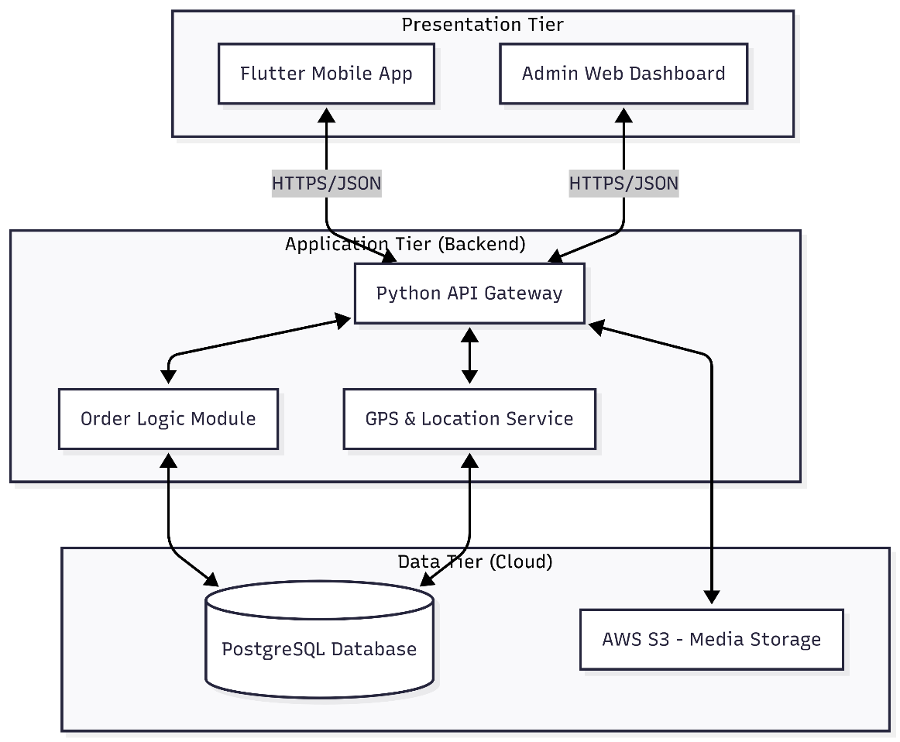

3.3 Explanation of Architecture The client tier consists of a responsive mobile application optimized for low-end smartphones. These clients send HTTPS requests to the application tier (Backend API). The API processes requests (such as produce filtering or order placement) and reads/writes to the database tier. Role-based access control at the application level ensures users only access authorized data.
4. UML DIAGRAMS
4.1 Use Case Diagram
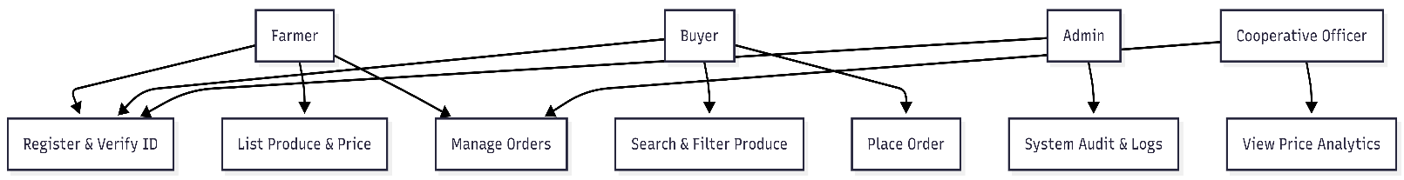
- Actors: Farmers, Buyers, System Administrators, Cooperative Officers.
- Use Cases: Register Account, List Produce, Search Produce, Place Order, Accept/Reject Order, View Price Analytics, Generate Reports.

4.2 Class Diagram

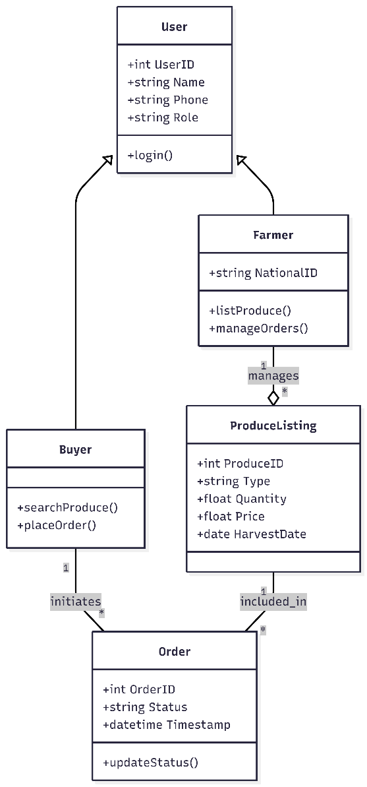
- Classes Identified:
  - User: Base class handling authentication and profile data.
  - Farmer: Inherits from User; manages listings
  - Buyer: Inherits from User; manages searches and orders.
  - ProduceListing: Contains item details (price, quantity, harvest date).
  - Order: Manages transaction lifecycle and status.

4.3 Sequence Diagram
- 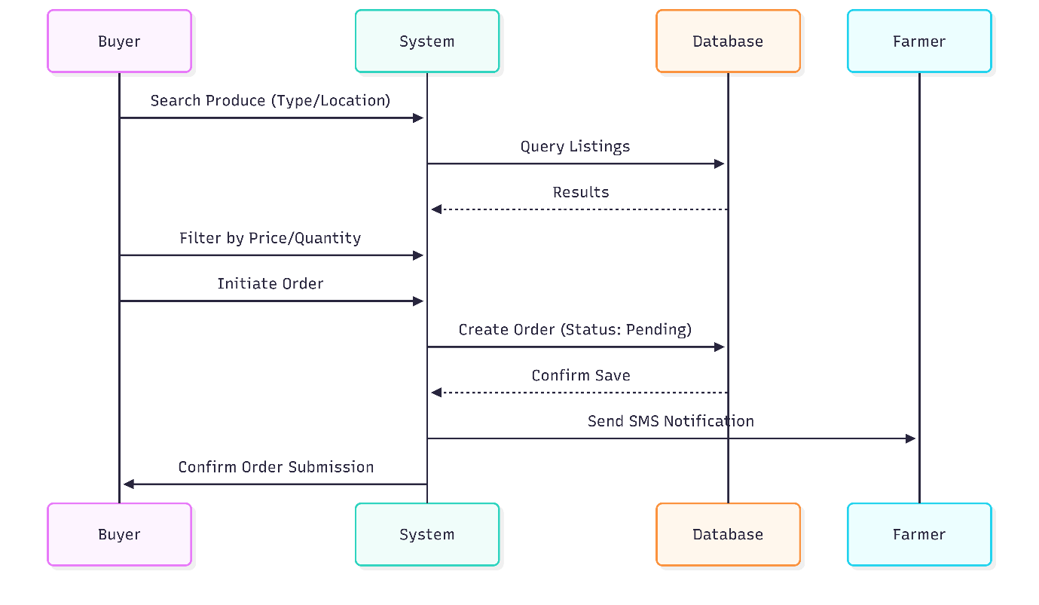Process Described: Buyer Order Placement. (Flow: Buyer searches produce -> Filters by price -> Initiates order -> System creates order -> System notifies Farmer via SMS ).

4.4 Activity Diagram
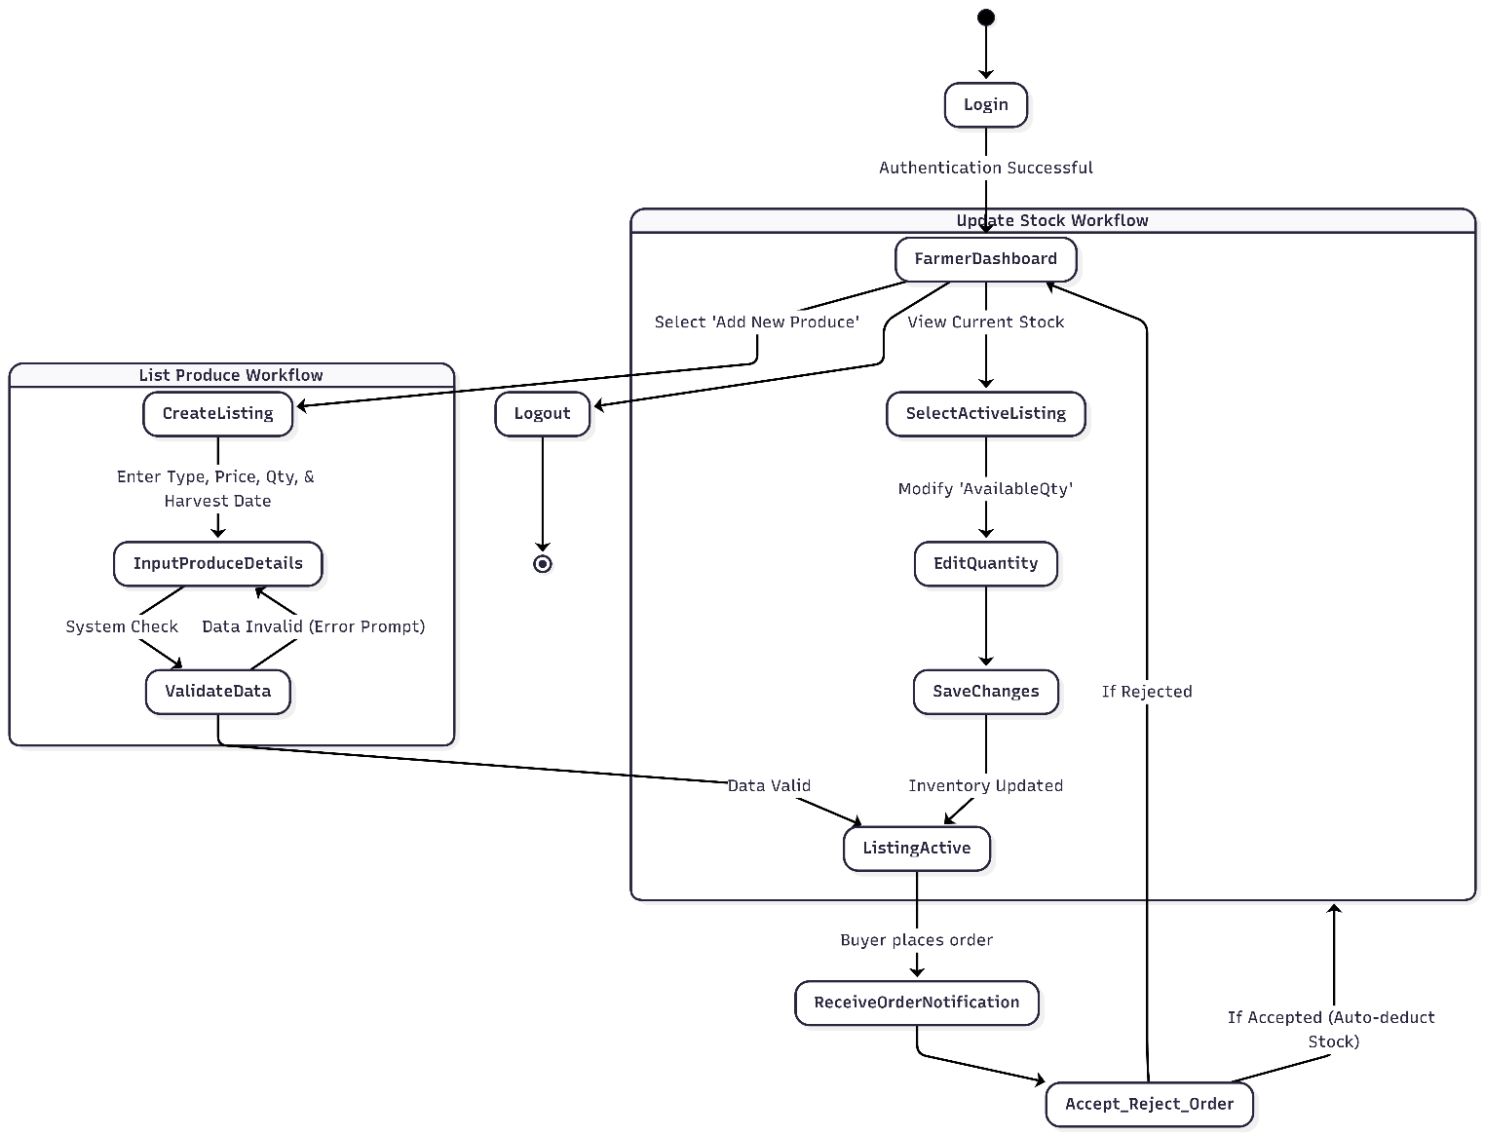

5. DATABASE DESIGN
5.1 ER Diagram
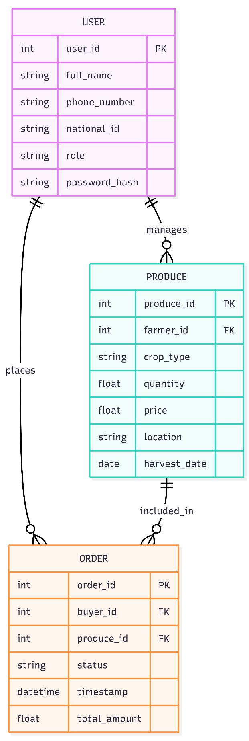

5.2 Entities and Attributes
Entity | Attributes
User | UserID (PK), Name, Phone, NationalID, Role, PasswordHash
Produce | ProduceID (PK), FarmerID (FK), Type, Quantity, Price, Location, HarvestDate
Order | OrderID (PK), BuyerID (FK), ProduceID (FK), Status, Timestamp, TotalAmount

5.3 Normalization
- 1NF: All attributes contain atomic values (e.g., location is broken down into district/village).
- 2NF: All non-key attributes are fully functionally dependent on the primary key (e.g., Produce type depends entirely on ProduceID).
- 3NF: No transitive dependencies. (e.g., Cooperative analytics are derived from Orders, not stored redundantly within the Farmer table).
5.4 Database Tables
Table Name | Columns
Users_Table | UserID, FullName, PhoneNumber, NationalID, RoleID, CreatedAt
Produce_Listings | ProduceID, FarmerID, CropType, PricePerKg, AvailableQty, HarvestDate
Transactions | TransactionID, OrderID, Status, DigitalReceiptRef, Timestamp
Export to Sheets
6. LOW-LEVEL DESIGN (LLD)
6.1 Key Modules User Management, Produce Management, Marketplace & Orders, Price History & Analytics, Notifications.
6.2 Module Description
Module | Description
User Management | Handles registration, authentication, and role-based access control for Farmers, Buyers, and Admins.
Produce Management | Allows farmers to create, update, delete, and view real-time availability of their stock.
Marketplace & Orders | GPS-based searching, filtering, order placement, and digital receipt generation.
Notifications | Triggering SMS and in-app alerts for order statuses and price changes.
Export to Sheets
7. TECHNOLOGY STACK
7.1 Selected Technologies
Layer | Technology
Frontend (Mobile) | Flutter
Backend API | Python (FastAPI or Django)
Database | PostgreSQL (hosted on AWS RDS)
Cloud/Hosting | AWS (EC2)
Export to Sheets
7.2 Justification of Stack
- Flutter: Ensures a mobile-first design approach and provides responsive UI optimization for low-end smartphones across both Android and iOS from a single codebase.
- Python: Excellent for scripting backend business logic and handling the mapping/proximity matching required for location-based services.
- PostgreSQL & AWS: A robust relational database is required to ensure data integrity and avoid data loss, while AWS ensures the system can hit the 99% uptime requirement and support 1,000 concurrent users.
7.3 Tools and Libraries
- Git/GitHub (Version Control)
- Twilio/Africa's Talking API (For SMS Notifications)
- Google Maps API (GPS-based produce search)
8. VERSION CONTROL
8.1 Repository Link
Farmers-Marketplace-Project
8.2 Version Control Strategy The team will maintain strict version control discipline aligned with Software Engineering lifecycle practices. We will use a Git feature-branch workflow. Main modules will be developed on separate branches and merged into the main branch only after peer review to ensure a stable prototype design.
9. ASSUMPTIONS AND LIMITATIONS
9.1 Assumptions
- Target users (farmers and buyers) have access to basic smartphones or feature phones capable of receiving SMS.
- National ID verification APIs or manual admin validation processes are available.
- The system will eventually integrate seamlessly with local mobile money services for payments.
9.2 Limitations
- The system requires an active internet connection or cellular network for real-time synchronization, which may be challenging in deep rural low-bandwidth environments.
- Initial deployment is restricted to English, with local language extensions planned for a future phase.
10. CONCLUSION
The system design for the Farmers’ Produce Aggregation & Marketplace Platform provides a highly scalable architecture to solve market inefficiencies and price opacity. By leveraging a mobile-first 3-tier architecture, the platform connects farmers directly to buyers and establishes a reliable data environment for agricultural cooperatives. The project is now structurally documented and ready for the prototype implementation phase.

