P190008-Mohammad Ali Malik

P190037-Fahad Nawaz

BCS-6A

Software Engineering

Assignment#02

Contents

1. Introduction

1.1. Purpose and Scope ……………………………………………………………………………………………………………………..3 1.2. Assumptions…………………………………………………………………………………………………………………………………3

2. Standard Overview

2.1. Standard Scope…………………………………………………………………………………………………………………………….3 2.2. Standard Compatibility…………………………………………………………………………………………………………………3

3. Focus For Requirements

3.1. End User Information…………………………………………………………………………………………………………………..3 3.2. Entity Information………………………………………………………………………………………………………………………..4

4. Usability Focus

4.1. Actor Profile…………………………………………………………………………………………………………………………………4 4.2. Usage Scenarios…………………………………………………………………………………………………………………………..4

5. System Requirements

5.1. General Requirement .. ……………………………………………………………………………………………………………….5 5.2. Quality Requirements...……………………………………………………………………………………………………………….5 5.2.1. Compatibility Requirements………………………………………………………………………………………………5 5.2.2. Security Requirements …………………………………………………………………………………………………….6

5.3. Testability Requirements……………………………………………………………………………………………………………..6

2

**1.** **Introduction**

* 1. **Purpose and Scope:**

Fast food restaurants want to make their services more digital for both customers and employees. In order to serve as a reference for developers and a document for clients seeking software validation, this document seeks to capture the system requirements and features from controlling restaurant systems to ordering meals.

* 1. **Assumptions:**

According to the software requirement document, none of the individual framework segments should be run as inserted programmes. The idea is that the target equipment will allow for standalone program/application organisation and won't need to have its installed firmware modified.

**2.** **Standard Overview**

**2.1.** **Standard Scope:**

This project's standard scope is to automate daily tasks and create a simple way for consumers and staff to access and manage items digitally. It would ease the workload for the staff members and make ordering easier and more accessible for the customers.

**2.2. Standard Compatibility:**

Application shall be accessible by any smartphone with the Android OS version 4.2 or higher.

**3. Focus For Requirements**

3.1 End User Information

Application is intended for all types of users from customers to operators of the system as application is generic in its working and simple to use.

3

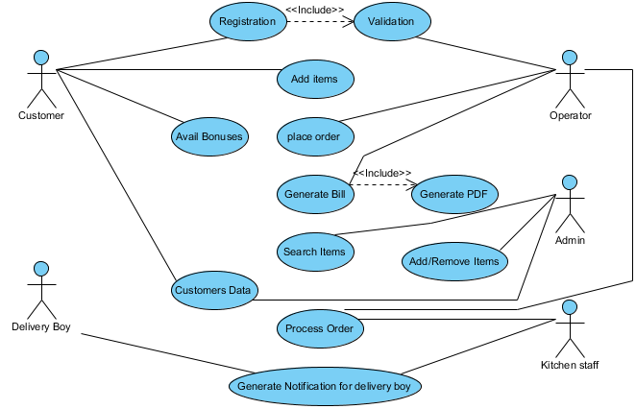

**3.2 Entity Information**

**4. Usability Focus**

**4.1 Actor Profile**

• Customer:

➢Can register to the restaurant to place order and avail bonus point on the amount of orders they place.

• Operator:

➢Operators can manage daily business work which includes customers and sales. • Admin:

➢Admin can do additional tasks of removing/adding/updating customers and items. • Kitchen Staff:

➢Kitchen staff prepare foods of the processed food. • Delivery Boy:

➢Receives processed order from kitchen staff and delivers it to customers

4

**4.2 Usage Scenarios:**

Customers may place orders through this application, which operators would manage. The customer's order would be listed in the order items, which the operators would process and then hand off to the kitchen. Admin would have the power to control the products and clients.

**5. System Requirement**

**5.1. General Requirement**

|  |  |
| --- | --- |
| Functional Name | Description |
| User Registration | Registering user so they can have unique identity so they can avail features ( bonuses ) according to their profile. |
| Operator Registration | Registering operators so they have unique identity as an employee |
| Ordering | Ordering Module which would help to list order items for both customer and operator end. |
| Calculating bill for ordered items | Ordered items price will be calculated. |
| Generating bill (PDF format) | Ordered items bill would be generated in this module in the pdf format and printed simultaneously on two systems |
| Managing items (adding/removing/ updating) | A module for admin to add/remove/update items . |
| Searching Items | A module with ability to search a specific item. |
| Managing sales and visualization | A module manage daily sales in a month and visualize it into the graph . |
| Featured Items/customers | Featured items module to show top items and customers |

**5.2. Quality Requirements**

**5.2.1. Compatibility Requirements**

Application shall be accessible by any smartphone with the Android OS version 2.2 or higher.

**5.2.2. Maintainability**

Project should have small modules and should be released in different versions which would be easy to maintain and more efficient.

5

**5.2.3. Security Requirements**

• A wp used for tablet login must have a bit-strength of at least 64 bits • A wp used for tablet login must be changed every three months.

**5.3. Testability Requirement** Complete:

• If all the module listed works accordingly to the user story. Correct:

• If all the modules working properly it is correct and hence it.

6