P190008-Mohammad Ali Malik

P190037-Fahad Nawaz

BCS-6A

Software Engineering

Assignment#03

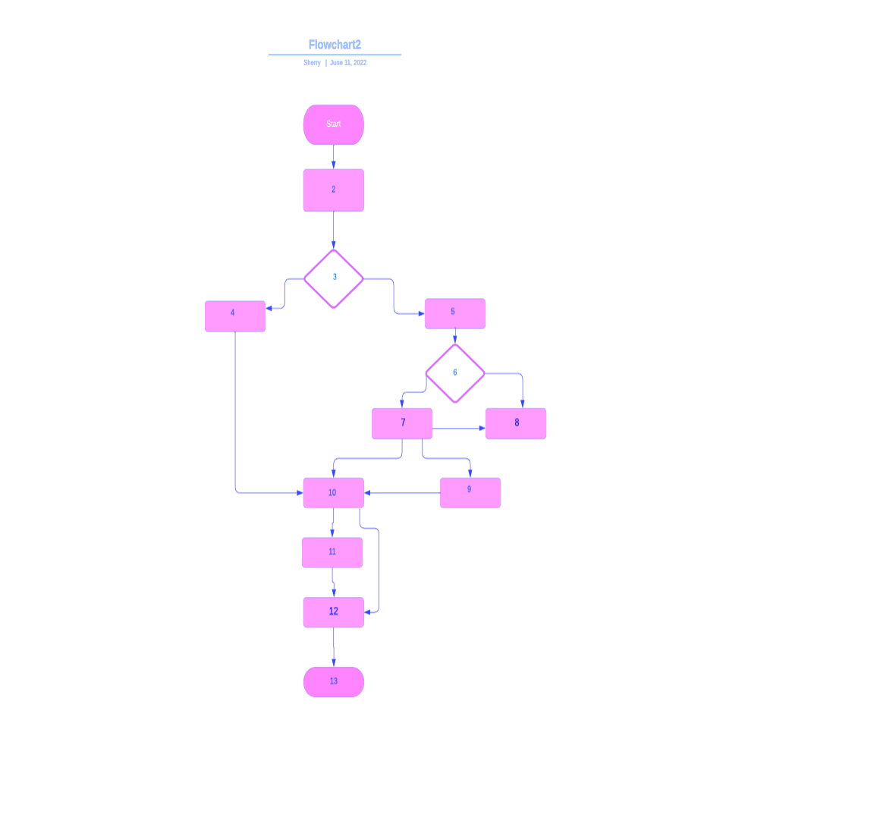

**Control Flow Graph:**

**Cyclomatic Complexity Metrics:**

V (G) = E - N + 2

V(G)= 5

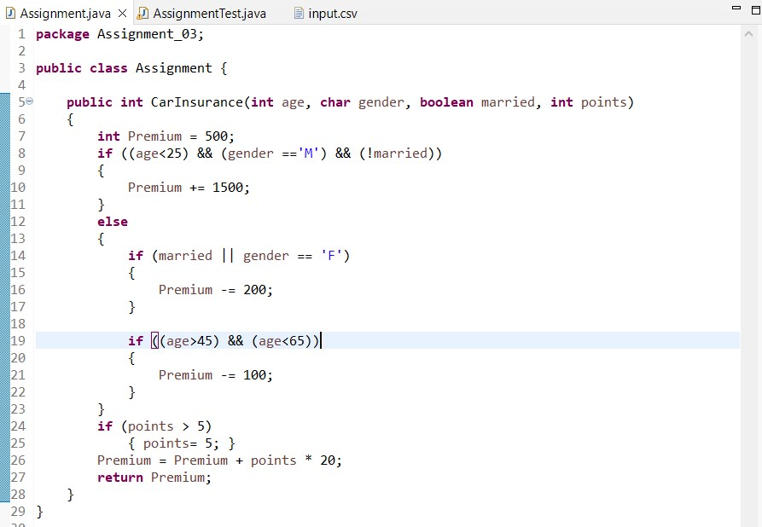

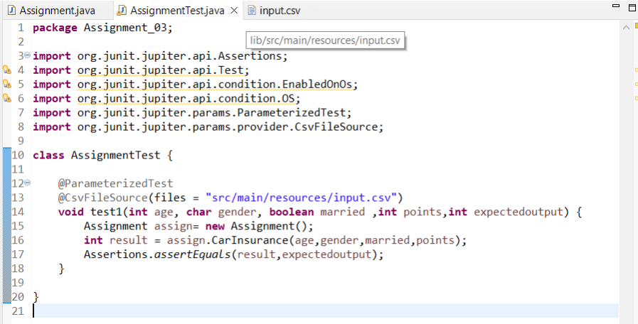

**Output:**

