Dear Editor and Reviewers,
Thank you for your hard work on our manuscript “Path planning algorithm for percutaneous puncture lung mass biopsy procedure based on the multi-objective constraints and fuzzy optimization” (ID: [PMB-115091.R4]). We have carefully considered all your comments and made changes to the manuscript's content. The changes in this revised manuscript have been marked in red. Our responses to the comments are provided below.

Response to reviewer #2:
COMMENTS TO THE AUTHOR(S)
The authors addressed 3 out of my 4 points of concern. The one not addressed is the discrepancy in the definition of the angle theta_i, between the Eq. 10 and the Figure 5. This was pointed out in the first review but remained unaddressed during the review process, while the authors never answered to this concern.

I present it again here:
In Figure 5 the angle theta_i is quite clearly shown to be the angle between the vector n_i (puncture path) and the vector a_i3. However, in Eq. 10 the angle theta_i is defined as the angle between these two vectors (through the 'arccos' function) SUBTRACTED from 90 degrees. it's a simple numerical difference that has to be resolved. The method presented in the manuscript follows the Eq. 10 definition of the theta_i, (otherwise the condition 20<=theta_i<=90 does not make sense) so it seems that is the Figure 5 the one that has to change to agree with the rest of the manuscript.

Response: Thank you for pointing that out. We have carefully checked Figure 6 and made changes so that the graphic corresponds to the text.

Page 8, Line 16-26:
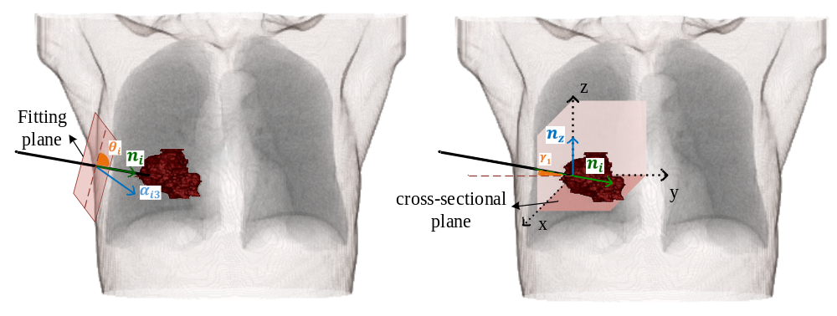
(a) | (b)
Figure6. Schematic of angle conditions. (a) the angle $θ_{i}$ between the fitted plane and the puncture path; (b) The angle $γ_{i}$between the puncture path and the cross-sectional plane

