*Recep Deniz Aksoy*

*2014400150*

CmpE 362 Homework 1

Getting Started with MATLAB

REPORT

I’ve prior experience in MATLAB. Also I’ve used plots and read them before. So in this homework I’ve not faced any particular challenge. However, lack of explanation of questions 1-2 made me search more, I’ve therefore learnt much more than expected in those questions. Rest of the questions gave me insights about different sine functions’ time-value distribution and I’ve seen different distributions on plots.

Other things that I knew before but ‘expected’ to written in this report are:

* MATLAB indices start at 1
* Plotting is a great tool to gain insights.
* MATLAB’s Gaussian random number generator work particularly better than other languages.
* In MATLAB, one can Run&Time their script to analyze its performance.

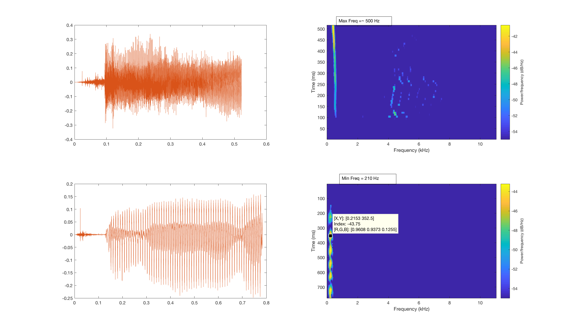

[y,Fs] = audioread('highFreq.wav');

t = linspace(0, length(y)/Fs, length(y));

subplot(2,2,1);

plot(t,y)

subplot(2,2,2);

spectrogram(y(:,1), 'MinThreshold', -55,256,60,512,Fs);

[m,high_freq]=max(y(:,1));

[y1,Fs1] = audioread('lowFreq.wav');

t1 = linspace(0, length(y1)/Fs1, length(y1));

subplot(2,2,3);

plot(t1,y1)

subplot(2,2,4);

spectrogram(y1(:,1), 'MinThreshold', -55,256,60,512,Fs);

[m1,low_freq]=max(y1(:,1));

ax = gca;

ax.YDir = 'reverse';

Max Freq = ~500 Hz

Min Freq = ~210 Hz

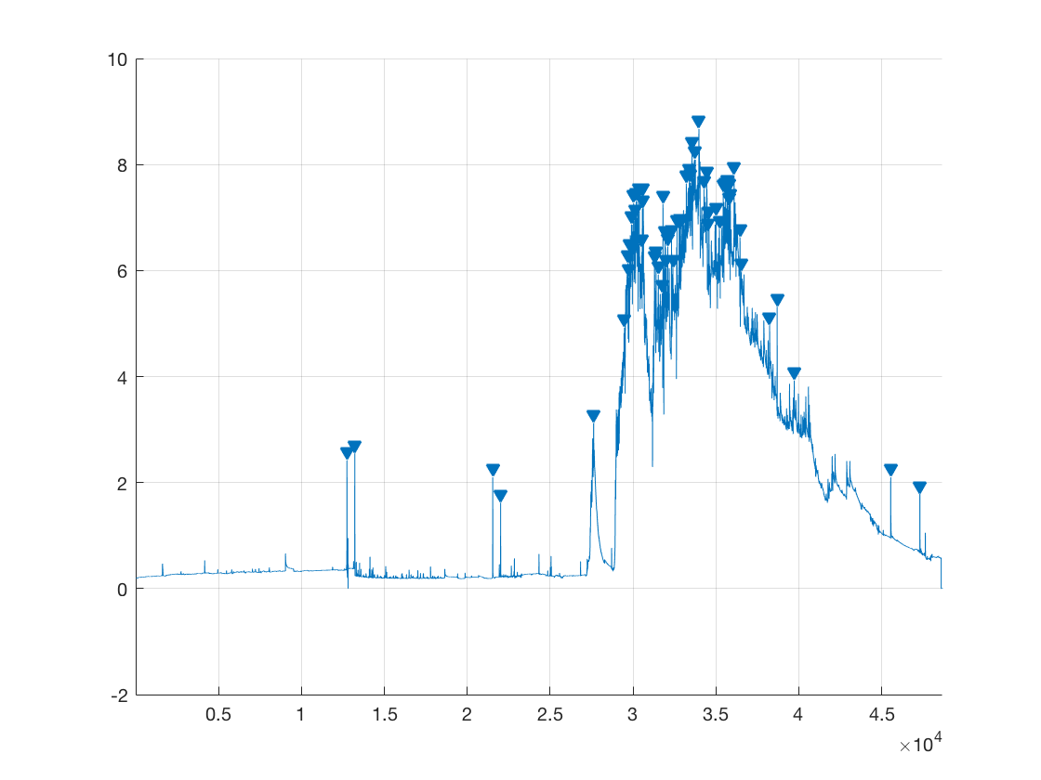d = dir('/Users/unstblecrsr/Desktop/CMPE362/hakli/**');

directs = d([d.isdir]);

hold on;

for i=1:length(directs)

    cd(strcat(directs(i).folder, '/' , directs(i).name));

    files = dir('*.csv');

    if(~isempty(files))

        for j=1:length(files)

            x = csvread(files(j).name, 1, 0);

            findpeaks(x,'MinPeakProminence', 1);

        end

    end

end

The findpeaks() method takes ‘MinPeakProminence’ as argument and that argument helps function to decide whether a local maxima is peak or not. I’ve given 1 as argument so that it does not count the noise as peaks.

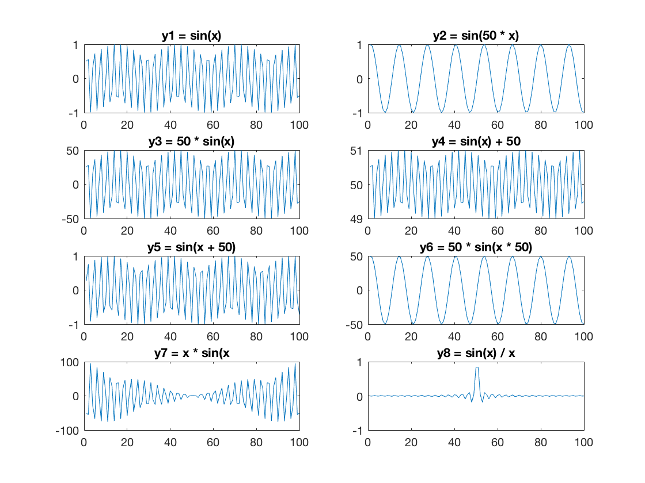

%% Problem 3

x = linspace(-100, 100);

subplot(4,2,1);

y1 = sin(x);

plot(y1);

title('y1 = sin(x)');

subplot(4,2,2);

y2 = sin(x * 50);

plot(y2);

title('y2 = sin(50 * x)');

subplot(4,2,3);

y3 = 50 * sin(x);

plot(y3);

title('y3 = 50 * sin(x)');

subplot(4,2,4);

y4 = sin(x) + 50;

plot(y4);

title('y4 = sin(x) + 50');

subplot(4,2,5);

y5 = sin(x + 50);

plot(y5);

title('y5 = sin(x + 50)');

subplot(4,2,6);

y6 = 50 * sin(x * 50);

plot(y6);

title('y6 = 50 * sin(x * 50)');

subplot(4,2,7);

y7 =  x.*sin(x);

plot(y7);

title('y7 = x * sin(x');

subplot(4,2,8);

y8 = sin(x)./x;

plot(y8);

title('y8 = sin(x) / x');

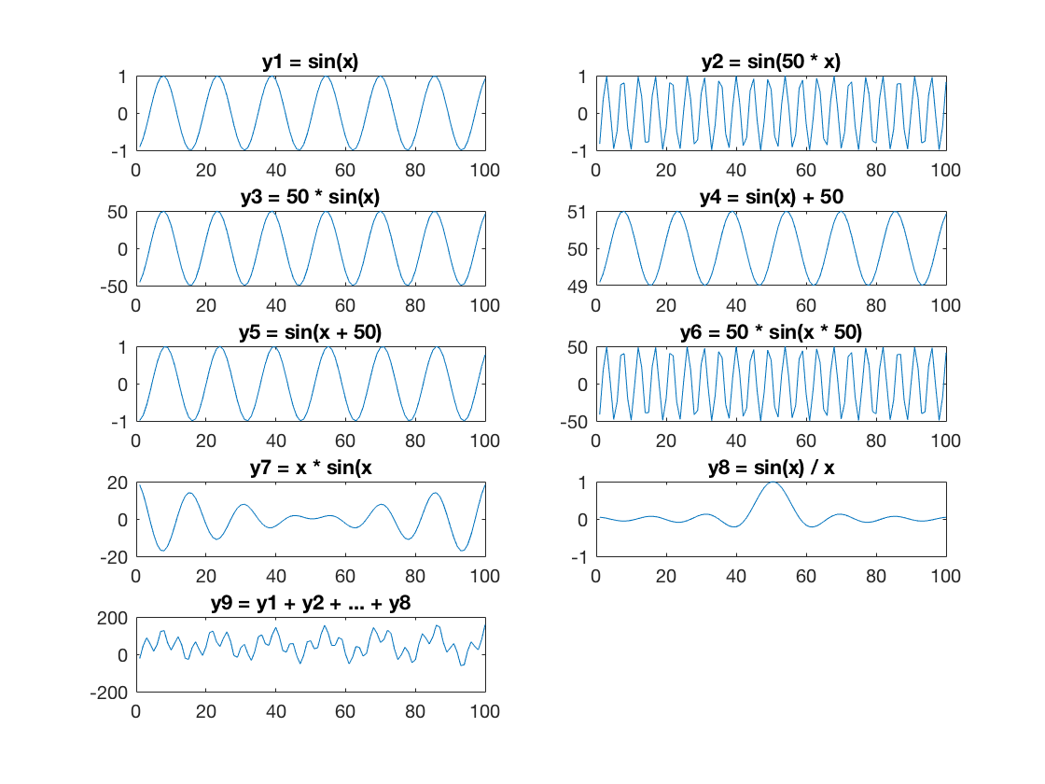

x = linspace(-20, 20);

subplot(5,2,1);

y1 = sin(x);

plot(y1);

title('y1 = sin(x)');

subplot(5,2,2);

y2 = sin(x * 50);

plot(y2);

title('y2 = sin(50 * x)');

subplot(5,2,3);

y3 = 50 * sin(x);

plot(y3);

title('y3 = 50 * sin(x)');

subplot(5,2,4);

y4 = sin(x) + 50;

plot(y4);

title('y4 = sin(x) + 50');

subplot(5,2,5);

y5 = sin(x + 50);

plot(y5);

title('y5 = sin(x + 50)');

subplot(5,2,6);

y6 = 50 * sin(x * 50);

plot(y6);

title('y6 = 50 * sin(x * 50)');

subplot(5,2,7);

y7 =  x.*sin(x);

plot(y7);

title('y7 = x * sin(x');

subplot(5,2,8);

y8 = sin(x)./x;

plot(y8);

title('y8 = sin(x) / x');

subplot(5,2,9);

y9 = y1 + y2 + y3 + y4 + y5 ...

    + y6 + y7 + y8;

plot(y9);

title('y9 = y1 + y2 + ... + y8');

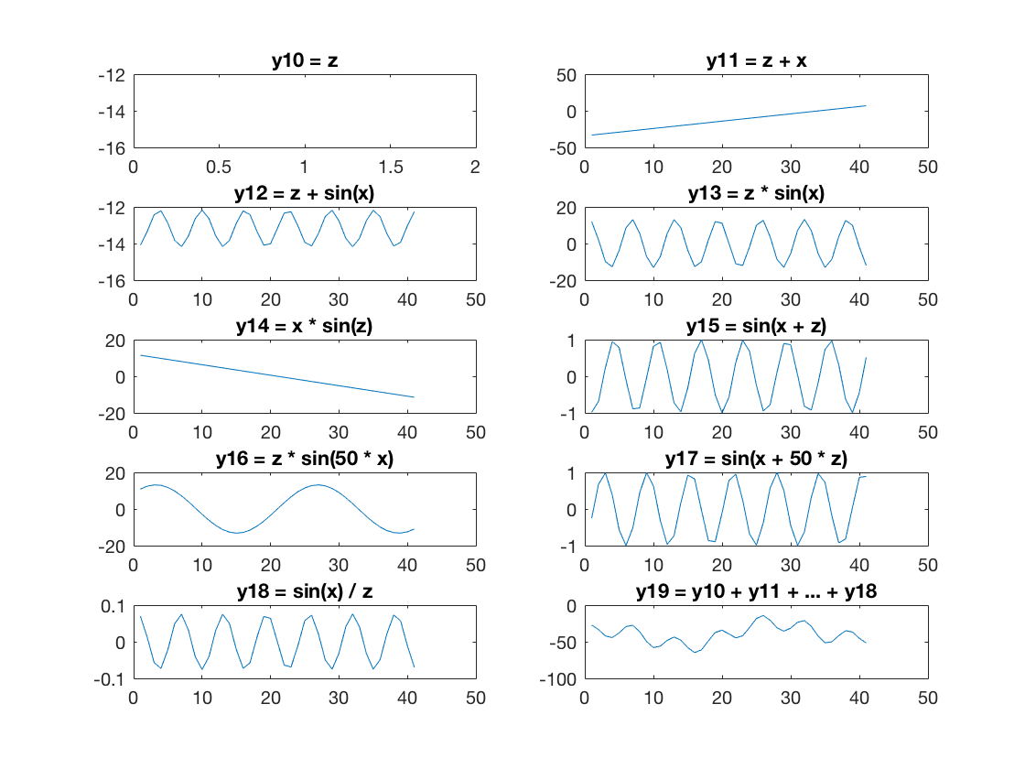x = linspace(-20, 20, 41);

z = normrnd(1,41);

subplot(5,2,1);

y10 = z;

plot(y10);

title('y10 = z');

subplot(5,2,2);

y11 = z + x;

plot(y11);

title('y11 = z + x');

subplot(5,2,3);

y12 = z + sin(x);

plot(y12);

title('y12 = z + sin(x)');

subplot(5,2,4);

y13 = z .* sin(x);

plot(y13);

title('y13 = z * sin(x)');

subplot(5,2,5);

y14 = x .* sin(z);

plot(y14);

title('y14 = x * sin(z)');

subplot(5,2,6);

y15 = sin(x + z);

plot(y15);

title('y15 = sin(x + z)');

subplot(5,2,7);

y16 = z .* sin(50 * x);

plot(y16);

title('y16 = z * sin(50 * x)');

subplot(5,2,8);

y17 = sin(x + 50 * z);

plot(y17);

title('y17 = sin(x + 50 * z)');

subplot(5,2,9);

y18 = sin(x) ./ z;

plot(y18);

title('y18 = sin(x) / z');

subplot(5,2,10);

y19 = y10 + y11 + y12 + y13 + y14 ...

    + y15 + y16 + y17 + y18;

plot(y19);

title('y19 = y10 + y11 + ... + y18');

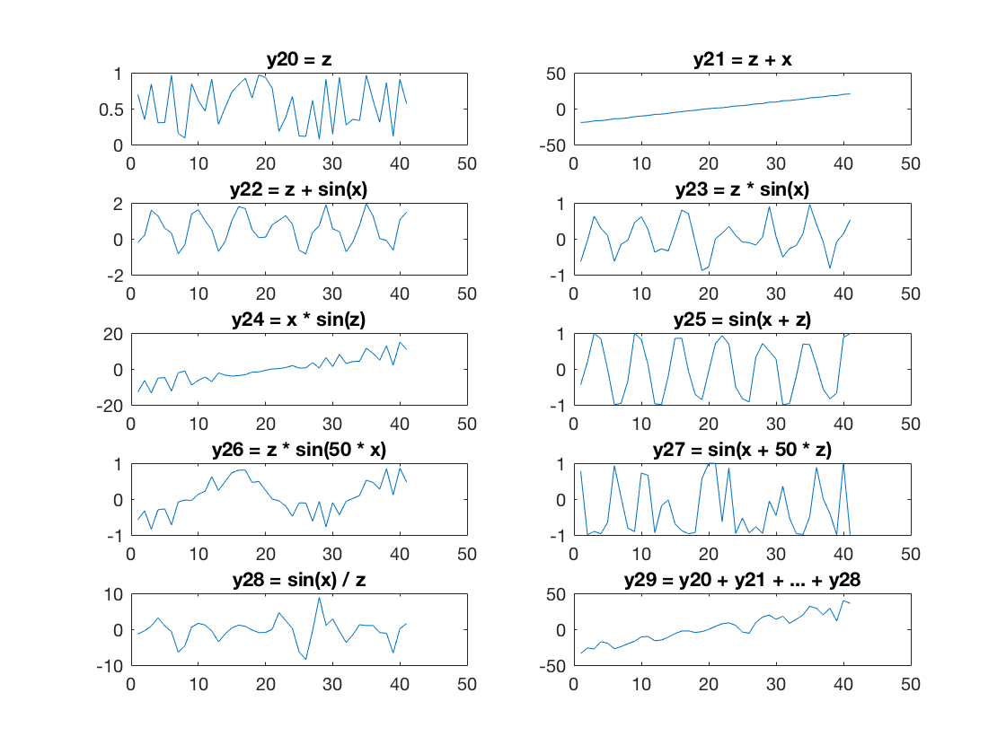

x = linspace(-20, 20, 41);

z = rand(1,41);

subplot(5,2,1);

y20 = z;

plot(y20);

title('y20 = z');

subplot(5,2,2);

y21 = z + x;

plot(y21);

title('y21 = z + x');

subplot(5,2,3);

y22 = z + sin(x);

plot(y22);

title('y22 = z + sin(x)');

subplot(5,2,4);

y23 = z .* sin(x);

plot(y23);

title('y23 = z * sin(x)');

subplot(5,2,5);

y24 = x .* sin(z);

plot(y24);

title('y24 = x * sin(z)');

subplot(5,2,6);

y25 = sin(x + z);

plot(y25);

title('y25 = sin(x + z)');

subplot(5,2,7);

y26 = z .* sin(50 * x);

plot(y26);

title('y26 = z * sin(50 * x)');

subplot(5,2,8);

y27 = sin(x + 50 * z);

plot(y27);

title('y27 = sin(x + 50 * z)');

subplot(5,2,9);

y28 = sin(x) ./ z;

plot(y28);

title('y28 = sin(x) / z');

subplot(5,2,10);

y29 = y20 + y21 + y22 + y23 + y24 ...

    + y25 + y26 + y27 + y28;

plot(y29);

title('y29 = y20 + y21 + ... + y28');

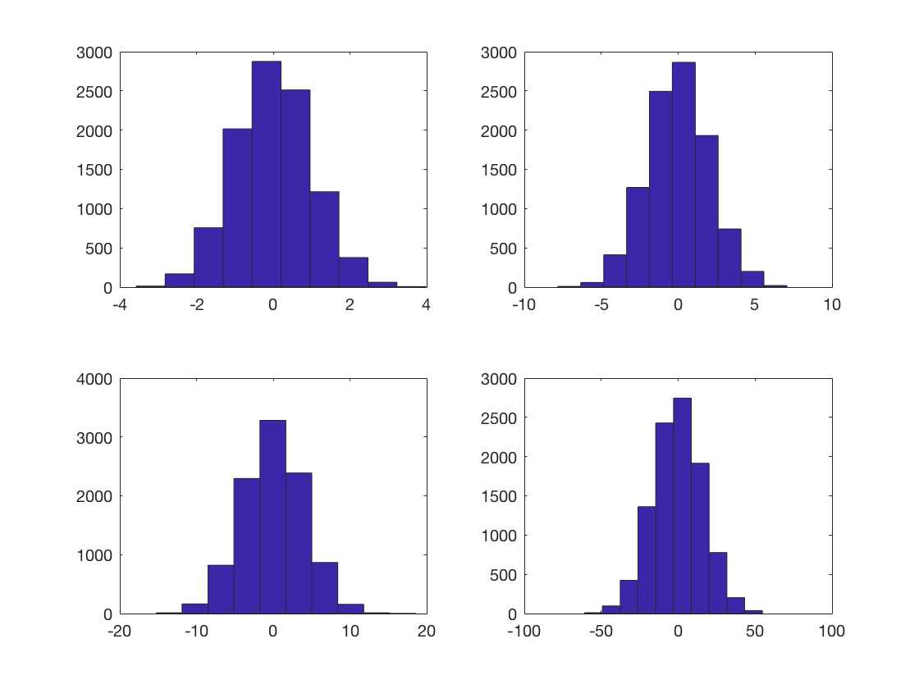r1 = normrnd(0,1, 10000, 1);

r2 = normrnd(0,sqrt(4), 10000, 1);

r3 = normrnd(0,sqrt(16), 10000, 1);

r4 = normrnd(0, sqrt(256), 10000, 1);

subplot(2,2,1);

hist(r1);

subplot(2,2,2);

hist(r2);

subplot(2,2,3);

hist(r3);

subplot(2,2,4);

hist(r4);

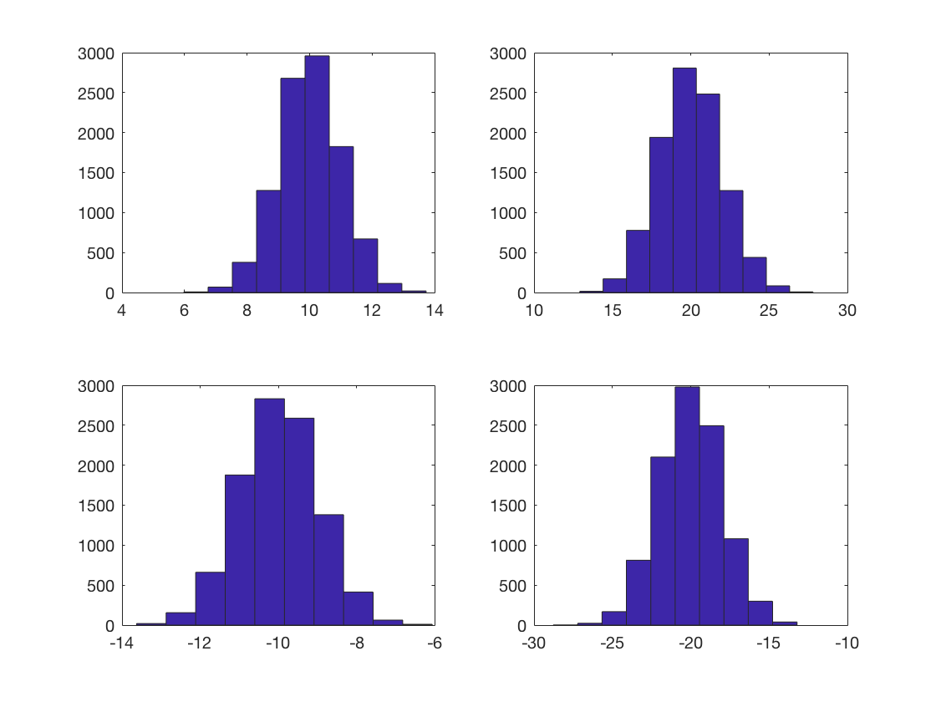r6 = normrnd(10,1, 10000, 1);

r7 = normrnd(20,sqrt(4), 10000, 1);

r8 = normrnd(-10,1, 10000, 1);

r9 = normrnd(-20, sqrt(4), 10000, 1 );

subplot(2,2,1);

hist(r6);

subplot(2,2,2);

hist(r7);

subplot(2,2,3);

hist(r8);

subplot(2,2,4);

hist(r9);

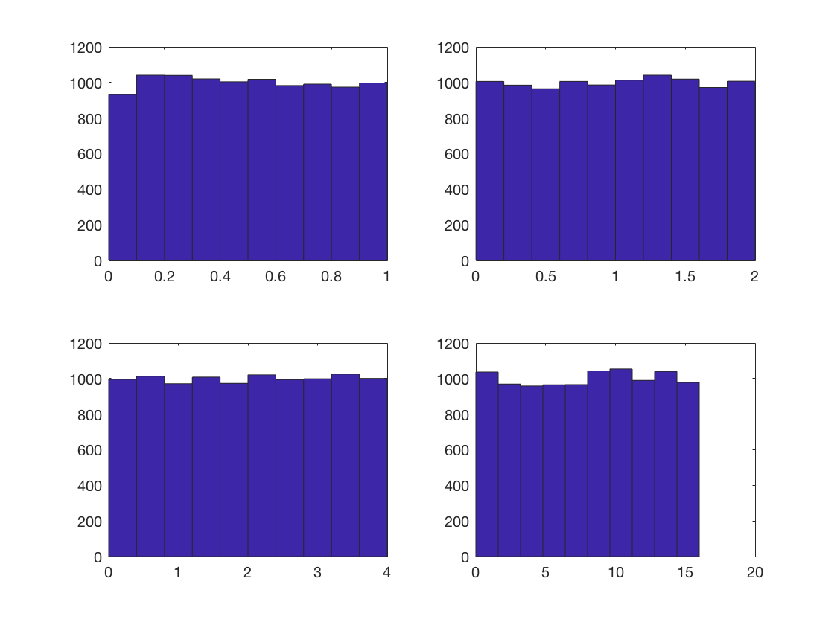r11 = rand(10000, 1);

r21 = sqrt(4) * rand(10000, 1);

r31 = sqrt(16) * rand(10000, 1);

r41 = sqrt(256) * rand(10000, 1);

subplot(2,2,1);

hist(r11);

subplot(2,2,2);

hist(r21);

subplot(2,2,3);

hist(r31);

subplot(2,2,4);

hist(r41);

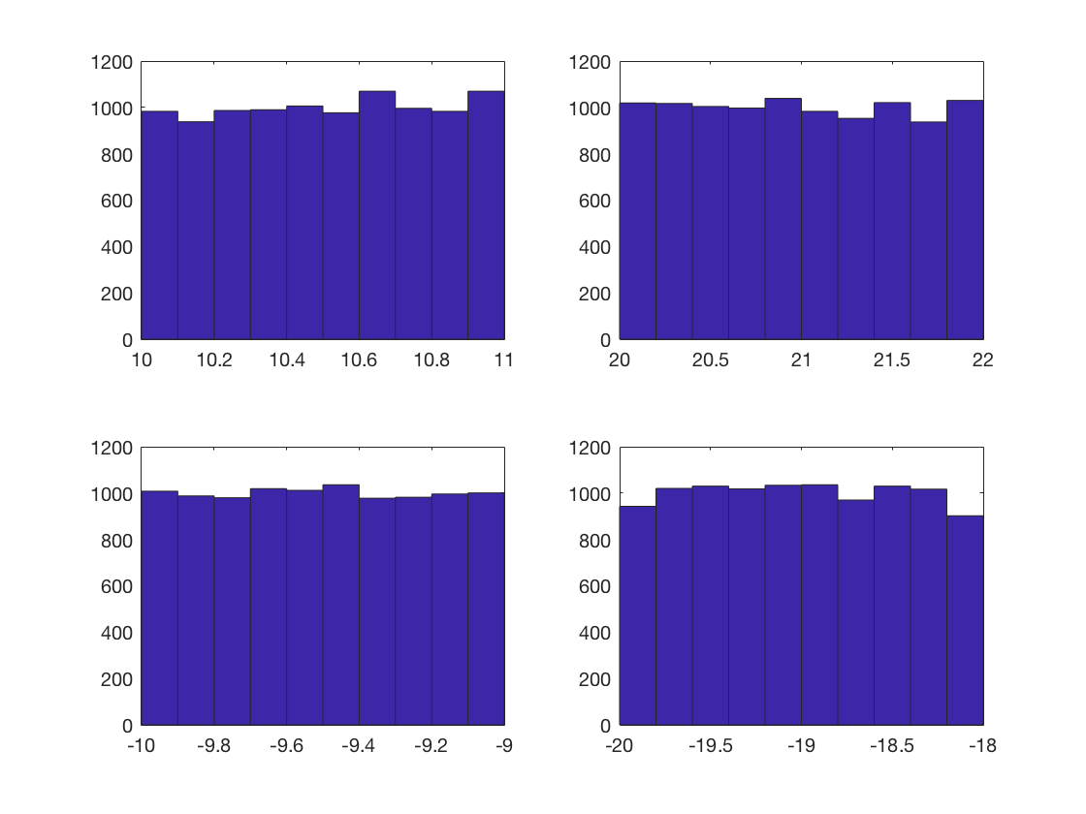

r61 = rand(10000, 1) + 10;

r71 = sqrt(4) * rand(10000, 1) + 20;

r81 = rand(10000, 1) - 10;

r91 = sqrt(4) * rand(10000, 1) - 20;

subplot(2,2,1);

hist(r61);

subplot(2,2,2);

hist(r71);

subplot(2,2,3);

hist(r81);

subplot(2,2,4);

hist(r91);