Development of Finite Element Program for Beams

Submit your code electronically: Put your code in a directory with your name… e.g. mine would be JohnWhitcomb. If you use Visual Studio, you must submit the entire project, input files, and the output file you got.

General Guidelines
- We are not writing a commercial quality code... that takes a lot of time and experience!
- We are writing a code that will illustrate how FEA works. The code will be able to perform impressive calculations.
- I am not going to emphasize efficiency... I am trying to keep things as simple as possible.
- I prefer that you use C or C++, but you can use MATLAB or Fortran.
- There are firm guidelines in terms of organization.
  - Specific subroutines must be implemented
  - Data must be read sequentially from a single file, not hardwired in the code. The file must be opened only once by your program. If you use MATLAB, you will need to learn how to use fopen, fscanf, and fclose (or some functions that are very similar)
  - Data must be passed to subroutines. Use of global data is not permissible
  - You must echo print your input
  - All output must be labeled
- Common blocks are not to be used. (If you do not know what a common block is, do not worry about it in this class. We will not use them.)
- Use 8-byte floating point numbers for all floating point variables

The goal is to write a finite element program that can analyze beam problems. The beam dimensions, properties, loads, number of elements, etc. are all specified as part of the input to the program...they are not hardwired in the code.

As we develop the code, we need a sample problem for testing the code. A sample problem is given below.

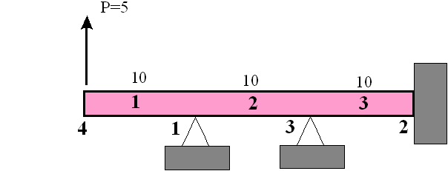
The nodal coordinates are ( 10,30,20,0)
The connectivity is always left to right for beam elements. For example, the connectivity of element #2 is (1,3).

Beam properties
Aluminum (Young's modulus of 1.e7 psi)
height = 1.339 inch
width = .5 inch
=> EI = 1.e6
Debugging hints:
- Make sure you are consistent in declaration of type (integer, real *8, scalar, array,etc.).
- Learn and use a debugger or use lots of write statements to check intermediate results and to determine if wrong result in a routine is due to wrong data making it to the routine.
- A correct result in a routine does not guarantee the result is passed back correctly to the calling routine.

Tasks

Part 1: Implement the data input routines
The goal of this step is to understand data management in FEA. This will be developed for an elastic beam.
- How does one describe a finite element model to a computer?
- How should the computer store this information?

The following is the "first draft" of the program.
int main( )
(
readMesh( );
readProperties( );
readConstraints( );
readLoads( );
assembleGlobalStiffnessMatrix( );
imposeConstraints( );
solver( );
reportResults( );
}

void readMesh( )
{ }
void readProperties( )
{ }
void readConstraints( )
{ }
void readLoads( )
{ }
void assembleGlobalStiffnessMatrix( )
{ }
void imposeConstraints( )
{ }
void solver( )
{ }
void reportResults( )
{ }
This program does nothing yet. Your assignment is to implement the input functions, ie.
readMesh
readProperties
readConstraints
readLoads

You will need to add parameter lists for each subroutine in order to pass the data from one routine to another.

Each of these routines will
- read the required data
- "echo print the data" with labels
- return the data to the main program

Hints:
readMesh( ) What data describes a mesh?
readProperties( ) What are the material properties and x-section dimensions?
readConstraints( ) Which dof are specified to be zero?
readLoads( ) Which dof have non-zero applied loads and what are the loads?

You can choose your own way of describing the input data. Listed below is a very simple possibility. This particular format was chosen for simplicity in coding. Comments are added in italics and are not part of the input data.

4 3 numberOfNodes numberOfElements
1 10. node# x-coordinate
2 30.
3 20.
4 0.

1 4 1 element# connectivity of element
2 1 3
3 3 2

1.e7 1.339 .5 Young's modulus height width

4 number of constraints
1 5 3 4 list of dof specified to be zero

1 number of point loads
7 5.0 dof load

Part 2a: Implement the calculation of the global stiffness matrix and imposition of constraints.

Implement: assembleGlobalStiffnessMatrix getElementDOF getElementK
imposeConstraints
Required output:
- Print out each element stiffness matrix
- Print out the global stiffness matrix before imposing constraints
- Print out the global stiffness matrix after imposing constraints
The global stiffness matrix contains the contributions from all of the element stiffness matrices. After assembling the stiffness matrix, the constraints must be imposed. The following is pseudo-code assembleGlobalStiffnessMatrix .

- Loop 1-> # elements
- call getElementDOF(.......) based on the node #'s, calculate the dof for the element (i.e. the assembly vector)
- print assembly vector (for debugging)
- call getElementK(.......) get element stiffness matrix
- print element stiffness matrix (for debugging)
- Add element stiffness matrix to global stiffness matrix (see notes below on Assembly of K)
- End loop
Return

Assembly of K pseudocode

do row =1, numberOfDOFPerElement
globalRow=elementDof(row)
do col = 1, numberOfDOFPerElement
globalCol = elementDof(col)
globalK(globalRow, globalCol) = globalK(globalRow, globalCol) + K(row,col)
end do
end do

Debugging information:
For this problem the element stiffness matrix and assembly vector for element 1 are
7 8 1 2
------------------------------------------------
7 | 1.2000e+04 6.0000e+04 -1.2000e+04 6.0000e+04
8 | 6.0000e+04 4.0000e+05 -6.0000e+04 2.0000e+05
1 | -1.2000e+04 -6.0000e+04 1.2000e+04 -6.0000e+04
2 | 6.0000e+04 2.0000e+05 -6.0000e+04 4.0000e+05
After assembling the element matrices for all elements, the global stiffness matrix is
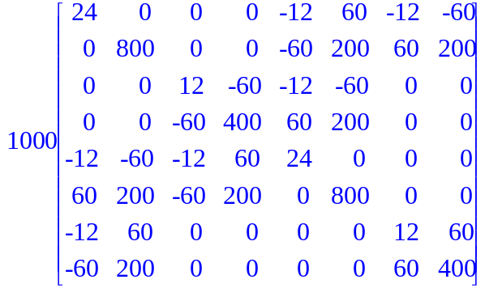

Imposition of constraints:
We will use the penalty technique to impose certain dof to be zero. For this particular problem, just add 1.e30 to the diagonal terms (1,1), (5,5), (3,3), 4,4). Of course, do not hardwire the code for these particular BC's.

Part 2b: Solve linear algebraic equations

For this particular problem the solution is approximately
Nodal Displacements
1 1.1429e-14 -1.4286e-04
2 2.1429e-15 -7.1429e-15
3 -8.5714e-15 3.5714e-05
4 3.0952e-03 -3.9286e-04

Your answers will be a little different, since these results are from the Maple notebook. I used a penalty of 1.e15 in the Maple code. Note that some of the terms are "numerical zeroes".

This highlighted block is for aero 306 only
In addition to what I have specified above, you need to add response to the following: (This is a real requirement… make sure you don’t forget it)
- Why did you choose the language you used?
- What did you learn new about programming as a result of this assignment?
- Did programming the FEA code help you understand FEA any better?
- Approximately how many hours did you spend on the first part? … the second part?
- Would you have liked to do more code development in this class? e.g. add the truss or frame element

Enhancements of your working code
- Add distributed load option (constant intensity)
- Add postprocessing
- Calculate stress resultants acting on each element (i.e. applied shear and moment at each end)
- Calculate internal stress resultants
- Calculate net forces acting on each node in the structure
- Calculate normal stress at top and bottom at both ends
- Calculate shear stress in the middle of the beam at both ends (assume the beam has a rectangular cross-section)
Solve the following problem using this enhanced code.
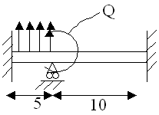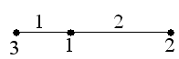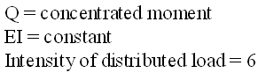

Q= 500 in-lbs
E = 10.e6 psi
Intensity of distributed load = 6 lbs/inch
Cross-section is 1 inch square
The dimensions on the sketch are in feet.

Additional possibilities
- Allow for different modulus, height, and width for each element
- Allow specification of more types of loads
- specified non-zero displacements
- thermal load
- Plot deformed shape

Reading data from a file with MATLAB
Below is some code I wrote that does what I am requiring. The data in the data file is listed after the code. Please try it out and see that it does line by line reading.

fid = fopen(dataFile.txt');
a = fscanf(‘fid,'%g %g',[1 2])

b = fscanf(fid,'%g %g %g',[1 3])

c = fscanf(fid,'%g %g',[1 2])

d = fscanf(fid,'%g',[1 1])

a(2)*b(3)*c(2)*d(1)

fclose(fid);

This is the data that was in the file

0.0 99.

66. 44. 77.

0. 3.

7.

Some Programming Advice
- Be sure you understand the theory before you start programming
- Develop a strategy (plan) to implement the theory
- Modularize the code
- Identify validity checkpoints
- Expect to spend more time checking, debugging, and correcting code than writing code. => be clear about how you will be checking the code as you progress.
- When hit with a tough error to identify, your immediate goal should be to narrow the scope of the code that could be causing the error.
- “Make it work… then make it fast” (loose quote). In this class, we will not spend much time on making it fast.
- There should be a clear connection between how you would solve the problem by hand and what you are asking the computer to do. However, the details will not be the same.
Command Driven Input
We will use a very simple format for the input data. For more complex problems, it becomes impossible to read the data unless we give some help. Also, for programs that are designed to handle many types of problems, the data that is read in one “job” can be very different than for another job. The solution is to use commands mixed in with the data that indicates the type of data that is being read. Here is an example from a code that my research group is writing.

createModel
ElasticityModel
exitcreateModel

ReadTitle
pl.alpha

setVerboseFlag 0
SolverSettings
setSolverVerboseFlag 0
setStorageMethod Sparse
setSparseSolverMaxIterations 100000
setSparseSolverTolerance 1e-8
replaceZeroDiagonal 1.0
exitSolverSettings

BasicElement::SetAnalysisType
0

maxResidual
0.01

CreateElements
1728
ElasticityElement3D
0 1727 1
-1
exitCreateElements

openFile S2_SC15_78_elastic.matlib ReadMaterials

openFile pl.plt ReadMesh

setNumDofPerNode
3 0 7716 1
6 7717 7717 1
-1

ReadMultiPointConstraints
PlaneToPlane
Coord 1.500000000000000e+000 -1.500000000000000e+000 5.000000000000000e-001 1.500000000000000e+000 -1.500000000000000e+000 -5.000000000000000e-001 1.500000000000000e+000 1.500000000000000e+000 -5.000000000000000e-001

Etc.

