E-commerce website

Rustam Zhitenov and Rustam Kenzhali

Astana IT University

CS-2006

Informational and communication technologies

Yerasyl Amanbek

**ABSTRACT**

**Online shopping is an application that allows the seller to retail all kinds of products that the world uses every day. (in this case, office supplies, books, and Souvenirs). In this information age of high technologies, no service merchant wants to lose customers who have switched to online purchases. also, if you look at the experience of other countries, the transformation from an offline format to an online sales model is the most effective transition, in which there is rapid growth. The goal of our team is to create a bridge between offline and online sales, thereby making life easier for customers. A fundamental aspect of online sales is the database, without which it is impossible to build a universal system. Therefore, we have set ourselves the task of creating a database with which the company can sell its products online instantly, while doing it safely, reliably and efficiently.**

**INTRODUCTION**

**The term electronic commerce or e-commerce refers to any sort of business transaction that involves the transfer of information through the internet. By definition, it covers a variety of business activities that use the internet as a platform for either information exchange or monetary transaction or both at times.**

**For example, the numbers of consumer brand retail sites like Amazon.com or Flipkart.com which normally provides information about products and also allows monetary transactions to happen over the internet.**

**On the contrary, there are the auctions sites like Quickr.com and Ebay.com where the information about certain listed products and services are provided but the monetary transactions normally happen physically.**

**Apart from these two categories of e-commerce sites, there are some sites which enable businesses to exchange trading goods and also service between two or more companies. All of these forms of internet-based business platforms are known as e-commerce.**

**E-Commerce – Objectives: Development of Business-Relationship, Better-Customer Service and Getting More Customers**

**The various objectives of e-commerce can be laid down as follows:**

**1. Development of Business-Relationship:**

**The business development can be done through e-commerce being the primary and the basic object. As their direct contact in between the company and the consumer, their business relationship will be enhanced. Hence the area of the market can be increased.**

**2. Better-Customer Service:**

**As it is done round the clock, the customer will always have online help regarding the products. As all the information is furnished to the customer, it becomes easy for him to choose the best product among all other alternatives. As even the service can also be done through the net immediately, the customer service will be ballooned. By highlighting the customer service, the companies are trying to subjugate a lion-share in the market.**

**3. Getting more Customers:**

**These days it becomes the mandate of the companies to double its customers, and this can be done by rendering the value add service and maintaining the quality. Hence, it is also one of the primary objectives of the companies which supply impetus for the robust growth in sales and overall profit.**

**The scale of e-Commerce is approaching the generally accepted business model by leaps and bounds. Every year, the number of people implementing this system on their websites is rapidly increasing. In other words, making Commerce over the Internet has become commonplace for all of us. The mission of our project is to develop a database where information about products, customers, and purchases will be safely stored. The project is based on book products, stationery, and Souvenirs.**

**To increase business profitability in e-commerce, it is necessary to expand the database using various solutions. But the main barrier to this goal setting is the lack of relevance of the online market, which is gradually disappearing, as online users in Kazakhstan are increasing every year. However, online shopping in such cities of national significance as Almaty and Nur-Sultan has become a common thing. Therefore, our project allows you to deliver goods to any point in Kazakhstan, to the destination address. In addition, there are cases when users are concerned about their personal data, are very cautious, and sometimes refuse to make purchases online. Recently, our legislation has changed, as a result of which the rights of buyers in the electronic platform will be protected in the same way as in regular trading. The importance of this project is to develop the level of digital literacy of the population and reduce the level of distrust on the part of citizens by offering them a secure and secure database system.**

**First of all, each site user has their own role (administrator, moderator, user, or guest), which gives different opportunities to users. When choosing products, the user can save and collect the selected products in the shopping cart, and soon pay for the products they need. When placing an order, the selected products will already be presented to customers as an order. To complete the purchase, the user must provide additional information. Most often, you are asked to fill out a form that contains the delivery address, delivery company, and payment information, such as a credit card. If the form is completed successfully, the user receives a notification about placing an order.**

**E-commerce means using the Internet and the web for business transactions and/or commercial transactions, which typically involve the exchange of value (e.g., money) across organizational or individual boundaries in return for products and services. Here we focus on digitally enabled commercial transactions among organizations and individuals.**

**E-business applications turn into e-commerce precisely, when an exchange of value occurs. Digitally enabled transactions include all transactions mediated by digital technology and platform; that is, transactions that occur over the Internet and the web.**

**CASE STUDY/RESULTS**

**1)**

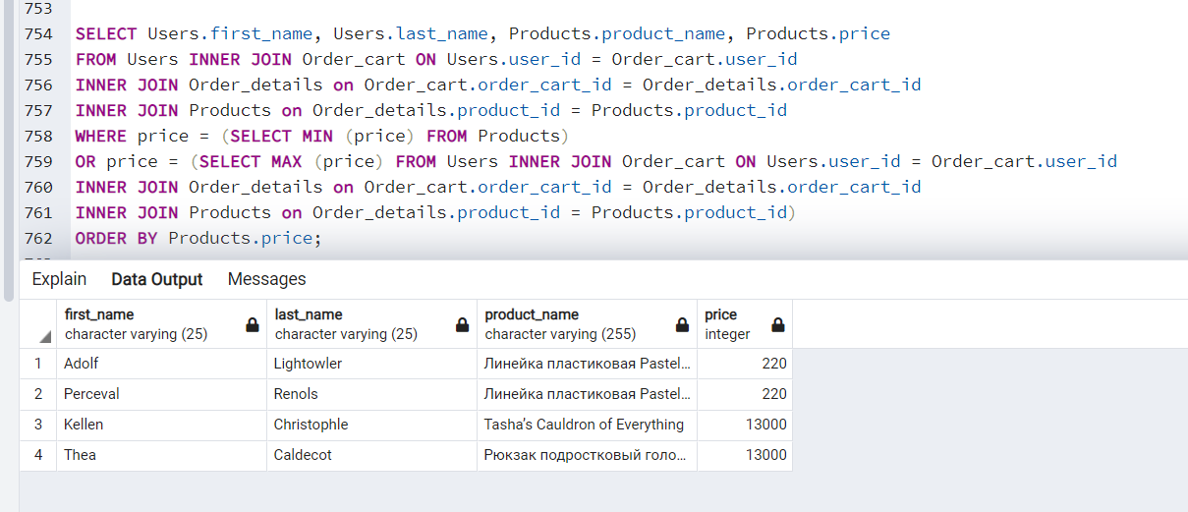

**In this condition, we brought out users who bought the most expensive and cheapest product, there were 4 of them (2 took the cheapest, the other 2 took the most expensive). We decided to show the use of such operators as MIN(), MAX(), JOIN and Subqueries in the database.**

**2)**

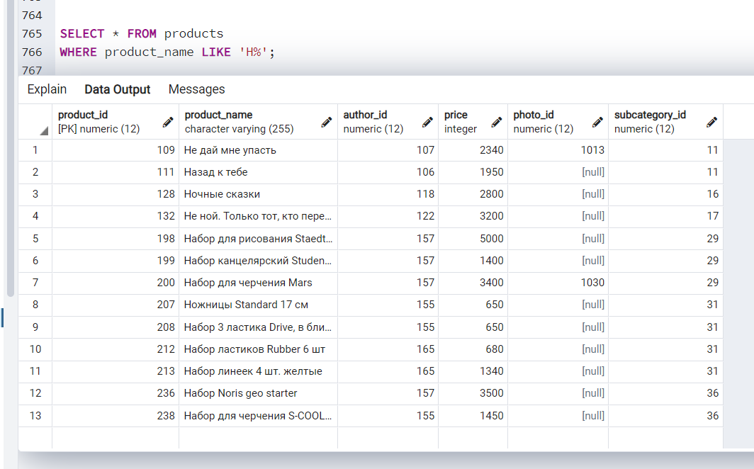

**This time we used the LIKE operator to get all product names starting with the letter ‘N’. This can be useful when searching the product database for each initial.**

**3)**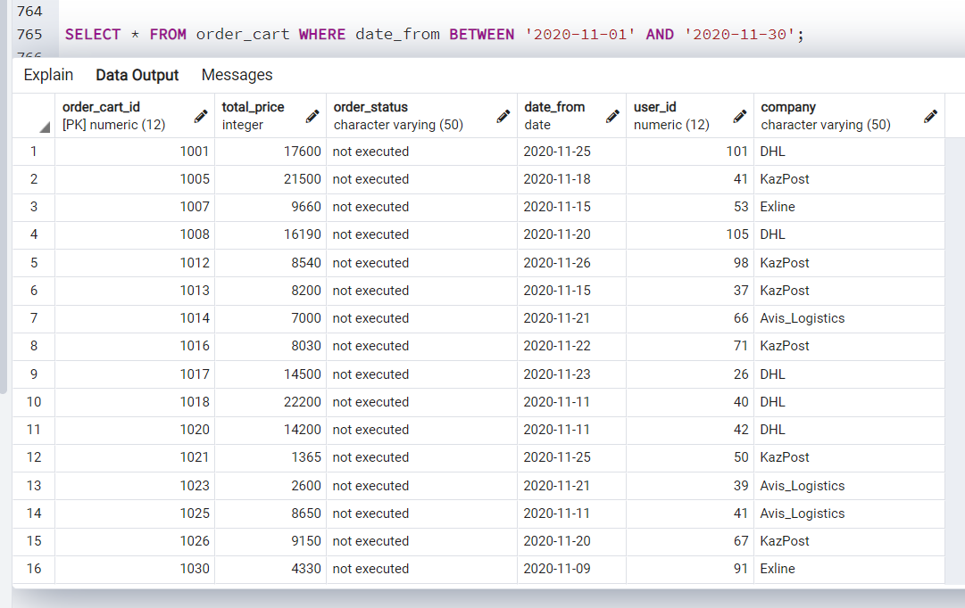

**Here we decided to show orders placed in the period from November 1, 2020, to November 30, 2020. So we decided to show the use of the between and AND operators.**

**4)**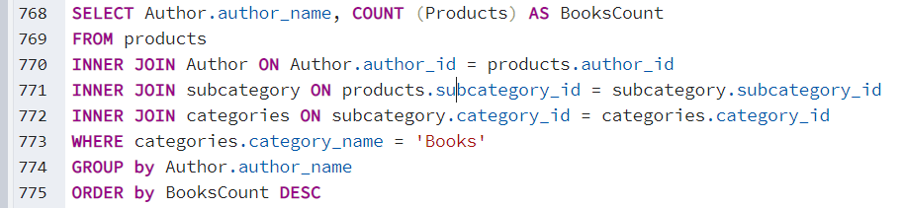

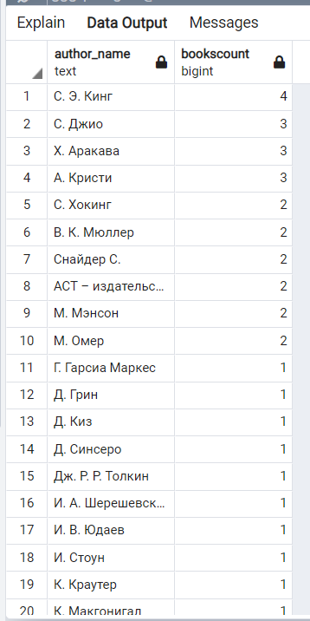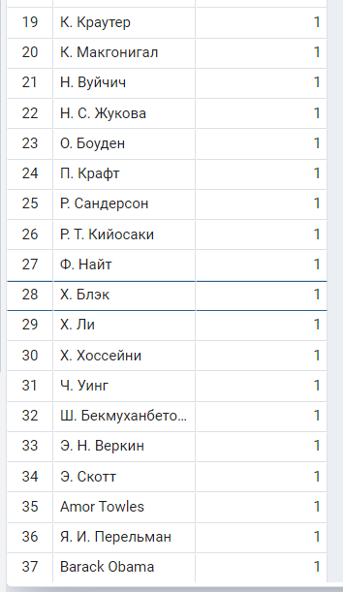

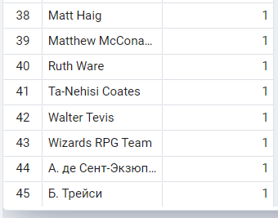

**Here we decided to use such operators as COUNT, INNER JOIN, GROUP BY and ORDER BY to output the number of books written by each author. This can be very useful for database analysis.**

**5)**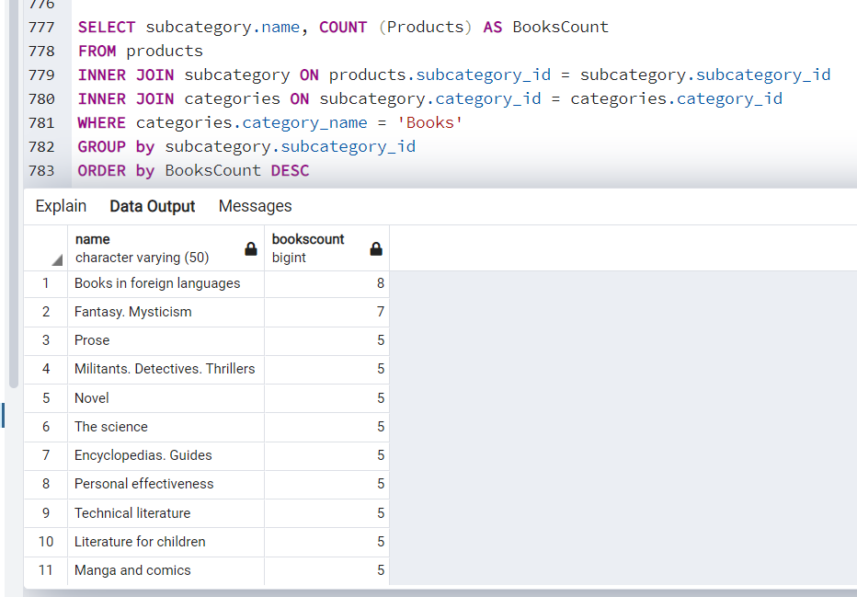

**Here, as in the previous condition, we decided to display the number of books that belong to each category, moreover, we sorted them in descending order.**

**6)**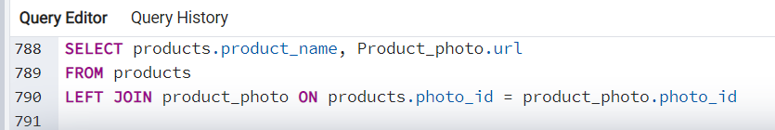

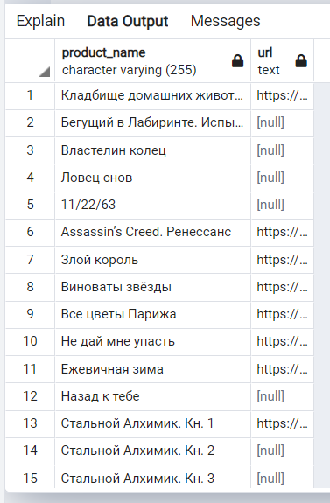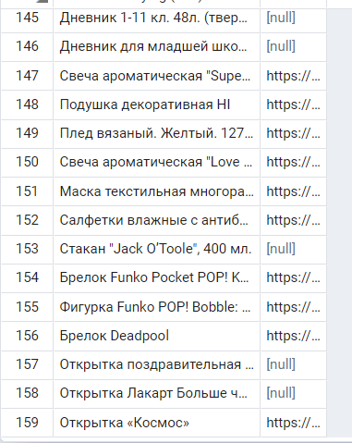

**We have a very large range of products and we decided to insert a screenshot of only the beginning and end of our list. Only about a quarter of the products had photos, so we decided to use the LEFT JOIN operator to show all the products even if they didn't have photos.**

**7)**

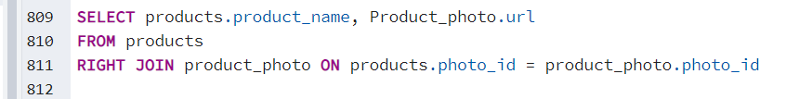

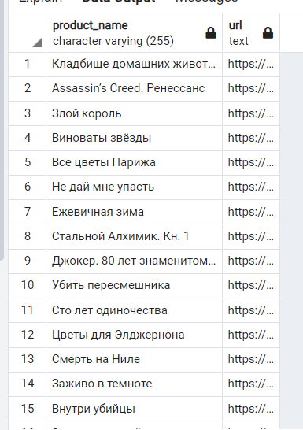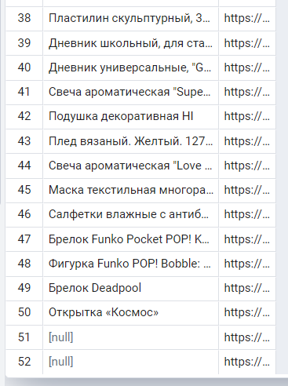

**As we said earlier, we have a large number of products, and we have not inserted photos on them everywhere. We decided to show the application to the RIGHT JOIN operator.**

**8)**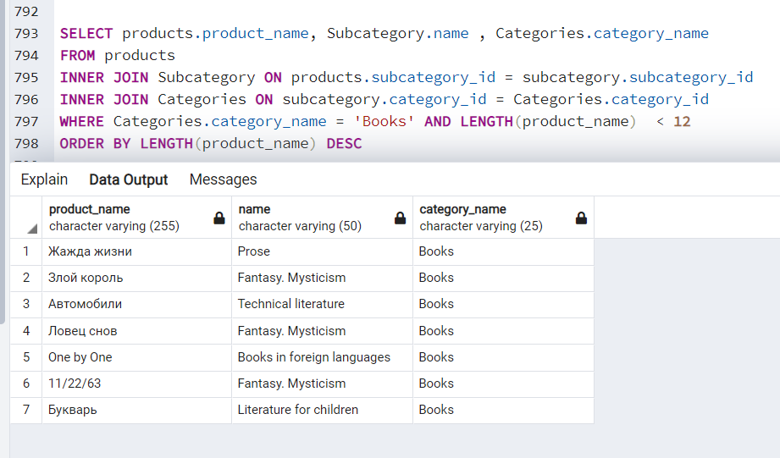

**Here we used an operator such as LENGTH. In this case, we have displayed the titles and genres of books that do not exceed 12 characters in length.**

**9)**

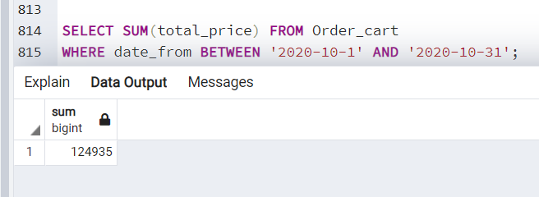

**In this case, we showed how much our site earned on sales for the whole of October. Here we used the operator SUM**

**10)**

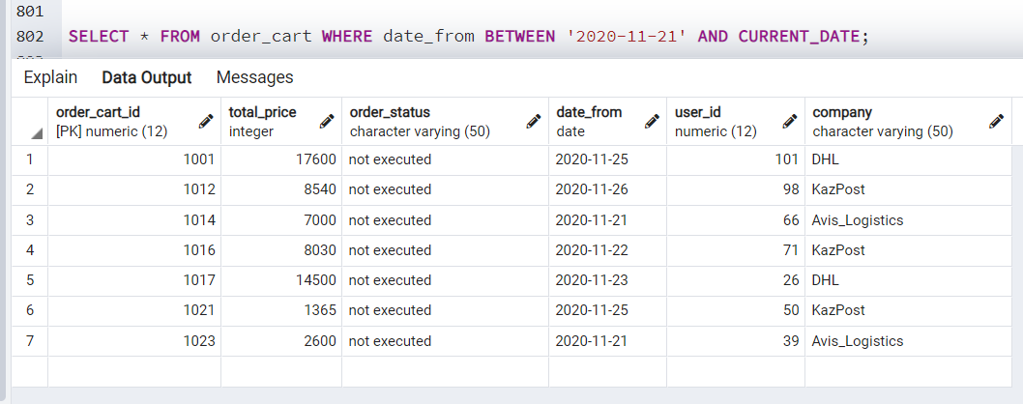

**Here, as in the 3rd example, we used the BETWEEN operator. Only this time it displays us orders issued in the period from November 1, 2020 to today**

**METHODOLOGY**

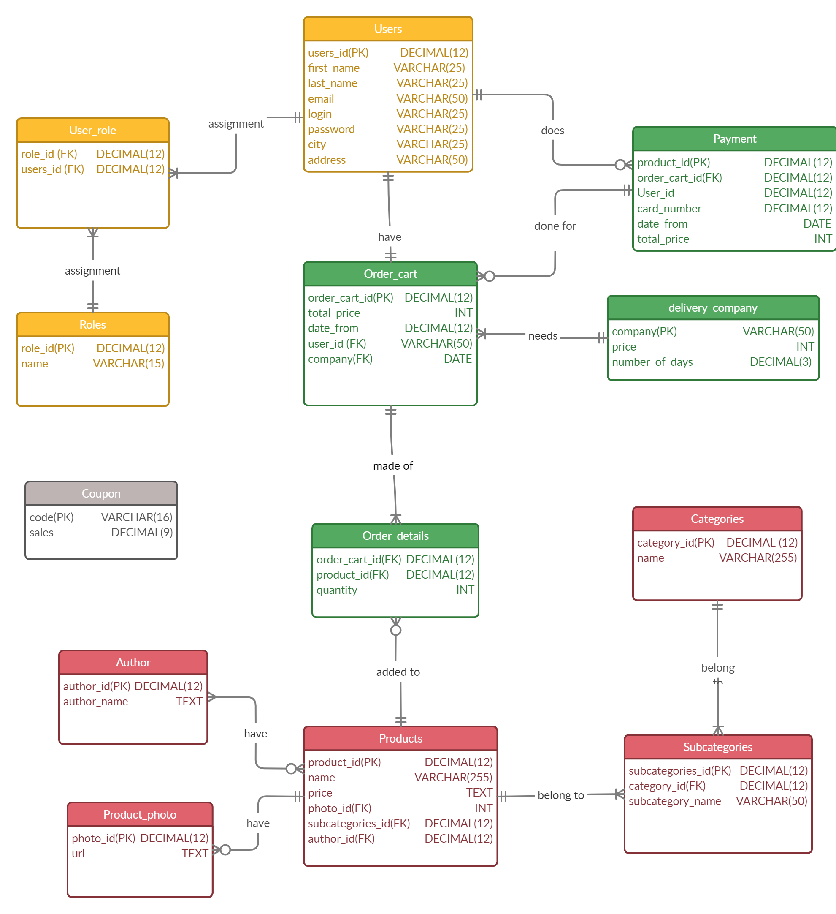

**When creating a database for an online store, we started by creating tables.**

**USERS-a table that contains information about users. In other words, it contains a unique identifier, first and last name, username, and password to log in to the website, city, email address, and residential address of each user.**

**ROLE-a a table that contains the types of roles. In General, almost every website today has similar names (administrator, moderator, user, and guest).**

**USER_ROLE-a join table that will contain two foreign keys. Typically, these tables are created to implement a many-to-many relationship. It will contain the role of each user logged in to the site.**

**In addition, each user will have a virtual shopping cart called ORDER_CART - a table that contains a unique identifier, the total amount of all products, the order implementation date, the order status, and foreign keys from the DELIVERY_COMPANY and USERS tables.**

**Any purchase made online has its own additional cost, that is, we pay the company that delivers the order money for the fact that it performs the process that we do when walking to the store offline. The DELIVERY_COMPANY table just contains the price that will be added to the full payment amount. This table contains the name of the delivery company, the full delivery price, and the maximum delivery time for each company.**

**When the shopping cart is completed, the user proceeds to pay for the order. Information about the order and the user's card number will be stored in the PAYMENT table. This table should be the most secure since this table contains information about the user's Bankcard.**

**PRODUCT is one of the largest tables that will contain information about all products. There will be a name, and its price, etc.**

**A product can have a photo and we created the PRODUCT_PHOTO table for this purpose. This table contains the photo ID and its URL.**

**In General, each product in an online store can be assigned to a certain category in one way or another. Since we decided to create a database for the online store of books, stationery, and various Souvenirs, We will divide our items into the same categories: Books, Chancellery, Souvenirs; which will be stored in the categories table.**

**But to divide products into such categories, we decided that it would not be enough and decided to create a SUBCATEGORY table. That is, we decided to continue the categories from the categories table in a hierarchical structure. That is, for example, books will have their own genre, stationery will have its own category, for example, a book called "Night tales “will belong to the genre” Literature for children".**

**The AUTHOR table contains information about the author of the book or the manufacturer of each stationery item or souvenir.**

**ORDER_DETAILS-a transition table that will contain the identification number of the basket and the identification number of the product that will be added to this very basket with a certain amount. That is, a person can not add the same pen every time but simply increase its number. Our database will automatically calculate the sum of all the products that the user has selected.**

**Let's look at the business rules of an online store based on our database. The user will have their own role on the site, which will give them the appropriate permissions.**

**A user can have one or more roles, or many users can have one role.**

**Each user has one virtual bucket, and the bucket can have one owner.**

**Payment is made for products that users have entered into the shopping cart. All items in the shopping cart are paid for once.**

**Every order is delivered by the company selected by the user, one company can deliver different baskets (orders).**

**The user can add several identical products to the shopping cart at once. The same product can be in many baskets.**

**In our database, we decided to leave only one manufacturer or author, that is, one product has one manufacturer. The manufacturer may not have any products.**

**A product can have one or more photos. A photo can't have multiple products.**

**A product can belong to several sub-categories and several categories. A category can have many sub-categories.**

**You can see all the relationships and relationships between tables on the ERD attached graph.**

**We decided to enter product data from various major online stores. We decided to take the example of online stores such as Meloman.kz, Flip.kz, Amazon.com. We took the cities of Kazakhstan as examples. In other words, our sample users will live in different cities of Kazakhstan. We entered all the data ourselves, but to fill in such columns as email, card number, first and last name, we used https://mockaroo.com/. We selected some of the most famous suppliers, and we filled in the prices and delivery dates based on personal experience. You can see all the data that we filled in in the .sql file that we attached with this .docx. We also selected authors and photos from the Internet and inserted their URLs.**

**REFLECTION**

**We started the project by opening a conversation in “Discord” and discussing our future project. Almost all actions from the beginning of the project to the very end were done in a team. All actions were discussed and the opinions of each participant were taken into account and everyone makes an equal contribution to the project.**

**CONCLUSION AND FUTURE WORK**

**At the beginning of the conclusion, I would like to say that this project has given us a huge amount of new information. This is the first project that we have completely from scratch.**

**We have created a fully functioning and working database for a website or store. We also met all the project requirements Such as: "ALTER TABLE, insert, delete, update, ( < ,>,=), OR, AND, BETWEEN, IN, LIKE, LENGHT, COUNT, MAX, MIN, SUM, AVG, INNER JOIN, LEFT JOIN, RIGHT JOIN, FULL JOIN and subqueries”**

**Our database is applicable not only to online stores. It can also be used by large, medium and small stores to automate their sales system. To clearly see your earnings, what is sold and best or the most impassable product. You will be able to see earnings, expenses, and profits. It is also very useful for our State. Which will be able to track the income of stores and take real taxes as they will see all the numbers associated with the store. As for online stores, we believe that this industry is not very developed in Kazakhstan. And the more online stores there are, the stronger the competition will be , the more online stores will start to entice users to buy online. Thus, the population's it literacy will grow.**

**As for how the project can be improved**

**First of all, it is adding and working with coupons. Unfortunately, we didn't have time to come up with a normal code for coupons. Because as we know all coupons are disposable after they are used they are deactivated and instead of them there are other codes consisting of a random set of numbers and letters**

**Also, at the moment we only have products that were produced by one author or company, and as we know, let's say books can be written by several authors. In the future, you should fix this bug.**