CVEN9723 Group Report
Grand Challenges and Emerging Opportunities for the Australian Construction Industry
Case Study, New Sydney Fish Market, Blackwattle Bay
Executive Summary
The New Sydney Fish Market is a large civic and industrial project that relocates and expands the legacy Pyrmont operations onto a purpose built waterfront facility at Blackwattle Bay. Designed by 3XN with BVN and Aspect Studios, the project combines a working market, a hall for retail and dining, education and tourism spaces, and a reconnected foreshore promenade under a distinctive 200 metre roof formed by glulam structure and an array of aluminium cassettes that read as scales. Government updates indicate construction completion is imminent, with tenants preparing fit outs and a staged handover to the operator prior to opening, while recent press reports point to a January opening date that follows the peak Christmas trading period, a timing choice that reduces operational risk during the first weeks of service for a facility that expects more than six million visitors each year (NSW Government, 2025a, ABC News, 2025, Inside FMCG, 2025, NSW Government, 2025b). The project concentrates several grand challenges that are common in Australian delivery, including marine construction in a live urban setting, multi party stakeholder and tenant coordination, food grade systems integration at scale, and access interfaces with a new ferry wharf and active transport links. This report synthesises those challenges, explains their intrinsic connections, reviews relevant practice, and proposes a benefits-led roadmap for the final stretch from construction completion to a stable first year of operation. The recommendations emphasise transparent opening readiness, digital assurance that ties evidence to each area release, coordinated access and crowd management, and portfolio learning that can be reused across the Bays Precinct and similar waterfront destinations (3XN, 2025, Multiplex, 2025, Infrastructure NSW, 2025).

1. Introduction to the project and identification of the main challenges
The New Sydney Fish Market is both a production facility and a public place. The building sits partly over water on a new marine deck and is shaped by a long canopy that shades the market floor and the promenade. The design brief sought to preserve the authenticity of a working seafood market while improving hygiene, logistics and visitor experience, which explains the clear separation of back of house flows from public circulation and the use of generous weather protection and cross ventilated volumes. The architectural team presents the project as a fusion of market typology and harbour landscape, while the delivery agencies position it as a catalyst for reconnecting previously inaccessible harbour edges to the wider community (3XN, 2025, NSW Government, 2025c). The contractor describes more than 6,000 square metres of new public space, with restaurants, cafés, bars, fishmongers and specialty retail arranged around a market hall that opens to the water, and a new ferry wharf and promenade connections that relieve pressure on local streets during peak days (Multiplex, 2025, NSW Government, 2025a).
The main challenges arise from the physical setting and the number of moving parts near the finish line. Marine works, piled decks and façade sequencing have to proceed within a sensitive water body with environmental protections and navigational constraints. Stakeholder coordination is unusually complex because a State delivery team must hand a food grade facility to a market operator and dozens of tenants while managing regulators and the community, and while aligning the commissioning of services that range from refrigeration to grease and drainage to public safety systems. Access and transport interfaces include a new commuter ferry wharf and upgrades around the Wentworth Park light rail stop, and the timing of those works affects opening day experience and the early months of operation. Public expectations are high and are being shaped by frequent media updates, which creates reputational risk if dates move or if early crowding events overwhelm wayfinding and amenity. There are also commercial pressures that can surface late in delivery, including claims and disputes that, if unmanaged, can slow decisions and propagate into fit out and commissioning windows (NSW Government, 2025a, ABC News, 2025, Daily Telegraph, 2025, Infrastructure NSW, 2023).
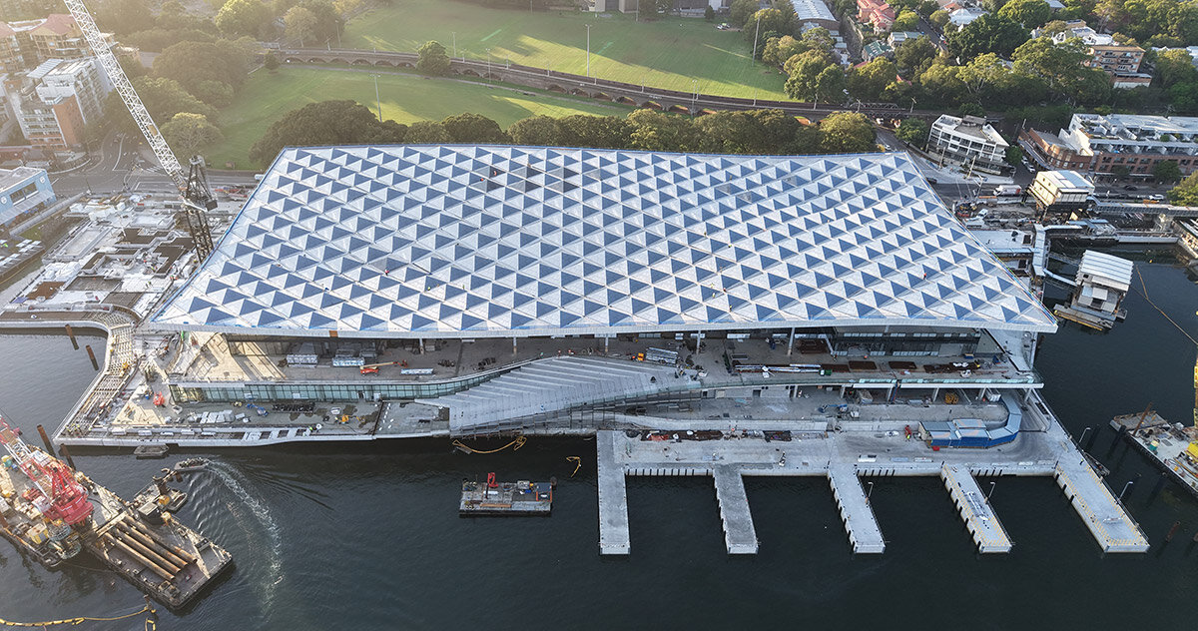
Figure 1. New Sydney Fish Market, roof and waterfront, aerial view

2. Reasons for the problems and the intrinsic connections between the challenges
The intrinsic connections between the issues at Blackwattle Bay are best understood as a network of dependencies that link building readiness, tenant readiness, approvals and evidence, and access. When marine works or façade closure are delayed by weather or logistics, the knock-on effect is felt in the timing of services commissioning and the availability of safe and clean areas for retail fit out. When tenant designs change late, approval processes compress and documentation backlogs accumulate, which can slow the release of spaces for training and soft opening. The access story is similarly coupled. The promise of a new ferry wharf and improved connections to light rail and the foreshore is more than a transport improvement, it is a crowd management tool that spreads arrivals and reduces queuing and local congestion on peak days. If the wharf or wayfinding lags, crowd pressure concentrates at fewer entry points, the first weeks feel more chaotic, and management bandwidth is drawn into operational firefighting rather than continuous improvement (NSW Government, 2025a, NSW Government, 2025d, Time Out, 2025, Daily Telegraph, 2025).
Information latency intensifies these couplings. Many evidence packs for a food grade building can only be completed once physical systems are installed and tested, and once tenants fix their layouts and equipment. If evidence is late, regulators cannot sign off on area release, which cascades into contractor demobilisation planning and tenant training calendars. Media coverage about dates, even when constructive, raises expectations, so transparent readiness criteria become essential for trust. A single integrated opening pathway with public milestones can reduce speculation and keep stakeholders aligned on what needs to be true before doors open to large crowds (ABC News, 2025, Inside FMCG, 2025, NSW Government, 2025b).
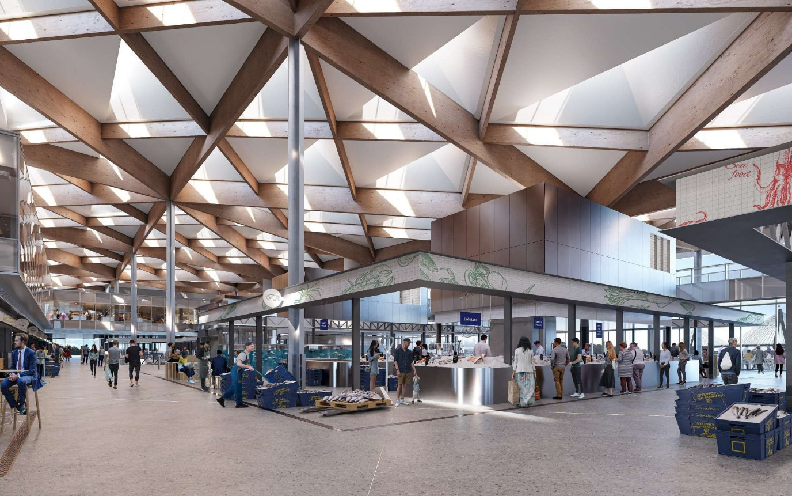
Figure 2. Interior under the scale roof, market hall visual

3. Review of best practice in similar projects, local and global
Best practice for large public markets and waterfront redevelopments points to staged activation, evidence led approvals, and deliberate access integration. Many cities use a soft opening period that allows operations to stabilise, staff to learn the building, and early defects to be resolved before the first marquee event. This is particularly relevant for a market where cold chain integrity, cleaning, waste, and hygiene have to operate flawlessly from day one. International case material and local guidance show the value of digital assurance, in which model objects correspond to work breakdown structure items and inspection points, and where every lot can produce a traceable package of evidence that bundles shop drawings, test results, commissioning data and photographs. This approach shortens regulator review and makes it easier to scale area release across dozens of shops and shared facilities. The third pillar is access integration, where a ferry wharf and a continuous waterfront walk can change the arrival profile, the dwell pattern and the distribution of foot traffic through the day, especially if real time information and clear wayfinding are present (3XN, 2025, Infrastructure NSW, 2025, NSW Government, 2025a, NSW Government, 2025d).

4. Opportunities and future development
A first opportunity is to publish a transparent opening pathway that sets out, in plain language, the sequence from construction completion to handover, tenant fit out, systems integration and training, soft opening and then formal public opening. This pathway should include objective readiness gates, for example completion of food grade evidence packs and area sign off, successful end to end cold chain tests, and live crowd simulations that validate queue management and wayfinding. A second opportunity is to deploy digital assurance across all tenant areas and shared systems, with QR coded inspections on site, photographs and test results linked to model objects, and weekly dashboards that show progress and risks to area release. A third opportunity is coordinated access and crowd management that treats the new ferry wharf as a strategic asset rather than a simple transport feature. This means integrating timetables with trading peaks, reinforcing the promenade and light rail links with clear signage, and using live footfall data to adjust operations in real time. A fourth opportunity is tenant enablement through standard templates for refrigeration, drainage, cleaning stations and finishes, which reduces rework and accelerates approvals. The final opportunity is portfolio learning, where the State captures structured lessons, data and templates from this project and reuses them on adjacent Bays Precinct works and similar destinations (NSW Government, 2025a, NSW Government, 2025d, 3XN, 2025, Multiplex, 2025).
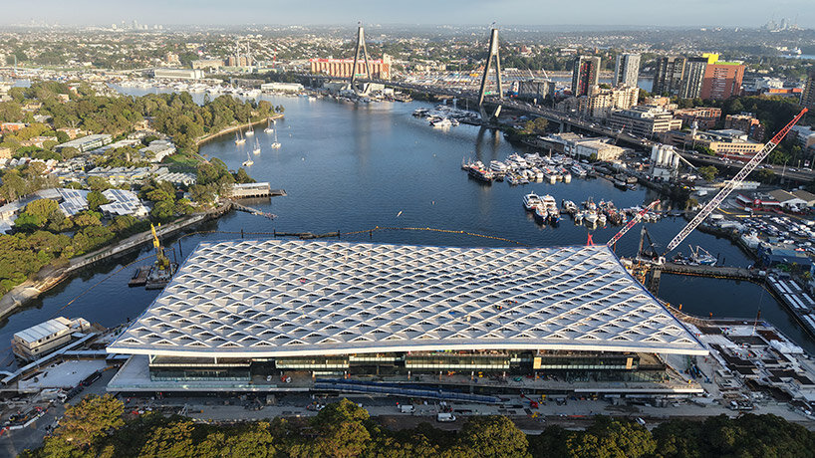
Figure 4. Site works and marine deck, construction phase

5. Implementation roadmap
The final kilometres from construction completion to stable operations can be planned as three overlapping tranches that are measured by benefits rather than only by activities. The immediate tranche covers zero to three months from construction completion and focuses on closing defects, cleaning and food grade validation, and the first wave of tenant fit outs under a single schedule of record that is visible to all parties. The middle tranche runs from month three to month nine and concentrates on scaling digital assurance to every area, training staff through supervised service, and running a soft opening period that is long enough to span at least one peak weekend and one foul weather event, since weather is a critical test for a waterfront hall and canopy. The maturation tranche covers months nine to eighteen and institutionalises reporting across visitor experience, safety and sustainability, shifts from project to business as usual governance, and publishes a playbook that captures what worked and what did not for reuse. At every step, dependencies with transport interfaces need continuous management. The ferry wharf and light rail improvements are key to a calm opening because they spread arrivals, they give visitors a clear mental map of how to approach the site, and they reduce pressure on local roads and kerbside space around Bridge Road and Wentworth Park (NSW Government, 2025a, Time Out, 2025, Daily Telegraph, 2025).

6. Evaluation framework and expected benefits
A benefits framework should connect enablers such as digital assurance, tenant enablement and access integration to outcomes that matter for the public and the supply chain. The most important near term measures are the time from area completion to regulator sign off, the proportion of tenant areas released on the first submission, queue time during peak periods at primary entries and flagship retailers, daily visitor throughput and dwell time, and a small set of food safety and hygiene indicators such as non conformances per inspection and time to rectify. Energy intensity in the hall and cold rooms, waste diversion rates, and the operator’s safety performance complete a compact set that can be tracked weekly during the soft opening and monthly thereafter. The expected benefits of executing the roadmap are faster and smoother area release, less rework during fit out and commissioning, more predictable visitor experience during the first peak weekend, and early confidence in sustainability and safety performance. These benefits also lower reputational risk because they reduce the chance of last minute rescheduling, confusing public messages or avoidable crowding during early trading days (Infrastructure NSW, 2025, NSW Government, 2025a, Inside FMCG, 2025).

7. Risks and mitigations
The most material risks during the transition to operations are a slippage in tenant fit out readiness that compresses commissioning windows, a lag in access upgrades that forces too many visitors through a small number of entries on early peak days, and late disputes that slow decisions during a period that is already dense with handovers and training. There is also a risk of food safety non conformances if cleaning and cold chain procedures are not rehearsed at scale before the first large trading weekend, and a communication risk if media messages lead public expectations faster than the readiness gates can support. These risks can be mitigated by a formal decision cell with weekly service level reviews for approvals and handovers, by clear authority over the single schedule of record, by a soft opening long enough to test operations under different conditions, and by a public readiness dashboard that explains what is complete and what remains, which reduces speculation and aligns visitors, tenants and the community (NSW Government, 2025a, ABC News, 2025, Inside FMCG, 2025).

8. Conclusion
The New Sydney Fish Market draws together challenges that recur in Australian city making, including the tension between production and place, the need to coordinate many actors under time pressure, and the importance of access and evidence during the sprint to opening. The case demonstrates how a benefits oriented approach, supported by digital assurance and transparent readiness, can convert those challenges into a credible pathway to a calm first month and a stable first year. The recommendations in this report translate well to other harbour edge projects and to any mixed civic and industrial facility that serves very large crowds. If the State, the operator and tenants continue to work from a single schedule and a shared definition of done, the project can deliver both a working market and a memorable public waterfront experience that feels worthy of its setting on Sydney Harbour (3XN, 2025, Multiplex, 2025, NSW Government, 2025a).

References
ABC News 2025, ‘Sydney’s new fish market to open January 19 next year as old site serves Christmas crowds’, viewed 19 Oct 2025. (ABC)
Inside FMCG 2025, ‘Sydney Fish Market confirms opening date and tenants’, viewed 19 Oct 2025. (Inside FMCG)
Infrastructure NSW 2023, ‘Local businesses building the new Sydney Fish Market’, viewed 19 Oct 2025.
Infrastructure NSW 2025, ‘New Sydney Fish Market, project portal and media gallery’, viewed 19 Oct 2025. (New Sydney Fish Market)
Multiplex 2025, ‘New Sydney Fish Market, project overview’, viewed 19 Oct 2025. (Multiplex)
NSW Government 2025a, ‘New Sydney Fish Market nears completion as retailers prepare to reel in locals and visitors’, ministerial release, viewed 19 Oct 2025. (NSW Government)
NSW Government 2025b, ‘Ferry wharf to connect Sydney’s new Fish Market to the Harbour’, ministerial release, viewed 19 Oct 2025. (NSW Government)
NSW Government 2025c, ‘Home, New Sydney Fish Market, Infrastructure NSW portal’, viewed 19 Oct 2025. (New Sydney Fish Market)
NSW Government 2025d, ‘Budget commitment for ferry wharf and access upgrades’, reported summary, viewed 19 Oct 2025. (Daily Telegraph)
3XN 2025, ‘Sydney fish market, a world class foodie destination’, studio project page and news, viewed 19 Oct 2025. (3XN)

