CVEN9723 Group Assignment
Grand Challenges and Emerging Opportunities in the Snowy 2.0 Pumped-Hydro Project
Prepared for: CVEN9723 Design of Construction Operations, Term 3, 2025

Executive summary
Snowy 2.0 is Australia’s largest long-duration energy-storage project. It will connect Tantangara and Talbingo reservoirs with roughly 27 km of headrace and tailrace tunnels and an underground powerhouse, delivering about 2.2 GW of fast-response capacity for multi-hour to multi-day energy shifting. Following a 2023 project reset, Snowy Hydro continues to signal first power in the second half of 2027 and commercial operation of all units by December 2028, while an updated cost reassessment proceeds in parallel. These settings frame a case where geotechnical uncertainty, safety governance, and transmission dependencies interact with cost and schedule at system scale (Snowy Hydro 2023, Renewable Energy World 2025). (Snowy Hydro)
The report addresses four required elements:
- an introduction and identification of the main challenges,
- causes and intrinsic connections between the challenges,
- a review of local and international good practice, and
- emerging opportunities and future development. The layout uses numbered figures, tables and in-text analysis in line with the marking criteria.

1. Introduction and key challenges

1.1 Project overview
Snowy 2.0 expands the historic Snowy Scheme. Water is pumped uphill when electricity is abundant, then released to generate during peaks, which complements short-duration battery storage with longer, bulk energy shifting. Snowy Hydro is the proponent, the Future Generation Joint Venture delivers major civil and electromechanical works, and Transgrid leads the Snowy 2.0 connection and the broader HumeLink augmentation that will move Snowy 2.0 energy to load centres (Snowy Hydro 2023, Transgrid 2024–25). (Snowy Hydro)
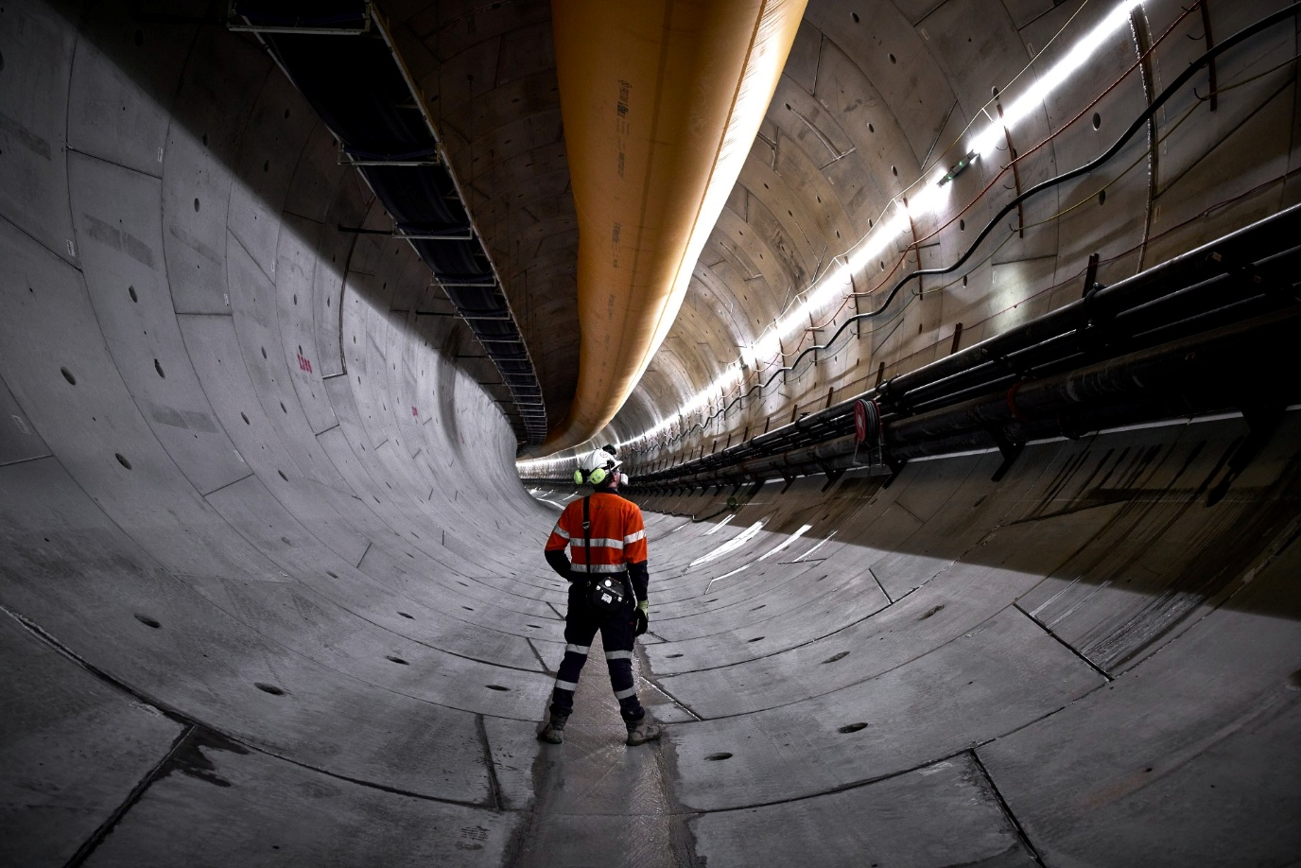
Figure 1. Inside a lined Snowy 2.0 tunnel showing services, lighting and ventilation, used to ground subsequent discussion of safety systems and underground logistics. Source for image: Snowy Hydro media gallery or equivalent.

1.2 Main challenges
- Geotechnical variability and TBM stoppages. The headrace TBM Florence encountered soft ground and later extremely hard, abrasive rock, leading to immobilisation and specialist recovery, including high-pressure water jetting (ABC News 2024, Snowy Hydro 2024, Geoengineer 2024). (ABC)
- Cost escalation and funding uncertainty. Public signals note that the earlier AUD 12 billion figure has been exceeded, with formal re-assessment underway, while schedule targets remain unchanged after the reset (Renewable Energy World 2025). (Factor This™)
- Schedule movement and productivity risk. First power is indicated for 2H 2027, with December 2028 targeted for all units, contingent on stable throughput in tunnelling and fit-out (Snowy Hydro 2023). (Snowy Hydro)
- Safety events and regulator intervention. A ventilation fan implosion in February 2025 led to six SafeWork NSW prohibition notices and an independent safety review, pausing underground works (ABC News 2025, ESDNews 2025). (ABC)
- Environmental and approvals complexity. Works intersect sensitive alpine landscapes, which increases the approvals workload and reduces flexibility for late method changes, especially on transmission corridors supporting Snowy 2.0 (Transgrid 2024–25). (Transgrid)
- Grid-integration dependencies. HumeLink and the Snowy 2.0 connection are critical to avoid stranded capacity at commissioning, with NSW and Commonwealth approvals in place and construction commencing in 2025 (ABC News 2024, Transgrid 2024–25). (ABC)
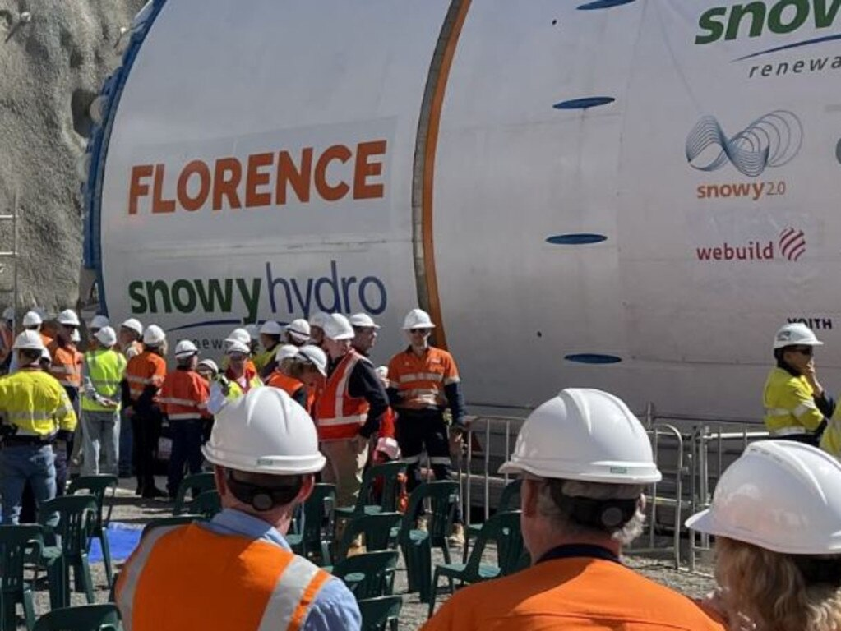
Figure 2. TBM Florence at the portal, used to anchor the geotechnical challenge and the recovery logistics. Example image source: national press photo of the Florence TBM.

Table 1. Summary of key challenges and likely effects
Challenge | Likely effect on time | Likely effect on cost | Notes and sources
Variable ground and TBM stoppages | High | High | Immobilisation, cutter wear, resequencing, recovery campaigns. (ABC)
Cost escalation signals | Medium to High | High | Re-assessment beyond prior public envelope. (Factor This™)
Safety incidents, compliance | High during stand-downs | Medium to High | Fan failure and prohibition notices. (ABC)
Approvals constraints | Medium | Medium | Less flexibility for late alignment or method changes. (Transgrid)
Transmission dependency | Medium | Medium | Risk of stranded capacity if misaligned. (ABC)

2. Causes of the problems and how they connect

2.1 Geotechnical drivers and stoppage cascades
Large-diameter TBMs rely on predictable rock mass conditions. When fracture density, abrasiveness or groundwater deviate from the ground model, advance rates fall, cutterhead damage rises, and the machine can stall. Recovery typically requires face pre-treatment and revised support, which absorbs time and labour, and sequentially pushes back cavern excavation, installation and commissioning. The Florence stoppages and the use of high-pressure water jetting in 2024 illustrate this cascade (ABC News 2024, Snowy Hydro 2024). (ABC)

2.2 Safety governance under pressure
Underground production depends on robust ventilation, certified refuge chambers and trained evacuation. The ventilation fan implosion produced dangerous fragments and triggered six prohibition notices, plus an independent review. Such events erode workforce confidence and slow remobilisation, which amplifies delay and cost. The confined services envelope that construction crews work within is shown in Figure 2 (ABC News 2025, ESDNews 2025). (ABC)
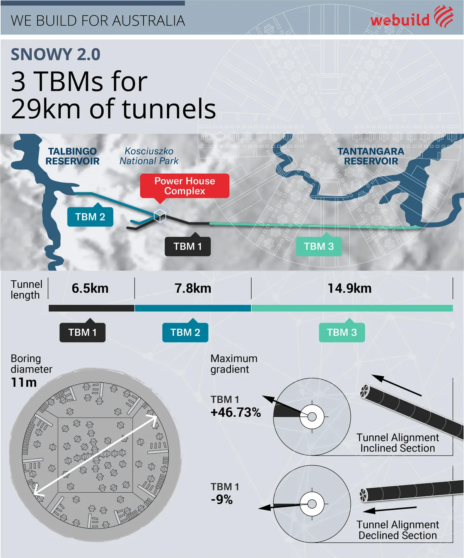
Figure 3. Tunnel services environment, showing ducting, cable trays and egress signage, used to anchor the safety discussion. Example image sources: Snowy Hydro and Webuild galleries.

2.3 Environmental approvals and constructability
The Snowy 2.0 connection and HumeLink traverse sensitive landscapes and multiple LGAs. Approvals constrain options for late design changes, for example relocating worksites or spoil areas, which limits agility in response to geotechnical surprises and raises the reporting burden during delivery (Transgrid 2024–25). (Transgrid)

2.4 System-level dependency on transmission
Snowy 2.0 captures full value only if transmission capacity is energised on time. HumeLink, around 360–365 km of 500 kV lines with new and upgraded substations, is a genuine critical path dependency. Misalignment can strand generation or the line in early years. Coordinated energisation planning reduces this risk (ABC News 2024, Transgrid 2024–25). (ABC)
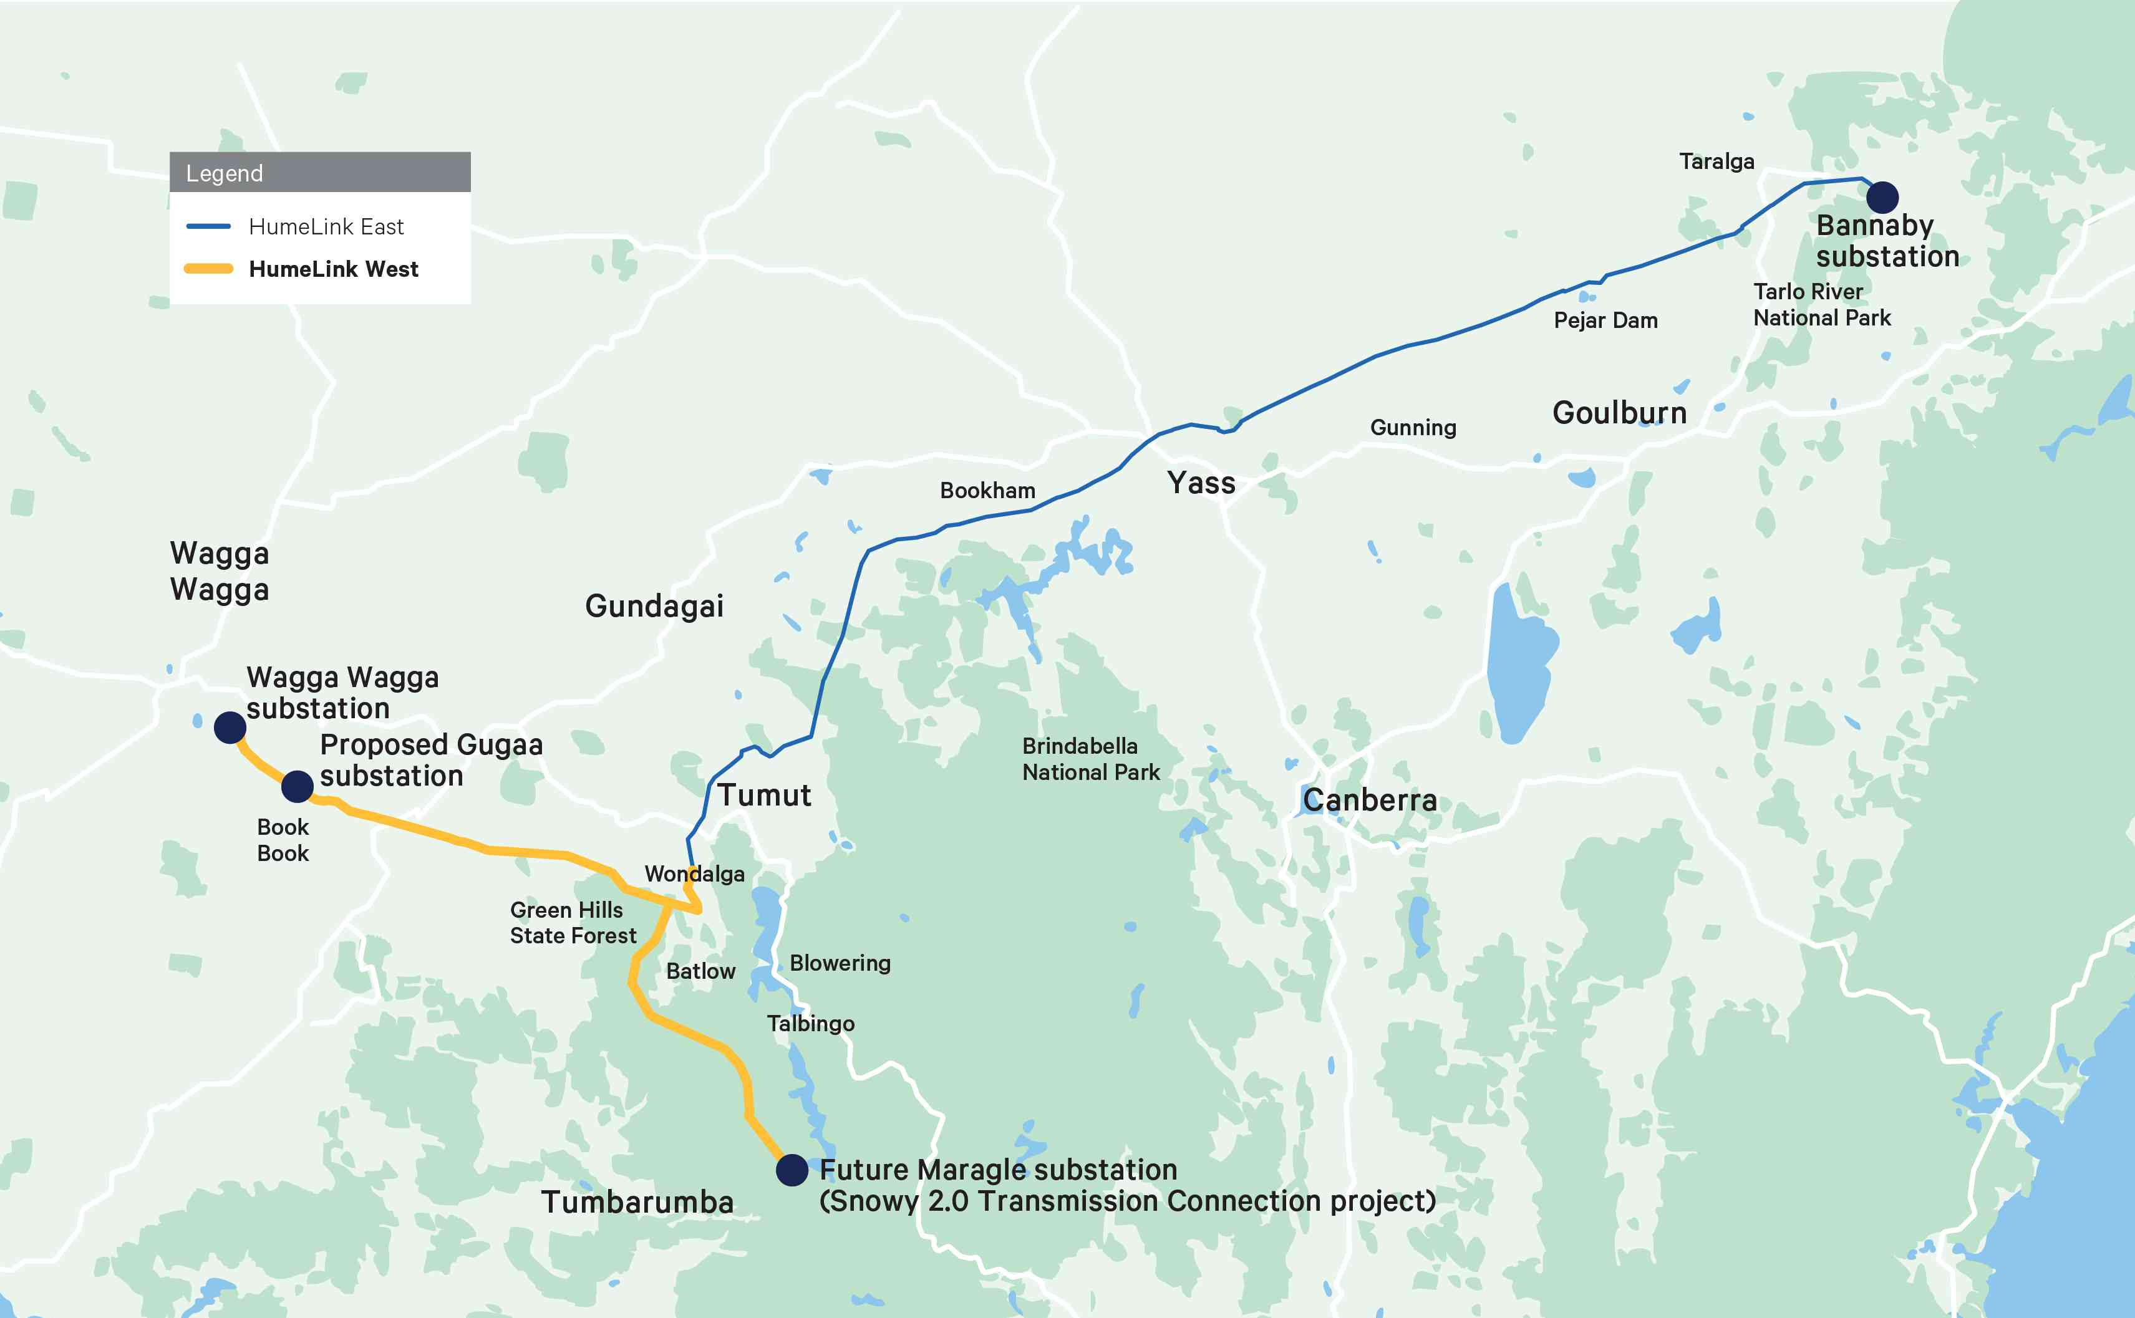
Figure 3. HumeLink regional overview map, locating Wagga Wagga, Bannaby and Maragle, used to place Snowy 2.0 in the grid. Example image source: Transgrid HumeLink West overview.

Table 2. Simple causal map of reinforcing loops
Trigger | Immediate effect | Cascade | Outcome
Weak or abrasive ground | TBM slowdown or stall | Recovery works, resequencing | Longer time, higher cost
Safety plant failure | Stop-work, prohibition notices | Morale drop, slow restart | Time loss, reputational hit
Tight approvals | Fewer rerouting options | Slower response to surprises | Schedule stress
Late transmission | Bottleneck at commissioning | Lower early-year revenue | Economic under-performance

3. Local and international good practice

3.1 Ground-risk management
For high-risk geology, front-load probe drilling and, where feasible, pilot headings. Baseline pre-grouting and method switches should be defined ahead of the TBM reaching hazards. This reduces immobilisation probability and shortens the tail of delay distributions, a pattern evidenced on European hydro and metro programs, and directly relevant to the Florence experience (Snowy Hydro 2024). (Snowy Hydro)

3.2 Contracting for variable subsurface conditions
When ground behaviour dominates uncertainty, target-cost or alliance models align incentives around safe throughput, shared data and joint decision-making, instead of adversarial claim cycles. Snowy Hydro’s reset notes a shift toward an Incentivised Target Cost arrangement with FGJV to manage variability more collaboratively (Snowy Hydro 2023). (Snowy Hydro)

3.3 Safety plant as critical path
Treat ventilation, refuge chambers and drills as critical equipment. Embed pass-fail gates and regulator sign-off into the excavation program. This reduces the likelihood of blanket stop-work outcomes after incidents and supports workforce confidence, as highlighted by the 2025 fan event and subsequent notices (ABC News 2025). (ABC)

3.4 Bundled planning for transmission
Generation, storage and transmission now function as one system. Approvals and delivery milestones should be bundled so neither asset is stranded. With HumeLink approved and moving into construction, a single integrated energisation plan with shared hold points will better protect Snowy 2.0’s early-year value (ABC News 2024, Transgrid 2024–25). (ABC)

Table 3. Good-practice crosswalk and application to Snowy 2.0
Theme | Typical elements | Application to Snowy 2.0
Staged ground model | Probing, pilot drives, change thresholds | Expand probe regimes ahead of remaining hard-rock segments, trigger pre-treatment on measured thresholds
Collaborative contracting | Target cost, joint boards, shared risk registers | Align incentives to P50 dates and safety metrics during cost reassessment
Safety as plant | Early procurement, acceptance tests, drills | Add regulator sign-off gates before sustained drives
Bundled transmission | Joint approvals and energisation plan | One integrated plan with shared hold points and test windows

4. Emerging opportunities and future development

4.1 Capability building
Snowy 2.0 is developing national capability in long-tunnel excavation, underground caverns, and 500 kV transmission integration. The trained workforce and supply chain from this project will de-risk future long-duration storage, including mine-pit pumped hydro concepts with lower tunnelling exposure.

4.2 Method innovation
For abrasive lithologies, consider hybrid excavation strategies, periodic cutterhead changes, or short drill-and-blast sections to bypass hazards. Trading nominal advance rate for lower stoppage probability can improve program certainty.

4.3 Integrated commissioning
Create a single commissioning plan across waterways, powerhouse, protection schemes and lines, with joint decision gates and outage windows. This aligns Snowy 2.0’s commissioning with HumeLink energisation, which reduces stranded-capacity risk (Transgrid 2024–25). (Transgrid)

4.4 Social licence and approvals
Bundle engagement across storage and transmission, keep multiple layout options permitted within one approvals envelope where possible, and publish concise monthly dashboards with date ranges and uncertainty bands during reassessment to maintain trust.

5. Implementation roadmap

5.1 Prioritised actions for the next 90 days
Priority | Action | Accountable | Outcome and measure
1 | Expand probe drilling ahead of high-risk segments, set pre-grouting triggers | Ground-risk board and JV | Fewer unplanned stoppages, weekly reporting
2 | Safety-plant sprint for ventilation and refuge systems, run drills before ramp-up | JV with SafeWork NSW oversight | Restart confidence, prohibition risk reduced (ABC News 2025) (ABC)
3 | Integrated energisation plan with HumeLink and the Snowy 2.0 connection | Proponent and Transgrid | Aligned test windows, no stranded capacity at COD (Transgrid 2024–25) (Transgrid)
4 | Commercial transparency in reassessment, align incentives to schedule and safety | Proponent and JV | Lower claim friction, clearer priorities (Snowy Hydro 2023) (Snowy Hydro)
5 | Public dashboards with date ranges and uncertainty bands | Proponent | Credibility with stakeholders and workforce

5.2 Monitoring and KPIs
Area | KPI | Target | Notes
Ground risk | Unplanned stop events per 100 m | Down by 50 percent in 90 days | Driven by probing and pre-treatment
Safety | Fan MTBF, refuge readiness, drill cadence | All green before ramp-up | Treat as plant acceptance
Transmission | Shared hold points met | 100 percent for next quarter | Joint calendar and governance
Cost and schedule | P50 date range width | Narrowed month on month | Reflects stabilised throughput

References
ABC News 2024, ‘Tunnel boring machine wedged in hard rock, leaving Snowy 2.0 hydropower project stalled’, viewed 22 May 2024. (ABC)
ABC News 2024, ‘$4.8b HumeLink transmission line approved to connect Snowy Hydro 2.0’, viewed 19 Dec 2024. (ABC)
ABC News 2025, ‘Snowy 2.0 project safety review underway after ventilation fan implodes, six prohibition notices issued’, viewed 27 Feb 2025. (ABC)
ESDNews 2025, ‘Flying shrapnel from giant fan forces Snowy 2.0 shutdown’, viewed 27 Feb 2025. (Energy Source & Distribution)
Geoengineer 2024, ‘Snowy 2.0 tunnel boring machine remains stuck after a month’, viewed 30 May 2024. (Geoengineer)
Renewable Energy World 2025, ‘When will Australia’s huge Snowy 2.0 pumped storage project be completed?’, viewed 21 Oct 2025. (Factor This™)
Snowy Hydro 2023, ‘Securing the future of critical energy transformation, resets’, viewed 31 Aug 2023. (Snowy Hydro)
Snowy Hydro 2024, ‘TBM Florence update, 12 June’, viewed 12 Jun 2024. (Snowy Hydro)
Transgrid 2024–2025, ‘HumeLink approvals and project updates’, viewed 2024–2025. (Transgrid)

