CVEN9723 Group Report
Grand Challenges and Emerging Opportunities for the Australian Construction Industry
Case Study, Snowy 2.0 Pumped-Hydro Project
Executive Summary
Snowy 2.0 is Australia’s largest renewable firming project, designed to provide 2.2 GW of dispatchable capacity and large-scale storage by linking Tantangara and Talbingo reservoirs with long headrace and tailrace tunnels and an underground power station. Since construction began in 2019, the project has faced compounding challenges that are representative of grand challenges across Australian construction, including difficult geology and ground behaviour, safety and workforce continuity, approvals complexity, supply chain constraints, systems integration, and transmission interface risk. These issues have driven cost escalation and schedule risk, for example the prolonged stoppages of the “Florence” TBM and episodic work suspensions for safety rectification in 2024. The case demonstrates how high coupling, information latency, and transient workfaces degrade productivity and amplify change churn. Drawing on local regulatory documents and international good practice, this report proposes a pragmatic roadmap that emphasises progressive ground truthing, a safety and approvals reset, standardised modular works where feasible, digital assurance tied to construction evidence, and buffered supply. We define a benefits and evaluation framework with measurable KPIs, for example TBM advance, decision lead time, and assurance pack throughput, and map risks to targeted mitigations. The recommendations are specific, evidence-linked, and sized for delivery under Australian conditions. The content aligns with the course brief and marking criteria for technical depth, structure, logic, and Harvard referencing.

1. Introduction to the case project, and identification of main challenges
Project overview
Snowy 2.0 expands the original Snowy Scheme by constructing about 27 km of underground water conveyance and a new underground pumped-hydro station between Tantangara and Talbingo reservoirs in the Snowy Mountains, NSW. It is planned to provide 2.2 GW of dispatchable capacity and very large energy storage, with commissioning now expected to ramp from late 2027 toward full operation in 2028, subject to construction progress and transmission readiness. Costs have risen over successive revisions, with public estimates now around AUD 12 billion. (Wikipedia)
Main challenges identified
C1. Geology and ground behaviour in long tunnels that traverse variable formations, evidenced by repeated stoppages of TBM “Florence.” (ABC)
C2. Safety and workforce continuity, including a 2024 underground work suspension to address safety systems. (The Australian)
C3. Approvals and environmental management under a complex set of conditions and management plans spanning biodiversity, spoil, water, heritage, noise, and traffic. (Snowy Hydro)
C4. Supply chain and productivity, with under-target monthly progress in 2024 and 2025 translating to cost pressure. (waterpowermagazine.com)
C5. Transmission interface risk, particularly reliance on HumeLink to evacuate energy, with approvals arriving late 2024 and construction starting in 2025. (ABC)
C6. Systems integration and progressive assurance across civil, mechanical, electrical, and controls in a highly coupled underground system. (Snowy Hydro)
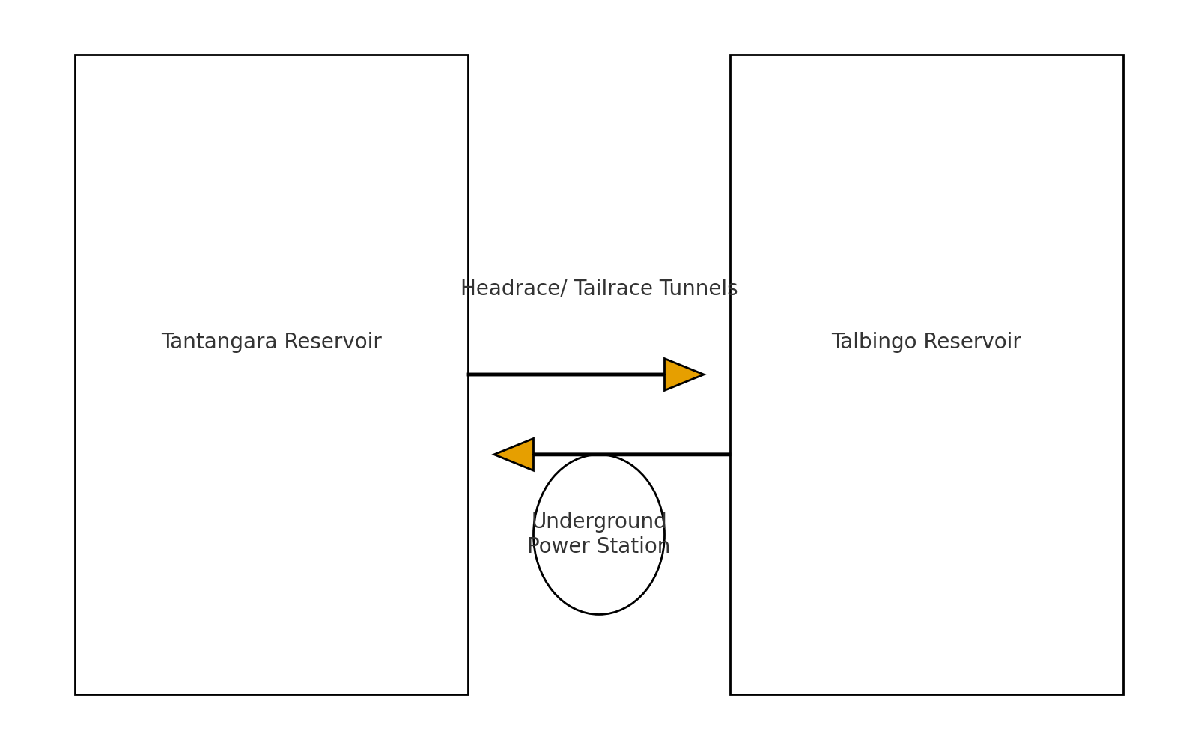
Figure 1. Project overview schematic

2. Investigation of reasons for the problems and intrinsic connections between challenges
Systemic drivers
- High coupling. Decisions in one workfront, for example ground treatment, immediately constrain downstream activities, for example segment erection, M&E fit-out, and commissioning sequence.
- Information latency. Ground reality is partially revealed only after excavation, which forces resequencing and design adjustments.
- Transient workfaces. Tunnelling and underground caverns involve many short operations with tight interdependencies, so small delays propagate.
Reinforcing loops
- Ground-productivity loop. Unanticipated ground conditions slow TBM advance, which reduces float, compresses maintenance windows, and raises change churn. This further depresses productivity. (ABC)
- Safety-flow loop. Safety non-conformances lead to suspensions and rectification, which fragment crews and extend learning curves, increasing variability. (The Australian)
- Approvals-assurance loop. Late or incomplete evidence packages extend approval times for changes, which lock inventory and delay workfront release, which in turn generate more unapproved changes. (Snowy Hydro)
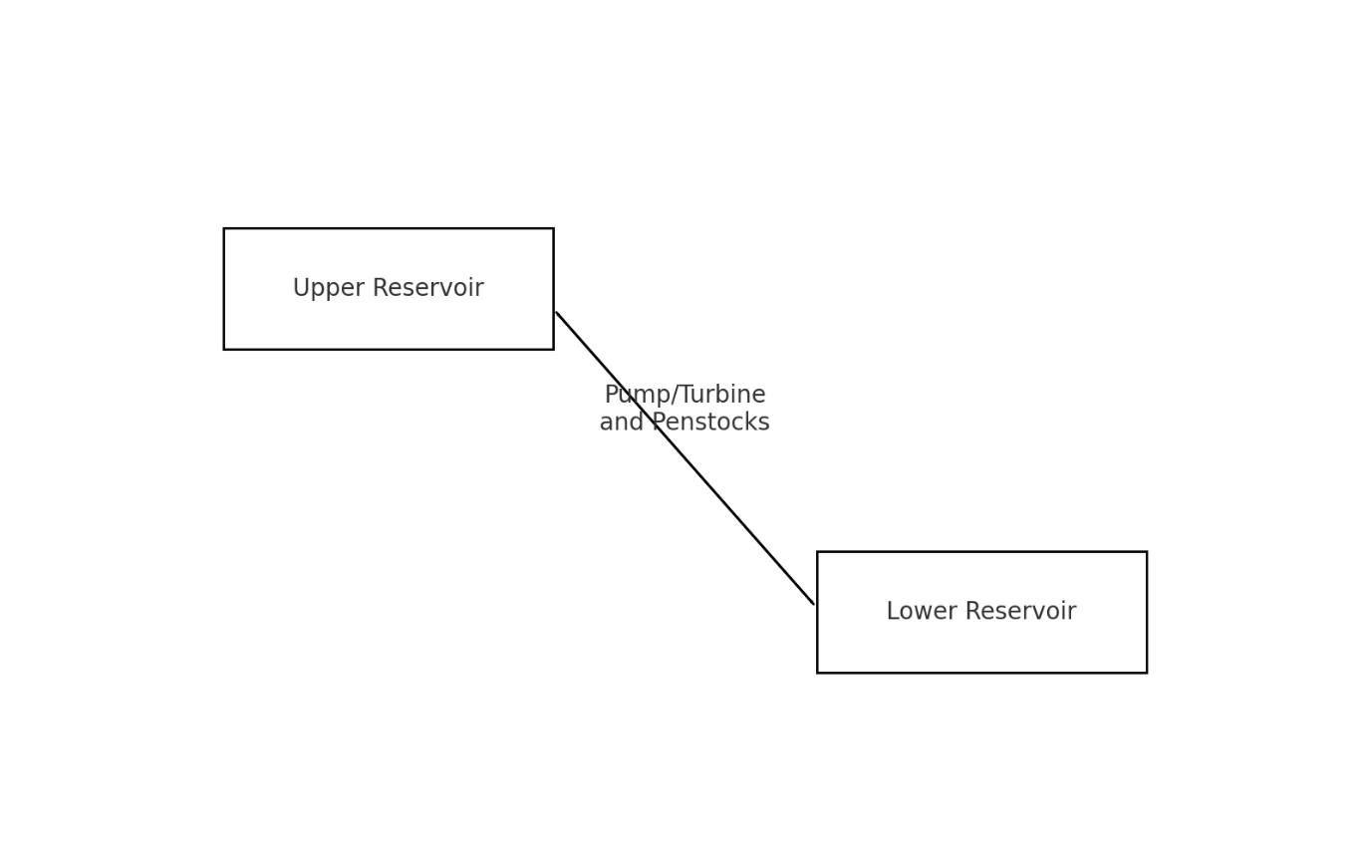
Figure 2. Challenge interaction map

3. Review of best practice in similar projects, locally and globally
Progressive ground truthing and decision gates
Long-tunnel hydro projects increasingly use staged investigation and “no-go” gates tied to verified ground conditions before committing to excavation through high-risk zones, and they maintain a ground behaviour playbook that couples probe drilling, pre-grouting, pressure grouting, and depressurisation with clear thresholds for each tactic. The objective is to reduce uncertainty before the TBM arrives, not during excavation. This aligns with risk-based management plans in the Snowy 2.0 regulatory suite. (Snowy Hydro)
Safety by design and rapid rectification
Global good practice emphasises designed-in refuge and egress, ventilation redundancy, remote gas and dust monitoring, and monthly emergency drills with full crew rotation. Safety incidents trigger structured resets that prioritise simplified systems, role clarity, and training before resumption. (The Australian)
Digital assurance tied to evidence
Progressive documentation is most credible when model objects link to inspections and tests. 4D schedules, field photologs, and automated lot packages shorten approval cycles and reduce rework. This direction is reflected in client digital strategies and independent audit frameworks. (Snowy Hydro)
Transmission program alignment
Firming assets must be synchronised with transmission delivery to realise benefits and avoid stranded capability. The HumeLink approval in December 2024 is a positive step, with construction set to commence 2025, but integration governance is critical. (ABC)
Productivity management in high-constraint environments
Where workfaces are small and interruptions frequent, stable cycles with protected time, standardised assemblies, and constraint removal routines are used to lift percent plan complete and reduce variability. Tunnelling programs commonly track daily advance, ring installation time, and maintenance adherence. (waterpowermagazine.com)

4. Discussion of emerging opportunities and future development
O1. Ground behaviour playbook and gating
Publish a site-specific ground behaviour playbook with trigger-based tactics and introduce segment release gates that require pre-verified conditions before TBM drive renewals. Expected effect is a higher and more stable m/day advance and fewer stoppages. (ABC)
O2. Safety and emergency capability reset
Undertake a structured reset that simplifies refuge systems, audits compliance against management plans, and rotates crews through drills. The goal is sustained continuity and faster recovery from incidents. (The Australian)
O3. Digital assurance with automated evidence packs
Link WBS items and inspection points to model objects and QR-coded field forms. Weekly photologs and periodic scans verify geometry and quality. Assurance packs are auto-compiled for each lot. (Snowy Hydro)
O4. Supply buffering and equivalence
Dual-source critical components where feasible, pre-approve equivalent items, and agree time-boxed call-offs to stabilise delivery and avoid cascading redesign. (waterpowermagazine.com)
O5. Transmission interface governance
Create a joint schedule with HumeLink, publish interface milestones, and convene a monthly integration forum to prevent cross-program slippage. (ABC)
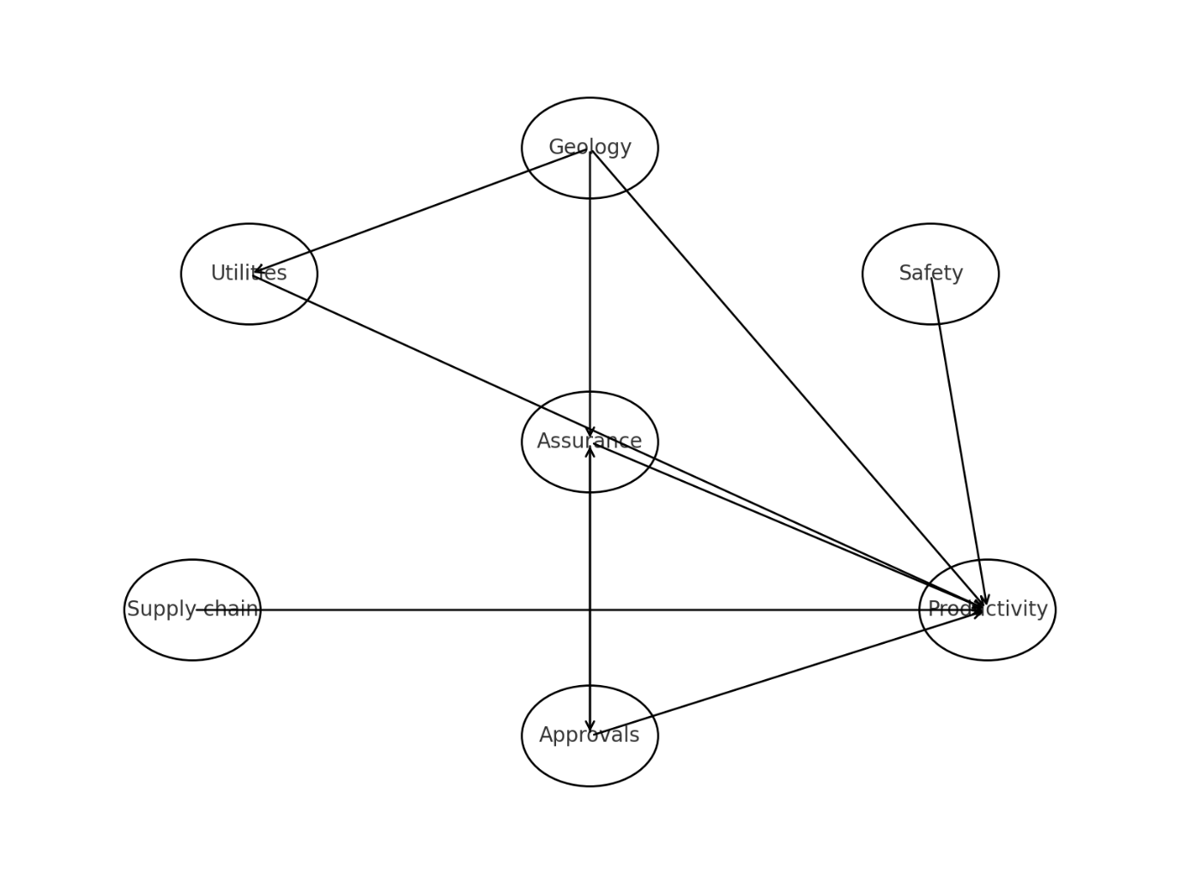
Figure 3. Pumped-hydro schematic

5. Implementation roadmap
Quick wins, months 0–6
- Issue v1 of the ground behaviour playbook and re-baseline TBM tactics by geozone.
- Conduct safety reset and drills across all underground teams.
- Switch on a minimal viable digital assurance stack for priority lots.
- Establish transmission interface forum and publish a single source of truth for milestones. (ABC)
Build-up, months 6–18
- Enforce condition-verified gates before entering high-risk zones.
- Expand digital assurance to all lots and automate evidence packs.
- Implement dual-sourcing for one high-risk component category and negotiate optioned inventories. (waterpowermagazine.com)
Maturation, months 18–36
- Institutionalise metrics review, publish monthly benefits dashboards, and codify lessons in a portfolio playbook.
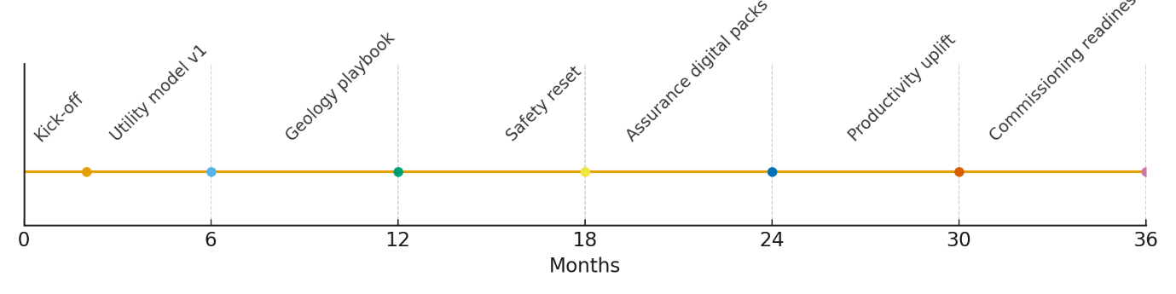
Figure 4. Roadmap timeline

6. Evaluation framework and expected benefits
Measures of success
We recommend a compact KPI set that speaks to flow, assurance, decision speed, and environmental performance:
- TBM advance, metres per day.
- Percent plan complete, weekly.
- Decision lead time for design and approvals, days.
- Time from work completion to lot acceptance, days.
- Environmental incidents per quarter.
Expected benefits
- Higher and more stable TBM advance and fewer stoppages.
- Faster design and approvals decisions and fewer stranded interfaces.
- Shorter assurance cycles and cleaner hand-over packages.
- Improved safety continuity and workforce confidence.
- Reduced schedule variance risk through transmission alignment. (ABC)

7. Risk register and mitigations

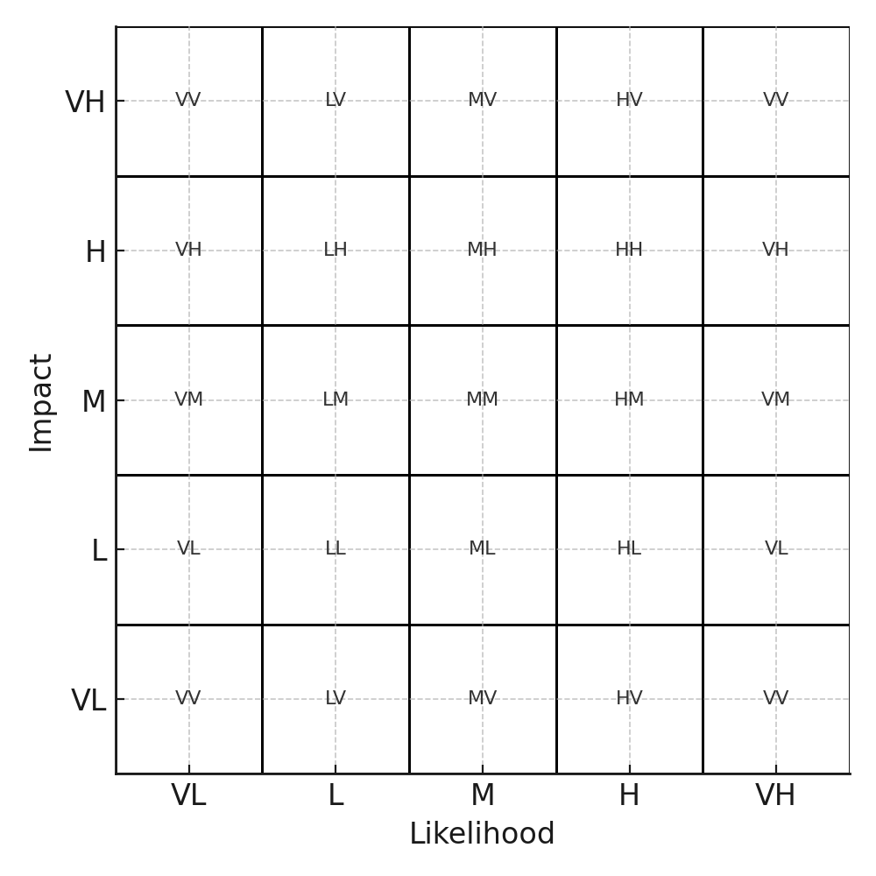
Figure 5. Risk matrix
Risk | Likelihood | Impact | Mitigation
Ground behaviour induces TBM stoppage | Medium | High | Probe drilling, pre-grouting, depressurisation, condition gates before drive
Safety system non-conformance | Low–Medium | High | Safety reset, simplified refuge systems, monthly drills and audits
Approvals delays for changes | Medium | Medium–High | Model-linked evidence packs, weekly decision forums, clear thresholds
Supply delay for critical components | Medium | Medium | Dual-sourcing, pre-approved equivalents, optioned call-offs
Transmission not ready when generation is | Low–Medium | High | Joint schedule with HumeLink and integration governance
Sources for risk context and mitigations draw on current project updates, approvals frameworks, and transmission program timelines. (ABC)

8. Conclusion
The Snowy 2.0 case clearly embodies the grand challenges highlighted in the CVEN9723 brief. The proposed roadmap focuses on controllable levers that reduce uncertainty before it reaches the face, stabilise production, and compress evidence-to-approval cycles, while aligning generation with transmission. The measures and risk-based controls provide a practical basis for benefits-driven reporting that is consistent with professional engineering practice and the marking criteria.

References
ABC News 2024, ‘$4.8b HumeLink transmission line approved to connect Snowy Hydro 2.0’, 19 December. Accessed 19 October 2025. (ABC)
ABC News 2024, ‘Snowy 2.0 faces fresh problems, with tunnel boring machine Florence stuck again’, 22 May. Accessed 19 October 2025. (ABC)
Snowy Hydro 2025, ‘Documents, approvals, management plans and audits for Snowy 2.0’, Snowy Hydro Ltd, accessed 19 October 2025. (Snowy Hydro)
WaterPower Magazine 2025, ‘Snowy Hydro directs cost review as Snowy 2.0 remains on schedule’, accessed 19 October 2025. (waterpowermagazine.com)
Wikipedia 2025, ‘Snowy 2.0 Pumped Storage Power Station’, last updated 6 days ago. Accessed 19 October 2025. (Wikipedia)

