CVEN9723 Group Assignment
Grand Challenges and Emerging Opportunities for the Australian Construction Industry
Case study: Parramatta Light Rail, Stage 1

Executive summary
This report provides a brief review of the Parramatta Light Rail Stage 1 project and outlines the main challenges that affected delivery in a dense brownfield corridor. The discussion focuses on four themes, which are utilities and brownfield conditions, multi-party governance and procurement, systems integration, and the construction impacts on local business access. A simple timeline figure and a short risk table are given to support the discussion. While the report is not comprehensive, it indicates practical opportunities that could help Stage 2 and similar Australian light rail programs, such as using relationship contracting on uncertainty hot-spots and strengthening digital assurance in testing and commissioning (NSW Government, 2025; Australasian Railway Association, 2020).

1. Introduction and case overview
Parramatta Light Rail Stage 1 connects Westmead to Carlingford over about twelve kilometres with sixteen stops and a depot. The line serves hospitals, education precincts, and the Parramatta CBD. Passenger services commenced late 2024 after a short delay to address faults identified during testing and commissioning. The system now operates as an east–west spine in Western Sydney and is expected to integrate with a Stage 2 extension toward Sydney Olympic Park in future planning phases (NSW Government, 2025; ABC News, 2024).
The project is typical of brownfield urban rail: narrow corridors, many underground services, several road authorities, and close proximity to homes and businesses. These aspects tend to increase transaction costs and create exposure to resequencing, especially when design changes ripple through traffic management approvals and construction staging (Audit Office of NSW, 2016).

2. Identification of challenges
Utilities and brownfield conditions. Service relocations in older streets are a leading source of uncertainty. Some utilities may be undocumented or their actual positions deviate from as-recorded drawings. Discovery events can drive redesign and trigger new approvals or working hours conditions. The effect is not only technical but also programmatic.
Governance and procurement. Multiple agencies and councils share responsibilities across road management, public domain, and approvals. When accountability is fragmented, decisions can take time. Procurement choices then have to decide how much risk to transfer. In high-uncertainty settings, attempts to push latent condition risk to a fixed-price contractor often reappear as variations and disputes (Australasian Railway Association, 2020).
Systems integration and assurance. Light rail combines track, power, signalling, communications, platform systems, and rollingstock. Small non-compliances can pause energisation or trial running. The December 2024 pre-opening issues widely reported in media illustrate how delicate the integration phase can be for schedule (ABC News, 2024).
Access and business continuity. Construction near active retail areas can reduce foot traffic and complicate deliveries. If detours and wayfinding are not well planned, local confidence falls and social licence weakens. This, in a loop, can also restrict allowable work windows and slow the site, so it becomes a feedback problem.

3. Root causes and connections
The root causes link back to brownfield complexity and interface density. Unplanned utility discoveries change geometry and sequence, which can reopen design for signalling and traction power and require fresh approvals. Those changes add pressure to the integration window, where configuration control and test readiness must be precise. Meanwhile business access measures must keep pace with staging. The interaction is simple to describe but tricky to manage in real streets.
Figure 1 below shows a basic timeline of five workstreams. It is illustrative only and does not claim to be the official schedule. The aim is to show how utilities and civil works sit upstream of integration, which then leads into testing and commissioning.
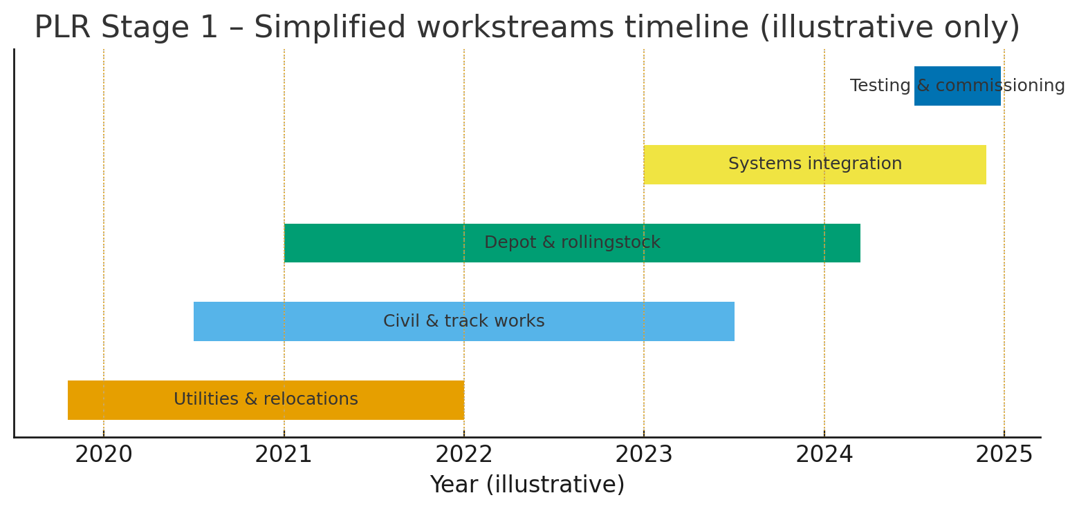
Figure 1. PLR Stage 1 simplified workstreams timeline

4. Best practice and short review
A full literature review is outside scope, but several practices appear repeatedly in Australian rail and are appropriate here. First, using early contractor involvement or alliancing for utility relocation corridors allows shared risk registers and delegated approvals, which keeps decisions moving when ground conditions are uncertain. The Australasian Railway Association’s procurement guidance notes that relationship models suit complex, interface-heavy projects where risk cannot be sensibly priced at tender (Australasian Railway Association, 2020). Second, setting up a digital assurance pathway that includes configuration management, hardware-in-the-loop testing, and clear test readiness criteria reduces unknowns before energisation and trial running. Third, place-based construction staging combined with activation funding and wayfinding standards can mitigate impacts on local businesses during long work phases (Audit Office of NSW, 2016; NSW Government, 2025).

5. Opportunities for Stage 2 and future programs
Three opportunities are proposed at a practical level. The first is to package uncertainty hot-spots under a relationship model with shared risk and transparent pain-share gain-share arrangements. That would be used on utility corridors, heritage interfaces, and complex intersections. The second is to formalise a commissioning playbook, where critical components are verified earlier against an integration model. This should include configuration baselines, component provenance checks, and a clear pass–fail gate for trial running. The third is to treat business access as a delivery KPI, not just a communications activity, with activation measures tied to contractor payments. Together these steps will not remove all risk, but they support a predictable program and a smoother public opening.

6. Risk summary table
Table 1 gives a concise summary of four risks, their likely causes, quick treatments, and who should own the action. This is not exhaustive. It is meant as a starter for a risk register that a real project team would expand.
Table 1. Selected risks, causes, and indicative treatments
Risk | Likely cause | Quick treatment | Owner
Utility clash at intersection | As-built not accurate; shallow services | Trial pits early, redesign loop pre-agreed; ECI with utility | Designer + Utility
Delay to integration tests | Late component non-compliance | Digital assurance, hardware-in-the-loop; configuration board | Systems Integrator
Business access complaints | Detours unclear, loading not maintained | Place-based staging, activation grants, signed detours | Contractor + Council
Contract claims growth | Fixed-price scope with latent conditions | Relationship contracting in hot-spots, joint risk register | Client + Contractor

7. Limitations
The report is concise and not a full technical investigation. Public sources are used, and some details like exact dates vary between websites and media. Data about costs are not analysed here. Despite those limits, the main challenges are consistent with the visible features of brownfield light rail in New South Wales.

8. Conclusion
Parramatta Light Rail Stage 1 faced typical brownfield challenges that connect utilities, governance, integration, and local access. A passable way forward for Stage 2 would combine a relationship-based approach on the most uncertain works with stronger digital assurance for systems and a place-led mindset for business continuity. These measures are well aligned with recent guidance and will give a more robust pathway to commissioning and opening.

References
ABC News 2024, Parramatta light rail opening delayed again after discovery of faulty components, 2 December, viewed 19 October 2025, https://www.abc.net.au/.
Audit Office of New South Wales 2016, CBD and South East Light Rail Project, Audit Office of NSW, viewed 19 October 2025, https://www.audit.nsw.gov.au/.
Australasian Railway Association 2020, Best Practice Principles for Rail Construction Procurement, ARA, Canberra, viewed 19 October 2025, https://ara.net.au/.
NSW Government 2025, Parramatta Light Rail Stage 1 overview, NSW Government, viewed 19 October 2025, https://www.parramattalightrail.nsw.gov.au/.

