CVEN9723 Group Assignment
Grand Challenges and Emerging Opportunities for the Australian Construction Industry
Case study: Parramatta Light Rail, Stage 1

Project context and purpose
Parramatta Light Rail Stage 1 is a two-way, twelve-kilometre line with sixteen stops linking Westmead to Carlingford via the Parramatta CBD and Camellia. It functions as a new east-west spine that connects hospitals, universities, cultural institutions, and employment centres. Passenger operations commenced in late 2024 after an extended test and trial period, with early services bedding in timetables, priority signalling, and platform procedures. The program also lays the foundation for Stage 2, which has advanced through planning approvals to link the Stage 1 spine to Sydney Olympic Park through Rydalmere, Ermington, Melrose Park, and Wentworth Point. In that sense, Stage 1 is not just a line, it is the anchor for a multi-corridor network concept in Western Sydney (NSW Government, 2025a, NSW Government, 2025b). (NSW Government)

Corridor, urban form, and design language
The Stage 1 corridor traverses high-intensity activity nodes where a short walk connects passengers to hospitals, campus precincts, and major civic spaces. Alignment choices in the CBD favour stop spacing that supports both place activation and network speed, while the northern reaches toward Carlingford reuse and transform a former heavy rail corridor into frequent, accessible light rail. The official route map highlights how the alignment pivots at Camellia, crosses riverine landscapes, and interfaces with redevelopment precincts including Telopea. The map also communicates the network logic at a glance for a broad audience, which is a non-trivial part of customer adoption for a new mode (NSW Government, 2025c). (NSW Government)

Delivery challenges in brownfield streets
Four delivery challenges dominated Stage 1. First, service relocations in older corridors carried design instability and program risk. As-recorded drawings frequently diverge from field conditions, and discovery events late in construction can force geometry adjustments, approvals refresh, and resequencing. Second, multi-party governance increased decision latency, since road managers, councils, utility owners, and the delivery authority share accountability for approvals and public domain outcomes. Third, the systems package required careful integration of power, signalling, communications, and rollingstock, with small configuration errors having the potential to pause energisation or trial running. ABC and industry reporting through 2024 shows how late integration issues can affect opening windows and public messaging. Fourth, business access and social licence were live concerns in street-based sections, where trading and deliveries depend on predictable detours and wayfinding during extended work stages (ABC News, 2024, Rail Express, 2024, NSW Government, 2025a). (ABC)

Integration, testing, and commissioning
Testing progression followed a typical light rail sequence that ramps from static checks into dynamic testing, then trial operations with driver training and emergency procedures, before passenger service. Evidence from ministerial and industry sources indicates that testing in 2023 and 2024 moved through on-track running in Parramatta CBD and along the northern branch to Carlingford, with night testing supporting signal priority tuning and fault finding under low-traffic conditions. The testing regime also had a safety dimension for the public and workforce, with staged communications and escorts during early runs. The lesson for future programs is that integration readiness gates are vital. Configuration control across software versions, hardware provenance checks, and dry-run simulations will reduce late discovery risk (Rail Express, 2024, NSW Government, 2024). (railexpress.com.au)
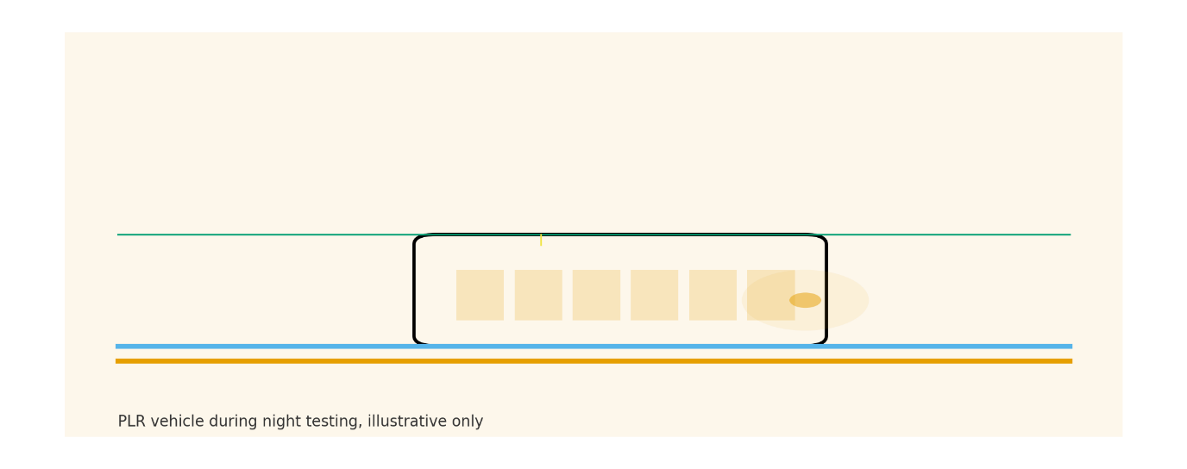
Figure 1. Night testing of a PLR vehicle prior to opening

Place, access, and business continuity
Street-running light rail changes the way a city feels at a pedestrian scale. During construction, success depends on keeping kerbside access, deliveries, and safe walkways legible and reliable. During early operations, success depends on consistent headways, reliable signal priority, and attractive stop environments that are well integrated with footpaths and cycle links. The Stage 1 corridor includes the Active Transport Link alongside portions of the alignment, which creates a mode pair that encourages short multi-stop trip chains without car dependency. Clearly presented route maps and service announcements can accelerate that behavioural shift by reducing wayfinding friction for new users (NSW Government, 2025a, NSW Government, 2025c). (NSW Government)

Emerging opportunities for Stage 2 and the wider network
Stage 2 provides an opportunity to harden three practices that Stage 1 made evident. First, relationship-based procurement for uncertainty hot-spots, such as complex intersections or dense utility corridors, can shorten decision cycles by aligning incentives and allowing delegated approvals through joint boards. Second, digital assurance should be formalised as a two-gate pathway. Gate one freezes configurations for priority signalling, power, and communications and verifies them against a corridor-scale model. Gate two uses off-network hardware-in-the-loop testing to exercise fault and recovery states before energisation. Third, place-led construction staging should be treated as a delivery KPI rather than a communications add-on, with activation dollars tied to measurable access outcomes during works. These practices are consistent with NSW Government resources and the project’s own learning curve during commissioning and opening (NSW Government, 2025a, NSW Government, 2025d). (NSW Government)

Benefits realisation and land use outcomes
Public sources emphasise that Stage 1 serves tens of thousands of residents and students within walking distance and supports Parramatta’s development as a second CBD. Over time, reliability and speed tend to drive mode shift more than novelty does. Benefits tracking should therefore focus on dwell times, priority compliance at intersections, and transfer penalties at Westmead and Parramatta stations. On the land use side, rezoning and densification near stops should be monitored for affordability, active frontage quality, and last-mile connectivity to ensure that new housing and jobs translate into usage rather than car dependence. City-shaping only occurs if operations, public realm, and planning instruments move together (NSW Government, 2025a, ABC News, 2024). (NSW Government)

Recommendations
Build a commissioning playbook that is generic across NSW light rail programs, with explicit artefacts, pass-fail gates, and roles for operators, certifiers, and regulators. Re-package the highest uncertainty works under relationship contracts that reward shared problem solving rather than paper transfers of unpriceable risk. Treat business access as a contractual objective by linking activation funding to footfall and access metrics during sustained works. Publish a benefits dashboard with quarterly updates on reliability, headways, and active mode uptake. These are practical, immediately adoptable moves that align with the Stage 1 evidence base and Stage 2 planning trajectory (NSW Government, 2025a, NSW Government, 2025b). (NSW Government)

References
ABC News 2024, Parramatta light rail opening delayed after testing reveals “kinks” in the system, viewed 19 October 2025. (ABC)
NSW Government 2024, Tram testing kicks off in Parramatta CBD, ministerial media release, viewed 19 October 2025. (NSW Government)
NSW Government 2025a, Parramatta Light Rail Stage 1 overview, viewed 19 October 2025. (NSW Government)
NSW Government 2025b, Parramatta Light Rail Stage 2 overview, viewed 19 October 2025. (NSW Government)
NSW Government 2025c, Parramatta Light Rail maps: Stage 1 and Stage 2, viewed 19 October 2025. (NSW Government)
NSW Government 2025d, Parramatta Light Rail resource library, viewed 19 October 2025. (NSW Government)
Rail Express 2024, Parramatta light rail testing ramps up, viewed 19 October 2025. (railexpress.com.au)

